Funding Proposal Template

Application Template for Fully-Developed Proposal and Project Concept Proposal

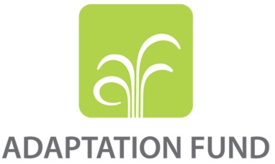

PROGRAMME ON INNOVATION:
LARGE GRANTS PROJECTS

REQUEST FOR PROJECT FUNDING FROM THE ADAPTATION FUND

The annexed form should be completed and transmitted to the Adaptation Fund Board Secretariat by email.

Please type in the responses using the template provided. The instructions attached to the form provide guidance to filling out the template.

Please note that a project must be fully prepared when the request is submitted.

Complete documentation should be sent to:

The Adaptation Fund Board Secretariat
1818 H Street NW
MSN N7-700
Washington, D.C., 20433
U.S.A
Fax: +1 (202) 522-3240/5
Email: afbsec@adaptation-fund.org

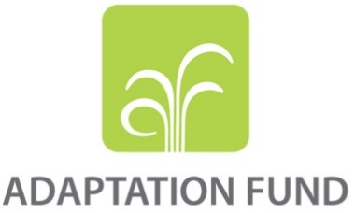

SINGLE COUNTRY/ REGIONAL INNOVATION PROJECT/PROGRAMME PROPOSAL

PART I: PROJECT/PROGRAMME INFORMATION

Title of Project/Programme: Securing Water Resources through Solar Energy and Innovative Adaptive Management (SEAM)
Country/ Countries: Belize
Thematic Focal Area: Rural Development and Water Management
Type of Implementing Entity: National Implementing Entity
Implementing Entity: National Implementing Entity
Executing Entities: Ministry of Rural Transformation, Community Development, Labour and Local Government
Amount of Financing Requested: US$ 5,000,000 (in U.S Dollars Equivalent)
Letter of Endorsement (LOE) signed: Yes ☒ No ☐
NOTE: The LOE should be signed by the Designated Authority (DA). The signatory DA must be on file with the Adaptation Fund. To find the DA currently on file check this page: https://www.adaptation-fund.org/apply-funding/designated-authorities
Stage of Submission:
☒ This proposal has been submitted before including at a different stage (concept, fully developed proposal)

Project / Programme Background and Context:

PROJECT BACKGROUND AND CONTEXT

Project Brief

- SEAM aims to provide a distinct and innovative approach to ensuring the adaptive capacities of four rural communities in Belize have access to reliable, potable water under periods of climatic stress. The project focuses on four identified factors that have prohibited a long-lasting solution to access to water, a) inconsistent and/or depleted water availability, b) lower yields on land use and available livelihoods, c) limited or unequal participation of a broad range of stakeholders in key decisions, d) limited capacity to provide training to improve water services. Water sources in the communities have deteriorated, in part due to land use and underlying geological characteristics of the watershed formation. Further, the villages remoteness location and persistent poverty have been a barrier to modern agricultural methods and diversification of livelihoods. These issues occur in a context where changes in climate affect key variables such as frequency and intensity of rain, as well as longer, hotter days. While climate concerns affect all of Belize, these concerns are particularly exacerbated in the Toledo District, a Maya enclave, and in low lying coastal areas of Northern Belize. The GOBZ has taken steps in other communities to supply rural areas with water with mixed results; some systems installed have deteriorated or are perceived to be of low quality. The Ministry of Rural Transformation, Community Development, Labor & Local Government (MRT), agency that liaisons with community or village governments, aims to change poor water supply by improving both the service and its governance, and further, it seeks to do so by improving the health of the ecosystem that produces water which also functions as the source of livelihoods for the project communities. The objectives and activities of SEAM will provide the communities with consistent and reliable potable water, avenues for restoring and conserving the ecosystem in relation to improvement of their livelihoods, community and national adaptive capacity and awareness on climate risk and its relationship to water, and most importantly, training in inclusive and participatory governance at the community and MRT level.

Background

- The proposed project seeks to provide a long-term sustainable solution to water supply concern in four communities in rural Belize. A variety of climate and other environmental and social issues have strained the capacity of the four communities to effectively produce and distribute potable water. Of the four rural communities, three are in the Toledo District of Belize, a traditional Maya enclave in the southern part the country; the other community, is in the Corozal District in the north of Belize, nearly 11 km (6.8 miles) from the Mexican border.

- Belize is a Caribbean country located in Central America, latitude 17 N 88 W. The national territory covers a land area of approximately 5.6 million acres (approximately 22,967 km²), including 174 miles (280 km) of coastline entirely along the Caribbean Sea. The mainland makes up 95% of the territory, and 5% is represented by more than 1,060 small islands or Cays. Belize borders Guatemala to the west, Honduras to the southwest (including a shared sea border), and Mexico to the North. Of its total land approximately 1.9 million acres (7,600 km²⁾ are considered suitable for agriculture, only 390,427 acres (1580 km²) or 7% is actively being used for such purposes. Most of the land use potential is considered to be marginal, mostly covered by forest. Agriculture is an important sector for the Belize economy, however its participation in gross domestic product (GDP) has decreased; during 2011-2015, the contribution of the sector to GDP was on average 15%, in 2020, the sector rebounded to 10.71% from 8.97% in 2019. Notwithstanding, the sector accounted for 11% of employment in 2023, behind tourism at 14.1%.

- The country has an estimated population of 414,239 people, with a 1.47% annual population growth rate according to United Nations data. It has a low population density of around 45.4 people per square mile – the lowest density of Latin America and amongst the lowest in the world. Belize City is the most densely populated city with 57,000 inhabitants, significantly higher than its capital Belmopan, with 16,500 inhabitants. Administratively, Belize is divided into six districts, Corozal and Orange Walk District in the north, Cayo District in the west, Belize District in the center, and Stann Creek and Toledo District in the south. The country has different ethnic groups, of which mestizo are the majority, 52.9%, followed by Creole, 25.9%, and Maya, 11.3%. Other ethnic groups in the country, include Garifuna, Mennonite, and East Indian. The ethnic diversity of Belize contributes to a rich language profile, where English is the official language, however Spanish is widely spoken; notable languages are Creole (Kriol), Maya (two principal dialects), German, and Garifuna. The indigenous Maya and Garifuna play an important role in Belizean culture, especially in the south, where they comprise the majority of the population.

- The country achieved independence from the United Kingdom relatively recently, in 1981. The country is organized as a constitutional democratic monarchy, with HM King Charles III, who is represented by a Governor General, as is common in most commonwealth former colonies. The Governor General is a Belizean National. In terms of representation, a bicameral parliament, composed of a House of Assembly (representatives) and a Senate, is tasked with forming the government and legislative affairs. Elections for the House of Assembly are held every five years. The Prime Minister, as head of government, is appointed by the Governor General, based on the majority of party of the Assembly. Further, Senate membership, of which its 12 members are also appointed by the Governor General; six are appointed under the advice of the Prime Minister, three are appointed on the advice of the opposition, and the remaining three, by non-government organizations.

- Belize is highly vulnerable to the effects of climate change, due to the exposure of its geographic location, low-lying coastal areas, level of infrastructure development, susceptible biodiversity and ecosystems, agricultural sensitivity, water resource stress, lack of economic diversification, sparse population density and lack of social networks and emergency relief plans. While nested in the Central American isthmus, Belize shares much of the characteristics of Small Islands Developments States (SIDS) and is classified as such. Belize has an agriculture and tourism oriented small economy, is vulnerable to external shocks, and limited administrative and governance to plan and implement climate adaptive action. Climate change vulnerabilities augment issues that blend the natural environment, social and cultural practices, economic access and geological features.

- Belize has a subtropical climate that is distinguished by humidity and rainfall as opposed to temperature – referenced as the wet and dry seasons. The mean annual rainfall increases sharply from about 50 inches (1,270 mm) in the North to 175 inches (4,445 mm) in the South. El Niño Southern Oscillation (ENSO) heavily influences Belize's climate, in addition to the worsening of the Inter-Tropical Convergence Zone (ITCZ). Hurricanes are a threat from July through November. Belize is exceptionally vulnerable to natural disaster. Frequent hurricanes, flooding, sea level rise, coastal erosion, coral bleaching, droughts and changing precipitation patterns threaten the physical and social infrastructure of the country. The EM-DAT, international disaster database, recorded 16 disaster events between 1990 and 2021 in Belize that affected approximately 304,000 people. Since 1990, 11 tropical cyclones have hit Belize, along with four floods and one cold wave. These extremes exacerbate existing water supply issues and adversely impact Belize’s key productive sectors of tourism and agriculture¹.

Geology and Land Use

- The area now known as Belize, which lies below the Yucatan peninsula, was formed over 100 million years ago in the early cretaceous, by both tectonic and volcanic activity. Most of the geological features of Belize (and Central America) were created by subduction of the Coco Plate to the North American and less dense Caribbean Plate². The rise of northern Central America (Guatemala, Belize, southern Mexico) created an igneous ridge under a flat bed of sedimentary limestone formation. The igneous ridge, generally known as the Maya Mountains, which are mostly made of granite, with valleys and troughs of limestone³. These geological features account for lush forest environments, limestone caves (karst systems), underwater rivers and sinkholes.

- The watersheds of Belize depend on the water retention of natural primary forests. Most of its watersheds depend on the capacity of the Maya Mountains to retain water during the dry season, which ranges between November and April⁴. The watersheds rely on a delicate balance between the solid granite formation of the Maya Mountains, the porous nature of a limestone layer, at time 3.7 miles (6 km) of thickness, and organic forest cover. The forest cover retains moisture from the rainy season and limits the rain flow towards the watershed⁴. Moreover, the limestone systems that abound in the Maya Mountains and neighboring regions supply much of the water for tributaries of rivers that provide nutrients to the Caribbean Sea. In Belize’s Caribbean Sea lies the Barrier Reef Reserve System, whose ecosystem depend on the nutrients that flow from the coastal watersheds.

- Land use practices in Belize are broad, from large mechanized modern farming to small subsistence production. The more productive land is in the Belize, Stann Creek, Orange Walk, and Corozal districts, and make up about 16% of the country’s land. Other suitable land, covering 20% of the land area, is adequate for agriculture, albeit with substantial investment, and may be preferable for small-scale farming; 44% of the remaining land is primarily covered by forest⁵. Much of the forest cover of Belize is in the western side of the country, in districts such as Cayo, Stann Creek, and Toledo. The geological formation of Belize, especially in the mountainous and near mountainous regions is extremely vulnerable to land degradation.

- Deforestation from land use has reduced forest cover. From 2002 to 2022, Belize lost 136,000 hectares of the forest ecosystem, nearly 12% of loss of humid primary forests⁷. Belize still maintains 67.4% of its territory under natural vegetation, and 34.9% is protected forest. These forest systems have been lost due to several factors, which include land use for agricultural purposes, logging, and forest fires. Agriculture and tourism are the main drivers of economic activity of the country. Tourism is focused principally on the coast, cayes, and Maya ruins in the Cayo District, while agricultural activity is prevalent throughout the country, albeit with different production methods and impacts. Belize is an important producer of citrus, sugarcane, and bananas and has recently begun successfully producing cocoa, coffee, and cardamon. The large export base is focused on sugarcane and citrus; most of which are produced in the northern part of the country and utilize modern farming techniques. The northern part of Belize has apt soils and mostly flat lands, that are suited for large scale production. In southern Belize, much of the agricultural production is traditional, generally called milpa farming, which rotates crop cultivation through slash-and-burn and/or slash-and-mulch techniques.⁶Belize has approximately 92,000 acres that are planted with sugarcane, 48,000 acres (194.3 km²) of citrus, and 48,500 acres (196.3 km²) of corn. Additionally, there are 351,700 acres (1423.3 km²) of pastures used to graze approximately 135,400 head of cattle.

- The geography of Belize is particularly vulnerable to climate-induced risks made worse by agricultural practices that have affected the watersheds of Belize, both from use of fertilizers, pesticides, and through land use. Neonicotinoids are widely used as chemicals in pesticides in melon production, and to a lesser degree in sugar cane and banana farms and have been, showing up in aquatic and birdlife when tested in Corozal (northern Belize).⁷Corozal is home to extensive mangroves and wetland ecosystems, which influence the primary livelihoods for many coastal fishing communities of northern Belize, such as Copper Bank. Whilst an environmental problem, the geological formation of Belize’s topography, exacerbate the problem as changes in climate modify the severity of rain patterns.

- The Toledo district has profound roots in Maya culture, with two predominant groups, Q’eqchi’ and Mopan Maya; these groups speak different languages but maintain similar traditions and farming techniques. The Maya peoples are organized, recognized, and live mostly in rural communities; though they have been sidelined from the economic progress that other areas of the country have achieved. Traditional subsistence farming is an important socio-cultural component of Maya culture. Agricultural land use in southern Belize is mostly through small scale farming, much of which is subsistence.¹⁰ In 2021, the Toledo District accounted for 2,545 farmers or 18% of total persons register as farmers; yet the district has 25% of all farms in Belize, and 77% of all small farms (below 20 acres/.08 km²); the low number of registered farming corresponds to the level of informal employment prevalent in the district. The district is the poorest in Belize and the Maya peoples have the highest poverty rate of any ethnic group in Belize, at 68%. Farming techniques utilized by many Maya communities are traditional or milpa Farming. This technique can be sustainable, as it has been used for hundreds of years, but depends on the amount of time provided for the forest to regenerate after crop were planted, typically eight to ten years, but more recently this period has been reduced to three to four years.

- The active involvement of women in agriculture, a facet often underestimated or overlooked, becomes apparent through insights from the 2011 Agricultural Census. While 30% of farmers in charge of all activities are women, this statistic does not fully encapsulate their substantial contribution. The census highlights that, particularly in family-operated farming businesses, women engage in a range of tasks such as irrigation and water management, harvesting of permanent crops and fruits, milling, grinding, sun drying, and livestock rearing, including cattle, sheep, pigs, and poultry⁸. Women, particularly in indigenous communities, are primarily small-scale producers for their subsistence and sale at local markets, often engaged in manual harvesting and marketing. Small-scale producers face numerous constraints, such as land holdings of less than 10 acres (.04 km²), prolonged soil fertility recovery, remote locations with poor road access, high post-harvest losses, limited technology, difficulty getting produce to markets and inadequate access to credit⁹.

- Domestic food production is at risk under climate scenarios. The Caribbean Community Climate Change Centre (CCCCC) commissioned a study to determine the vulnerabilities of agriculture and food security in Belize; yielding alarming results based on climate scenarios. The yields of staple crops of maize, rice, and beans were modeled to determine potential yield loss based on parameters such as physiological response to climate, soil, and crop management. The result was that under climate scenarios of temperature increases of between 1ºC and 2ºC, and +/- 20% change in precipitation, in all of three crops, yields would decrease between 10% to 20% in all scenarios, with most severe yield loss in maize of between 17% and 22%.¹⁰ In effect, such simulated climate impacts on agriculture would amount to between US$6 and $8 million, based on 2006 prices. It is important to note that production of crops such as maize, beans and rice are mostly relied on for domestic consumption and are widely cultivated by small plot farmers. Large scale farming concentrates on “traditional” export crops.

- Poverty, limited livelihood options, and traditional production methods contribute to forest and watershed stress. Socioeconomic factors, limited access to education, training, and technology, as well as lack of financing, have led many communities in Belize, especially those in the Toledo District, to sustain livelihoods through milpa farming, animal rearing, and at times logging (both legal and illegal). 76.4% and 67.8% of the population of the Toledo and Corozal districts, respectively, lacked secondary education; in 2018, 81.7% of inhabitants were considered poor, with the national average at 51.8%. The figures are more dire when broken down by ethnic groups, 60% of the poor of Belize are Maya, and the 40% of the population lives in rural poverty. While agriculture rebounded from 8.9% in 2019 to 10.7% in 2020, the sector’s performance has been volatile, in part due to climatic factors (weather events), and commodity prices. The Maya communities in the Toledo district, whose crops beyond subsistence production are bound principally for the local market, face transport costs, exchange rate losses when selling in Guatemala, and lower yields due to soil degradation.

- The stress placed on watersheds will be exacerbated by climate change, albeit differently in southern and northern Belize. Climate projections, deploying a CIMP-6 scenario, and other generally accepted Caribbean models, expect that rainfall will decrease in Belize.¹² The number of consecutive dry days is increasing, as well as is the amount of rain during rainfall events; and is more severe in southern Belize due to receiving on average more rain. It may seem that lower rainfall should contribute to lesser runoff, however, when the LULC factor is included, evidence suggests the contrary; the decrease of forest cover increases excess nutrient pollution⁴. Further, tropical forests are remarkably effective at slowing precipitation rates, which coupled with Belize’s porous limestone soil formation, contribute to the delicate balance of water retention.

- The impact of lower water availability is already being observed. The Toledo project communities have indicated faster depletion of their water sources during the later period of the dry season. One recent project on reforestation (Ya’axché Conservation Trust), has brought to attention the impact of the deterioration of forests on the livelihoods of the most impoverished communities in Belize. Other impacts observed are water born illnesses related to water contamination, especially when communities are forced to resort to consuming surface water due to other water shortages. In the Corozal project community, the wells commonly run dry during the dry season and salinity has become an increasing issue, especially for older water wells.

Water in Belize

- Belize has abundant water resources, in terms of surface and groundwater. Its watersheds are comprised of a network of springs, creeks, rivers, lagoons, and groundwater which many are limestone underwater reservoirs. There are 35 major rivers and 39 identified major watersheds in the country. These watersheds primarily originate from the Maya Mountains and drain into the Caribbean Sea. The quantified river discharges are 3706.6 acres (15 km)³ per year, occupying 59% of the territory.¹¹ Five of the rivers originate in Mexico and Guatemala. The Rio Hondo forms the northern boundary of the country, with Mexico, and, in the south, the Sarstoon River is the boundary with Guatemala.

- Belize’s water resources however face climate risk due to, amongst others, to changes in precipitation patterns, increased extreme weather, sea-level rise and saltwater intrusion, shifts in hydrological cycles and impact on ecosystems. The WWF Nature Country Water Risk Filter scores 2.21 and ranks Belize 37; the score is a combination of aggregate physical and regulatory risks scores, where a lower figure indicates lower risk. In terms of aggregate physical risk, flooding (3.35) and water quality (3.15), weigh against its higher water scarcity ranking (3). The water scarcity ranking is partially due to a higher score in ecosystem services status (1.97). In terms of basin regulatory risk, an aggregate of water conservation policies, Belize ranks 140, with a score of 3.01; enabling environment and management instruments, scored 3.25 and 3.37 respectively. In terms of risks related to water Infrastructure and governance, Belize ranks 120, and 89. These indicators demonstrate that even with plentiful water, there is management and risk exposures.

- Communities, large and small, in Belize receive water from two main sources, a) utility piped water, and b) Rudimentary Water System (RWS). Larger communities such as Belmopan (capital), San Pedro Town and Belize City receive water by a metered service operated by the national water and sewerage company Belize Water Service (BWS). BWS, provides water service to nearly 59% of the population of Belize, with non-revenue water (NRW) below 27%, amongst the lowest in the region. Currently, BWS charges a monthly flat rate of approximately US$5 for up to 1,000 gallons. Residential users with higher water consumption pay more, as do non-residential consumers. BWS is also the sole provider of sewerage services in Belize, however it only provides this service to about 21% of its water customers. Rural and non-BWS communities’ water service is provided through Water Boards whose water is from RWS. There are 191 communities, of which 132 have established 117 Water Boards (some Water Boards oversee more than one community). Community Water Boards are fraught with governance issues, most have not established metering, and the quality of service is generally poor. In 2012, only 36% of the Water Boards had water meters, and the rate of fee collection varies by community. 44% of Water Boards collect less than 60% of water sold. The communities served by Water Boards are small, less than 4,000 people, and mostly less than 500, which exacerbates the capital investment issue. In 2021, the total income for the Water Boards was US$1.553 million, while expenses were US$1.496 million; barely breaking even.¹² Even small water systems are beyond the repayment capacity of these communities assuming BWS rates. Given the poor performance of water systems in rural communities, many households have opted for private wells and pumps. Communities and Water Board issues are the responsibility of the Ministry of Rural Transformation (MRT), which has made investments throughout Belize by drilling production wells and installing hand pumps in those communities that do not have Water Boards. Improvement of Water Board governance is a major concern for the authorities of Belize.

- Water Board governance is dictated by national statute and requires the interaction of the Village Council with the MRT. Water Boards in Belize fall under the governance framework of the Villages Councils Act, where the Water Board structure is established under section 43:01. The Minister of the MRT has the duty to establish (appoint) a Water Board consisting of a) the Chairman of the Village Council, b) a member of the Village Council nominated by the Village Council, and five other members in consultation with Electoral District Area Representative, and Village Council. Water Boards are independent from the Village Councils and are responsible for operation, maintenance, and all activities required for uninterrupted water services. Water Boards must keep proper accounting records, collect fees, and seek to expand and improve the water system. Water Boards can and do hire personnel to operate the system effectively, however no member of the board may be employed by the Water Board.

- There is insufficient public confidence in village Water Boards in rural Belize. Rural area water provision is characterized by high levels of coverage but poor service quality.¹⁵None of the Water Boards of Belize provide wastewater, sewage, or sanitation services nor provide WASH capacity building. Water contamination from human and animal fecal matter is a known and evident issue for rural water systems in Belize¹³, and further, recent water tests sustain this assertion. The situation of contamination is more prevalent in rural communities during the end of the dry season.¹⁴ Water Born illness are frequent in Belize, Salmonella and Shigella are often detected in water testing¹⁵ throughout the country. Non-consistent and poor-quality service, often fraught with leaks and lack of maintenance impact the community’s perspective on service payments, where over 40% of Water Boards have less than 60% collection rates. Under the perspective of improvement to service quality, mitigation to contamination must be addressed to ensure reduction in water born illnesses.

General Vulnerabilities of Project Communities

- Most communities in Belize are rural, with agriculture as primary livelihood. There are 191 villages in the six districts of Belize. The Toledo District has the highest number of communities, at 64, followed by Stann Creek, with 47, according to the 2010 census. The Toledo District is also the less densely populated district in Belize, with about 470 persons per village. Local governance depends on the size of the community, larger communities are established as towns and cities.

- The project seeks to increase the adaptive capacity of four communities in Belize to respond to the increased vulnerability and impact of climate change and increase their ecosystem resilience in response to climate change induced stresses. Three of the project villages are located in the Toledo District, and one, in the Corozal District. The Toledo District communities are Dolores, Otoxha, and Boom Creek. Dolores and Otoxha, share similarities in terms of livelihoods, cultural dynamics, and are located4.3 miles (7 km) (4.3 miles) apart, near the border with Guatemala. Boom Creek is about 9.3 miles (15 km) from the capital and largest town in the Toledo District, Punta Gorda Town, yet like all the other project communities in this district, does not have grid electricity. The Corozal district community, Copper Bank is located in the mouth of the New Creek, a tributary to the Corozal Bay estuary. Copper Bank is a low-lying area, and differs culturally, and to a degree, ethnically from the three Toledo district communities. Furthermore, Copper Bank is serviced by Belize Electricity Limited, the national electric utility. The project presents an opportunity to provide innovative solutions to two different areas of the country that face substantial climate risks, yet for unrelated factors. Moreover, the differences between the communities can provide the development community with valuable lessons learned in terms of governance and sustainability of water systems. (See Annex IV, for the Social Assessment of each project community village: pgs. 74-82 for Dolores; pgs. 66-73 for Otoxha; pgs. 41-65 for Boom Creek; and pgs. 40-59 for the Copper Bank).

Toledo district

- Food security, illiteracy, and access to health care are major concerns for the Toledo District. Toledo’s children are the most malnourished in the country. 42% of them are stunted, compared to 19% nationally. Only 38% of them get the immunizations needed, versus 63% nationally. Adult literacy is also lower in Toledo, at 69%, versus 80% countrywide. If we break down the data by gender, men in Toledo exhibit a lower literacy rate at 67.4% compared to women, who have a rate of 71.0%. However, when we analyze the data by both gender and ethnic group, it becomes apparent that Maya Q'eqchi' and Maya Mopan men exhibit higher literacy rates, with rates of 67.1% and 77.0%, respectively, than their female counterparts (63.0% and 71.1%). On the other hand, Maya Yucatec women surpass their male counterparts in literacy, with a rate of 78.8% compared to 77.8%.¹⁶ 35% of Toledo’s Q’eqchi’ Maya adults cannot read or write. Farming areas also have the most poverty in Belize. The Toledo District has 25% of all the country’s farms, mostly small. (77% under 20 acres), and Corozal has 21% of all farms. Half of Toledo’s people are indigent, compared to 16% across Belize, incidence of poverty in male-headed households was 31.1%, and 24.7% in female-headed households in 2021¹⁷. In rural Toledo, indigence is even higher, at 60%. This means more than half of rural Toledo cannot afford enough food for a healthy life. The region is poor for many reasons, mainly from lack of education and infrastructure. There are few roads, and they are of poor quality and there is little public transport, making people isolated. The Toledo District project communities, like many others, have no electricity, water, or cell service. They cannot get their farm products or crafts to market very easily, making them poorer. In general, only 15% of Toledo households have computers and only 3% have internet. Many rural Toledo villages use kerosene lanterns and live in huts with thatched roofs. Over 56% of Toledo families cook with wood (compared to 18% nationally), impacting their health and resulting in breathing issues, especially women, considering they are typically responsible for domestic chores, following traditional Maya gender roles. Half of Toledo’s people use pit latrines, while most people in other regions have flush toilets. The Toledo district also suffers from the large number of political refugees from other Central American countries, which strains the poor education, health, water, and sanitation services.¹⁸

Otoxha

- Otoxha is a Maya village in a ‘reservation’ of about 50 acres. It has crop fields, small creeks, and a view of the Maya Mountains. It is 34 miles from Punta Gorda, four miles from Dolores, and six miles from Guatemala. The village has thatched roof houses along the main rural road, a wooden health outpost, and a new bakery with solar panels that is rarely used due to the difficulty in buying supplies and access transport to sell what is produced. Only 2% of the houses are made of cement blocks. On numerous occasions, the village has received support from Non- Government Organization (NGO) projects with mixed results.

- Otoxha Village’s inhabitants migrated from Chacalte’ and other Maya enclaves in Coban Alta Vera Paz, Petén, Guatemala around 1924. Village reports provided by the MRT, indicated unfair labor requirements imposed by the Guatemalan government’s infrastructure projects resulted in the migration to the area. Once more populated, Otoxha’s inhabitants moved, over time, to form new villages like San Benito Poite, Mabil Ha, Corazon, San Lucas and Valley of Peace. Currently, 357 people live in 58 households. About 47.5% are male and 49.6% are female; the vast majority are Q’eqchi’ Maya, with a small number of Mopan Maya. Almost all of them speak Q’eqchi’, only 1% speak Mopan,56% speak some English, and 26% can also write English. In the Maya tradition, household structures are mostly based on male leadership. The village is predominantly Catholic, with Bibles and hymn books written in Maya Q’eqchi’; however, community has a high rate of illiteracy, and many members lack the reading skills to use them. The area has a network of karst formations, like limestone caves and sink holes, that are significant to the Maya culture. The elders do traditional rituals and offerings inside these formations for their milpa fields, planting and harvesting. They want to respect “mother earth” and ask for her permission and blessings. Village surveys indicate that the younger villagers do not participate in these practices as much as their elders.

- The village of Otoxha experiences some of the highest levels of poverty in Belize. With an average monthly income of less than US$50 (BZ$100) per month, they are classified as indigent, or extremely poor, lacking the basic resources for normal existence. Villagers reported that though almost 58% fell in this income bracket, 22% earned between US$ 50-125 (BZ$100- BZ$250) and a small percentage above that. The majority of the community members are subsistence farmers, most men and women are not in the paid labor force, and their main source of income is from cultivating an average of four to five acres of seasonal milpa, rice, and other staple. Production of staples not used for consumption are sold in Guatemala and other communities though the nearest market in which to sell rice is approximately 30 miles away to the north. Like most land that is resided on by the Maya population in Belize, the Otoxha villagers have no land titles and are considered to be on ‘reservation land’. Despite this land rights issue, 98.1% indicated. Other sources of income are livestock, small scale logging, handicrafts, and incense. Some members of the community are government employees, pensioners, and construction workers.

- The main road to Otoxha is an unpaved, gravel dirt road and connects this part of the country with Punta Gorda; its condition varies greatly depending on the season and severity of the rain and receives limited maintenance. Trucks and public-access buses make the route to Punta Gorda regularly. These buses are used especially by students attending high schools; a journey that takes about one hour and 45 minutes. Aside from the main road, it is not uncommon for community members to ride (motorcycles) to nearby Guatemala, motivated at times by higher prices for staples. There are also a series of bush trails connecting various nearby communities. The village has three wooden bridges which are repaired by the government every three to four years or when it is pressing to do so.

- Otoxha has no connection to the electric grid. Some households have solar panels, and 11% of the village is reported to use gas and diesel generators. The main source of light for homes comes from homemade lamps fueled by kerosene. There is almost no cell service in the area - though villagers will climb to the highest hill to get service from Guatemala in case of an emergency. Otoxha’s primary source of cooking fuel is firewood. Most of the villagers cook in the main house dwelling, though some had a separate structure for cooking.

- Otoxha‘s infrastructure includes a school, a health post attended monthly, a community center, and a large Church. There is a cement-built primary school that has three classrooms, three male teachers, and 183 students, 49% male and 51% female. The school has three bathrooms separated by male, female and teacher which are operated by dumping a bucket of water from the handpump into the toilet bowl to force the water down. There are sinks outside the bathroom that have no running water but are supplied with buckets filled from the handpump and which drain onto the ground. Otoxha does not have a high school and the nearest is about a one-to-two-hour drive by bus. There are about 28 students in high school from the village, though there is a reported 11% dropout rate.

- Consistent with the practices of other Maya communities, traditional gender roles prevail, delineating women as responsible for reproductive work and men as primary breadwinners. The entire male population is engaged in farming, hunting, and possesses traditional house-building skills. Among men, there are two primary school teachers and two drivers. Approximately 38% of women participate in work outside their households, primarily focusing on handicraft production, with five seamstresses and four shopkeepers (accompanied by four male counterparts) (see Annex V, p.23-26,63). Local power structures are male dominated, since no woman has secured a position as a Village Council member in the 2019 and 2021 elections, nor as Alcaldes (see Annex V, p.34). Gender parity is observed in primary school enrollment, with a ratio of 0.92 girls to boys. In secondary education, however, girls outnumber boys, establishing a ratio of 1.44 (see Annex V, p.16-18).

Water in Otoxha

- The main source of water for the village is from seven operational community hand pump wells. These wells are encased 10 to 20 feet down which is insufficient to protect the water source from animal and human waste contamination. While some homes are near the hand pumps, others must travel further. 68.5% of the villagers use water from hand pumps, 9.3% springs, 9.3% wells, 3.7% surface water and 1.9% water piped into the yard. Water quality testing of community hand pumps and residences has periodically indicated contamination from e-coli and fecal coliform. Free roaming livestock and human sanitation practices are known to increase susceptibility to contamination especially in the rainy season.

Dolores

- Dolores, located on the privately owned 18,513 acres Cramer Estate, is located 40 miles from Punta Gorda, 6 miles from Otoxha, and 6 miles away from the Guatemala border. This community lies along the Maya Mountains and is surrounded by picturesque farmland and secondary growth, with mostly houses constructed from rough wooden plank walls and thatched roofs. The community farming boundary is marked by landmarks such as hills, creeks, caves, and hard wood trees.

- Dolores Village was established in 1929 by a group of Q’eqchi’ Mayas originating from Guatemala. In response to a long dry season, the settlers of a nearby community moved in search of fertile land and water. In 1930, 25 additional families moved to the settlement and built thatched houses; the community’s name was inspired by the Santa Dolores statue in its Catholic Church. The population is approximately 596 people, with approximately 49% male and 51% female, living in 106 households. All of the village is Q’eqchi’ Maya, whose mother tongue is Q’eqchi’, with few villagers speaking some conversational English. There is a high illiteracy rate in the village.

- Subsistence farming of food staples is prevalent in Dolores. The majority of community members are subsistence farmers who grow primarily corn, beans, rice, root vegetables, cardamom, and cocoa. They also rear domestic animals such as pigs, chicken, turkey, ducks, and cattle. The main income-generating activity is dependent on seasonal crops and what is not consumed, is commonly sold at the nearest markets either in Guatemala or other towns in Belize. Rice is typically sold in Belize which pays in Belize currency, while other products sold in Guatemala are paid in Quetzal; leading to some difficulties for two local petty shops that sell goods in the village. The average income generated in Dolores is unclear as only a few (two teachers, a few Belize Defense Force) and some young people in tourism industry outside the village) are in the paid labor force. Income is generated seasonally based on crops and animal rearing and impacted by crop yields, unstable agriculture prices, exchange rates variability when selling in Guatemala and fluctuating transportation cost.

- Corn and black beans are sold to local markets in Los Angeles and Cadenas, both communities in Guatemala, with some complaints that the prices are low at times but the only available market. Some residents earn income by renting horses to other villagers to transport their produce to markets in Guatemala. The area is endemic with Copal Trees, Protium Copal, whose sap can be extracted and dried as incense, a pound (428g) of copal can be sold locally to peddlers and villagers for about US$2.50 (BZ$5.00); copal extraction is an activity carried out by both men and women. Some members of the community sell cooked annatto (achiote) and other root vegetables.

- The community uses its land mostly for farming and rotates crops traditionally. Each season, they use about 8-10 acres of land per household. The process is clearing secondary vegetation for housing, cattle, corn and beans; and clearing high (virgin) forest for rice and corn. Dolores has a spoken agreement with Otoxha and Hicattee about farming boundaries. No one in Dolores has land titles, and land ownership is unclear. In the late 1960s, the Alcalde received a letter from the (supposed) landowner indicting the village was on private land; since then, the land has been sold many times and after the current owner fell behind in paying property taxes, an agreement was reached with the government allowing residents to stay on the land indefinitely. Though there is no evidence of this, the village has been without further threats of eviction. The village is in the process of acquiring and demarcating 2,000 acres of communal land. The villagers know they are living on land with uncertain ownership and are trying hard to make their village communal land official.

- Dolores does not have grid energy. Its infrastructure includes a primary school and three concrete churches and two made of lumber with zinc roofs. The primary school, a concrete building, was donated to the village; the building has flush toilets from gravity fed rainwater catchment tanks on the roof of the building. The school has seven teachers for 156 students in grades k-6. The concrete school building can be used as a hurricane shelter when an alert is received through the Otoxha community telephone, about 6 km (3.7 miles) away. The only sanitation system in the village is the school restroom, which has a deteriorated septic tank that is located behind the school. The Village’s primary form of cooking fuel is firewood, collected from the nearby forest; none of the houses have solar panels but kerosene lamps are used at night.

- Dolores has few roads. The main road from Punta Gorda is the same unpaved, gravel dirt road that leads to Otoxha which is open year-round but varied in quality. Its other roads which go to Hicattee and Machakilha are also unpaved. The only transport available to the community is a passenger bus running Wednesdays and Fridays from Santa Theresa, nearly 18 miles (29 km) away. When transporting produce (black beans and corn) to Guatemala, villagers get rides from visitors or use horses; transport has been mentioned to be a livelihoods issue, as it is expensive and cumbersome. Road and bush trail conditions can deteriorate quickly during the rainy season, especially when selling the rice harvest. The community has no phone or cell service, although service is available near the Guatemala border. Residents can use the Otoxha phone (from a hillside where cell signal from Guatemala can be accessed), which is an hour walk. Residents receive information from battery powered radios, with one station being most prevalent, Love FM, for news, music, and events in Spanish and Q’eqchi’.

- In line with other Maya communities, traditional gender roles persist in Dolores, designating women to reproductive work while men take on the role of breadwinners. The male population is uniformly engaged in farming, hunting, and possesses the skill to construct traditional houses. Six men and six women serve as shopkeepers, representing the sole profession for women. There are also two primary school teachers, five drivers, and two bus drivers, who are all men (see Annex V, p.23.26, 63). Power structure is also male dominated: out of the last three municipal elections, only three women secured positions in 2019, leaving the remaining Village Council seats dominated by men (see Annex V, p.34). Education enrollment shows gender parity, with a female-to-male ratio of 1.09 for primary school and 1.00 for secondary school (see Annex V, p.16-18).

- Access to health services is a major problem in this community due to its remoteness. A mobile health clinic, administered by the Ministry of Health, visits the village about every six weeks. If need arises, villagers rely on the Punta Gorda Town hospital or at times local clinics in Guatemala. The community has a health post facility in poor condition; nurses (based in Punta Gorda Town) travel to serve the village. Occasionally, the Hill Side Clinic of nearby Big Falls uses the facility along with other visiting medical personnel. Punta Gorda’s one doctor will on occasion coordinates and supervises an annual visit with missionaries and other medical doctors to tend to the medical needs of the Village. Most mothers and midwives prepare home remedies when people are ill and traditional healers, most commonly men, provide herbal medicine.

Water in Dolores

- The Village has natural mountain springs that feed into four cement water reservoirs which were donated by a Missionary group in 2018. The mountain springs fill the 1,000-gallon reservoirs which are piped by 2-inch PVC pipes downhill to central spigots and to the exterior of some individual houses in the Village. The school uses one of the water lines coming from the reservoir for drinking and washing, and rainwater collected from the school roof for flushing toilets. The natural springs are limestone caves that filter water in the rainy season and store it during most of the dry season, however towards the end of the dry season, they often go dry, as little water is available to refill the reservoirs. Considering each person uses approximately five gallons of water per day, during the end of the dry season, water rationing is common, and water is only available between four to five hours a day, compared to 12 hours a day during the rainy season. These water shortages have been increasing in recent years. In May 2013, a request was made through the MRT to drill three wells with handpumps to address the water shortage during the dry season. In response, one handpump well was installed in 2014. The water from the reservoirs is potentially exposed to contamination from breaks in the water system, allowing entry of fertilizers, chemicals, and bacterial contamination from foraging pigs and turkeys, as well as open defecation practices. The water is not chlorinated nor commonly boiled. This water source has been increasingly less reliable and in 2023 consistently tested positive for bacterial contamination from fecal coliform, as well as positive for e-coli in previous years. The testing unfortunately has been conducted with irregularity, with a gap of over five years with no testing performed between 2017 and 2023.

Boom Creek

- Boom Creek Village is located along dense forest stretching next to the bank of the Mojo River in the Toledo District of Southern Belize, approximately 6 miles from Punta Gorda. Until 1992 when the main road from Punta Gorda was built, the village was only accessible by water. In addition to the Moho River, the village also has a creek that is often used by community members for bathing and washing clothes. While the road is used frequently, the river is still an important means of transportation, as floods and lack of maintenance deem the road unusable during sustained periods of the wet season.

- The Village was originally settled in the 1940s, by two men, one Honduran and the other Guatemalan, who migrated to the area selecting Boom Creek for its fertile soil. The village population is 112, made up of approximately 46% males and 54% females, living in 25 households (in 2021, five other houses were under construction). Of these households, there are 16 Mestizo, eight Maya, and one Mennonite. The 16 mestizo households speak both Spanish and English, while the eight Maya speak Q’eqchi’ /Mopan and English, the Mennonite household speaks only English. The majority of the community attends the village’s only church - the Living Word Church.

- Agriculture makes up a large portion of the village’s livelihood activities. Though limited income is generated, mostly due to the reliance on subsistence farming which 16% of the community practices. The most cultivated crops are corn, rice, and beans and crop rotation is practiced. As is common with other communities in the Toledo District, very few households in Boom Creek have land titles. As of 2020, 85% of the villagers reported being in favor of a communal land system, and the community is in the process of acquiring and demarcating communal land for the Village through the Alcalde system. Approximately 20% of the Village earns income from rearing cattle and pigs. Some of members of the community rely on fishing and hunting to supplement their diet; and 12% on logging.

- Most of the houses lie along the (main) rural, gravel road, with two households established more than 600 feet back from the road. Of the houses, five are concrete, 11 are wood with zinc roofs, while the others are wood with thatched roofs. The community is not connected to the national grid, and 88% of Boom Creek residents rely on modest solar panels for energy used to charge cell phones and light their homes with 12 volt and small AC voltage light bulbs. The other three households rely on lanterns and candles. Other infrastructure includes a concrete primary school, a wooden church building, a communal corn mill, a seasonal sawmill, and two petty shops. The Living Word Church building, which is built on stilts along the river, also serves as a community meeting hall, Alcalde’s Hearing court, and is used for Village Council meetings. Most groceries, medicine and building materials are purchased in Punta Gorda, aside from basic food items found in the petty shops.

- The school in the village has 28 students with two teachers in grades 1 to 6 (primary). The government recently took over management of the school. Prior to the construction of the primary school, students travelled by canoe up the Moho River to attend school in Santa Anna. Secondary schooling is available outside of the village and students need to procure transportation to attend. There are five students attending Toledo Community College and five enrolled in the University of Belize.

- Boom Creek, with its diverse Mestizo and Maya populations, exhibits reduced gender disparities. Notably, women have consistently been elected as Village Council members in the past three elections, even surpassing men in 2016 and 2019, although the chairmanship remains constantly held by men (see Annex V, p.34). Domestic work is primarily shouldered by women (95%), with a few engaged in external occupations such as shopkeeping, teaching, and fishing. In line with traditional roles, men predominantly serve as breadwinners, engaging in farming, agriculture, and occupations like plumbing and mechanics. While men actively participate in cooking, a noteworthy percentage of women hold driving licenses (33% compared to men's 45%) (see Annex V, p.23-26, 63). The female-to-male ratios in primary (2) and secondary school (7) enrollment reveal gender disparities, where girls notably outnumber boys, particularly in higher education levels (see Annex V, p. 16.18).

Water in Boom Creek

- The Moho River, and the nearby creek are important sources of water for the community, especially for laundry and washing; females do laundry at the creek as the river’s salinity makes it difficult for washing. The village also has two functioning hand pumps, one production well that was decommissioned due contamination, and three hand dug wells which go dry in the dry season. Their main source of drinking water comes from rainwater catchment systems. The hand pumps are mostly utilized during the dry season, as collection is time and labor intensive. Community members who do not have vehicles face a disadvantage when collecting water from the pumps. The community does not have any water treatment system.

- In 2011, The MRT drilled a 120-foot-deep production well which was decommissioned after water tests indicated it was contaminated by excessive iron content, significantly higher than World Health Organization guidelines. (WHO Iron 0.3 mg/1 while Boom Creek tested Iron 1.06 mg/1.) There are two families that have installed solar pumps into this well to withdraw water for washing and bathing in their individual households.

- Boom Creek’s water supply has only been tested on three dates since 2014. In 2015 the water tested from the school rainwater tank tested positive for fecal coliform. The next test was conducted in 2017 and again the school rainwater tested positive for fecal coliform. There is no evidence to indicate that this was resolved, and it is likely the bacterial contamination continued without follow up for two years. Boom Creek has had no chemical water testing done other than the production well’s initial test, which decommissioned the well for public use.

Corozal District

- The Corozal District, comprised of 31 cities, towns and villages, has an area of 718 square miles and sits along the Chetumal Bay on the Caribbean coastline and borders Mexico to the north. Corozal Town is the capital and its main city. The district is primarily known for agriculture (mainly citrus), sugar cane, and its status as a Free Trade Zone with Mexico. Many people are drawn to Corozal for its low cost of living and proximity to Mexico.

- Though there are many local ethnic populations, Corozal District is inhabited predominantly by Mestizos, who are descendants of indigenous Maya and European Spaniards. It is understood that most inhabitants came to northern Belize from southern Yucatan, as refugees escaping the Caste War of Yucatán in 1848. Even though Belizean Mestizos of the north share Maya ancestry, they do not self-identify as indigenous peoples. Most consider themselves Mestizos and do not claim indigenous status. The Mestizo influence is seen with Spanish being Corozal’s predominant language as well as has influenced the food and culture. English is also common as it is Belize’s primary language and is taught in school.

- In contrast to the Toledo District, the Corozal district has historically been consolidated in individual ownership. The contrast has historical context stemming from the Caste War of 1847, which delineated the Mexican-Belize Border and consolidated the British claim on Belize (then British Honduras). The creation of the Corozal and Orange Walk districts were largely populated by emigrants from Yucatan peninsula, harbored by the British Crown during the war. The settlement, which until then leaned towards lumber extraction, diversified to include the production of maize, beans, sugar cane, and cotton.¹⁹ The British Crown levied a tax on occupied land, which essentially prohibited many of the ongoing production activities by the settlers. Over time, this situation was consolidated with more land dedicated towards large private holdings focused on logging by slave hands; this process was streamlined by the Crown Lands Ordinance of 1872. In 1920, land policy was modified to allow for “Indian (and Carib) reserves”, mostly in the Toledo and Stann Creek districts; Maya and other Ethnic groups were “encouraged” to settle in these lands, although at inception many declined. During the 1960s, several land reforms were implemented, which allowed many small farmers to gain access to land, especially in the sugar cane producing districts, such as Corozal and Orange Walk. Land tenure in Belize has been influenced by the colonial consolidation period, production focus (logging versus sugar cane and bananas), and its ethnic distribution.²⁰

- Compared to Toledo, the Corozal District has relatively better socioeconomic indicators, with less incidence of extreme poverty and better access to essential services such as electricity and medical care. Corozal also has more pronounced tourism and economic development compared to the Toledo District. The proportion of people in multidimensional poverty in Corozal is 44.3%, in contrast to Toledo which has the highest percentage rate of 60.3%. In turn, the poverty index for 2018 indicates that Corozal had 44.7% while Toledo had 81.7%. It is crucial to highlight the increase in the gap between both districts over time. In 2009, the difference in poverty rates between Corozal and Toledo was only 4.2%, but by 2018, this gap widened significantly to 37%. This division over the years shows the deterioration of the socioeconomic conditions in Toledo compared to Corozal. The disparity of the average household size between the Corozal and Toledo districts is minimal. Corozal registers a value of 4.4, while Toledo is slightly higher at 4.7.

- Evidence demonstrates risks to the watersheds in Northern Belize²¹, issues facing the New River Watershed (NRW), the third largest watershed in the country, are representative of the eco-system issues within the Corozal District. The NRW is one of four watersheds, three major and one minor, that empty into the Corozal/Chetumal Bay – to which Copper Bank’s lagoon connects.²² It is one of Belize’s most economically and socially important watersheds, supporting the agricultural production in the district and manufacturing industries as well as an extensive portion of Belize’s population. Through a multidisciplinary study, initiated by the Department of Environment, scientific data on the NRW was collected and synthesized with the goal to prepare a sustainable management plan to promote conservation and restoration activities and policies. The study indicated the watershed’s health is impacted by various factors such as its geologic features, effects of climate change, and direct impacts on the watershed systems from human activities. The most significant of these activities stems from effluents, mainly due to agricultural activities, as well as rural and urban growth. This results in degradation of the water quality from excessive organic materials pollution that runs into the New River affecting the area's biodiversity and human health²³. The study describes the importance of riparian forests both for the filtering capacity it has on pollutants as well as its retention of water and erosion prevention. It stated that, ‘maintaining and restoring riparian forests wide enough and dense enough to serve as landscape filter systems, capturing and retaining water-borne sediment and pollutants long enough for microbes within the soil/root system to act on these compounds and break them up into less harmful by- products, essentially bioremediation. Actions by various stakeholders have had success in improving the health of the estuary, where mangroves and seagrass, both fundamental for fish, conch, and lobster reproduction have improved in parts of the Chetumal Bay (which shares the estuary with the Corozal Bay)²⁴.

- The Corozal District would benefit from eco-system restoration through reforestation of riparian habitats which would provide ecological benefits from erosion prevention, filtering nutrients and pollutants, providing shade and support for wildlife natural habitat. Additionally, mangrove restoration and propagation would provide numerous benefits to the watershed and to the fishing industry, the primary livelihood in Copper Bank. Over the last decades, mangroves have experienced significant losses globally. Global mangrove covers declined from 139,777 km2 in 2000 to 131,931 km in 2014. Protecting and restoring these forests is key to fighting climate change, protecting community livelihoods, and supporting biodiversity.²²

- The watershed has also been impacted by an average rate of deforestation in the district which increased from .6% annually between 2005-2011, to 2.3% annually between 2011-2015. No conclusive updated data was found for the district but from 2002-2022, Belize, in its entirety, had an average 12% annual rate of deforestation.²⁵

Copper Bank

- Copper Bank is situated in the Corozal District of Northern Belize along the west bank of Laguna Seca, a shallow lagoon-estuary that empties into Chetumal Bay just northeast of the village. The closest neighboring village is Chunox, located approximately 1.25 miles away on the east bank of the lagoon. In contrast to the Toledo District communities, Copper Bank is formalized in terms of property delineation and land titles: 20% of households had freehold or purchased land with titles, 70% had (some type of) lease agreement, 10% were squatting on the land that at some point it was believed that a family member may have had an expired leasehold. Most of the homes in the village of Copper Bank are concrete houses (60%), mix structure 39% and wooden houses 1%. The Village’s streets, laid out in an organized grid, were constructed in 1985, its phone lines established in 1988, and connected to the national electrical grid in 1990, to which the majority of the village is connected.

- The village has a population of 600 people, with approximately a 45.5% male to 54.5% female ratio. There are 150 households, 98% of which are Mestizo and the remaining 2% are Caucasian. Spanish is the Village’s predominant language though a large percent of the village members also speak some English. The head of the households is predominantly male, and the main religion is Catholic.

- Copper Bank historically was highly dependent on sugar cane farming and participated heavily in the sugar industry. Though the sugar industry is the predominant industry in northern Belize, 90% of the community earns its income from fishing. Approximately 2% of the village’s income is from construction, 2% from cane farming and approximately 5% of women in the town earn money by doing domestic work. The average monthly income per family for fishing is around US$750-1000 (BZ$1,500 -BZ$2000) a month during the period February 15th to July 1st but varies greatly due to the high prices paid during conch and lobster season. Belize’s susceptibility to hurricanes economically impacts not only the fisherman’s ability to go out to sea and their equipment, but also produces damaging current that effects underwater formations that the fish inhabit. The construction trade earns between US$500-1,000 (BZ$1,000 to BZ$2,000) per month, while cane farming is reported to earn the least, with an average monthly income between US$175-250 (BZ$350-BZ$500) per month. The village is considered lower-middle class in accordance with the SIB Poverty Index.

- The community has various infrastructure assets, a primary school building, two restaurants, four small food stores, a bar, four churches, and a community library. The community does not have a health clinic or receive mobile health services from the Ministry of Health and Wellness (MoHW). In 1960, Copper Bank started its first primary school at a local church (RC Church) and 33 years later in 1993 was moved into a larger cement building to house more classrooms; currently five teachers service primary grades k to 6th grade for 92 students (48 males and 44 females). The school has toilets, and a septic system which is in disrepair. The Audubon Society donated a rainwater filtration system to the school, which filters and chlorinates the water for drinking purposes only. A teacher oversees the maintenance of the school’s water supply. The handpump well water is used for handwashing and cleaning only. The school charges US$5 (BZ$10) per student per school year for water, which is paid by 90% of the parents. The school water system was tested for bacteria for the first time in November 2023. The results indicated extreme bacterial contamination from coliform and e-coli (total coliform: TNTC “too numerous to count”; fecal coliform 6, e coli 16). Students seeking secondary education attend schools in nearby towns of Chunux or Corozal town, a 15-minute ferry ride or longer journey by road. Community members seeking medical attention or services, travel to the nearest health facility, a Polyclinic in Corozal Town or Chunox, approximately a 50-minute drive to Corozal Town or 20 minutes by ferry to Chunox.

- In 2019, the government of Belize signed a contract with a Taiwanese firm and the Organization for European Economic Co-operation (OECC) to design and upgrade 27 miles of road, including the construction of two bridges. One of these bridges will replace the quaint hand cranked sugar barge which operates as a ferry at Pueblo Nuevo and the other bridge to replace the ferry for Laguna Seca. This construction is expected to have an economic impact on Copper Bank as it will provide a much faster, reliable, direct, and all-weather link between Corozal Town and Copper Bank (as well as various other communities). The road is being paved, widened, and raised to avoid the chronic flooding that occurs in the area. The bridge and road will improve access to secondary schooling, facilitating the transport of students to nearby towns.

Water in Copper Bank

- The community sources its water through four different methods, a) one community handpump, b) hand dug wells, c) rainwater catchment, and d) purchasing bottled filtered water. The well and rainwater catchment are sourced at a household level. While there are three community pumps installed, only one functions reliably, and it is mainly used to supplement lack of rainwater during the dry season. When hand dug wells run dry during the dry season, villagers' resort to either digging additional wells on their properties or relying on filling large plastic containers from the one working handpump; some residents use trucks, others carry buckets by hand. The hand dug wells are used primarily for toilets, laundry and for other household uses. There are 85 hand dug wells in the community, of which only 20% have water during the dry season. 80% of households have to collect water from the hand pump. The main source of drinking water for the Village comes from harvesting rainwater, which varies greatly depending on the time of the year or when able, purchasing bottled water.

- Copper Bank’s low elevation above sea level, influenced by the distance from the lagoon, results in a shallow watershed with water being found anywhere from four to 15 feet deep below ground. The prevalence of hand dug wells and inadequate sewage systems (often poorly maintained pit latrines) and wastewater treatment expose the water table to contamination and surface runoff. Testing has identified the presence of bacterial contaminants, such as e-coli and fecal coliform. To prevent exposure to water borne illness, households often boil rainwater, and add chlorine to the well-sourced water to wash their dishes. Notwithstanding, several outbreaks of gastroenteritis (diarrhea and vomiting) and Hepatitis A, have reportedly led the Ministry of Health to distribute chlorine tablets.

- Copper Bank manifests a prevailing male-dominated power structure, exemplified by the absence of women in the Village Council across the last three municipal elections (2016, 2019, and 2021) (see Annex V, p.34). This alignment with traditional gender roles underscores the customary division of labor, where women primarily undertake reproductive work, and men assume the role of primary breadwinners. The village's economic landscape revolves around fishing, a sector exclusively occupied by men. Approximately a third of the male adult population is engaged in farming, other occupations include construction, electricians, plumbers, and mechanics. About a fourth of the female adult population participate in the workforce. This includes roles as shopkeepers (7 out of 8), schoolteachers (4 out of 5) and seamstresses. Interestingly, two out of the three town tourist guides are women, challenging gender expectations. While traditional gender norms persist, there are noteworthy departures. More than 90% of men hold driving licenses, significantly higher than the 15% among women. Approximately 10% of men contribute to domestic work, while around 15% are involved in cooking activities and barbecue sales. Out of the three traditional healers in the village, two of them are women (see Annex V, p.23-26, 63). In education, girls tend to surpass boys in the duration of their schooling. The female-to-male ratio is 1.7 in secondary school, indicating a higher enrollment of girls, whereas primary school exhibits a gender ratio of 0.92, signaling a balance between girls and boys in enrollment (see Annex V., p.16-18).

The Ministry of Rural Transformation, Community Development, Labor & Local Government (MRT)

- The Ministry of Rural Transformation, Community Development, Labor & Local Government, established by the direction of the Governor General on the advice of the Prime Minister has three main departments, a) Rural Transformation, b) Labor, c) Local Government. The Rural Transformation portfolio includes rural development and rural water supply, working closely with the Local Government Department to full fill its mandate related to village governance. The Department works with Village Councils, Alcaldes, and Water Board who are recognized for local governance and democracy which is a vehicle for the empowerment of villages/communities. The department is charged with fulfilling the government’s mandate of ensuring a sustained strategy to improve the quality of life of the low-income rural population by guaranteeing that the rural communities have access to safe and healthy water sources. The key priorities of the ministry are a) Policy and Legislative Reform, b) Digitalization Program, c) Financial Sustainability of (Village council) Water Boards, d) Strategic Rural Development, e) Reorganization and Strengthening of Technical Capacity. The Local Government works with Village Councils on issues related to governance, tax and permit income, and boundaries. Much of the work of the Local Government Department is to revise and update local governance policies. The Labor department ensures worker’s rights, collective bargaining agreements, labor education, issues related to child labor, and temporary employment permits. Currently, the Labor Department is seeking to update the national Labor Act and increase the minimum wage to US$2.5. The organizational structure of the MRT is illustrated in Figure 1. The headquarters of the MRT is in Belmopan.

- The MRT will provide training for each village Water Board that Includes the village Water Board, Village Councils and other community members who have expressed interest to improve continuity regardless of periodic changes in Water Board membership, supporting management and oversight of 194 rural communities and 108 water systems. The training will be designed with consideration for cultural and gender norms and traditions to encourage participation. Pump operators will obtain certified training for the operation of the systems. The training for operational topics includes, for example, maintenance of the water and solar systems; technical capacity to install and repair chlorinators; and pumping and filling of the water tanks. The financial and administrative training include topics, such as, how to determine sustainable water rates, fee and debt collection practice, outlines timelines for billing, procedure for collecting fees and debts, reminder process, steps to discontinue service for non-payment, water meter reading, billing and proper accounting and reporting procedures. In 2020, the MRT trained 90 Water Boards members who were appointed in 2021.

- The MRT has 106 people in its staff, with 16 field officers, who are the main liaison with rural communities in Belize. The MRT field officers are led by a National Coordinator, who liaisons with different ministries in actions related to community issues.

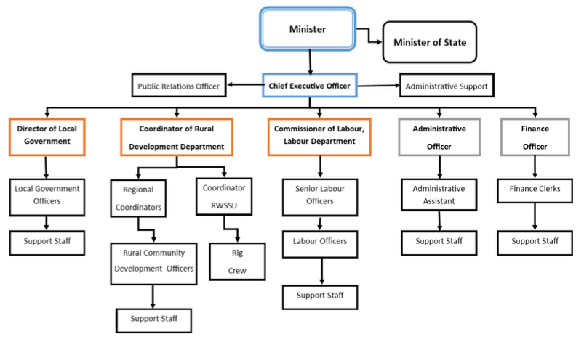
Figure 1: Organizational Structure of the MRT, 2022.

Project / Programme Objectives:

PROJECT OBJECTIVE

Project Goal

The goal of the project is to empower communities to appreciate and sustainably manage their water resources which are affected by climate change. This will be achieved through investments in capacity building on the interconnection between water sustainability and its relationship to their livelihoods, allowing communities to be more resilient, to be vested through strong inclusive participation and governance permitting an improved response to changes in climate. The project goal and objectives are carefully designed to deliver transformative, sustainable adaptation outcomes by integrating innovative technologies, ecosystem-based approaches, and inclusive governance. The core goal is to reduce the uncertainty and vulnerability of water availability in four rural Belizean communities by providing climate-resilient, solar-powered water supply systems combined with strengthened ecosystem management and governance frameworks. This goal aligns with the Adaptation Fund’s mandate to reduce exposure to climate-induced hazards and enhance adaptive capacities in vulnerable populations.

The first component focuses on the design and construction of cost-effective, solar/hybrid-powered water supply and distribution systems tailored to the cultural, physical, and technical contexts of the communities. This objective is critical because water scarcity in Belize’s rural areas is exacerbated by climate variability—manifested through irregular rainfall patterns, droughts, and increased temperatures. By harnessing solar energy and hybrid technologies, the project ensures water systems remain operational even during power outages or fuel shortages, thus guaranteeing reliable access to potable water. This component directly contributes to reducing communities’ exposure to climate-related hazards (Adaptation Fund Outcome 1) and increases the adaptive capacity of water infrastructure (Outcome 4). Furthermore, by reducing unsustainable water extraction, it supports ecosystem resilience (Outcome 5). The participatory design process ensures that community knowledge and capacities are embedded in the system, enhancing ownership and sustainability.

The second Component addresses the sustainability of water resources through community-led watershed protection and livelihood diversification. Belize’s watersheds are under pressure from land use changes, deforestation, and unsustainable agricultural practices, which degrade water quality and availability. This objective promotes riparian forest restoration and sustainable land management to protect water catchments, thereby enhancing ecosystem services that regulate water flow and quality. Simultaneously, the project fosters alternative livelihood opportunities linked to ecosystem conservation, such as agroforestry and eco-tourism. This dual approach reduces pressure on water resources and builds economic resilience, aligning with Adaptation Fund Outcome 6, which emphasizes diversified and strengthened livelihoods for vulnerable populations.

The third component targets strengthening the governance structures and institutional capacities of rural communities and public authorities to manage water resources sustainably and respond adaptively to climate risks. This includes training village leadership and water boards on inclusive governance, climate risk awareness, and maintenance of solar/hybrid water systems. By enhancing local ownership and decision-making, the project fosters social innovation and ensures that adaptive water management practices are embedded in community governance. Capacity building for the Ministry of Rural Transformation and other public entities strengthens institutional knowledge and supports the diffusion of innovative adaptation technologies (Adaptation Fund Outcomes 2, 3, and 8).

The three components are interlinked, creating a comprehensive adaptation package: reliable water systems provide the physical basis for water security; ecosystem restoration safeguards the natural infrastructure supporting water availability; and governance strengthening ensures that these benefits are sustained and scaled. This integrated approach reflects the Adaptation Fund’s emphasis on systemic, multi-sectoral adaptation interventions. The project embodies a holistic, participatory, and innovative response to climate-induced water insecurity in Belize. Its goal and objectives are mutually reinforcing, ensuring that vulnerable communities gain reliable access to safe water, improved livelihoods, and empowered governance structures, ultimately building long-term resilience to climate change impacts.

Component | AF Results Framework Linkage
1. Design and build Cost-effective solar/hybrid sustainable water system in four selected communities’ access to potable and reliable water service | AF Outcome 1: Reduced exposure to climate-related hazards and threats.  AF Outcome 4: Increased adaptive capacity within relevant development sector services and infrastructure assets.  AF Outcome 5: Increased ecosystem resilience in response to climate change and variability induced stress.
2. Ensuring the sustainability of water resources through improvement of livelihood opportunities | AF Outcome 6: Diversified and strengthen livelihoods and sources of income for vulnerable people in targeted areas.
3. Increased capacities and governance of rural communities on sustainability of water resources and strengthening the knowledge management capacities of the public authorities. | AF Outcome 3: Strengthened awareness and ownership of adaptation and climate risk reduction processes at local level.  AF Outcome 8: Support the development and diffusion of innovative adaptation practices, tools and technologies.  AF Outcome 2: Strengthened institutional capacity to reduce risks associated with climate-induced socio-economic and environmental issues.
Table 1. Alignment with Strategic Results Framework of Adaptation Fund

- The Theory of Change underpinning the project envisions that by designing and implementing cost-effective, solar-powered hybrid water supply systems tailored to the cultural and physical realities of four vulnerable rural communities, combined with community-led watershed protection and strengthened governance, the project will significantly reduce the uncertainty and vulnerability of water availability caused by climate change. The participatory development and operationalization of these climate-adaptive water systems will ensure reliable access to potable water, thereby directly reducing exposure to climate-induced water scarcity and related hazards. Concurrently, empowering communities through capacity building, inclusive governance training, and livelihood diversification will enhance their adaptive capacities and foster ownership and sustainable management of water resources. By restoring and protecting watershed ecosystems, the project further strengthens the natural infrastructure that supports water availability and quality. This integrated approach will lead to improved water security, resilient livelihoods, and strengthened institutional knowledge and governance, enabling communities to better respond to current and future climate stressors. Ultimately, the project’s outcomes will contribute to building adaptive capacity at the local and institutional levels, increasing ecosystem resilience, and promoting innovative, sustainable water management practices that align with the Adaptation Fund’s strategic objectives to reduce climate risks and enhance resilience in vulnerable populations.

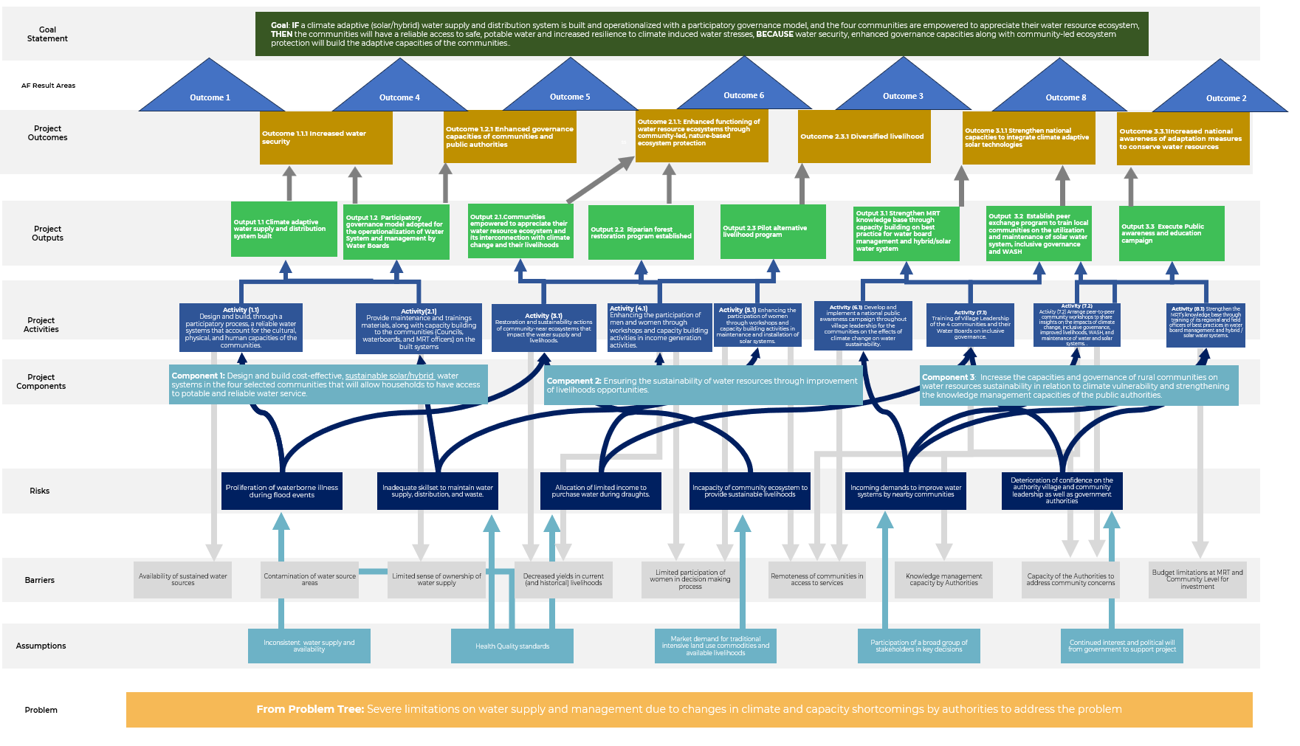
Figure 2: Theory of Change

- The project goal strategically designed to contribute to seven key Adaptation Fund (AF) outcomes, each reflecting critical dimensions of climate adaptation and resilience building. First, by implementing climate-adaptive solar/hybrid water supply systems, the project directly reduces communities’ exposure to climate-related hazards and threats (AF Outcome 1), ensuring reliable access to potable water even under adverse weather conditions. This infrastructure enhancement simultaneously increases adaptive capacity within vital development sectors, particularly water service delivery and infrastructure management (AF Outcome 4). Through community-led ecosystem restoration and sustainable watershed management, the project bolsters ecosystem resilience against climate variability and stressors (AF Outcome 5), safeguarding natural water sources essential for long-term sustainability. Recognizing the socio-economic dimensions of adaptation, the project promotes diversified and strengthened livelihoods, providing vulnerable populations with alternative income sources that reduce dependency on climate-sensitive activities (AF Outcome 6). At the community level, it strengthens awareness and ownership of climate risk reduction processes by engaging local stakeholders in governance, capacity building, and participatory decision-making (AF Outcome 3). The project also supports the development and diffusion of innovative adaptation technologies and practices—including solar-powered water systems and hybrid management models, facilitating knowledge transfer and scaling of best practices (AF Outcome 8). Finally, by enhancing institutional capacities within public authorities and local governance structures and strengthens the systemic ability to manage climate-induced socio-economic and environmental risks effectively (AF Outcome 2). Collectively, these interlinked outcomes ensure that the project not only addresses immediate water security challenges but also fosters resilient, empowered communities and institutions capable of sustaining adaptation gains over time.

The project’s primary objective is to reduce the uncertainty and vulnerability of water availability caused by climate change through the design, construction, and operationalization of cost-effective solar/hybrid water supply systems that provide reliable and potable water access. Complementing this technological intervention, the project seeks to ensure the sustainability of water resources by promoting community-led watershed protection and restoration activities, which enhance ecosystem services critical for water quality and availability. Additionally, the project focuses on strengthening governance and institutional capacities at both community and national levels by building knowledge, fostering inclusive participation, and improving water resource management frameworks. These objectives are aligned with the Adaptation Fund’s strategic outcomes, aiming to reduce exposure to climate hazards, increase adaptive capacity of infrastructure and institutions, enhance ecosystem resilience, diversify livelihoods, and promote innovative adaptation practices. Through this integrated approach, the project empowers communities to sustainably manage their water resources, adapt to climate variability, and improve livelihoods, thereby contributing to long-term resilience and socio-economic stability in the face of ongoing climate challenges.

Project / Programme Components and Financing:

Project/Programme Components | Expected Outputs | Expected Outcomes | Countries |  | Amount (US$)
1: Design and build cost-effective solar hybrid sustainable water systems in the four selected communities that will allow households to have access to potable and reliable water service. | Output 1.1 Climate adaptive water supply and distribution system built  Output 1.2 Participatory governance model adopted for the operationalization of Water System and management by Water Boards | Outcome 1.1.1 Increased water security  Outcome 1.2.1 Enhanced governance capacities of communities and public authorities | Belize |  | $3,395,908
2. Ensuring the sustainability of water resources through improvement of livelihoods opportunities | Output 2.1. Communities empowered to appreciate their water resource ecosystem and its interconnection with climate change and their livelihoods.  Output 2.2 Riparian Forest restoration program established.  Output 2.3 Pilot alternative livelihood program. | Outcome 2.1.1: Enhanced functioning of water resource ecosystems through community-led, nature-based ecosystem protection.  Outcome 2.3.1 Diversified livelihood | Belize |  | $771,892
3. Increase the capacities and governance of rural communities on water resources sustainability in relation to climate vulnerability and strengthening the knowledge management capacities of the public authorities and the communities | Output 3.1 Strengthen MRT knowledge base through capacity building on best practice for water board management and hybrid/solar water system.  Output 3.2 Establish peer exchange program to train local communities on the utilization and maintenance of the solar water system, inclusive governance and WASH.  Output 3.3 Execute Public awareness and education campaign  1 Strengthen | Outcome 3.1.1 Strengthen national capacities to integrate climate adaptive solar technologies.  Outcome 3.3.1 Increased national awareness of adaptation measures to conserve water resources. | Belize |  | $109,850
6. Project/Programme Execution cost  7. Total Project/Programme Cost  8. Project/Programme Cycle Management Fee charged by the Implementing Entity (if applicable) |  |  |  |  | $365,000
 |  |  |  |  | $4,642,650
 |  |  |  |  | $357,350
Amount of Financing Requested |  |  |  |  | $5,000,000

Projected Calendar:

Indicate the dates of the following milestones for the proposed project/programme
Milestones | Expected Dates
Start of Project/Programme Implementation | March 2026
Mid-term Review (if planned) | June 2028
Project/Programme Closing | March 2030
Terminal Evaluation | April 2030

PART II: PROJECT JUSTIFICATION

Describe the project components, particularly focusing on the concrete adaptation activities of the project, and how these activities contribute to climate resilience.

The four Project communities have had ongoing water shortages and quality issues exacerbated by the effects of climate variation and change. The country’s climate change hazards (hurricanes, droughts, flooding, and storm surges) pose further challenges. The Project communities confront water scarcity in dry seasons and prolonged flooding in the rainy season, resulting in a dire need for climate adaptive measures. During the latter part of dry season, two of the four communities, Dolores and Otoxha, resort to using outdated hand pumps to carry buckets of water to their homes as the limestone aquifers which supply water are insufficient to support the consumption needs of the communities. Degradation of soil from land use has diminished the area’s capacity to retain moisture and additionally is resulting in excessive nutrients downstream in the watershed.

Boom Creek and Copper Bank are both resting on shallow water tables and are impacted by similar issues, vulnerability to water contamination and salinity due to proximity to the Caribbean Sea. Bacterial contamination of water sources is prevalent, and higher levels of salinity are common during the annual droughts. Boom Creek sits along the low-lying banks of the Moho River, a tributary ending in the Caribbean Sea, increasing its exposure to flooding during severe tropical storms. Copper Bank, next to Corozal Bay, is similarly affected by severe storm surges and high winds during tropical storms.

Given that the Maya community's reliance on natural resources and their traditional gender roles²⁸, Maya women, burdened with caregiving roles and domestic chores, face heightened vulnerabilities during disasters, while they play a crucial role as frontline responders in the aftermath⁹. Gender and age vulnerabilities in Belize are influenced by institutional and cultural factors, emphasizing the necessity to address inequalities.

Component 1: Design and build cost-effective solar hybrid sustainable water systems in the four selected communities that will allow households to have access to potable and reliable water service.

Component 1 is cross-cutting and leverages the activities of components 2 and 3. The four communities have limited or no access to reliable potable water, which increases health and livelihood vulnerabilities. This component has two integrated activities , 1.1) Design and build, through a participatory process, of inclusive and reliable water systems that account for the cultural, physical, and human capacities of the communities and 2.1) Provide maintenance and trainings materials, along with capacity building to the communities (Councils, waterboards, and MRT officers) on the built systems. Activity 2.1 will be executed by the MRT’s PMU through procured consultants and engineers. To provide the communities with reliable water service, several actions must be taken, such as designing a system that is adequate to the needs and considerations of each community, ensuring that Water Boards are established, and necessary training is provided for its strategic, operational, and financial management to ensure the adaptive capacities and thus sustainability of the investment.

The four project communities are different, in terms of infrastructure, geology, culture, and livelihoods. Copper Bank, has grid energy from the national distribution company Belize Electricity Limited (BEL); while the three communities, Otoxha, Dolores, and Boom Creek, are not connected to the energy grid. In terms of geology, the two districts have distinct features; the Toledo District communities are in the foothills of the granite Maya Mountains, which has a layer of limestone and dolomite formation, leading to the creation of karst or limestone mounts and cave formation. Geology impacts the soil quality (refer to Annex I), while the soil of both districts is clay over limestone, the soils in the Corozal District are more productive for sugar cane and citrus production, while the soils in the Toledo District are better suited for livestock, beans, and maize farming. The practice of milpa farming is a concern throughout the Toledo District, as it involves clearing native forest for agriculture, at times through fires, and planting repeatedly until the soil no longer yields due to nutrient deficiency. Modern farming techniques which include Climate Smart Agriculture5 have been able to substantially improve on this, especially in Mennonite Communities of Belize, but are seldom used in more rural Maya communities. Moreover, logging and milpa farming impacts the capacity of the limestone aquifers to produce and store water, which exacerbates the issue. The project seeks to address depleting practices by designing activities to protect the ecosystem and build water systems tailored to each community.

Components 2 and 3 will leverage the water system infrastructure with watershed ecosystem restoration efforts, livelihoods options, and inclusive governance capacities. Community assets developed in Component 1, namely such as the water system and Water Boards, will provide a reliable potable water source providing communities members more time, which is currently used to address water scarcity issues, especially during the dry season, and instead undertake other income-generating activities, a key element of Component 2. The demonstrative effect of enhanced water systems and improved governance will allow the MRT to replicate similar arrangements in other communities. MRT and Water Board governance is particularly critical to enhance response capacities to climate variability, improve community confidence and decrease response time to address water system issues.

Activity (1.1) Design and build, through a participatory process, inclusive and reliable water systems that account for the cultural, physical, and human capacities of the communities.
- Activity 1.1 will contribute to increase adaptive capacity to respond to climate variability and change in four rural communities of Belize through an inclusive drought-resistant potable and reliable water supply by designing a system that considers the physical and social situation of each community. This system will be designed and implemented to withstand extreme weather events such as drought or floods. The project’s goal is to ensure the communities are empowered to appreciate their water resources through inclusive participation, and the design of the system is grounded on this principle. A specialized engineering firm, with additional capacities in stakeholder consultation and management, will assess, in coordination with the MRT and the village leaders, the location of the most abundant and sustainable water sources taking into consideration siting to prevent human encroachment and exposure to contamination. The MRT has begun conducting geo-resistivity testing and is identifying several suitable locations for production wells. The engineering firm will undertake soil and geological analysis to determine the most appropriate water table(s), taking into consideration communal assets such as land used for cultivation, recreation, or for religious purposes. The community will be involved in the design of the system, through gender-responsive consultations, and approval of the lay out, connections, location of assets, in efforts to ensure broad dissemination of the operation of the system, and in compliance with the FPIC protocol in the self-identified indigenous communities. The purpose of community engagement in the design of the system is to ensure ownership, provide a forum for discussion on water supply risks, increase transparency and to allow women and men from the community to share their inputs on land knowledge. The design process will be accompanied by the Project’s PMU, with participation of the Environmental, Social & Gender Specialist.
- From the outset, the project adopts a participatory and inclusive approach that actively involves indigenous and local knowledge holders, community leaders, and local experts in the design, construction, and management of solar/hybrid water systems. During the planning phase, community consultations and focus group discussions are organized to gather traditional insights on water sources, seasonal availability, cultural water uses, and local environmental indicators. These inputs help tailor the water system design to reflect community priorities, respect cultural practices, and optimize system placement and functionality. Local experts and traditional leaders serve as advisors and co-facilitators in technical assessments and decision-making forums, ensuring that the water infrastructure aligns with indigenous values and ecological understanding. Through implementation, Water Boards are formed with representation from traditional authorities and knowledgeable community members who are trained not only in technical maintenance but also in integrating customary water governance principles. This ensures that system operation respects local norms around water access and stewardship, fostering community ownership and sustainability. Community members will actively participate in decision-making committees and design review panels established specifically for this purpose, ensuring their voices influence key technical and operational choices. Participatory mapping exercises will be used to identify critical water sources, preferred infrastructure locations, and areas requiring protection or restoration. Additionally, iterative feedback loops will be established, allowing communities to review preliminary designs and suggest modifications before finalization.
To ensure meaningful engagement, the project will employ facilitation techniques that encourage equitable participation, such as breakout groups, visual aids, and consensus-building activities. This co-design methodology not only fosters ownership and trust but also integrates local knowledge and preferences with technical expertise, resulting in water systems that are culturally appropriate, technically sound, and socially sustainable. Through this structured, transparent, and inclusive process, Activity 1.1 ensures that community members are not passive recipients but active partners in shaping resilient water infrastructure.

An experienced construction firm will undertake the required civil and engineering works to ensure a fully commissioned water system in each community. Other communities in Belize have systems that are like the proposed, which include solar pumps, equipment rooms, and similar distribution systems. The construction firm will also be required to install the electrical solar system, which can be done by the same firm or by sub-contracting to specialized firms. A Technical Committee has been included in the project’s Implementation Arrangements to facilitate the PMU in determining the proper procurement requirements to undertake this activity. The construction firm will also provide structured and practical training exercises to train community members in construction and plumbing with women being specifically targeted. During the field consultations, each community reported they had some men skilled in construction, and the construction firm will be required to train and hire some community members during the construction process, including women.

Concrete measures to ensure gender inclusivity during the design and construction of water infrastructure include:

1. Gender-Sensitive Planning Consultations: The project will conduct targeted consultations with women during the planning phases to gather their feedback on infrastructure needs, accessibility, safety, and usability. This ensures that women’s perspectives shape system design.
2. Representation in Decision-Making Bodies: Women will be actively included in water boards and community governance structures overseeing infrastructure projects, ensuring their voices influence key decisions throughout implementation.
3. Infrastructure Design for Accessibility and Safety: Water supply systems and related facilities will be designed considering women’s safety and ease of access, such as proximity to homes, secure lighting, and ergonomic features that reduce physical burdens.
4. Capacity Building and Training: Women will receive training related to operation, maintenance, and management of water systems, empowering them with technical skills and leadership roles.
5. Monitoring and Accountability: Gender-disaggregated indicators will track women’s participation and satisfaction with infrastructure services, allowing adaptive management to address any gaps.

At a minimum, the design of the system will provide, on average, 20 days of potable water during the dry season. This will be achieved by sourcing several groundwater wells that can be independently deployed in case of low capacity and fed into a large concrete elevated storage tank. The well pumps will be operated with solar energy and batteries in the case of Toledo District) and with solar and grid energy in the case of Copper Bank. In the case of the Toledo District communities, the water will be gravity fed. In Copper Bank, in addition to an elevated tank, a pressure pump will provide the required pressure to distribute to the entire community, as has been previously implemented in communities that have grid energy and are able to have water heaters and other water pressure sensitive appliances. It is estimated that between 12 and 18 monocrystalline solar panels will be required for each water system, depending on the nature and scale of the system for each community. This technology is widely available in Belize with several local suppliers with vast experience in installation and operation. All the water system will have a piped network made of PVC pipe of different widths (mostly ¾” and 2”), will have water meters, be connected to smart centralized community meter housed in the equipment room. The equipment room will also house the chlorinator, batteries, and maintenance supplies. The service providers selected for the design and construction of the wells and tanks will be required to have the necessary expertise and technology to identify the most suitable location of these two infrastructures. Topography maps, water catchments models and ground water mapping technology will be used to inform the implementation of this project activity. Experts will utilize advanced technologies such as GPS mapping to identify the highest elevation points within target communities, ensuring optimal placement of water infrastructure that facilitates efficient gravity-fed distribution systems. The selection of well sites will be conducted in close collaboration with the Ministry of Rural Transformation (MRT), which plays a critical role in determining the most suitable drilling locations. To accurately assess subsurface conditions and locate viable water sources, scientific methods including geo-resistivity analysis and other water exploration techniques will be employed. These technologies significantly enhance the precision of site selection, reducing risks related to groundwater depletion and contamination. The criteria for selecting these advanced technological solutions include technical suitability to local conditions, accuracy, cost-effectiveness, ease of integration with existing institutional frameworks, environmental sustainability, and local capacity for operation and maintenance. Applying these criteria ensures that the chosen technologies improve the accuracy and efficiency of well and tank placement by enabling data-driven decisions that optimize resource use and system performance. The project budget and timeline explicitly accommodate the selection, procurement, and deployment of these advanced technologies, including provisions for training local technicians and MRT staff. Furthermore, service providers engaged in site selection and design will be required to demonstrate specialized expertise in the use of such advanced technologies, relevant professional qualifications, and experience working within similar environmental and institutional contexts. This comprehensive approach guarantees that the technological tools and expertise applied will support the sustainable and resilient delivery of water infrastructure in Belize’s vulnerable communities.

Activity (2.1) Provide maintenance and training materials, along with capacity building to the communities (Councils, Water Boards, and MRT officers) on the built systems.

Activity 2.1 will provide maintenance and trainings materials, along with capacity building to the communities (Councils, Water Boards, and MRT officers) on the built systems. This activity will take place prior to commencing the construction of the system, and the Village Council with the MRT will appoint members to the Water Board in each community. Each Water Board will have female participation of at least 50%. The MRT will first train Water Boards on the water systems' basic operation. Prior to commissioning the system of each community, a specialized firm will provide training to the Water Board and staff on the operation of the system, including providing detailed plans to be stored in the Equipment Room, (photo and graphical) manuals, and preventive maintenance. The MRT and the specialized firm will introduce the village and the village council, along with other stakeholders, to the operation of the system. Note that Activities 7.1 and 7.2 also provide additional training for the Water Boards.
- Training community members, especially Water Boards, in the maintenance and operation of solar-powered water systems is a critical adaptation activity that directly supports the sustainability of water resources and surrounding ecosystems. By equipping Water Boards with the technical skills and knowledge to effectively manage these systems (as outlined in Activity 2.1), the project ensures the continuous and efficient functioning of climate-adaptive water infrastructure. Reliable operation of solar water systems reduces the risk of system failures that could lead to water shortages or reliance on unsustainable water extraction methods, such as over-pumping from vulnerable groundwater sources. Moreover, solar-powered systems minimize environmental impacts by utilizing renewable energy, thereby reducing carbon emissions and avoiding ecosystem degradation associated with fossil fuel-based energy sources. Proper maintenance prevents leaks, water loss, and contamination risks, safeguarding water quality and conserving limited water supplies. When Water Boards are trained and empowered, they can implement preventive maintenance schedules, promptly address technical issues, and optimize water distribution, which collectively enhances water use efficiency. This community-led stewardship fosters a sense of ownership and responsibility, encouraging sustainable water management practices that are sensitive to ecosystem health. By maintaining the integrity of water supply infrastructure, the project supports the protection of riparian zones and watershed areas, which are vital for ecosystem resilience. In essence, training Water Boards to maintain solar water systems creates a sustainable feedback loop—ensuring reliable water delivery while preserving the natural environment that sustains these water resources, thereby reinforcing the long-term climate resilience goals of the project. The Ministry is responsible for ensuring that both the board and maintenance personnel receive proper training to operate the water system effectively. Training will be conducted using the Rural Water System Operation and Maintenance Manual, supplemented by technical expertise to address system operations not covered in the manual, including complex diagnostics of electrical power components. Additionally, as the oversight authority for all water systems, the Ministry will closely monitor operations, conducting regular site inspections to ensure smooth and efficient functionality.

Outputs under this Component 1 entail:
- Output 1.1 Climate Adaptive water supply and distribution system built
- Output 1.2 Participatory governance model adopted for the operationalization of water system and management by waterboards.

- This project aims to provide an alternative and reliable water production system to the four target communities of Dolores, Boom Creek, Copper Bank and Otoxha, which are in the poorest and remote areas of the country. These communities were traditionally utilizing Rudimentary Water Systems, that supplied water via wells constructed for extraction from underground aquifers. Some communities contain numerous wells, some suppling water resources to individual households. Other sources of water include rain fed collection systems and the manual extraction of water from local streams and springs. The target communities lack access to potable water for drinking and household use, which is further inaccessible during Belize’s dry season. During the dry season, some communities are only able to access water from water trucks that transport water from other municipalities. The unavailability of potable water and improper wastewater management further prevails the prominence of disease outbreaks in the communities, leading to long-term health impacts. The success of these outputs will depend on the activities listed above to provide four rural remote communities, with secure access to potable water resources thereby increasing the ability of the community to adapt to changes in the climate that would further threaten the availability of water resources during periods of drought, inclusive of hydrological droughts. The project also contributes to Belize’s mitigation potential by minimizing the utilization of fossil fuels tied to the use of traditional systems for the extraction, treatment, and supply of water resources in communities.

Component 2: Ensuring the sustainability of water resources and ecosystem through improvement of livelihoods opportunities.

Three identified factors influence the sustainability of water supply in the four communities, 1) deterioration of the ecosystem that produces or stores water, 2) and necessity of the communities to rely on the ecosystem for livelihoods, 3) limited incomes to afford sustainability of the water service to each household. The project aims to address these factors through strengthening the capacities of each community to increase the ability to earn income from other sources, including improving the health of the ecosystem which they currently rely, as well as ensuring that the nearby ecosystems are sufficient water production and provide the communities with sustainable livelihoods. Component 2 will be executed by the MRT (PMU) through grants provided to eligible entities guaranteeing inclusiveness, cultural sensitivity, and ability to communicate in the preferred language of the community.
The project ensures meaningful community engagement beyond participation in infrastructure construction by embedding communities deeply in the decision-making process, particularly within Component 2 focused on watershed protection and management. Through a participatory governance approach, community members, including women, youth, indigenous leaders, and local experts are actively involved in planning, budgeting, implementation, and monitoring activities. This inclusive process begins with consultations conducted in preferred local languages to gather traditional knowledge and community priorities, which inform the design of restoration and livelihood initiatives. Communities participate in mapping watershed areas, identifying restoration sites, and co-developing alternative livelihood programs, ensuring interventions are culturally appropriate and locally relevant. Water Boards and governance bodies are established with inclusive representation and trained in transparent decision-making, operational management, and maintenance. Furthermore, community members engage in ecological monitoring and adaptive management, fostering stewardship and accountability. This comprehensive involvement builds local capacity, ownership, and transparency, which are critical to sustaining project outcomes and enhancing resilience to climate change impacts in the targeted Belizean communities.

. During consultations, it was evident that the Toledo District communities require particular attention, especially noting the quality of the nearby forests and aquifers. The MRT has indicated that there is sufficient water accessible (or being produced) in current and future production wells. Concerns arise on the capacity of the communities to a) meet the water payment obligation, b) restore the nearby ecosystem to ensure future water supply as well as concern for the MRT’s efforts to effectively carry out actions related to restoration of the ecosystems. In terms of income, the Toledo District communities, especially those near Guatemala, are limited in their capacity to pay a US$5.50/month Water Board fee; a fee to make the water system sustainable would be close to US$12. Other income sources will be required to ensure system sustainability. Several NGOs have worked with alternative livelihood programs, with a degree of success, in implementing projects that involve cardamon cultivation, coffee, cocoa, tree nurseries, bee keeping, and other livelihoods to complement forest restoration activities and increase community income. In the case of the Toledo District, another objective has been added, given the fact that these communities are off grid, training mainly women, in providing maintenance and operation of solar systems, could also provide an additional source of income. The component will also address the Corozal District community, whose livelihoods are affected by deterioration of the Corozal Bay due to effluents from tributaries often related to the use of pesticides in larger-scale agricultural production. One of the main sources of income of Corozal Bay is fishing, which provides the community with higher incomes than other rural areas of the country. While there is limited evidence that fishing is particularly at risk, there is evidence of contaminants found in crocodiles and birds, which feed on fish from Corozal Bay. Further, the reliance of the community on fishing as an income source can be complemented with working under similar existing conservation frameworks of nearby communities, such as the Corozal Bay Wildlife Sanctuary. Mangrove and bay restoration efforts have been proven to improve the overall health of the bay as well as act as hatchery for fish.

Component 2 has three Activities, Activity (3.1) Restoration and sustainability actions of the community-near ecosystems services that impact the water supply and livelihoods. Activity (4.1) Enhancing the participation of men and women through workshops and capacity building activities in income generation activities. Activity (5.1) Enhancing the participation of men and women through workshops and capacity building activities in maintenance and installation of solar systems.

Particularly in these targeted communities, creating this access to clean water will enhance and improve the livelihoods of the villagers by empowering them to pursue Environmental sustainability. The water from the new solar-powered systems will provide access to safe water for these local communities. Importantly, increasing water conservation and strengthening community resilience. They’re making sure their natural resources stay beautiful and undisturbed for the generations that come after them. Additionally, the project interventions will support the sustainability of access to potable water and the ecosystem through the active participation of communities throughout the implementation of the project activities, allowing them to own and guide the entire process. .

Activity (3.1) Restoration and sustainability actions of the community-near ecosystems services that impact the water supply and livelihoods.

Activity 3.1 will ensure long-term change in attitudes towards water preservation and climate change impacts, through restoration of community-near ecosystem services. In the Toledo District communities, land use has increasingly impacted water availability limiting water retention in the aquifers during the wet season; amongst the solutions to ensure water availability that will be carried out is improving the current agricultural practices, reforestation, as well as awareness of the risks of climate change and land use poses to the community. In the Corozal District, degradation of mangroves, heavier runoffs (during the wet season) from upstream use of chemicals in commercial farming, along with unconstrained fishing (piracy), have caused decreases in fisheries and other wildlife; the focus for Copper Bank in the Corozal District is to include the Community in ongoing conservation efforts.

- The degradation of mangroves in the Corozal District of Belize is primarily driven by a combination of coastal development, pollution, and climate change impacts, which together threaten the ecological integrity and functions of these vital ecosystems. Specifically, unchecked coastal development, including residential projects, tourism infrastructure has led to significant mangrove clearance, reducing natural coastal buffers and accelerating shoreline erosion. The impacts to livelihoods in surrounding communities as a result of climate impacts have displaced vulnerable populations to urban areas, increasing the demand of land in urban areas like Corozal Town, which contribute to inadequate urban development. Pollution from urban runoff and sedimentation further stresses mangrove habitats, while climate change exacerbates these impacts through rising sea levels, increased storm frequency, and altered hydrological patterns. Weak enforcement of mangrove protection legislation, limited resources for monitoring, and occasional non-compliance by developers compound the problem, allowing continued habitat loss despite regulatory frameworks. To address these causes, the restoration planning in Corozal integrates a multi-faceted approach. The project will implement community-based mangrove restoration efforts involving local stakeholders, including conservation groups and municipal authorities, to rehabilitate degraded mangrove areas and re-establish natural coastal defenses. Restoration activities will focus on replanting native mangrove species, controlling pollution sources, and promoting sustainable land-use practices that limit further habitat destruction. Additionally, the project supports strengthening policy enforcement and raising public awareness about the ecological and socio-economic importance of mangroves, thereby fostering local stewardship and compliance. This integrated strategy aims to halt erosion, improve coastal resilience to climate hazards, and ensure the long-term sustainability of mangrove ecosystems in Corozal.
- In the Toledo District, restoration activities will complement those in Corozal but focus on different ecosystem types and community needs. The project plans to implement riparian forest restoration and watershed rehabilitation to protect freshwater resources and enhance ecosystem services critical for water quality and availability. These activities include reforestation of degraded riparian zones, erosion control measures, and community training on sustainable land management practices. By restoring these terrestrial ecosystems, the project aims to reduce sedimentation and runoff that negatively impact downstream aquatic habitats, including mangroves and coral reefs. Livelihood diversification programs will also be piloted to reduce pressure on natural resources and support climate-resilient economic opportunities for local communities. Together, these restoration efforts in Toledo strengthen watershed function, improve water security, and contribute to broader ecosystem resilience in the face of climate change.

The main goal of this activity in the Corozal District is to work together with communities, organizations and local government to ensure successful mangrove restoration, with the following steps:

- Coordinate with the relevant government entity (Forest Department) to implement the activities under this component.
- Understand the ecology of the naturally occurring mangrove species at the site such as the patterns of reproduction, distribution, and successful seeding establishment. Understand the normal local hydrology that controls the distribution, settlement and growth of mangrove species.
- Estimate the modifications of the mangrove environment that occurred and that currently prevent natural secondary succession

Select appropriate restoration areas through application of step 1-3 above, that are both likely to succeed in rehabilitating a forest ecosystem and are cost effective. This step includes resolving land ownership/use issues necessary for ensuring long-term access to and conservation of the site. This activity was initially based on the restoration and conservation work of several NGOs throughout Belize that understood the importance of safeguarding forest and estuaries ecosystems services and its relationship to water conservation and fish stocks. Restoration and conservation activities will ensure the communities overtime persistent water retention, and maintenance of fish stocks, along with alternative livelihoods that allow them to improve their income.

This project aims to improve and safeguard the ecological functionality of the watersheds via the adoption of climate friendly restoration action and alternative livelihoods that contribute to the long-term protection of the watershed and resources within. Restoration actions will enable the watershed to continuously provide water resources to local communities through its natural processes. It will also enable a holistic approach to the management and utilization of water resources. As riparian forests provide key filtration and stabilization functions in watersheds, it is important that they be restored and protected to ensure ecological functionality and the stable supply of water resources. Alternatively, the action also contributes to the sequestration of carbon dioxide, thereby contributing to Belize’s climate mitigation targets as well. This will be done via the cultivation of nitrogen fixing trees species in and along the watershed corridor to maintain and enhance forest cover, supporting environmental protection, climate resilient agriculture and alternative livelihoods.

Copper Bank’s fishing livelihood is directly supported by preserving and restoring its coastal ecosystem, which safeguards this key income source. The project’s water system infrastructure is designed to withstand extreme weather events, reducing repair needs and environmental impacts from maintenance. Ecosystem restoration promotes efficient water use, reduces demand, and helps maintain aquifer levels through reforestation, supporting both water supply and ecosystem health. Repairing riparian buffers decreases erosion, improves water quality, and provides wildlife habitat. Collectively, these ecosystem activities enhance watershed quality, sustain aquatic habitats, and protect biodiversity, contributing to climate mitigation and adaptation. For ecosystem restoration and livelihood activities, the project places indigenous and local knowledge at the core of planning and execution. Traditional ecological knowledge (TEK) about native plant species, seasonal cycles, and watershed dynamics is documented through participatory mapping and oral histories facilitated by community elders and local environmental stewards. This knowledge guides the selection of appropriate native species for riparian restoration and informs sustainable land-use practices that have been proven effective over generations. Community leaders and traditional healers are engaged as trainers and mentors during workshops on ecosystem services and climate change, bridging scientific concepts with cultural worldviews. Livelihood diversification initiatives incorporate indigenous skills and practices—such as agroforestry, non-timber forest product harvesting, and artisanal crafts—ensuring that new income sources are culturally relevant and environmentally sustainable. The project also supports community-led monitoring, where local knowledge holders use traditional indicators alongside scientific tools to assess ecosystem health and restoration progress. This inclusive approach strengthens social cohesion, empowers marginalized groups, and ensures that adaptation strategies are culturally appropriate and locally owned.

Activity (4.1) Enhancing the participation of men and women through workshops and capacity building activities in income generation activities.

Activity 4.1 will strengthen the capacities of community members to earn or diversify incomes through enhanced livelihoods options. This activity is set to complement Activity 3.1, as the project links ecosystem restoration and conservation with increasing the participation of men and women in alternative livelihoods. Further, the project aims to increase the participation of women in household income generation. In the case of the Toledo District, Activity 4.1 will focus on improving the current practices of Milpa Farming towards substituting low productive land areas to other crops and cultivars, such as cocoa, coffee, bee keeping, and reforestation. This Activity specifically aims to enhance the participation of men and women in alternative livelihoods that are closely linked to ecosystem conservation and climate resilience. This will be achieved through a combination of capacity building, practical training, and support mechanisms tailored to the local context of the four target communities. The project will organize workshops and hands-on training sessions that introduce sustainable livelihood options such as agroforestry, eco-tourism, non-timber forest product harvesting, and small-scale sustainable agriculture practices. These activities are designed to build technical skills and knowledge, enabling community members to diversify their income sources while reducing pressure on natural resources. Moreover, Activity 4.1 will facilitate access to necessary inputs, tools, and resources, and provide guidance on developing viable business plans and market linkages to ensure these alternative livelihoods are economically sustainable. The project places strong emphasis on inclusive participation, ensuring that women and marginalized groups are actively engaged and benefit equally. By integrating ecosystem-based approaches with livelihood diversification, this activity not only improves household income but also reinforces the sustainable management of watersheds and ecosystems critical to water security. Through these targeted interventions, Activity 4.1 seeks to transform existing descriptive ideas into concrete, community-driven livelihood opportunities that enhance resilience to climate variability and foster long-term environmental stewardship.

The work in the Toledo District under the program has been tried and tested, Ya’axche Conservation Trust has developed a series of interventions, working with the Mayan communities in conservation and reforestation, using climate-smart agricultural techniques, and most importantly, practices that are coherent with the Maya culture. Climate-smart agriculture practices include mulching, soil nutrient enrichment, and soil cover will be incorporated while continuing to work within the cultural traditions of milpa farmers. Extension services will be able to promote Climate Smart Agriculture (CSA) practices for a more sustainable milpa farming system for food and livelihood security within the four communities. Mulching improves water holding capacity, soil organic matter (SOM), fertility, and stability, as well as reducing runoff and weed growth. Further, mulching can improve soil water-holding by adding crop residues and manure to soil which affects soil properties and nutrient cycling, as well as lowering emissions. Practiced by about half the milpa farmers in southern Belize’ Toledo District, mulching has similar planting and harvesting timing and is beneﬁcial because it restores degraded soils, provides shorter fallow periods, and stabilizes crop yields. Also, mulching in addition to soil cover, such as mucuna beans can lead to higher yields due to decreased on-farm erosion and nutrient leaching, lower grain losses due to pests, and reduced labor for weeding and fertilizer applications. These techniques are woven into the project’s broader ecosystem-based adaptation activities, including agroforestry, reforestation, and watershed management. Their collective impact includes:

Improved soil health and moisture retention, increasing the survival and growth rates of planted trees and crops.

Enhanced carbon sequestration and resilience to climate variability.

Support for biodiversity and long-term ecosystem stability

The decisions that men and women farmers make in these cultural communities to instill the CSA practices are triggered by specific factors, including the need to provide for the family, available risk management tools, their level of knowledge, and their access to inputs, financing and markets. By providing incentives and removing barriers to adaptation, a conducive environment can be created for producers to adopt climate-smart agriculture practices. Women are more likely to adopt improved CSA approaches when they are involved in decision-making and have equal access to information and resources. The odds can be improved through knowledge dissemination approaches that target women farmers and ensure their participation, such as Farmer Field Schools and training by extension services, access to equipment and empowerment on business development plans.

The general contents of the training and specific support measures provided to communities under this activity include:
- Training Content:
  - Capacity building on climate-smart agricultural practices and sustainable resource management to improve product quality and resilience.
  - Skills development in business planning, financial literacy, and market analysis to enhance community members’ ability to access and compete in markets.
  - Training on value addition, packaging, and branding to increase the market appeal and profitability of local products.
  - Guidance on navigating regulatory requirements and certifications that may open new market opportunities.
- Specific Support Measures:
  - Provision of equipment such as tools for processing agricultural or forest products, storage facilities to maintain product quality, and transportation means to improve market access.
  - Infrastructure support including establishment or upgrading of local marketplaces, collection centers, or cooperative facilities that enable aggregation and sale of products.
  - Technical assistance and facilitation of linkages with private sector partners, buyers, and exporters to create sustainable market channels.
  - Support for digital marketing platforms or information systems to connect producers with consumers and provide market intelligence.

This Activity aims to transform agricultural practices by addressing the root barriers to CSA adoption, knowledge, resources, and support systems. By providing practical training, improving access to equipment, supporting business development, and fostering inclusive participation, the project will enable farmers to increase productivity, reduce vulnerability to climate shocks, and sustainably manage their natural resources and contribute directly to community resilience and long-term food security. The project will facilitate training workshops on product development, packaging, and storytelling to help community members effectively communicate the value of their goods and services to potential buyers and visitors. Digital marketing will be a key focus, with support provided for the creation of social media campaigns, the use of online platforms, and the development of community websites or profiles to reach broader markets. Additionally, the project will foster connections with local and national tourism boards, business networks, and regional fairs to create new market linkages and opportunities for product showcasing. Technical assistance will be provided for the adoption of e-commerce tools and the establishment of feedback mechanisms to monitor customer satisfaction and adapt marketing approaches as needed. Through these targeted actions, Activity 4.1 will empower communities to not only produce climate-smart products and services but also to successfully access, compete in, and benefit from local and international markets, thereby strengthening the sustainability and impact of alternative livelihoods
Receiving support via the lessons learning from Ya’axche Conservation Trust as the key champions of integrating CSA in the southern Maya Golden Landscape will be integral for this project. Farmers in these communities are expressing the need to implement farming practices that are good for the environment and that also generate sustainable income. They realize that their farming techniques need to improve so that the environment can continue to support them and their families in the future. This project will support the farmers implementing climate-smart farming practices, such as cacao-based agroforestry, inga alley cropping, slash and mulch, apiculture and developing value-added farm products. (see annex IV and appendix 4) Many of these CSA practices already exist in some of the communities, but the project will build on that community knowledge and experience to enhance the impact of the project activities. Additionally, through component 3, the project will enhance capacity development of the communities to expand the project interventions beyond the project lifespan and hence increase its impacts.
The project employs a systemic approach to Climate-Smart Agriculture (CSA) that holistically integrates agricultural production, trade, and environmental sustainability to build resilient rural livelihoods and ecosystems. This approach involves:
- Agricultural Production: Training farmers through participatory methods such as Farmer Field Schools to adopt climate-resilient practices that improve productivity and sustainability, including water management, soil conservation, and crop diversification.
- Trade and Livelihoods: Supporting farmers in developing climate-resilient value chains and accessing markets, complemented by business development assistance and matching grants to enhance income stability and economic resilience.
- Environmental Sustainability: Implementing watershed restoration, mangrove rehabilitation, and ecosystem-based adaptation measures to protect natural habitats and maintain ecosystem services critical for agriculture and community well-being.
By linking these components, the project fosters adaptive capacity at the community level, promotes sustainable resource use, and aligns with Belize’s national climate strategies, ensuring that CSA contributes to long-term climate adaptation and socio-economic development.

In the case of the Corozal District, tying conservation activities with alternative livelihood options activities will build on the efforts carried out by other nearby villages, such as Sarteneja and Chunux. These two villages, about 10km from Copper Bank, share the Corozal Bay estuary. Various organizations, such as the Sarteneja Alliance for Conservation have undertaken programs to monitor the health of the Corozal Bay and provided residents with other income sources to supplement fishing, such as tourism-related activities. With support from donors, the GOBZ is constructing a new roadway and two bridges, one bridge from Progresso, a nearby town, and second bridge over the Laguna Seca, towards Chunox; these bridges will not only improve connectivity of the village to other aeras of Belize but will reduce travel times. Even though Copper Bank is on the mainland, it is currently only accessible by a three-car manually operated ferry. The improved transit and water system infrastructure will facilitate Copper Bank’s opportunity to develop climate-friendly eco-tourism activities aimed to minimize the environmental impact of tourism while promoting sustainability and conservation. For example, activities such as environmental conservation volunteer tourism; sustainable accommodations (energy-saving practices, waste reduction, and water conservation measures), or non-motorized water activities such as kayaking or canoeing. The work on alternative livelihoods in relation to conservation has been tried and tested in the Corozal District, with the work of Sarteneja Alliance for Conservation and Development (SACD), and the Belize Enterprise for Sustainable Technology (BEST).
- Recognizing Corozal’s rich natural and cultural heritage, including its proximity to the Corozal Bay Wildlife Sanctuary, important mangrove ecosystems, and Maya archaeological sites, the project will build capacity among local residents to develop sustainable eco-tourism enterprises that leverage these assets. This will involve practical training in eco-tourism management, hospitality services, and environmental stewardship, enabling community members to offer authentic, low-impact tourism experiences such as guided wildlife tours, bird watching, cultural heritage visits, and traditional craft workshops. The project will facilitate the creation of community-led eco-tourism initiatives, including homestays and small-scale tour operations, that generate diversified income while promoting conservation. Support will also be provided to establish market linkages and partnerships with regional tourism networks to attract responsible visitors. Emphasis will be placed on sustainable infrastructure developments such as eco-friendly lodging and waste management systems, to minimize environmental footprints and protect sensitive mangrove and coastal habitats. Furthermore, the project will engage youth and women in leadership and entrepreneurship roles to ensure inclusive benefits. By integrating climate resilience principles, such as conserving mangroves that buffer against storms and sea-level rise, and promoting cultural preservation through Maya heritage interpretation, Activity 4.1 aims to create a sustainable eco-tourism sector that enhances livelihoods, fosters environmental awareness, and strengthens community stewardship in Corozal. This targeted approach transforms general livelihood ideas into concrete, locally relevant opportunities that align with both conservation goals and economic development.

Activity (5.1) Enhancing the participation of women through workshops and capacity building activities in maintenance and installation of solar systems.”

Activity 5.1 will contribute to increasing the capacities in solar technologies through training of indigenous women in the three Toledo District Communities. This activity builds on success cases of a GEF-grant project of training rural women administered by Plenty International in Santa Elena, where indigenous women were trained to support community electric boards in the installation and maintenance of solar systems. Further, this prior project’s curriculum was designed in collaboration with the Barefoot College, whereby women, most who have limited education, are trained as solar engineers. This project activity is tailored to the three Toledo District communities to a) no grid energy is available for the communities, b) the poverty level is higher than other districts in Belize, and c) two of the three communities are considerably far from the nearest largest town, thus self-reliance is critical.

Training to maintain solar energy water systems directly supports the sustainability of water resources and ecosystems in several important ways. First, well-maintained solar water systems ensure reliable, continuous access to potable water without interruptions caused by equipment failure. This reliability reduces the need for alternative, often unsustainable water extraction methods that can deplete groundwater or surface water sources, helping to preserve the quantity and quality of local water resources. Solar-powered systems operate using renewable energy, eliminating reliance on fossil fuels that contribute to pollution and ecosystem degradation. By reducing greenhouse gas emissions and avoiding water-intensive energy generation processes, these systems lessen environmental stress and protect aquatic and terrestrial ecosystems. Moreover, regular maintenance by trained community members prevents leaks, water losses, and contamination risks, which are critical for conserving scarce water resources and maintaining ecosystem health. Effective operation of solar water systems also supports ecosystem restoration activities—such as riparian forest rehabilitation—by providing consistent water supply needed for vegetation growth, which in turn stabilizes soils, filters runoff, and enhances biodiversity. Training Water Boards fosters local ownership and stewardship, ensuring that water infrastructure is managed sustainably with attention to ecological impacts. This community-led approach creates a positive feedback loop where sustainable water use supports ecosystem resilience, and healthy ecosystems sustain water availability, thereby strengthening overall climate resilience.

Activity 5.1 will be undertaken by a grant-award entities (NGOs or similar), specialized in working with women from Maya communities, and supervised by the MRT’s PMU, in close collaboration with MRT field officers and Village Leadership. Several entities in Belize have gained experience in working with rural indigenous communities in solar installations. Entities seeking grant funding to undertake this activity will be required pre-qualify for basic fiduciary management and to submit a proposal to PACT that details their perspective on the suitable options for training women in solar installations. During the stakeholder consultations ,14 entities in Belize were interviewed for a). knowledge of project management, b). understanding the characteristics of the project communities, c). track record of managing grants from national or international donors, d). specialization in key project areas such as ecosystem restoration, livelihoods, gender inclusion, and environmental sustainability. This Activity will be carried out by grant provide specialized entities that submit a proposal under the criteria established in Annex II “implementation arrangements”. Two grants will be awarded, one for an entity that will work with the Toledo District communities, and one grant for entities that will work with Copper Bank. These grants are not considered unidentified sub-projects as details involving this activity have previously been identified and notified to the 4 communities.

Outputs under this Component 2 entail:
* 2.1 Communities empowered to appreciate their water resource ecosystem and its interconnection with climate change and their livelihoods.
* 2.2 Riparian Forest restoration program established
* 2.3Pilot alternative livelihood program

The success of these outputs will ensure improvement and safeguard of the ecological functionality of the watersheds via the adoption of climate friendly restoration action and alternative livelihoods that contribute to the long-term protection of the watershed and resources within. Restoration actions will enable the watershed to continuously provide water resources to local communities through its natural processes. It will also enable a holistic approach to the management and utilization of water resources. As riparian forests provide key filtration and stabilization functions in watersheds, it is important that they be restored and protected to ensure ecological functionality and the stable supply of water resources. Alternatively, the action also contributes to the sequestration of carbon dioxide, thereby contributing to Belize’s climate mitigation targets as well. This will be done via the cultivation of nitrogen fixing trees species in and along the watershed corridor to maintain and enhance forest cover, supporting environmental protection, climate resilient agriculture and alternative livelihoods.
Component 3: Increase the capacities and governance of rural communities on water resources sustainability in relation to climate vulnerability and strengthen the knowledge management capacities of the public authorities and the communities.

For communities to have sustainable water supply, Water Boards must be effective, and this effectiveness is bound by strong governance and public confidence. Ensuring strong governance goes beyond training Water Boards in maintaining and operating the water service, it involves understanding the challenges faced by other communities, a responsible MRT, and sensitivity to community issues. This component aims to address these concerns through understanding how changes in climate can affect water supply (and actions that can be taken to address) and strengthening the capacities of the MRT to respond to changes in climate, water sustainability, and inclusivity. The component takes a unique perspective to water governance, allowing key stakeholders to share their experiences, current risks, and receive capacities to address climate concerns. Component 3 builds on the systems and Water Boards established in Component 1, the work on Component 2 on restoration, and provides the communities, their leadership, and the MRT, with a toolkit to address climate risks.

Component 3 will be achieved through three Activities. Activity (6.1), Develop and implement a national public awareness campaign throughout village leadership for the communities on the effects of climate change on water sustainability. Activity (7.1) Training of Village Leadership of the four communities and their Water Boards on inclusive governance. Activity (7.2) Arrange peer-to-peer community workshops to share insights on the impacts of climate change, inclusive governance, improved livelihoods, WASH, and maintenance of water and solar systems. Activity (8.1) Strengthen the MRT’s knowledge base through training of its regional and field officers of best practices in water board management and hybrid / solar water systems with a gender perspective.

Activity (6.1) Develop and implement a national public awareness campaign throughout village leadership for the communities on the effects of climate change on water sustainability.

Activity 6.1 will contribute to strengthen the awareness of rural communities in Belize about the impacts of climate change on water sustainability. There are 191 communities in Belize, most of them rural, that will be affected, into a different degree, by climate variability. Under Activity 6.1, the national campaign will focus on rural communities that are under the MRT’s responsibility. The awareness campaign will focus on climate and climate and water issues, with a gender perspective, that affect and will affect these communities. The campaign will undertake by a stakeholder firm with expertise in climate, water issues, and inclusivity, research will be carried out prior to campaign launch to as to tailor the context and message; the firm will be procured through a competitive tender process (See Procurement Plan). Local language communication and mediums (local radio, social media, etc.) will be used when appropriate, especially in Maya and Garifuna Communities. Ex-ante and ex-post Knowledge, Attitudes, and Practice (KPA) surveys will be conducted to measure awareness both at the community, and most importantly at the leadership level. Data surveys will be disaggregated by gender and results will be analyzed with a gender lens. As aforementioned, building community confidence in leadership is a major element in community member’s engagement to address and respond to climate risks. The activity will be implemented by the MRT’s PMU, which will tender the services of communication / stakeholder engagement specialized in climate consulting firms, using PACT’s procurement guidelines.

Activity (7.1) Training of Village Leadership of the four communities and their Water Boards on inclusive governance

Activity 7.1 will contribute by improving the resiliency of the four Project Communities of Belize through enhanced governance of their Water Boards to ensure sustainability. Two sub-activities implement this activity, 7.1.1 will focus on water boards and village leadership, and 7.1.2 will focus on school personnel. Building on Component 1, the Water Boards of each community will be trained on how to effectively deal with community issues that will likely be faced in the future. Training will involve stakeholder expectations, the relationship between health and hygiene, the importance of women’s rights, and enhancing the relationship between the Water Boards and community schools. The perspective is to ensure current and future generations of the community value the work of leadership to resolve community water issues, through the perspective of inclusiveness and gender equality. The activity will be carried out with the support of consultants, contracted after a procurement process, as well as with the support of the MRT’s PMU Environmental, Social & Gender Specialist.

Activity (7.2) Arrange peer-to-peer community workshops to share insights on the impacts of climate change, inclusive governance, improved livelihoods, WASH, and maintenance of water and solar systems.

Activity 7.2 will arrange peer-to-peer community workshops to share insights on the impacts of climate change, inclusive governance, improved livelihoods, and maintenance of water systems, contributing to Objective 8. Two separate workshops will be undertaken in this activity, one day workshop tailored to communities near the project communities, focused on water, WASH and overall project experiences (sub-activity 7.2.1), and a one-day workshop for members of MRT communities, selected from responses to ex-post surveys of Activity 6.1, that will focus on climate change and water management (sub-activity 7.2.2). Both workshops will be undertaken in one of the project communities to be selected by the MRT PMU and MRT Field Officers, where community members can share their experiences, and will be proctored by a workshop facilitator. Both workshops will also have the participation of MRT officers and PMU, water system operation specialists (from Activity 2.1), and WASH specialists (from Activity 6.1).

Activity (8.1) Strengthen the MRT’s knowledge base through training of its regional and field officers on best practices for Water Board management and hybrid/solar water systems.

Activity 8.1 aims to contribute by strengthening the knowledge base of the MRT to effectively carry out its mandate of supporting rural communities and their local governments. The activity will be implemented through two sub-activities: training of the MRT’s regional and field officers on best practices for Water Board management and hybrid / solar water systems (sub-activity 8.1.1) and training the MRT’s staff (all departments) on gender equality and women’s rights, climate risks and adaptation measures, and governance (sub-activity 8.1.2).

To foster awareness on gender equality principles and ensure a more effective gender-sensitive approach, MRT Field Officers will receive capacity-building sessions on gender mainstreaming into their day-to –day operations. Also, MRT staff will be sensitized on the importance of gender equality and the interlinkages of climate change and gender, and water and gender. To allow the MRT officers to better respond to climate risks in the communities, a series of seminars designed on the key risks that affect rural communities in Belize will be provided, along with training on actions that MRT officers can carry out in their jurisdiction. MRT officers’ knowledge base will be strengthened, focusing on how to better train water board members and village leadership. Additionally, the training for the MRT officers, will include field training on the solar and solar/hybrid systems, which have widespread use in Belize. The structure of the training will be a series of modules, to be provided by a firm with specialized knowledge on effective and inclusive governance, familiarity with Belize’s local government, climate risks, and gender inclusivity. The training will consist of 30 days of mixed training, in the office, and in the field tailored to the agenda of the MRT field officers.

Similarly, to ensure broad adoption in the Ministry on the importance of gender equality and the interlinkages of climate change and gender, and water and gender, a 30-day in-house training (mixture of online courses and on-site workshops). The priority will sensitize the actions of all staff of the MRT towards inclusive governance to ensure a culture of sensitivity and better response to community issues.

Outputs under this Component 3 entail:

* 3.1 Strengthen MRT knowledge base through capacity building on best practice for water board management and hybrid/solar water system.
* 3.2 Establish peer exchange program to train local communities on the utilization and maintenance of solar water system, inclusive governance and WASH.
* 3.3 Execute Public awareness and education campaign

The success of the outputs will create an enabling environment that would support the large-scale adoption of innovative practices and technologies in communities across the country. The EE has recognised the need to create sustainable structures and avenues for the enhanced understanding of climate change impacts and adaptive measures to minimize impact and increase resilience. As public acceptance and support are key to the success of the proposed initiatives, actions to integrate community members and provide them with the resources and skills necessary to effectively contribute to the successful implementation of the project is vital.

Describe how the project would promote new and innovative solutions to climate change adaptation, such as new approaches, technologies, and mechanisms.

SEAM provides a series of solutions, based on tested actions and technologies under the umbrella that inclusive governance that drives the adoption of strong collective action towards sustainability; stand-alone solutions such as installation of solar water systems won’t ensure the long-term sustainability of water service, rather, its combination of solutions.

The innovative perspective of the project rests on resolving a set of interrelated problems that affect the daily life of community members and thus the sustainability of water service. As mentioned in the previous section, the project communities are affected by widespread poverty, low yields on agricultural production, limited alternative livelihoods, and remoteness are all issues that impact the community incomes. Severe limitations of income retrain the capacity of the communities to make large investments that would effectively provide reliable water. Community leadership is aware of these shortcomings; in similar communities, solar water systems have been installed, albeit these systems are fraught with maintenance issues and low collection rates. Furthermore, land use practices have impacted on the capacity of the watershed to retain water through the dry season. Of the indicated issues, some solutions have been proposed, a bakery project was implemented by an NGO in one of the project communities, American missionaries installed water catchments, restoration of ecosystems have allowed similar communities to earn extra income, and water systems have been installed. In essence, these solutions solve one problem, but don’t take an integral perspective that would be a game changer. For an integrated series of solutions to be effective, there must be wide adoption of the actions proposed in the project.

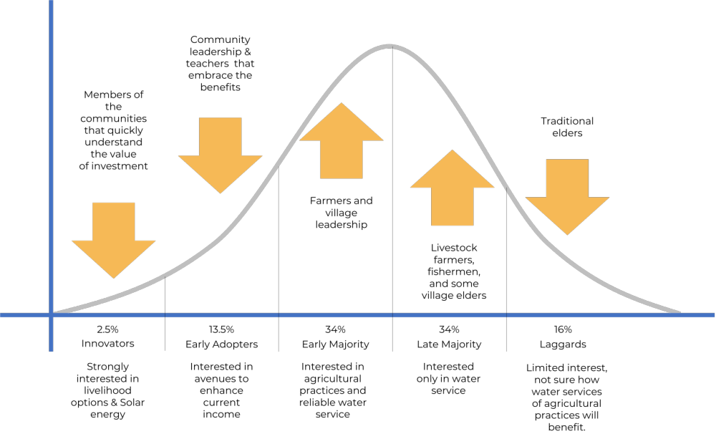
Figure 3: Diffusion of Innovation through SEAM.

The solutions proposed by the project aim to target key drivers for water sustainability. Restoration of the ecosystem through improved practices in land use ensure that water can be available during the latter months of the dry season, a major concern for Belize as the rainy season is expected to shorten and more be intense, while more dry days are also expected. Alternative livelihoods, which also include improvement in land use through Adaptive agricultural practices, and training on the installation of solar energy systems in communities with no grid energy are focused on generating income.

Training community members on climate risks, health, and sanitation, aim to lessen the cost burden for community members in their daily lives. Training of the MRT and the water boards on inclusive governance seeks to shift the responsibility for water care from elected authorities to community ownership. The water systems to be installed will provide the four communities with reliable water service, reducing the need to transport or purchase water. Through the adoption of project action (Figure X) the diffusion of innovation will lead to communities having confidence in themselves and in their leadership to solve collective issues. The integrated approach to the project’s innovative practices will contribute to the resilience and sustainability of the water distribution and management systems, promoting efficient resource use, reducing losses, and enhancing the overall climate adaptability of communities and their water infrastructure. Details of specific actions under each Activity are described in Section A.

Describe how the project aims to roll out successful innovative adaptation practices, tools, and technologies and/or describe how the project aims to scale up viable innovative adaptation practices, tools, and technologies.

Research and consultations provided a context, and lessons learned on success (and limitations) of proposed solutions. Solar solutions are widespread in Belize, and the country has had lengthy list of development projects that address livelihood option, SEAM takes the perspective that these solutions in of it themselves are not truly innovative, rather, the innovation perspective is the combination of these tried and tested solutions under inclusive governance that drives the adoption of strong collective action towards sustainability. The sequence of project implementation is critical to ensure that buy-in and adoption (participation) in project activities. The following activities detail how innovative practices and technologies are integrated and diffused to ensure the long-term sustainability of the water resources of each community.

Project Management Unit (PMU) in the MRT. In the case of project implementation, SEAM will be the first project to be implemented by the MRT, a skillset that would greatly improve its capacity to service communities under its responsibility. A Project Management Unit will be created within the MRT that will allow its staff to better understand how to administer a complex project, including procurement, monitoring and reporting, stakeholder management, amongst others. The MRT has provided technical guidance to other government agencies in similar projects, and its well suited to enhance their offering by working with project management professionals within their staff. To maintain and keep the PMU regularly updated so as for the team to remain responsive to new challenges and opportunities. The following steps will be taken:

Analyze and apply the lessons learned so other teams and future projects can benefit from it. This is especially relevant if we conduct a lesson learned session mid-project. Analyze the information from the lessons learned survey to effectively improve this project for the upcoming phases. Alternatively, if we are running a lesson at the end of a project, we can use the Analyze phase to glean insights and opportunities before beginning the next project.

Store the lessons learned in a central repository that everyone can access, (project management tool). With a central source of truth, as project leaders can access shared information to best prepare for their projects.

If a similar project has already been implemented, we can search for a lesson learned report from a past project to avoid making the same mistakes from a previous project. These reports should be shared in a central source of truth that all project managers can review before beginning the project planning process.

Documented lessons learned can be passed on to other project managers running similar initiatives or used by team members who are getting started on similar projects. Sharing lessons learned between teams is a great way to prevent the same mistakes from happening.

To ensure effective knowledge sharing and continuous improvement, the SEAM project’s lessons learned process will include at least two formal sessions: a mid-project review and a final review held within four weeks of project completion. Each session will produce a dedicated Lessons Learned Report that summarizes key findings, provides actionable recommendations, and informs both current and future project phases. These Lessons Learned Reports are distinct from the broader Project Evaluation Reports, which cover overall project performance and outcomes; lessons learned form an integral, but separate, component focusing specifically on practical insights and improvements. All lessons learned reports will be centrally stored in an accessible project management tool, making them available to all MRT staff and relevant stakeholders. This process will be explicitly integrated into the project’s results framework, with indicators tracking the number of lessons learned sessions held and reports produced. The Project Management Unit (PMU) will be responsible for scheduling these sessions, maintaining the repository, and ensuring that lessons learned are regularly reviewed and applied in both ongoing and future initiatives. This structured approach will foster continuous learning, build institutional capacity within the MRT, and enhance the quality and impact of project implementation.

Design studies on wells and systems. In similar projects, BSIF has relied on internal engineers and support consultants to design a system, and liaison with the MRT on community water and governance issues; construction was sourced through different contractors and suppliers. The project takes a different approach, largely due to the unique circumstances of the Toledo District Communities. To build a reliable and community focused system, engagement by water and stakeholder management professionals is necessary; this will support identifying well and tank placement, and most importantly, community inputs will be at the centerpiece of this consultancy. The study of design will allow those interested in the operation of water systems to be involved early on.

Construction and installation of solar water systems. Firms with a proven track record will be procured to use the design studies to drill wells, build tank structures, maintenance and supplies shed, distribution piping and metering. The proposed system would have wireless water meters to centralize water consumption measurement and metering. The MRT aims, in the future, to centralize data from rural communities under its management to have better statistics on water usage and collection rates. Firms interested in participating in the tender, must ensure that part of the work force is people in the community (especially women and youth). Participation in the construction of the system will allow community members to be familiarized with the distribution network and the general operation of the system.

Restoring and conserving the ecosystem that maintains the watershed and provides community income. The project builds on work by Belize-based NGOs that have successfully implemented projects that link the restoration of the forest environment through adaptive agricultural practices as well as conservation of the estuary. The dual objectives will be implemented by a grant award to interested CSO or NGOs that submit proposals on what activities are most adequate for merging income generating activities that also conserve and/or restore the ecosystem. There is a broad range of income generation activities that have been implemented in Belize in similar communities and include bee keeping, coffee and cocoa production, reforesting with soil regenerative tree species. The project engages communities in reforestation and restoration efforts that prioritize native species, which are better adapted to local climatic and soil conditions, thereby enhancing ecosystem resilience and promoting biodiversity conservation. This revival process draws on indigenous knowledge about traditional uses, seasonal cycles, and ecological relationships of native flora, gathered through participatory mapping, oral histories, and community workshops. Scientific methods complement this by applying ecological assessments, propagation techniques, and monitoring protocols developed in collaboration with research institutions and botanical gardens. By combining these knowledge systems, the project ensures that restoration activities not only rehabilitate degraded landscapes but also maintain habitat connectivity, improve soil health, and support native wildlife populations. These efforts contribute to stabilizing watersheds, reducing erosion, and enhancing carbon sequestration. Additionally, the project fosters the establishment of community-based ecological monitoring programs, where trained citizen scientists track the success of native species reintroduction and ecosystem recovery, enabling adaptive management. Economic incentives linked to sustainable harvesting and agroforestry further motivate communities to maintain biodiversity-friendly practices. This integrated approach aligns with Belize’s National Landscape Restoration Strategy and agroforestry policies, positioning this project at the forefront of innovative, culturally relevant, and scientifically sound ecosystem restoration that advances climate resilience and sustainable livelihoods. This project recognizes that fostering community participation in ecosystem-based conservation requires not only alternative livelihood opportunities but also additional economic incentives to motivate sustained engagement. Beyond direct income from diversified livelihoods such as eco-tourism, agroforestry, and sustainable harvesting, the project will explore mechanisms including payment for ecosystem services (PES) schemes, where communities receive financial compensation for maintaining and enhancing watershed functions like water purification, carbon sequestration, and flood regulation. These incentives may be linked to partnerships with government programs, private sector buyers, or international climate finance initiatives. The project will also facilitate access to microfinance, grants, and technical assistance to support community-led enterprises that align with conservation goals. Capacity building in business development and market access will further enhance economic returns, creating a virtuous cycle of ecological stewardship and financial benefit.

Regarding watershed revitalization, the project restoration and conservation activities are designed to rehabilitate degraded riparian zones, reforest native vegetation, and control erosion, thereby restoring the natural hydrological functions essential for water security. Healthy watersheds improve water availability and quality, reduce vulnerability to droughts and floods, and buffer communities against climate extremes. These ecological improvements directly enhance community resilience by safeguarding agricultural productivity, reducing disaster risk, and supporting biodiversity that underpins ecosystem services. By integrating scientific methods with local knowledge and engaging communities as active stewards, the project ensures that watershed revitalization is both ecologically effective and socially sustainable, providing long-term climate adaptation benefits to vulnerable Belizean populations.

Traditional funding has often overlooked nature-based solutions in favor of conventional infrastructure projects. However, a range of innovative financing mechanisms can bridge this financing gap and scale up nature-based solutions. This project will take the Public-Private Partnerships (PPPs) approach to offer a collaborative approach to tackle the challenges of climate adaptation. In these partnerships, public and private sectors combine their resources and expertise to deliver more efficient solutions. This can range from local nature-based solutions projects to strategic partnerships aimed at protecting or restoring ecosystems. The sustainability of the project depends not only on the system’s capacity and capabilities, or on its financial prospects, but also on the larger socioeconomic and resource environment that both supports and draws on the system, the regulatory requirements the system must meet, and the technical and financial assistance available to it. To maximize the innovation potential of ecosystem-based measures, the project has established strategic partnerships with key entities during the project design phase, and these collaborations will be actively operationalized throughout implementation to extend the reach and effectiveness of conservation efforts. Specifically, the project will leverage the shared expertise of governmental agencies such as the Ministry of Rural Transformation (MRT), the Protected Areas Conservation Trust (PACT), local NGOs, academic institutions, and indigenous organizations through joint planning, capacity building, and coordinated field activities. These partners will co-facilitate training workshops, community engagement sessions, and technical assessments, ensuring that scientific knowledge, policy frameworks, and traditional ecological insights are integrated into restoration and watershed management practices. Operational mechanisms include the formation of multi-stakeholder governance bodies and technical working groups that meet regularly to review progress, share data, and adapt strategies collaboratively. Shared data platforms and centralized monitoring and evaluation systems will enable real-time information exchange, fostering transparency and informed decision-making. Additionally, partners will contribute specialized resources such as advanced mapping technologies, nursery facilities for native species propagation, and expertise in sustainable livelihood development. By embedding these partnerships into the core project activities—from riparian forest restoration to community empowerment and alternative livelihoods—SEAM Innovation Belize ensures that collective knowledge and capacities are harnessed effectively, enhancing innovation, scalability, and sustainability of ecosystem-based adaptation measures.

It is vital to Involve the local communities in this project, to foster a sense of ownership and empowerment. When people feel connected to and responsible for their local environment, they are more likely to actively participate in conservation efforts and adopt sustainable practices. Engaging them will create a sense of pride and enable them to become stewards of their own natural resources. To strengthen local ownership, address community needs, and leverage local expertise for sustainable implementation, the proejct employs a range of participatory and ecosystem-based methods that integrate local and indigenous knowledge throughout project activities. The project will engage communities through inclusive participatory planning sessions, focus groups, and workshops designed to elicit traditional ecological knowledge, cultural practices, and community priorities related to water resource management and ecosystem conservation. These forums ensure that local insights directly inform the design and implementation of interventions such as riparian restoration, watershed protection, and alternative livelihoods. The project also fosters community-led ecological monitoring programs, where trained citizen scientists contribute to tracking ecosystem health and restoration progress, thereby enhancing local stewardship and adaptive management capacity. Collaboration with local NGOs, indigenous organizations, and research institutions facilitates knowledge exchange and the integration of innovative scientific and traditional approaches, such as reviving native plant species in reforestation efforts and applying geo-resistivity techniques for water source identification. Economic incentives and capacity-building initiatives further motivate community engagement by linking sustainable practices to improved livelihoods. This comprehensive approach ensures that ecosystem-based measures are not only ecologically effective but also socially accepted and culturally relevant, thereby maximizing their innovation potential and long-term sustainability.
Restoration actions further protect the communities by minimizing erosion, thereby reducing the need to relocate in instances where homes are near eroded riverbanks. Restoration actions also enhance local biodiversity. This in turn provides communities with building materials for traditional homes and firewood as well as secure sources of game meat, harvested from the surrounding forest. The above enables the community to maintain their traditional cultural practices. To ensure social inclusion, both men and women will be given equal opportunity to participate in all training and capacity building activities under Component 3. In Indigenous communities, with permission from the Alcalde, the project will ensure that if needed, men and women will be engaged separately, in accordance with traditional norms, to ensure that women can fully participate in the training and capacity building activities. The project will ensure that the proper protocols for engagement are adhered to. At the national level, both men and women will be provided with information from the knowledge dissemination campaigns. This project will call on those traditional norms and those men to be able to allow women to do more than just the domesticated work. For those that will not break down the barriers, the women will be trained separately from the men and with the innovation of the projects such as this, change and development will allow those men to realize that to survive in the future progress must be free. The project is committed to ensuring women’s meaningful participation not only within water boards but across all community decision-making processes throughout the project lifecycle. Beyond their inclusion in water boards, the project adopts a multi-dimensional approach to empower women in leadership and governance roles in activities such as ecosystem restoration, alternative livelihood development, and climate adaptation planning. This will be achieved by intentionally designing participatory forums, such as community workshops, focus groups, and planning sessions that are accessible and welcoming to women, including scheduling meetings at times and locations convenient for women and providing childcare support when needed. The project will actively engage local women’s groups, indigenous women leaders, and gender-focused organizations as partners and facilitators to encourage broader female representation and voice. Capacity-building initiatives will include targeted training to enhance women’s leadership skills, confidence, and technical knowledge, enabling them to contribute effectively to decision-making beyond traditional roles. Gender-sensitive facilitation techniques will be employed to ensure that women’s perspectives are heard and integrated into project planning and implementation. Furthermore, the project’s monitoring and evaluation framework incorporates gender-disaggregated indicators and qualitative assessments to track women’s participation levels and influence in various decision-making arenas. By fostering an inclusive environment and addressing social and cultural barriers, the project ensures that women are empowered as active agents of change across all community-driven activities, thereby strengthening the project’s social equity and sustainability outcomes.

Addressing access to energy. For the Toledo district communities, where no grid energy is available arises the opportunity to provide training for community members on the installation of a solar energy system. The project will work with interested parties, based on the Barefoot College Curriculum, on how to install, maintain, and operate household solar systems. The participants will also receive training on developing a business, access to funding, and contacts with local suppliers; thus, installation of solar systems in other household in the community or in nearby villages can be an income-generating activity.

Boosting confidence in community and authorities. By providing water services to all households in the community, a long-standing claim, confidence in the authorities and in the community will increase. This will be enhanced by several training and capacity building exercises, that will not be limited to those what serve on the water board, but also to the broad community. The focus is on having a shared consciousness of water sustainability, which is crucial for responding to future changes in climate. Moreover, the integral gender-focus of the project aims to increase the participation of women in community decisions. The key opportunities or assets for increasing women’s participation in local decision making are women’s groups and social capital, information dissemination, and efforts to teach and practice women’s participation in relation to the new local government structures. The project will prioritize women’s participation in decision-making about community investments. It will creating safe spaces for women and offering them a suite of trainings on topics such as gender equality, participatory planning, social accountability, procurement, disaster risk management, climate change and local governance.

Enhancing the capacities of the MRT to provide better service. As aforementioned, the MRT will gain valuable project management skills, and moreover, it will receive training on how to improve water board efficiency through training on inclusive governance. Other training for the MRT that will support future actions include training on health and sanitation, climate risks, and the operation of solar water systems. The lessons learned from implementing the project will allow the MRT to better train water boards and engage with rural communities throughout Belize. Component 3 will enable MRT to share knowledge and disseminate lessons learnt for the scaling up and modification of similar actions in different communities. The capturing of lessons learnt will better enable the Executing Entity (EE) and communities to address the impact of climate change and water security via the utilization of innovative technologies and the construction of climate adaptive infrastructure. The multistakeholder approach to management will further improve collaborative action across departments. Agencies such as the NHS, BWS, MOHW, Forest Department, National Climate Change Office (NCCO) and Ministry of Natural Resources have operated under this approach recognizing the need for various skills and expertise to be utilized for the formulation, construction, and maintenance of water systems and for addressing the climate adaptive needs of communities. The technical committee will take note of project success and the necessary adjustments required for the useful scale up of the innovation. Given the varied characteristics of each community, the committee will ensure that community dynamics are taken into consideration for the potential scale up. This project will strengthen that collaboration for unified action and serve as the baseline for future actions. As the EE works closely with all communities across Belize, with water supply systems under their management, the EE can utilize the success of this project to garner support to advance its work with other communities that have similar characteristics to begin the process of assessing their water supply needs and potentially adopting similar innovative practices. Peer exchanges are an excellent way to support the long-term provision of knowledge dissemination beyond the lifespan of the project across other communities in the country and in neighboring countries. In this project, the roles and coordination mechanisms among NGOs, the private sector, and governance bodies are clearly defined to ensure effective implementation and sustainability. NGOs primarily focus on community capacity building, watershed protection, and providing technical support to local stakeholders. They actively participate in governance bodies and contribute to regular meetings to align efforts and share progress. The private sector is responsible for delivering technical services, operating infrastructure, and supporting livelihood development initiatives. Their involvement is formalized through service contracts and subject to performance reviews to maintain quality and accountability. Coordination and monitoring are overseen through multi-stakeholder governance structures, supported by memoranda of understanding (MoUs) and joint planning sessions that bring together all partners. Quarterly coordination meetings and community engagement forums facilitate ongoing dialogue and adaptive management. Reporting and monitoring systems are integrated, with NGOs providing progress reports and financial accountability, while private sector partners submit performance-based reports and system monitoring data. All information feeds into a centralized monitoring and evaluation (M&E) system, supported by shared data platforms and periodic evaluations to track project outcomes and inform decision-making. This collaborative framework fosters transparency, accountability, and effective coordination among all actors involved in this project.

Describe how the project provides economic, social, and environmental benefits, with particular reference to the most vulnerable communities, and vulnerable groups within communities, including gender considerations. Describe how the project will avoid or mitigate negative impacts, in compliance with the E&S Policy and Gender Policy of the Adaptation Fund.

The project aims to benefit over 1,665 men, women, and children in over 335 households in four villages. Three of the four communities of the project are in Belize’s poorest region, the Toledo District, where around 60% of persons reside in extreme poverty. (see Annex IV, section 3 Poverty and section 4 Toledo Poverty) Toledo District communities have minimal access to health and education, which is compounded by often contaminated water sources towards the end of the dry season or after severe weather events. The three Toledo District communities are mostly comprised of indigenous Maya peoples, who maintain traditional customs, religious practices, and leadership roles. The Corozal District community, Copper Bank, is a shore side village where the main economic livelihood is fishing, primarily conch and lobster. There is strict seasonal restriction on fishing lobster and conch, leaving many inhabitants to look for work in Mexico or other communities. Copper Bank will likely see an improvement of living standards due to government investment in road and bridge infrastructure; however, this will not address the surmounting need to provide potable water. Currently in Copper Bank, about half the households obtain water from hand dug shallow wells, which are often contaminated from rainwater and surface water runoff and wastewater. Drinking water is often purchased in five-gallon bottles. The project offers substantial long-term benefits that outweigh its initial higher costs through enhanced sustainability of water systems, improved community health, and economic gains from increased productivity and reduced water-related disruptions. The project’s investment in solar hybrid sustainable water systems ensures reliable, climate-resilient potable water supply with lower operational and maintenance costs compared to conventional systems, thereby enhancing the sustainability and longevity of infrastructure managed by local water boards and executing entities15. These systems reduce dependency on fossil fuels and minimize breakdowns, leading to fewer service interruptions and cost savings over time. Improved water access directly contributes to better community health by reducing waterborne diseases and improving hygiene, which decreases healthcare expenses and absenteeism from work and school. Reliable water availability also saves significant time, especially for women and children, previously spent on water collection, allowing reallocation of hours to education, income-generating activities, and community participation, thereby enhancing social well-being and productivity. Economically, the project fosters increased agricultural productivity through ecosystem-based watershed protection and restoration that improve soil moisture and reduce erosion, leading to higher crop yields and food security. Alternative livelihood opportunities supported by the project, such as eco-tourism and agroforestry, generate new income streams, diversifying household economies and reducing vulnerability to climate shocks. These economic benefits contribute to poverty alleviation and community resilience. When comparing these long-term benefits against the initial capital and implementation costs, the project’s innovative design, integrating renewable energy, adaptive management, and community governance, ensures cost-effectiveness by lowering recurrent expenses, enhancing system reliability, and maximizing social and economic returns. This holistic approach aligns with Belize’s national priorities and global adaptation goals, demonstrating that upfront investments in sustainable, climate-smart water infrastructure and ecosystem management yield durable benefits that far exceed initial expenditures.

Environmental Benefits

Two of the three Toledo District communities have at-risk aquifers, that are mostly layers of limestone formations that filter and store rainwater throughout the year, which presents an environmental problem locally and throughout the watershed. The limestone aquifers are an essential component of the Belizean watershed, as many of the countries river’s tributaries are fed from water collection in the Mayan Mountain formation. Environmental concern arises when the delicate balance between the moisture held by forest cover above these limestone formations is disrupted due to land use. Traditional farming techniques, unscrupulous logging have advanced over natural primary forest in Belize, limiting the capacity of the aquifers to retain sufficient water to last throughout the dry season. The concern over land use is more critical in Belize, precisely due to the mentioned geological formation, as less water is retained by the forest ecosystem, more nutrients drain towards the Caribbean basin and its reef systems. The communities are impacted due to the incapacity of the current water sources to effectively replenish fully, a concern that will be exacerbated by climate change forecasts of longer dry seasons in Belize. The Project promotes the use of traditional ecological knowledge (TEK) in land and resource management by systematically integrating Indigenous and local cultural practices with scientific approaches to ensure sustainable and resilient ecosystems. The project recognizes that Maya communities in Belize have long-standing, sophisticated systems of ecological stewardship deeply rooted in their cultural values, such as the milpa agricultural cycle and forest garden management, which maintain biodiversity, soil fertility, and water resources. To incorporate TEK, the project will engage Indigenous leaders, elders, and knowledge holders through participatory planning, workshops, and co-management arrangements, ensuring their expertise guides restoration, watershed protection, and sustainable agriculture activities. Specific approaches include reviving traditional practices like the milpa system, a cyclical agroforestry method that combines crop cultivation with forest regeneration and the management of diverse forest gardens that provide food, medicine, and materials while preserving ecological balance. The project will facilitate knowledge exchange sessions where scientific methods, such as geo-resistivity analysis and ecological monitoring, are combined with Indigenous observations and land-use customs to optimize interventions. Community-based ecological monitoring programs will empower local participants to track ecosystem health using culturally relevant indicators, reinforcing stewardship and adaptive management. By valuing and applying TEK alongside modern science, the project ensures that land and resource management practices are culturally appropriate, ecologically effective, and socially sustainable, thereby strengthening local ownership, biodiversity conservation, and climate resilience in target communities. This approach aligns with documented Maya values of living in harmony with nature and supports the protection of customary lands and natural resources for future generations

The project addresses both the preservation of the aquifers and the water supply through improvement in agricultural livelihoods tailored to Maya tradition, especially through a mixture of reforestation and cultivars. Plants and soils in natural coastal habitats (like marshes, mangroves, seagrasses, etc.) sequester and store large quantities of carbon - called “Blue Carbon”. Managing coastal wetlands and near-shore marine ecosystems can provide many benefits, such as protecting shorelines, cycling nutrients, keeping water clean, controlling floods, and providing homes and food for birds, other wildlife, and fish. One of the main sources of income of Copper Bank is fishing, thus supporting the preservation and restoration of coastal ecosystem will ensure an additional safeguard for this important livelihood.
The project will result in several environmental benefits that contribute to mitigating and adapting to climate-related impacts being addressed. The water system infrastructure will be designed to withstand extreme weather events such as hurricanes, floods, and storms which means less repair and replacement and a reduced environmental impact of construction and maintenance. This resilience also reduces the risk of damage to the water system and minimizes the environmental impact associated with disruptions to the water supply. The ecosystem restoration and management efforts promote efficient water use and reduce overall water demand. This helps in preserving local water resources, particularly during periods of drought or changing precipitation patterns. Restoration measures will promote water retention through reforestation which aims to help maintain aquifer levels, supporting both water supply and the health of ecosystems dependent on groundwater. The repair of the riparian buffer will decrease riverbank erosion, benefit water quality and provide habitat for wildlife. All ecosystem activities work on behalf of the quality and sustainability of the watershed as well as ensure healthy aquatic habitats and biodiversity.

The use of renewable energy in the three communities avoids producing greenhouse gas emissions associated with electricity or diesel pumps. Water meters provide environmental benefits by reducing water waste and promoting efficient water use. The meters also can be used to detect leaks in the water distribution pipes preventing unnecessary water loss, conserving resources, and reducing the energy required to pump water. The involvement of communities and national campaigns increase environmental awareness and encourage responsible water use. This educational effort, in addition to tying alternative livelihoods to water and ecosystem restoration, is likely to increase the community’s buy in to participate in conservation efforts, further enhancing environmental benefits. WASH training will convey critical information for preventing water contamination and benefit the preservation of the watershed.

Social Benefit

The water distribution system designed with adaptive measures for climate change brings various social benefits that enhance community well-being, resilience, and equity. First and foremost, it provides access to clean and reliable, potable water which is a necessity of life as well as contributing to improvement in public health, reduced water borne diseases and enhanced overall well-being. Reliable access to clean water as well as WASH training facilitates better hygiene and sanitation requirements.

Inclusive collaboration with communities in the planning, implementation, and maintenance of the systems will provide community members with confidence in their leadership, improve relations with the MRT and foster a sense of project ownership. Amongst the project objectives is to provide leadership, through enhancing the governance of Water Boards. The project recognizes the vital role of indigenous governance bodies within the target communities, particularly the Maya Alcalde system, as a foundational element for strengthening local governance and ensuring project sustainability. The Alcalde system, practiced predominantly by the Maya communities in southern Belize, functions as a traditional local government and judicial authority responsible for village administration, dispute resolution, land and forest stewardship, and organizing communal activities such as fajinas (community work). Unlike elected village councils, alcaldes hold culturally rooted authority and are deeply respected as custodians of indigenous laws and customs. The project will incorporate these indigenous governance bodies by formally engaging alcaldes and their councils as key partners in project planning, decision-making, and implementation. This includes involving alcaldes in multi-stakeholder governance structures and community committees to ensure that project activities align with customary laws, local priorities, and traditional knowledge systems. The alcaldes’ role in land and resource management will be leveraged to facilitate community mobilization for ecosystem restoration, water infrastructure siting, and sustainable livelihood initiatives, thereby reinforcing their leadership and authority. Moreover, SEAM Innovation Belize will support capacity building and dialogue platforms that foster collaboration between alcaldes, village councils, government agencies (such as the Ministry of Rural Transformation), and NGOs, promoting harmonious coexistence and shared governance. This approach respects indigenous self-determination and strengthens the legitimacy and effectiveness of local governance, enhancing community ownership and long-term sustainability of project outcomes. By embedding the Alcalde system within the project’s governance framework, SEAM Innovation Belize ensures culturally appropriate, inclusive, and resilient management of natural resources in its target areas.

Women and men from the communities will be trained to engage with the communities on the importance of water sustainability; a concept that is currently not well understood. Water Boards’ capacity to respond to community water related issues enhances the overall community adaptive capacity to climate variability and change. Moreover, by ensuring 50% female representation within Water Boards, the project will actively promote women's leadership, fostering recognition of their capabilities and rights, and paving the way for potential positive transformation, particularly in traditional patriarchal cultures like the Maya community. Community engagement and raising awareness about the importance of water conservation, climate resilience, and sustainable water use practices are better equipped to contribute to the water system sustainability. Enhancing water systems not only partially relieves women of traditional reproductive work but also improve community health. The inclusive engagement of both women and men in project design and constructing the water system infrastructure is pivotal for functional structures that resonate with diverse community needs. The number of women representatives in the water boards will not be the sole goal, neither the ultimate objective of gender mainstreaming. Having women in planning bodies alone doesn’t guarantee that gender issues are mainstreamed; it is a much wider process. The presence of women in these systems won’t radically influence the impact of the project if the women have not been included in the design phase and if the projects have not integrated all gender needs and set objectives that are gender-sensitive and beneficial for all. To address these issues, adopting a gender mainstreaming approach in water resource management and policy development is crucial. This approach ensures that gender considerations are integrated into all stages of planning, implementation, and evaluation of water access initiatives. By doing so, the specific needs and challenges faced by women-headed and dual-headed households can be effectively addressed. Promoting women’s empowerment and enhancing their participation in decision-making processes related to water management is essential. Providing training, capacity-building programs, and creating opportunities for women to actively engage in water-related initiatives will contribute to their empowerment and enable them to have a voice in shaping water access policies. By addressing the gender disparities in this project through gender mainstreaming, women empowerment, infrastructure development, and awareness campaigns, Belize can strive towards achieving greater equity and inclusiveness, particularly in these four communities. These efforts will ultimately improve the overall well-being and livelihood of the rural population.
In addition, the project will foster an inclusive culture by establishing gender-sensitive policies and facilitation practices during meetings and workshops such as ensuring equitable speaking opportunities, scheduling sessions at times convenient for women, and providing childcare support where needed. Mentorship programs pairing experienced women leaders with emerging female participants will further support confidence-building and knowledge transfer. The project will also engage men and community leaders through gender awareness and sensitization workshops to promote shared understanding of the benefits of women’s leadership and to address cultural or social barriers to inclusion. Monitoring and evaluation frameworks include gender-disaggregated indicators and qualitative assessments to track women’s participation, leadership roles, and influence in decision-making processes, enabling adaptive management to address gaps. Through these comprehensive and culturally appropriate actions, the project ensures that women are not only present but are empowered as equal partners and leaders, thereby strengthening the project’s social equity, governance, and sustainability outcomes.

The project capitalizes on opportunities through livelihoods and watershed management programs, coupled with targeted training initiatives to include women in job openings provided by the project in particularly male-dominated sectors. The livelihoods program, geared towards expanding community income sources, recognizes the importance of addressing the needs of both men and women. A gender-sensitive needs assessment precedes its implementation, and another will be conducted before executing the ecosystem management program. Encouraging women to explore diverse occupations aligns with cultural shifts spurred by solar energy technology training or construction skills development, challenging established gender roles. Women's increased participation in decision-making, particularly on Water Boards, goes beyond representation, fostering autonomy and recognition within their communities.

Under Component 3, the Project manifests a holistic commitment to promoting transformative change in gender dynamics, not only within the project communities but also at the macro level (MRT). Through a series of sensitization activities and tailored training programs, the SEAM project aspires to create a transformative ripple effect, fostering a community-wide commitment to gender equality. This commitment extends to individuals directly engaged in the project's execution, embodying a multifaceted and comprehensive approach to gender sensitivity and innovation.

In sum, the project carries the potential to influence gender dynamics within the targeted communities in the long run, by deploying a holistic approach that not only empowers women but also engages men, fostering a more inclusive and nuanced understanding of gender roles. As the project encourages women to venture into traditionally male-dominated sectors like construction and energy, it sparks a fundamental shift in societal perceptions and workplace norms. This diversification of professions contributes to breaking down gender barriers, creating an environment where individuals are recognized for their skills and capabilities rather than conforming to gender stereotypes. The alternative livelihood actions foster men and women as entrepreneurs in communities traditionally stricken by poverty; having an added benefit of food security, dependent on the solutions identified in conjunction with community members. Water and food security are key issues threatened by the changing climate; therefore, the project intends to simultaneously address both issues to enable the resilience of the target communities and its members. Alternative livelihood activities provide a new revenue stream for the communities minimizing their social dependence on financing from unreliable sources. These actions will be selected during project implementation in conjunction with the communities and can cover a broad range of actions. As the characteristics of each community differs, the alternative livelihood actions will be dependent on the location of the community, traditional practices, materials readily available and the traditional skills of the men and women in the community. Further assessment of the alternative livelihood options was examined during the project development phases under the social impact Assessment through consultations with community members. (see Annex IV)

In parallel, the project's emphasis on enhancing water system infrastructure carries enduring effects on health and reproductive work. Beyond immediate benefits, the improved infrastructure provides a foundation for long-term advancements in community well-being. Crucially, the inclusion of women in water boards emerges as a pivotal strategy for instigating change. By becoming role models for their daughters, these women not only bolster their own self-esteem but also challenge traditional gender norms. Their active participation in tasks traditionally reserved for men sends a powerful message about the capabilities of women. Improving the lives and opportunities of women and girls is an explicit objective for this infrastructure projects. Well-designed, appropriately located and affordably priced infrastructure can be a powerful tool in the pursuit of gender equality. Gender should not be regarded as something requiring attention in infrastructure projects. Rather, women and girls must be considered primary clients whose satisfaction is a critical factor in ensuring the project’s success and sustainability. When gender equality issues are not considered, women can become worse off – both absolutely and in relation to men.

Moreover, training MRT staff in gender issues becomes a linchpin in the project's broader impact. This capacity-building initiative does not merely enhance the skills of the team but also radiates positive influence in community interactions. As the trained staff engages with communities, initiates new projects, and shares their insights in other regions, the ripple effect of gender awareness is magnified.

Economic Benefits

The project will provide various economic benefits, contributing to the overall well-being of the communities. In addition to other benefits from obtaining water security, it can also lead to increased economic productivity and reduced vulnerability to water-related disruptions.Training of community members on solar maintenance will potentially provide employment opportunities with other nearby communities utilizing solar water pumps who have not received this training. Additionally, there will be temporary jobs generated from income as the result of the construction of the infrastructure. Training and capacity building on the operation, maintenance and management of the water system, as well as that provided for construction, may provide skills that are applicable to other income generating activities beyond the project. Component 3 -Alternative Livelihood activities are also sustainable as they provide members of the communities with a source of income taking into consideration their cultural and traditional practices. Following the Covid-19 pandemic, the communities in the poorest region of the country were severely impacted by the economic implications of the pandemic. This project aims to provide the communities with an alternative source of income and supply of food that would enable them to recover from the impacts of the pandemic. By creating an alternative source of food and livelihood for the communities the actions of the project will enable communities to become independent and better provide for themselves beyond the one-off investment. The project anticipates quantifiable benefits in time savings, increased productivity, and income generation from new livelihood opportunities. Reliable and climate-resilient water access will reduce the time community members especially women and youth, spend collecting water, potentially saving several hours daily, which can be redirected toward productive activities such as farming, education, or entrepreneurship. Improved water availability and soil moisture through ecosystem restoration and sustainable land management are expected to increase agricultural yields by enhancing crop resilience and reducing losses from drought or erratic rainfall, thereby boosting productivity and food security. Alternative livelihood options promoted by the project, such as climate-friendly eco-tourism, agroforestry, and value-added agricultural products, will create new income streams for households. For example, training and support in eco-tourism in Corozal District can generate additional revenue by attracting visitors interested in natural and cultural heritage, while agroforestry practices diversify farm income and improve long-term land productivity. These economic benefits align with findings from Belize’s socio-economic assessments, which highlight the positive impact of entrepreneurship and MSME development on income and resilience, especially when supported by capacity building and market access initiatives. By integrating these livelihood improvements with water and ecosystem interventions, the project aims to deliver measurable socio-economic gains that enhance community well-being and climate resilience.

147. Community members from Copper Bank expect savings from not having to purchase bottled water and bottles of chlorine bleach which, in addition to costing significantly more than the monthly fee for water, also has a negative environmental impact. The water metering and efficient water systems with good governance can reduce water losses through leaks detection and its associated costs. The villages’ improved infrastructure should also positively impact on the value of land (for the landowners in the Corozal district).A reliable water supply also contributes to the Village’s ability to promote tourism. Tourism-related businesses, such as bed and breakfasts, small hotels, restaurants and bars require access to clean and sufficient water resources.

For communities dependent on subsistence farming as the main source of income; income is subject to high variability. The erratic nature of income generation from the sale of crop-surplus is based on various fluctuating factors, including weather conditions, crop yield, product market price, transportation costs and exchange rates. These fluctuations inhibit economic mobility. The project communities also experience other influential factors that maintain poverty such as remote location, limited access to education or capacity building, lack of proper health care and time demands to acquire basic needs such as water. Reducing the water collection burden and addressing health-related concerns will give community members more opportunities to market their products in farther communities. The technical support and services that the project will seek to support the communities under Activity 4.1 will include marketing mechanism and plans to enhance the marking of the products produced in the target communities. These will include support to the communities with equipment, infrastructure and training to maximize the marketability of products and its value added.

It is challenging to calculate the tangible net benefit from the time savings resulting from not having to collect water or wash in the river. Some similar projects estimate this figure to be 40 minutes per day, although this was not able to be verified during field consultation.

Removing the water collection burden from community members, especially women, in addition to providing time savings will have the potential to enhance income generation through alternative livelihoods, albeit difficult to calculate the specific net benefit. Most Toledo communities are living in extreme poverty, with most households earning less than US$50 (BZ$100) per month. ￼ suggest that this figure is underreported and is likely closer to US$150 (BZ$ 300) per household. Using Dolores as an example, with its 106 households and the investment cost for its water system of over US$468,000, it would take 30 years of every household in the community to allocate their entire income to pay for the system.

Using the same household income profile as an example and considering the 40 minutes per household used to get water per day, such amount would save around US$6 per month, more than the suggested (sustainable) water rate of US$5.5 per month. Consequently, the savings in each household in terms of time would far surpass the cost of water delivery, assuming that the investment is granted. Consequently, the savings in each household in terms of time would far surpass the cost of water delivery, assuming that the investment is granted. The project seeks to augment the water time savings with capacity building through established entities (grant awards), that will provide members of the community with alternatives, such as bee keeping, which would bring an extra US$5 to US$15 per month. Planning, construction, and maintenance of the climate-adaptive water systems also creates employment opportunities within local communities from construction which can contribute to local economic development and empowerment. Skills acquired through capacity building and training provided from the Project will also potentially create income-generating opportunities with local communities which can contribute to local economic development and empowerment. The project will support the capacity development of community members in maintaining and installing the solar systems that will be installed in the communities. This model has been used in some of the communities in Southern Belize, where women were trained on solar systems, which will be replicated and expanded in the target communities. Due to the remoteness of the communities, this will support the long-term sustainability of the project interventions (including the longevity of the solar system) and promote capacity development and income generation for the impacted families and by extension the communities.

Avoiding or mitigating negative impacts

The proposed project is Category C given the low to minimal risk posed to the communities and natural environment in which the project interventions are proposed. The comprehensive assessment of environmental, social and gender risk demonstrates the project is expected to yield an overall positive environmental and social benefits by developing a water supply and distribution system to provide safe, sufficient, and year-round potable water to four communities. The project aims to address the full water cycle including eco-system management measures; WASH capacity building to address health as well as water contamination issues; extraction and distribution; as well as innovative approaches to wastewater use. The project anticipates a reduction in the vulnerability of children, women, and men to incidences of water-borne, food borne, and vector borne diseases in addition to communicable and non-communicable diseases. Thus, making critical achievements in improving wellness and quality of health to the community.

Without adequate mitigation, there could be potential negative impact from social or cultural disruption or interference in community cohesion; conflict obtaining informed consent from the indigenous villages; unequal access to benefits; economic hardship maintaining the system or women’s difficulties to engage with the project.

Potential social or cultural disruption will be mitigated by ensuring that planning, design, implementation, and project closure involve active, inclusive participation and consultation with the project communities. Language preference, cultural practices, values, and traditions will be respected and incorporated into project design. Thus far there, numerous consultations have taken place with the communities, who demonstrated openness, interest, and eagerness to begin the project. Consultations will be supported by the long-established relationships with the MRT field officers, engaging NGOs with cultural familiarity and previous experience working with the communities, especially those who have a track record working with indigenous women, and by working with the PMU gender specialist to structure conditions for success with women’s engagement. The project acknowledges the critical importance of effective communication and knowledge sharing in local languages to ensure inclusive participation and understanding among target communities. Accordingly, the project will produce key knowledge products such as training materials, technical guides, awareness brochures, and monitoring tools in the primary local languages spoken within the project areas. This approach ensures that information is accessible, culturally relevant, and easily understood by all community members, including those with limited proficiency in English or Spanish. To systematically track this commitment, the project results framework will include a specific indicator measuring the percentage of knowledge products translated and disseminated in local languages, enabling clear monitoring of outreach effectiveness. Furthermore, the project budget explicitly allocates resources for professional translation services, community-based translation support, and the production of multilingual materials. These budget provisions cover costs related to translation, printing, and distribution, ensuring that language accessibility is adequately funded and prioritized throughout implementation. This comprehensive strategy reinforces the project’s dedication to fostering meaningful community engagement, capacity building, and sustainable outcomes through culturally and linguistically appropriate knowledge dissemination.

Working in Indigenous communities requires familiarity with cultural norms, indigenous people’s protocol, and thorough understanding of FPIC. This potential negative impact has been mitigated by following indigenous people’s protocol and FPIC procedures and obtaining FPIC during the field visit (see FP Annex IV: SIA, Appendix 8). The project will continue to follow FPIC protocol which is an iterative process if there are adjustments or additions to the agreed upon project activities. From the outset, the project has engaged Indigenous representatives in participatory consultations to understand cultural values, traditional governance structures, and knowledge systems. Building on this foundation, the project will establish formal mechanisms such as Indigenous Advisory Councils or Elders’ Committees that provide ongoing guidance and oversight, ensuring that Indigenous perspectives shape decision-making at every stage. Project activities will be designed and delivered in culturally appropriate ways, including conducting meetings and workshops in local Indigenous languages where needed, respecting customary protocols, and scheduling events to align with community rhythms and ceremonies. Indigenous leaders and elders will be actively involved as co-facilitators, knowledge holders, and trainers, particularly in ecosystem restoration and water management activities where traditional ecological knowledge is invaluable. The project will also support capacity-building initiatives tailored to Indigenous governance systems to strengthen their role in resource stewardship. Monitoring and evaluation frameworks will include culturally relevant indicators and participatory methods that reflect Indigenous values and priorities. By embedding respect for Indigenous identity, knowledge, and leadership into the project’s governance and implementation mechanisms, the project ensures that Indigenous communities are not only consulted but are empowered partners, fostering trust, ownership, and sustainable outcomes aligned with their cultural heritage.

Any potential uneven access to benefits or economic disparities will be mitigated through the structure of a fully inclusive project that is designed with the community, for the community. All community members are eligible and encouraged to participate in all aspects of the project and the MRT, project manager and gender specialist will ensure full communication with the communities, meetings time and location selected by the community and family friendly events or childcare provisions.

The introduction of a centralized water distribution system may lead to a dependency on external entities for maintenance, repairs, and technical support. Potential dependencies will be mitigated through community engagement in the project design and implementation increasing in and reflecting the needs and cultural norms of each village. Training for Water Boards and for the women involved in the solar system and maintenance will provide the necessary capacity to be self-sufficient. Trouble shooting techniques will be provided that will help guide when technical support is needed.

Economic challenges to cover the monthly fee for the water system will be mitigated by the alternative livelihood program, prioritizing local hiring, skill development and capacity building initiatives to ensure community members benefit economically from the project and allow for long term sustainability of the water system. The lessons learnt from similar projects will be used as a benchmark for this one. Where possible, the traditional tools and practices of the local and Indigenous communities will be integrated, captured and disseminated for the eventual scaling-up of the process. This project seeks to increase the capacities in solar technologies through training of indigenous in the southern targeted Communities. This activity builds on success cases of a GEF-grant project of training rural women administered by Plenty International in Santa Elena, where indigenous women were trained to support community electric boards in the installation and maintenance of solar systems. Further, this prior project’s curriculum was designed in collaboration with the Barefoot College, whereby women, most who have limited education, are trained as solar engineers.

All the project communities are lacking access to a reliable potable water source and some villages are continuing to practice both open defecation and others have limited access to basic sanitation. Though not a measure of poverty, all the villages are currently, in part, contaminating their water source through a lack of sanitation practices – mostly resulting from open pit latrines and faulty septic systems. Three project communities, Dolores, Otoxha and Boom Creek, are located Toledo District, which has consistently over the years has some of the most extreme statistics for poverty in Belize. The bottom 40% of the population is mostly situated in rural areas with the highest rates of extreme poverty. Figure 3 illustrates the poverty dynamics of the administrative districts of Belize.

Poverty seems to be higher in these areas because they tend to concentrate households headed by individuals with low levels of schooling, exhibiting lower female participation in the labor market and belonging to ethnic minorities. The Toledo District had the highest percentage of multidimensionally poor people at 60.3 %, compared to the lowest of 20.9% found in the Belize District. It is also noteworthy that 61% of all poor Belizeans are Mayas - the highest rate of poverty compared to Belize’s other major ethnic groups. Table 6 details the disparities between administrative districts.

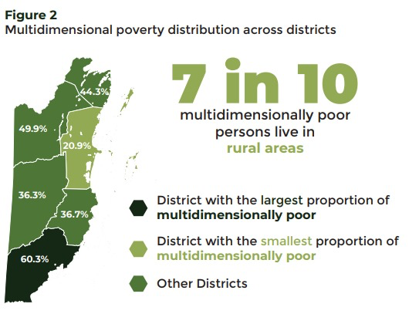
Figure 4: Multidimensional poverty distribution across districts (Source: Statistical Institute of Belize. Multidimensional Poverty Index, 2022.)
District | Poverty Rate  2009 (%) | Poverty rate  2018 (%) | Indigent | All rural poor | Mean HH Size (2010,  Census)
Toledo | 60.4 | 81.7 | 40 | 88 | 4.7
Cayo | 40.6 | 51.8 | 10 | 60 | 4.4
Stann Creek | 43.7 | 46.6 | 5 | 49 | 3.8
Belize | 28.8 | 45.4 | 8 | 47 | 3.5
Orange Walk | 42.8 | 56.8 | 16 | 63 | 4.4
Corozal | 56.2 | 44.7 | 5 | 48 | 4.4
Country | 41.3% | 51.8% | 14 | 59 | 4.1⁸¹
Table 2 : Poverty rates by District 2009 -2018 (Source: The Statistical Institute of Belize. Census 2010 projections; Poverty Assessment Report 2009. Poverty Analysis 2018). Note in bold, the districts of project communities.

Challenges related to women’s participation in the project will be addressed through the expertise of the PMU gender specialist, setting minimum involvement targets, providing gender separate training (when needed) and ensuring a community-centric, culturally sensitive, gender responsive and participatory approach is consistently maintained.

Describe or provide an analysis of the cost-effectiveness of the proposed project.

The project was formulated based on related projects undertaken in similar communities and including provisions for improved implementation. The Belize Social Investment Fund (BSIF), under a Caribbean Development Bank Facility, carried out several water sourcing projects in Toledo District communities, namely a) Crique Jute, b) San Victor, c) and San Carlos. Other projects used as reference were a United Nations Development Program UNDP funded Female Solar Engineer Project started in 2013 in Santa Elena and Santa Teresa and, the GEF Small Grants Program carried out by Plenty International Belize Limited in Graham Creek and Machakilha. The CDB funded projects reviewed did not have evaluation reports available, however input interviews with BSIF and other documents were used extensively to formulate the project. The GEF Small Grants project does have an evaluation, which was reviewed to draw from lessons learned during this Project formulation. Table 2 summarizes projects used to assess the benefit, in terms of cost, type of investment, and beneficiaries. Not that SEAM is considerably broader than some of the listed projects, except for the Jaguar Corridor.

Project | District | Implementing Entity | Funding | Description | Cost  (US$) | Beneficiaries (direct)
Crique Jute* | Toledo | BSIF | CDB (Sovereign loan) | Water system, conventional | 600,000 | 224
San Victor* | Corozal | BSIF | CDB (Sovereign loan) | Water system, Solar | 473,448 | 962
San Carlos / Indian Creek* | Orange Walk | BSIF | CDB (Sovereign loan) | Water system, conventional | 498,114 | 530
Machakil Ha / Graham Creek** | Toledo | Plenty | GEF (Grant) | Solar Panel Installation and Training | 150,000 | 280
Jaguar Corridor*** | National | UNDP | GEF (Grant) | Conservation | 1,264,404 | 15,000
*BSIF project costs do not include project management costs and include mainly infrastructure investments. Implementation period 2 years.
**Implementation period, 2 years.
***3-year National project of forest conservation, also co-financed by GOBZ, total project amount US$11.3 million, project management cost US$140,000
Table 3: Similar projects implemented in Belize.

The project will serve as a demonstrative platform for the MRT. The MRT has supported the implementation of several projects, including those implemented by BSIF. Considering the MRT is responsible for 190 rural communities in Belize, it’s fundamental to develop project management skills to strengthen their capacities to play their expected role for planning, management, and monitoring projects. The project aims to achieve this co-benefit in several ways, a) the establishment of the PMU within the MRT, b) the MRT’s role in the Project Steering Committee (PSC), and c) training of the MRT in governance, gender inclusion and sensitization, climate risk, solar water systems and WASH. To this effect, the MRT will receive capacity support and learning opportunities that will allow them, with PACT‘s oversight, to acquire the necessary experience to manage projects, including monitoring and evaluation and procurement. The co-benefit will allow the MRT to better serve its rural communities with additional projects in the future. The project and intended goals are intrinsically linked to the operational mandate of the EE. As such, it is the aims of the EE to replicate and promote the adoption of similar technologies in other communities. The introduction of new technologies/methodologies and the participatory governance approach to watershed management for the supply of potable water in rural communities will be beneficial to the country well beyond the lifespan of the project. The technologies and practices selected during the implementation of the project can be scaled up and modified to provide access to water in other communities that are still relying on traditional well and pump systems for the provision of water. Systems such as proposed are more sustainable for the local water boards and EE to manage as they reduce costs for maintenance, and reduce fossil fuel utilization, which is a challenge to access in remote areas. However, there are costs associated with the maintenance of the solar panel system. Solar systems will require regular maintenance to ensure they operate safely, correctly and efficiently. Over time dust and debris can build up on the solar panels, which may compromise the performance of the system. Hence the system requires monthly maintenance including the batteries that require regular cleaning. One of the challenges is the scheduled maintenance that will be required by the supplier of the system with the aid of the maintenance personnel in the village. As there is limited capacity in most villages for the maintenance of the systems, training will need to be provided under the project to ensure that people are equipped with the skills to manage and maintain the systems. This training can be guided by the Indigenous Female Solar Engineers Project. This maintenance of the entire rural water system will have a monthly cost to it, and it will be covered by the water board that will be appointed to manage the day-to-day operation and the maintenance of the system. Revenues will be collected from residents utilizing the service. The project has taken into consideration the cost for such an operation, which will be the responsibility of the EE and communities, beyond the project’s lifespan.

If the project is assessed beyond its infrastructure investment; the ecosystem restoration, livelihood skills, and capacity building activities are within the boundaries of similar technical assistance projects in Belize. The infrastructure cost is higher in the Project than in that of the BSIF due to separating the design from the construction phase, and the use of turnkey contract for construction. Further, other activities, such as construction training for community members were embedded in the construction contract which increases the overall budget.
The integration of a new governance approach and training programs will enable the EE and Local Water Boards to manage systems and project interventions’ success in the long term. The latter contributes to the cost effectiveness of Component Three. By building formal structures and national capacity to integrate and manage the new systems and ecosystem-based actions, the proposed actions within the project will be beneficial to the country, beyond the one-off investment. Training on day-to-day management will ensure that the systems are maintained to function at optimal capacity. The strengthening of the water boards that will be appointed to manage the operational aspect of the water system will be done using module and a more practical approach. The peer exchange programme will enable the adaptation of modified systems in other communities in Belize that are experiencing similar water availability issues to be exacerbated by climate change. Programs such as this one can be easily replicated in country.

- Ecosystem restoration and livelihood components in Belize have demonstrated strong cost-effectiveness by delivering substantial environmental services and economic returns that exceed initial investments. Mangrove restoration offers exceptional value through disaster risk reduction and carbon sequestration, while sustainable agriculture and diversified livelihoods complement these benefits by improving productivity and community resilience. These examples provide a robust basis for the expected high return on investment from similar activities within this project.

1. Mangrove Restoration and Coastal Ecosystem Protection

Costs: Mangrove restoration costs in Belize are estimated at approximately USD $10,000 per hectare for restoration and around USD $63,630 per hectare for protection, depending on land tenure and restoration complexity.

Environmental Benefits: Mangroves provide critical ecosystem services such as coastal protection, fisheries habitat, carbon sequestration, and water filtration. The InVEST Coastal Protection Model valued avoided damages from Belize’s mangroves, coral reefs, and seagrass beds at BZ $50.4 billion (~USD $25 million) in 2015. Mangrove restoration also sequesters about 8.34 to 18 tCO2e per hectare per year, contributing to climate mitigation goals.

Economic Benefits and ROI: Coastal ecosystem restoration reduces disaster risk and supports fisheries and tourism, generating substantial economic returns. For example, integrated coastal adaptation scenarios in Placencia showed doubled visitor days and 1.5 times tourism revenue compared to reactive approaches. This demonstrates a high ROI by preventing losses and enhancing livelihoods.

2. Sustainable Agriculture and Landscape Restoration

Costs: The WWF GEF Ridge to Reef project in Belize secured approximately USD $28.9 million to manage over 30,500 hectares under sustainable agriculture and 4,500 hectares with landscape management tools, including riparian forests and groundwater recharge zones.

Environmental Benefits: Sustainable land management improves soil health, water retention, biodiversity, and carbon sequestration, contributing to ecosystem resilience and climate adaptation.

Economic Benefits and ROI: Improved agricultural practices increase crop yields by 10–30%, stabilize production, and reduce vulnerability to climate shocks. These benefits translate into greater food security and increased farmer incomes, yielding positive economic returns over time.

3. Livelihood Diversification and Capacity Building

Costs: Investments in training, equipment, and market access for alternative livelihoods vary but are generally moderate compared to infrastructure costs.

Economic Benefits and ROI: Livelihood diversification through climate-smart agriculture, eco-tourism, and sustainable fisheries has shown income increases of 15–40% among participating households. These activities enhance resilience and reduce poverty, offering relatively quick and sustained economic returns.

Describe how the project is consistent with national or sub-national sustainable development strategies, including, where appropriate, national adaptation plan (NAP), national or sub-national development plans, poverty reduction strategies, national communications, or national adaptation programs of action, or other relevant instruments.

The Project is aligned with several national climate development strategies, such as the Climate Financing Strategy 2021-2026³⁰, the Medium-Term Development Strategy³¹ (2022-2026), and the National Adaptation Strategy to Address Climate Change in the Water Sector in Belize. The National Adaptation Strategy to Address Climate Change in the Water Sector (2009)³² is an older document and some of the baseline is dated, notwithstanding, the analysis used, and recommendations are still valid and have been referenced in other adaptation documents reviewed. Furthermore, the project considers priority measures established in Belize’s 4th National Communication to the UNFCCC³³ (2022). Belize has a compendium of sectorial and development strategies (many outdated); the Project addresses some aspects established in those guidance documents; however, the most recent and relevant (cited) documents were considered. Additionally, as discussion in Integrated Water Resources Management given that it is a recurring theme in adaptation documents reviewed, it may have impact in Project implementation and has yet to be fully implemented.

A fundamental document used during the formulation of the project was the National Adaptation Strategy to Address Climate Change in the Water Sector (2009). The document while dated, provides a profound and relevant context analysis on the water issues related to Belize’s adaptation to Climate Change, further some key strategic actions therein, have yet to be implemented, such as an integrated water management agency. The MDG Accelerator (2010), reinforces much of the work from the Adaptation Strategy. The document considers the key risks and challenges facing watershed and water supply due to changes in climate in the Country and establishes 5 Strategic Actions : 1) establish an agency to execute integrated water resources management, 2) Strengthen the existing human resource capabilities and capacities in the water sector for improved management practice, 3) Formalize the legal mandate and the operations of the National Climate Change Committee, 4) Strengthen the trans-boundary relationships to cover the impacts of climate on the water sector, and 5) Increase public awareness and education on water culture and climate change. These Strategic Actions are based on recommendations related to a) water conservation and watershed protection, b) use of water in agriculture, c) crop cycle management, d) alternative sources of energy, and e) tourism. Based on the aforementioned Project, in all its Components, it addresses nearly all of the recommended actions established in the Strategy. The document indicates that watersheds are at risk, due to changes in climate, in land use, and a concern for the Project communities. In terms of conservation, the document flags the lack of coverage in rural areas, and the inadequacy of the Water Boards to collect sufficient fees for water where there is coverage. The Project will provide the communities with a water system that can provide reliable water during the dry season, when creeks and current wells produce little or no water. It will also address the contamination issues identified in the communities. Poor collection rates are prevalent in rural communities where Water Boards have been established; flat water fees incentivize wasteful water use and poor overall collection. The Project addresses this barrier by metering all households, and the financial model establishes rates according to consumption. Component 2 activities, which aim to improve the watershed by restoring the forest ecosystem around the Toledo District communities, consider lower crop yields in Milpa farming due to land degradation and future rain variability, both addressed in the document. The water systems to be installed in all four project communities will be powered by solar energy, in the case of the Toledo District communities these systems will be fully off-grid, while in Copper Bank, grid energy will power pumps at night. Moreover, the specifications for these systems have embedded redundancies in terms of wells, storage, solar panels, and batteries; these redundancies will allow for water services during times of stress and provide sufficient water as the community continues to grow. Lastly, other GOBZ activities related to providing road access to Copper Bank will enhance the community’s contribution to Belize’s tourism sector, by being able to provide visitors with clean drinking water in restaurants, for fishermen and tour guides.

Growth and Sustainable Development Strategy (GSDS) 2016-2019, whose implementation period lapsed, but whose strategic themes were included in the post-Pandemic Medium-Term Development Strategy (2022-2026). The project will contribute to several goals reinforced in the latter document, primarily a) Poverty Reduction in rural areas (Strategic Action 6.1), and b) Protection of the Environment and Natural Resources (Strategic Action 6.5). In terms of contribution to poverty reduction, the project will contribute to the expected outcome of doubling the investment in social services (water is included). In terms of contribution to protecting the environment and natural resources, by decreasing the degradation of forest areas and improving the access to drinking water.

Belize's Climate Financing Strategy 2021-2026, which aims to provide the country with financial resources to accomplish its ambitions to mobilize funding towards climate mitigation and resilience, establishing a climate funding gap to implement its NDC of nearly US$1.6 billion. Under Strategy’s Strategic Direction 1 (Enhancing national capacities to mobilize, access, and manage climate finance), priority is given to sectors such as fisheries and aquaculture, agriculture, water, and human health; the project will address both the water supply and the drivers of water uncertainly, both which are exacerbated by climate variability.

Belize's Nationally Determined Contribution has also prioritized actions to protect and manage water resources, which are one of the priority sectoral adaptation objectives for the country. Belize’s 4th National Communication (2022) establishes five priority measures for the water sector, 1) water recycling/reuse, 2) monitoring and early warning system, 3) temporary or permanent retreat for areas risk of flooding, 4) storm water management, and 5) water conservation practices, including water harvest, storage, temporal transfer, and efficient use of rainfall water. The Project will address priority measures 1, 2, 4, and 5. Village water boards are encouraged to take measures to reduce water usage / waste, which the Project aims to address by metering and collecting water fees from households. The document prioritizes the role of village leadership in early warning, which the Project addresses by improving the overall governance of Water Boards and through capacity strengthening and awareness of leadership and communities on climate risks. Other priority measures to be addressed by the Project include protecting the community’s water sources through restoration of the forest ecosystem which sustains the aquifer and building awareness of water sustainability to ensure conservation.

The National Gender Policy (NGP) in Belize has identified five priority sectors: (1) health; (2) education and skills training; (3) wealth and employment generation; (4) conditions contributing to violence; and (5) power and decision-making. The SEAM project aligns directly with the National Gender Policy by promoting women's involvement in Water Boards (NGP’s 5th priority). Additionally, it creates avenues for skills development (NGP’s 2nd priority) and income generation activities (NGP’s 3rd priority) under the livelihoods program and the construction of the rural water systems, contributing to the second and third pillars.
The project aligns closely with Belize’s Technology Needs Assessment (TNA) and Technology Action Plan (TAP) documents, which identify priority technologies and strategies for climate change mitigation and adaptation. The TNA reports, coordinated by Belize’s National Climate Change Office and supported by the Global Environment Facility and UNEP, emphasize the urgent need for climate-resilient water management, ecosystem restoration, and sustainable livelihoods core elements addressed by the project. Specifically, the project’s focus on deploying advanced water infrastructure technologies such as solar hybrid water systems and gravity-fed distribution aligns with the TNA’s prioritization of renewable energy and water sector innovations to enhance climate resilience. SEAM’s ecosystem-based adaptation measures, including watershed protection and native species restoration, directly respond to the TAP’s recommendations for integrating traditional ecological knowledge with scientific methods to sustain biodiversity and improve land use. The project’s emphasis on community capacity building, gender mainstreaming, and inclusive governance reflects the institutional strengthening and stakeholder engagement strategies highlighted in the TNA process. Moreover, SEAM Innovation Belize supports Belize’s National Integrated Water Resources Management Policy and Low Emission Development Strategy (LEDS), which are informed by TNA findings and aim to promote sustainable, low-carbon development pathways. By incorporating advanced technologies, fostering public-private partnerships, and embedding participatory approaches, the project operationalizes the TAP’s call for accelerated technology transfer and deployment tailored to Belize’s socio-economic and environmental context.

Discussion on Integrated Water Resources Management

Several national documents related to adaptation to climate change mention the need for Integrated Water Management Agency; in fact, Belize does have National Integrated Water Resources Management Policy from 2008. The Policy was drafted with support of the CCCCC and the World Bank. The Policy falls short in determining a specific agency for implementing or at least coordinating with other Ministries that have some water-related responsibilities. National Environmental Policy and Strategy (2014-2024) also mentions the need for Integrated Water Resources Management. In 2010, the House of Representatives and the Senate of Belize, enacted the National Integrated Water Resources Act, which establishes a National Integrated Water Resources Authority (NIWRA), which has yet to be fully implemented. The Act includes provisions for licensing water usage and the vested parties that are to be consulted for issuance. In the 2022 4th National Communication (2022), as part of policy recommendations for adaptation recommend the implementation of the National Integrated Water Resources Management Policy and the National Integrated Water Resources Act (2011); actions which have yet to take place. The NIWRA is to be operationalized in the near future, according to the Medium-Term Development Strategy (2022-2026); thus, PACT and the MRT will ensure during implementation that the Project is contemplated during the operationalization process, including the need to obtain licenses in case that the new agency require it.

A new project has been designed to assist countries like Belize in carrying out improved TNAs supported by the Global Environment Facility (GEF) grant financing. Project activities include in-depth analysis and prioritization of technologies, analysis of potential barriers hindering the transfer of prioritized technologies, and analysis of potential market opportunities at the national, regional and international level. All activities were organized around three main components, namely: i) support for the development or strengthening of TNAs; ii) development of tools and provision of methodological information to support the TNA and Technology Action Plan (TAP) processes; and iii) establishment of a cooperation mechanism that aids preparation and refinement of the TNA and TAP implementation and dissemination. This project is intended to assist countries, like Belize to complete a TAP based on strong consensus amongst stakeholders on prioritized technologies, including relevant actions to accelerate the transfer and deployment of clean and viable technologies.

The Project significantly contributes to the attainment of several Sustainable Development Goals (SDGs), specifically:

SDG 5: Gender Equality | SDG 6: Clean Water and Sanitation | SDG 7: Affordable Clean Energy | SDG 11: Sustainable Cities and Communities | SDG 13: Climate Action | SDG 15: Life on Land
Table 4: Alignment with Sustainable Development Goals.

Describe how the project meets relevant national technical standards, where applicable, such as standards for environmental assessment, building codes, etc., and complies with the Environmental and Social Policy of the Adaptation Fund.

All Project activities will adhere to the applicable standards of environmental management to avoid negative impacts on ecosystems, biodiversity, and people’s health. The project will be structured to follow the Environmental and Social Policy of PACT and the AF and will maintain full compliance with all human rights including those of marginalizes and vulnerable groups and indigenous peoples Any environmental and social risks identified, have measures outlined to mitigate against such impacts and the PMU will monitor and report to maintain ongoing oversight. The project aims to mitigate potential E&S risks by ensuring strong oversight of involved actors; in the case of the construction of each water system, a design firm will provide detailed plans, permit documents, and assessments to ensure the construction meets all national regulations. Further, during implementation of alternative livelihood activities, will be assessed by the PMU, with input from the Project Technical Committee (PTC) and systems will be developed to monitor and report on such risks if identified, ensuring staying within the risk categorization C.

The Environmental Protection Agency Chapter 328, Schedule II, Regulation 8 indicates that projects listed on schedule II, which include 1) drilling for water supply and 2) rural water supply and sanitation, may require an EIA at the Ministry of Environment’s discretion based upon size and location of the project. Though not anticipated to be required considering the size and scope of the water systems, once the project is approved, it will be submitted the Minister of Environment to determine the necessity of an EIA (which the MoE determines on a case-by-case basis for small scale water projects in Belize.

In the case of construction of the water tower, an application for a permit must be submitted to the Central Building Authority (CBA), enabled by the Belize Building Act 2003, which is an act to control building operations in the interest of public health and safety and regulate standards for construction. The infrastructure will be designed by a contracted engineer and all requisite permits and building regulations will be executed by the contracted construction firm and overseen by the MRT.

In general, when seeking to build in Belize it is recommended to ensure when building on a selected site that the site has no restrictions placed on it that could result in the denial of a construction permit. Therefore, once the experts have identified the ideal site, based on geo-resistivity studies, community input as well as mitigation from potential contamination, the design firm will provide the PMU with the necessary verification that there are no building restrictions through the Lands Registry nor future road constructions plan through the Ministry of Works. It will also confirm there are no issues on the site through the MoHW.

The project has updated all water tests to determine the quality of each community’s water source and the MRT will ensure MoHW’s compliance with nationally established water quality testing schedules once the new water systems are built and operationalized. The development of the project’s infrastructure, ecosystem restoration, and alternative livelihood endeavors will follow all environmental standards to control pollution as established by the DoE. In anticipation of additional people being in the community and the waste generated by construction, the project design firm, overseen by the PMU, will design a plan for sanitation and solid waste management during the implementation of the infrastructure – ensuring portable restrooms (porta-potties) are used and solid waste is removed from the villages. The PMU will obtain all necessary permits for activities developed during implementation, engaging the relevant sector authorities as needed based on national legislation.

If grievances arise, national stakeholders have various grievance redress mechanisms available for resolution of conflict, including those traditional to their villages. (

). Table 5 provides a summary of the national legislation that is applicable to project activities.

Reference | Date | Level of Government | Key points | Description | Requirements applicable to the Project | Responsible Authority
Protected Area Conservation Trust Act, Cap. 218 | Revised Edition 2000 | National | - It establishes the functions of trusts. Powers of the trust.  - Conservation of protected areas.  - Sustainable management and development of protected areas. | This Act establishes the functions of trust foundations for protecting protected areas in Belize. | The Project must take into account the management of Conservation of protected areas.  Component 1 and 2 | Forest Department, Ministry of Sustainable Development, Climate Change and Disaster Risk Management
National Parks System Act, Cap. 215 | Revised Edition 2000 | National | - Defines the essential characteristics to establish an area as a National Park, Nature Reserve, Wildlife Sanctuary, or Natural Monument.  - Restrictions on entering these areas. | The Law of the National Park System establishes the regulation of use and prohibitions of activities to be developed within the zones of the national park system. In addition, it creates the protection and conservation measures of the national parks. | Through ecotourism activities, the Project aims to expand the employment offer and promote the development of the country's tourism sector. Therefore, you must be aware of and abide by existing regulations on national parks.  Component 2 and 3 | Department of the Environment, Ministry of Sustainable Development, climate change and Disaster Risk Management
Environmental Protection Act, Cap. 328 | Edition 2011 | National | - Powers to intervene, prevent and control environmental pollution.  - Dumping bans.  - Regulations and requirements for environmental assessment.  - Regulation and inspection of nutrients. Investigation and procedures for the criminalization of environmental damage. | Law establishes that any project to be developed in all its phases must implement and follow all regulations and guidelines for environmental protection in terms of pollution control and environmental impact assessment. | The project's actions may develop implementation activities, which must comply with the regulations and requirements necessary to comply with the measures adopted or to be adopted to mitigate the impacts according to the environmental assessment.  Component 1 and 2 | Department of the Environment, Ministry of Sustainable Development, Climate Change and Disaster Risk Management
Waste Management Authority Act, Cap. 224 | Revised Edition 2000 | National | - Functions of the authority.  - Service areas.  - Solid waste regulations. | This Law establishes the regulations for the handling, transporting, and disposing of solid waste. In addition, it creates the necessary conditions for service areas. | The Project will develop activities that must consider the handling, transport, and final disposal of solid waste.  Component 1 and 2 | Forest Department, Ministry of Sustainable Development, Climate  Change and Disaster Risk Management
Workers' Compensation Act, Cap. 303 | Edition 2003 | National | - Conditions of compensation for accidents at work Employment for special persons | This Law establishes that in the event of an accident at work, it will issue regulated compensation to the workers. In addition, it creates the conditions for its issuance. | The project develops activities complying with the regulations on the matter.  Component 3 | Labour Department, Ministry of Rural Transformation
Act, Cap 118 | Edition 2000 | National. | - Power of courts of summary jurisdiction to order the abatement of nuisances.  - Power to revoke the order prohibiting recidivism of the nuisance.  - Recording of prohibition orders. | The act establishes the procedure for lodging nuisances with the courts of jurisdiction. In addition, it has the power to revoke orders. | The project will seek to comply with and abide by this Law, with attention to the inconvenience caused by the actions to be carried out.  Component 1 and 3 | Court may authorize the city, Village or Town Council in whose district the building, place or way is situated
Impact Assessment Regulations, Cap. 328 Section 21 | Edition 2011 | National | - Powers to intervene, prevent and control environmental pollution.  - Dumping bans.  - Regulations and requirements for environmental assessment.  - Regulation and inspection of nutrients.  - Investigation and procedures for the criminalization of environmental damage. | This regulation establishes the guidelines that every project to be developed in all its phases must implement and follow all rules and guidelines for environmental protection in terms of pollution control and environmental impact assessment. | For projects requiring infrastructure construction, the respective national regulations will be considered to minimize the impacts and establish relevant environmental measures.  Component 1 and 2 | Department of the Environment, Ministry of Sustainable Development, Climate Change and Disaster Risk Management
Regulation of pollution, Capt. 328 Section 45 | Edition 2000 | National | - Emission of pollutants into the environment. Overview of air pollution.  - Water pollution.  - Land pollution | . Law establishes the requirements to prevent air, water, and land pollution. | The project will avoid in the development of all its phases the contamination of water, air and land resources.  Component 1 and 2 | Department of the Environment, Ministry of Sustainable Development, Climate Change and Disaster Risk Management Social Security
Regulations, Chap. 44 | Edition 2003 | National | - Regulations for the payment of social security Regulations for benefits  - Occupational diseases and accidents | This Law establishes that all employers contribute to social security by the established rules. | All actions to be developed by the project must comply with these social security regulations.  Component 1 and 3 | Ministry of Finance
Labour Regulations, Chap. 297 | Edition 2011 | National | - Recruitment Working hours and rest days.  - Work regulations.  - Work for women and children.  - Non-discrimination against pregnant women  - Statutory protection towards sexual harassment at the workplace | This Law establishes the regulations that must be considered for all work under certain conditions and provisions. | The project will develop actions in which existing regulations for work must be complied with.  Component 1 and 3 | Labour Department, Ministry of Rural Transformation
Immigrant Regulations, Cap. 156 Section 35 | Revised Edition 2000 | National | - Regularization of immigrants.  - Temporary permits  - People who do not require a passport | This Law establishes the requirements for the regularization of the migrant population. | The project will seek the integration of the migrant population in compliance with existing regulations on the subject.  Component 1 and 3 | Ministry of Foreign Affairs, Foreign Trade and Immigration
Table 5: Laws and Regulations for the Environmental and Social Sector

Describe if there is duplication of project with other funding sources, if any.

The project is aligned with and aimed at complementing and scaling up the on-going efforts by the Government of Belize, which is highlighted in the country’s Medium-Term Strategy and Action Plan (2022-2025). As the country transitions to Green and Blue Economies, sustaining and improving the health of Belize’s natural resources and biodiversity is paramount as it provides the substrate for such initiatives, to be achieved by supporting local communities as partners and custodians of the natural capital for future generations. Moreover, the Project will contribute to the goals (strategic directions) in Belize’s Climate Finance Strategy (2021-2026), by enhancing the national capacities to access climate finance. Belize has been active in procuring climate funds over the last 3 years, with a strong Green Climate Fund (GCF) Country Program and has two Direct Access Entities in the process of GCF accreditation (BSIF and Development Finance Corporation). PACT was executing entity for the Belize Marine Conservation and Climate Adaptation Project, funded by the World Bank. In essence Belize has an extensive portfolio of past, ongoing, and future climate projects.

As a member of the Caribbean Community and Common Market (CARICOM), Central American Integration System (SICA), and Organization of American States (OAS), Belize has access to regional development banks, such as the Caribbean Development Bank (CDB), the Central American Bank for Economic Integration (CABEI), and the Inter-American Development Bank (IADB). Additionally, Belize works closely with the Caribbean Community Climate Change Centre (CCCCC), Food and Agriculture Organization (FAO), and the International Fund for Agricultural Development (IFAD). Of the reviewed projects currently under execution, and others being considered, only those financed under a facility from CDB’s Basic Needs Trust Fund have similar characteristics, but no duplication of investment in Project communities; other projects provide synergies in terms of livelihoods in the same districts where the Project is to be implemented. To further safeguard any duplication efforts, the Project is to take place in communities that have not been and will not be investment objectives of BSIF, the most similar project. The IFAD GCF “Be-Resilient” program, whose executing entity is the Ministry of Economic Development, aims to improve (amongst other things) market access for agricultural production and climate resilient infrastructure. IFAD has made inroads into some communities in the Toledo and Corozal District in supporting value chains for value chain analyses for sweet pepper and tomatoes, pineapple, and cabbage, and climate vulnerability workshops; none of the communities that are participating in the IFAD program are the Project Communities. Notwithstanding, the IFAD program PMU is under the oversight of the Ministry of Economic Development, which is the seat of the Adaptation Focal Point for SEAM; the ministry has been included in the Project Steering Committee to ensure coordination with the MRT PMU. While not an overlap, the project communities could benefit from some of the activities carried out by IFAD, especially in the Infrastructure and Production Plan (IPP) which will be a roadmap for rural communities’ access to markets, and the improvement of rural roads.

Proposal Title | Funding Agency | Executing  Entity | Current Status | Description | Complementarities/Synergies
Building Community Resilience via Transformative Adaptation | Adaptation Fund | PACT | Approved but has not commenced | Project Goal: The goal of this project is to improve Belize’s long-term capacity to protect communities from climate threats posed by drought, unpredictable water availability, floods and improper wildfire management. The project would be implemented in Mopan and Macal Rivers which constitute one of the most densely populated watersheds in the country, the Belize River Watershed.  Project Components:  i. Safeguarding Forest and water resources through strategic protection and restoration solutions.  ii. Combating wildfires through adaptive management.  iii. Creating opportunities to support alternative livelihoods.  iv. Building national capacity to access adaptation finance.  v. Community disaster risk management. | Lessons learned and best practices can be taken into account in the design of this project. Exchange visits can be established to promote capacity and exchange feedback/experience on water treatment, restorations solutions, alternative livelihoods and community disaster risk management. Both projects can support and complement one another, leveraging off of advances made as they are compatible with each other. Therefore, they will not create duplication, especially since they also target different areas. The Belize River does not flow through any of the four communities targeted of the SEAM Project.
Adapting to Climate Change through Sustainable Integrated Watershed Management of the New River in Belize | GCF | Belize Red Cross | under review Concept note stage | The Project seeks to increase the resilience of the New River Watershed, the most vulnerable watershed in Belize, to withstand climate impacts by strengthening management practices. This will be achieved through the implementation of the following three components.  Component 1: Increased local monitoring and capacities to assess and utilize climate information to reduce climate vulnerability and risks to the system.  Component 2: Enhanced integrated watershed and riparian forest management practices to include climate adaptation measures for a behavior shift in watershed management.  Component 3: Raising awareness, knowledge management and disseminating information on the importance of watershed and climate change impact to the surrounding communities of the New River Watershed | Together, these projects can work in a complementary manner to strengthen the resilience of local communities to climate change, improve access to clean water, and develop sustainable practices that protect natural resources. Sharing knowledge and resources among these projects could maximize their impacts and benefit communities more comprehensively.
Resilient Rural Belize Programme | IFAD, GCF, Government of Belize (GOB) | Ministry of Economic Development (MED) | Ongoing | Programme to address constraints and improve the profitability of the value chain process within the context of developing climate-smart agriculture while reducing the financial, economic, and climate-related vulnerabilities small farmers face; provide necessary drainage and irrigation infrastructure and reduce the physical vulnerability of public infrastructure through retrofitting and rehabilitation of existing rural infrastructure. This project is taking a more direct approach, especially focusing on existing infrastructure to support the agriculture sector, this project will focus on creating opportunities to support alternative livelihoods, with a strong focus on women involvement. | This project will complement the proposed project by sharing insight and lessons learned on providing drainage and irrigation infrastructure that is critical to ensure access to safe water and proper wastewater disposal. It will also help to ensure that the livelihoods identified during the SEAM project can be realized. Collaborating on best practices to encourage the participation of women will be very valuable. Encouraging and supporting women´s participation helps to get them involved in other projects.
Support to Integrated Water Resources Management | IADB | Ministry of Natural Resources,  Petroleum & Mining  (MNRPM) | Ongoing | Technical assistance to assess the environmental conditions of two New River and the Belize River watersheds. two of the largest watersheds in Belize and review the institutional and legal framework for water resources management in Belize. | Though both projects address water, this project is focused on policy and science while SEAM focuses on accessing sufficient potable water, capacity building and governance. Improving the management of watershed is where these two projects complement each other.  Additionally, the IADB project plays a crucial role in the conservation and management of the New River watershed, recognized as one of the largest and most vital river systems within the Corozal district, where Copper Bank, one of the four target communities of the SEAM project.
Enabling a Gender-Responsive Disaster Recovery, Climate and Environmental Resilience in the Caribbean  ENGENDER | Department For International Development (DFID)  Department of Foreign Affairs, Trade and Development  UNDP | UNDP | Completed | The EnGenDER project aims to bolster Climate Change (CC), Disaster Risk Reduction (DRR), and environmental management initiatives across nine Caribbean nations. It will strategically utilize sector-specific entry points such as National Adaptation Plans (NAPs) and Nationally Appropriate Mitigation Actions (NAMAs) to facilitate the implementation or expansion of each country’s crucial initiatives. This project will conduct a comprehensive analysis to prioritize the requirements of the most vulnerable populations concerning both climate adaptation and mitigation in key sectors. The focus will be on enhancing their resilience within vital livelihood areas. Moreover, it will fortify institutional capabilities to efficiently deliver services, particularly for the most vulnerable groups, expediting post-disaster recovery efforts and diminishing risks. | One of the key objectives of this project is to enhance the practices and skills of relevant actors in the implementation and sustainable planning of climate change strategies, integrally incorporating gender perspectives. This initiative is complemented by the actions proposed in the project, thus strengthening the consideration and effective application of gender-sensitive climate measures, ensuring an active and representative participation of all groups in decision-making.
Protection and Sustainable use of the Selva Maya’ Project | GIZ | Belize’s Forest Department | Completed | The project has developed and piloted measures to protect and sustainably use biodiversity and natural resources in the Selva Maya tri-national forest taking into consideration climate change impacts to the system. Activities under the project extended to the promotion of environmentally friendly income generating programs, creation of value-added products, development of and implement climate-smart management plans for the BNPAS, piloting of participatory community land use plans, and improved environmental governance by strengthening national institutions | Thematic Line 3 of this project focuses on the creation of sustainable alternatives for income generation. This specific part of the project was carried out in the Toledo district and is complemented by the alternative livelihood’s selection of the SEAM project. This joint approach reinforces the search for viable and sustainable economic strategies in the region, supporting the diversification of income opportunities and the strengthening of local communities.
Enhancing Belize’s  Resilience to Adapt  to the Effects of  Climate Change | European Union Global Climate Change Alliance (EU GCCA) and Ministry of Infrastructure  Development and Housing (MIDH) | European Union Global Climate Change Alliance (EU GCCA) and Ministry of Infrastructure  Development and Housing (MIDH) | Completed | The project aims to enhance adaptive capacity and resilience to climate change in national policies and demonstrate action in support of effective governance of climate change and climate change related impacts in the water sector in Belize. | This project has led to the establishment and adoption of a comprehensive water management policy, resulting in the creation of the National Integrated Water Resources Authority (NIWRA) and the establishment of a National Climate Change Office (NCCO) within the Ministry of Forestry, Fisheries and Sustainable Development. This has enabled the integration of climate change policies and considerations across all ministries, representing a significant step forward for the activities to be undertaken in the SEAM Project. The lessons learned from this project will be fundamental in guiding the implementation of SEAM Project.
Belize Social Investment Fund Loan III, Basic Needs Trust Fund Tenth Programme | Caribbean Development Bank (SFR Resources) | BSIF | On-going | The program aims to provide funding towards investment towards a broad set of investments that meet specify criteria related to improvement of health, water, and sanitation access, amongst others. | CDB and BSIF have financed over 9 community water systems throughout Belize. The Project took guidance from BSIF when developing this project. While BSIF project also addresses infrastructure concerns, their focus is not on restoration or management of the ecosystem.
Indigenous Female Solar Engineers Scaling up Solar Energy to Machakilha and Graham Creek Villages -Belize`s most rural and remote communities | GEF – Small Grants Programme | Plenty International Belize Limited | On-going | This project seeks to empower villages in the Toledo district by training rural women to build and maintain small-scale solar energy systems. | Building on this experience, Activity 5.1 will broaden its scope to train women in solar technologies for diverse communities and subsectors. This expansion is particularly significant as the focus will shift from providing electricity to powering water pumps with solar technologies.
Table 6: List of synergistic and complementary projects

Knowledge and Capacities Management

The Project will take several steps to assess and ensure dissemination of knowledge, and sustainability of improved capacities; the project was conceived as building capacities to ensure the ecosystem can sustain the watershed to withstand the impacts of changes in climate. In Component 1, Activity 1.1, has the within its Objective the inclusion of community input on the design of each water system, with the purpose of ensuring that community members are engaged (and understand) the location of the water source, the general operation of the system, and how water is treated and distributed to each household. Under Activity 2.1, Water Boards will be trained by the MRT and solar water systems experts in the operation and management of the Water Board, including technical knowledge in treatment, preventive maintenance, and pump operation in efforts to minimize the repair costs. Component 2, which focuses in ensuring the sustainability of water resources through improvement of livelihoods opportunities, Activity 3.1 will work with the project Communities in ecosystem restoration and conservation, which includes building the capacity base of each community to care for their ecosystem for which they rely on for water and livelihoods. Activities 4.1 aims to leverage actions of Activity 3.1 by link restoration and conservation to livelihood alternatives in project communities, by improving skills, especially of women, that enhances their income. Activity 5.1 address the lack of grid energy in three Toledo District Communities, by replicating a project undertaken by a Belize NGO of training indigenous women in the installation and maintenance of solar systems. Component 3 aims to increase the capacities and governance of rural communities on water resources sustainability in relation to climate vulnerability and strengthen the knowledge management capacities of the public authorities and the communities. Activity 6.1 will provide rural communities with an awareness campaign tailored to rural audiences on climate risks, water sustainability, and gender inclusivity. Activity 7.1 will provide hands on training to village leadership and Water Boards to understand the water issues facing the community, health and sanitation, and community empowerment to maintain water supply. Activity 7.2 will provide the Project Communities and other nearby communities with a proctored peer-to-peer workshop to share their experiences in water issues, governance, and climate risks. Activity 8.1 addresses the capacities for the MRT to better train and respond to Water Boards and village leadership in governance, gender inclusivity, water systems, and climate risks. The project log frame contemplates over 100 workshops and training seminars in each community through the project activities, ranging from training the water boards (Activity 2.1, 7.2), to restoring and conserving the nearby ecosystem (Activity 3.1), enhancing livelihoods (Activity 4.1 and 5.1), as well capacity building for the MRT’s to ensure improved services to rural communities through Belize.

From a gender perspective, all training, capacity-building and educational materials will be reviewed and adapted by the PMU’s Gender Specialist to ensure gender sensitivity. Additionally, gender-related issues, such as specific vulnerabilities and impacts from climate change, will be incorporated into climate change awareness campaigns. The PMU’s Gender Specialist will also facilitate workshops on incorporating an intersectional gender perspective in MRT Field Officers’ work, demonstrating the interlinkages between gender, water and climate change, and conduct sensitization sessions on gender equality and women’s rights. Perspectives on Gender in Belize are assessed in detail in Annex V “Gender Assessment Report”. Beyond the quarterly Project Steering Committee (PSC) meetings scheduled for the first two years, the project ensures continuous feedback and engagement with community members and stakeholders through multiple complementary mechanisms. Regular community consultations will be held monthly or bi-monthly at the local level, facilitated by Rural Community Development Officers and local leaders, providing accessible forums for updates, dialogue, and prompt resolution of issues. The project will establish accessible feedback channels such as suggestion boxes, a dedicated hotline, and digital platforms like WhatsApp to enable community members to raise concerns or share ideas at any time. Additionally, scheduled check-ins with key stakeholders including indigenous governance bodies, NGOs, private sector partners, and government agencies will occur monthly to coordinate activities and incorporate diverse perspectives. Community liaisons will serve as ongoing points of contact, ensuring two-way communication flows between the project team and residents. Transparent information sharing through newsletters, radio broadcasts, and public notice boards will keep communities informed and engaged. Together, these continuous engagement strategies foster adaptive management, build trust, and ensure that the project remains responsive to community needs throughout its duration.

The Project also includes in the Budget the improvement of the PACT website, to serve as platform for sharing monitoring reports, evaluation reports, procurement tenders and awards, contracts with grant award entities, and provide access to the project’s GRM. Social networks are widely used as (official) communication mediums in Belize and the project will communicate actions, procurement, and staffing opportunities, through project -specific pages. In each community, Project Road signs with locked boxes for community members to include grievances and suggestions. The MRT PMU will have dedicated phones to provide an outreach channel for stakeholders.

Noting that the Project’s Goal is for “communities to be empowered to appreciate their water resources which are affected by climate change through investments in capacity building and water sustainability and its relationship to their livelihoods, allowing communities to be more resilient, to be vested through strong inclusive participation and governance permitting an improved response to changes in climate”, the role of the MRT to disseminated knowledge gained in the project to other communities is critical. The innovative perspective of the Project is in effect strengthening the public confidence of authorities, to ensure response to potentially severe climate conditions.

The project contemplates two independent evaluations, a Mid-term evaluation, and a Final Evaluation; these documents should provide valuable information on the achievement of project objectives, primary to the MRT, who is seeing this project as a model to ensure sustainability in other rural communities under their responsibility. The Project Steering Committee (PSC) will meet quarterly for the first 2 years of the project, on a twice-yearly basis, thereafter and additionally if deemed necessary and called for by the chairs. One reason for meeting on a quarterly basis is the importance of ensuring effective coordination between the Project Manager, PACT, and the MRT. If it is found that this level of oversight is not required, the PSC could decide to move to twice per year meetings. PACT and the PMU may modify the scope of work of this committee to ensure project effectiveness. The project will implement several mechanisms to maintain ongoing dialogue, responsiveness, and community ownership:

1. Regular Community Consultations
- Monthly or bi-monthly community meetings will be held in each target area, facilitated by Rural Community Development Officers (RCDOs) and local leaders. These sessions provide updates, gather feedback, and address emerging concerns in real time.
- Thematic focus groups (e.g., women, youth, indigenous elders) will be organized to ensure diverse perspectives are heard and incorporated into project activities.
2. Feedback Mechanisms
- Suggestion boxes and feedback forms will be placed at community centers and water points, allowing anonymous input on project progress and challenges.
- A dedicated project hotline and WhatsApp number will be established for community members to raise issues, ask questions, or provide suggestions at any time.
- Digital surveys and quick polls (where internet access allows) will be used to capture community sentiment and ideas between formal meetings.
3. Scheduled Check-ins with Key Stakeholders
- Monthly check-ins with local NGOs, indigenous governance bodies (such as Alcalde councils), private sector partners, and government agencies will be scheduled to review progress and coordinate actions.
- Quarterly multi-stakeholder forums will supplement PSC meetings, bringing together broader groups for shared learning and collective problem-solving.
4. Community Liaisons and Champions
- The project will designate and train community liaisons or champions in each village to act as ongoing points of contact, ensuring regular communication flows between the project team and residents.
5. Transparent Reporting and Information Sharing
- Bulletins, newsletters, and radio updates in local languages will keep communities informed about milestones, upcoming activities, and opportunities for involvement.
- Public notice boards will display project timelines, achievements, and contact information for feedback.
6. Participatory Monitoring and Evaluation
- Community members will be directly involved in monitoring activities, collecting data, and participating in reflection sessions to review outcomes and adapt strategies as needed.
By embedding these feedback and engagement mechanisms into the project structure, the project ensures that community voices are continuously heard, respected, and acted upon—supporting adaptive management, building trust, and maximizing project impact and sustainability.

Describe the consultative process, including the list of stakeholders consulted, undertaken during project preparation, with particular reference to vulnerable groups, including gender considerations, in compliance with the Environmental and Social Policy and Gender Policy of the Adaptation Fund.

During the Project Concept, the approach was designed with participatory governance principles which entail the communities’ engagement in the decision-making process by PACT through collaborative planning, budgeting, action, and M&E systems. The approach aimed to contribute towards beneficiary ownership, local capacity enhancement, accountability, and transparency. As such, PACT appointed an MRT committee who met with the four project communities at the very beginning of the design process. Consultations were conducted by Field Officers, well established with the communities, to discuss the project concept in their preferred language. Meetings were also held with various government agencies such as the National Hydrological Service (NHS), the Ministry of Health and Wellness (MoHW), the Belize Water Service (BWS) as well as with the Caribbean Community Climate Centre (CCCCC). The proposed project’s success is built on the collaborative efforts of key entities and target communities. The project’s actions were identified via observation and information gathering by Rural Development Officers in the districts within the MRT as well as through consultations with community leaders and members. Other government ministries such as the MOHW have also noted the need for immediate interventions in communities, to safeguard human health and wellbeing. The National Hydrological Service (NHS) has continuously highlighted the need to assess, monitor and properly utilize water resources for future access to the commodity. The project builds on those needs and collaborative actions that have been clearly signaled by parties. Through this project the relationships established will be further strengthened by further integrating communities and their climate adaptive needs into the proposed interventions.

During the development of the full project proposal, stakeholder mapping was carried out in collaboration with the MRT and PACT, to identify all relevant stakeholders in the project. Consultations were made through interviews with experts who have in-depth knowledge on the project components, as well as with NGOs with direct experience in the Corozal and Toledo district; project managers of water and solar projects; members from women’s groups, and various government ministries. The intention was to combine technical expertise with insight into the interests and needs of the communities, seeking a comprehensive perspective including the gender, cultural and socio-economic context. These interviews were conducted through video calls as well as through face-to-face meetings during the Consultant Team's site visits in Belize. A comprehensive assessment of livelihoods of project communities is detailed in Annex IV “Social Impact Assessment”, PACT can make available a Final Consultation Report which outlines all the consultations carried out during the preparation of this proposal.

During Project formulation, over 50 people were consulted, as well as multiple meetings with the community leaders and with the communities. Various topics were discussed, including water and solar systems; sanitation/wastewater management; national water distribution projects; watershed management; alternative livelihoods; gender; capacity building and governance. These consultations provided an opportunity to address concerns identified by the research, such as water salinity, maintenance of solar systems, setting and collecting water fees, and apply lessons learned from other similar projects and work in the villages. Additionally, this provided valuable suggestions for community engagement, gender dynamics and socio-economic context were obtained, as well as the opportunity to incorporate specific suggestions and priorities into the project design and implementation plan that enhances the project’s feasibility and effectiveness. Community members/Indigenous collaboration in design is essential for several reasons. It allows for the respectful integration of community knowledge and cultural values into modern building practices, that are both functional and culturally significant. This collaboration promotes reconciliation by acknowledging historical injustices and fostering mutual respect and understanding. Therefore, by engaging communities in the design process, we honour their rights and contributions, ensuring that projects reflect their needs and aspirations. This approach helps preserve cultural heritage, promotes environmental stewardship, and builds a more inclusive society where Indigenous voices are heard and valued.

In consideration of self-identify indigenous people in the project, the stakeholder consultation process followed Belize’s Free Prior, and Informed Consent Protocol (FPIC) as well as remained consistent with UNDRIP. Initial consultations were held with the MRT and its Field Officers, who conveyed key information from their long-term relationships with the communities, provided feedback on the village profiles, cultural norms, insight on needs as well as advice on how to properly execute FPIC protocol. Further guidance and insights were provided by the Commissioner of Indigenous People Affairs (Ministry of Human Development) who provided guidance on the approach to FPIC in the Toledo District Communities. Maya communities in the Toledo District have a unique approach to leadership, based on historical and traditional consideration, and extra care was taken to ensure these considerations were observed both during consultations and during formulation. Meetings were held with indigenous organizations such as the Maya Leaders Association and the Toledo Alcaldes Association, who provided perspective on the governance, social structure, and decision-making processes within these communities.

In addition to the original village consultation during the project concept, two other meetings were held with the village leaders and community members discussing: all the components of the project; project benefits and potential adverse effects; inclusive community participatory approach for design and implementation; importance of women's participation and contribution to project discussions and design, inclusive livelihood opportunities; in-kind community contribution; Adaptation Fund project priorities; application process and timelines; feedback and community questions and priorities and brainstorming potential alternative livelihood ideas. Consultations were gender-responsive, since they were designed and carried out to consider and meaningfully integrate the views and experiences of women, men and youth. Tailored measures were implemented to meet the needs of both women and men, thus creating a safe space that respect traditional indigenous norms. Specific actions included: Spanish and Maya translators to improve effective communication, separating men and women for specific moments of the consultation, holding meetings on the weekend, in order to accommodate to different schedules as well as allowing mothers, accompanied by their children, to participate. Communal spaces were chosen to align with Maya customs. These initiatives improved conditions for women's voices to be heard and considered in decision-making. The meetings resulted in a 29% global participation of women and an engagement of 191 individuals. The Project consultations were participatory, inclusive, and complied with international good practices, as well as the AF and PACT policies and standards. The methods used to convey information and engage community members in consultation were, and will be, done using appropriate methods. This included holding meetings in their preferred language. In Copper Bank, presentations and meetings were done in Spanish and English to make it accessible to all the attendees; Spanish is widely spoken in this part of Belize both for its nearness to the Mexican Border and due to large diaspora of Belizeans living and working in the nearby Mexican state of Quintana Roo. The MRT field officer assigned to this village has a long-established relationship with the village and is bilingual. All organizations working with this community will be bilingual or use a translator. Boom Creek meetings were addressed bilingually, to ensure all attendees are being interacted with in their native tongue, while in Otoxha and Dolores, Q'eqchi' was, and will be, the language utilized as it is their indigenous language. The two MRT field officers who have been participating during the Project formulation are bilingual. One, is bilingual in Spanish and English, and has assigned Boom Creek. The other, with more than a decade of experience working in the Toledo District and who is intended as to be a project district focal point in the Toledo District, amongst other languages is fluent in English and Q'eqchi'. Additionally, in most cases, there are community members who can translate from their indigenous languages to Spanish and/or English. Meetings were held in a participatory fashion and should use formats that are geared toward ease of understanding, using visuals, direct language and be presented in a culturally respectful and gender inclusive manner. The information will be provided in an objective format. As is common in a sustainable development project that aims to carry out capacity building introducing new or unfamiliar topics, it is common to get a delayed response from participant at the beginning and follow-up meetings should be anticipated and prepared for. (View Annex IV).

To better understand specific community needs and community members’ positions, a questionnaire was conducted that focused on key themes such as challenges to access water, water quality, understanding of climate change and its impact on the Village. The information collected, which was disaggregated by gender, was utilized to align project activities with the needs and priorities expressed by the Village members themselves. After providing sufficient time for the village’s consideration, unanimously in favor of the project, the FPIC was signed by each village member attending the meeting. The implementation arrangements have a framework for stakeholder views to be heard during the project implementation as described in Annex I and section III Implementation arrangements. At the commencement of the project, an inception meeting will be held with the PMU and MRT and all project activities have, and will be, designed with in-person participation with the communities.

Stakeholder input has influenced the project design, with special attention given to the indigenous leaders and community members, as well as insight from the Maya Leaders Alliance (MLA), Toledo Leaders Alliance (TAA), and the Commissioner of Indigenous Peoples Affairs. The main feedback and recommendations applied to the project design are summarized in Annex I Implementation and Operations Arrangements. A list of Project stakeholders, including all individuals, organizations, parties, or entities that may have an interest in the outcome of the project, interest either positive or negative, are listed in Annex VI.

Amongst the considerations that were addressed during formulation and consultation, was the role of women in the project communities. A Gender Assessment was undertaken as part of the project formulation to a) ascertain the current condition of gender equality and women’s rights in Belize and in the Communities, b) identify cultural norms, political, legal and socio-economic aspects in Belize and the Communities, c) gauge the participation of individuals, considering gender roles in leadership, education, and livelihoods, d) examine gender-differentiated impacts of climate change, and e) provide measurable actions that the project can undertake to ensure an inclusive and equitable treatment of women, men and vulnerable groups. Gender Assessment, which can be found in Annex V, adopts an intersectional perspective by assessing different factors that, combined with gender, may amplify conditions of vulnerability.

The key summary of the consultation outcomes and their impact on the project design, as detailed in Appendix 4 of Annex IV, highlights the following:
- Extensive Community Engagement: Consultations involved diverse stakeholders including Indigenous leaders, women, youth, and marginalized groups, ensuring broad-based input into project priorities and activities.
- Incorporation of Indigenous Knowledge: Feedback emphasized the importance of integrating Traditional Ecological Knowledge into ecosystem restoration and water management strategies.
- Gender and Social Inclusion: Stakeholders stressed the need for meaningful participation of women and marginalized groups, leading to strengthened gender mainstreaming measures and inclusive governance structures in the project design.
- Adaptation to Local Needs: The project design was refined to address specific community concerns such as water access reliability, livelihood diversification, and climate resilience tailored to local contexts.
- Enhanced Capacity Building: The consultations underscored the importance of training and empowerment, resulting in dedicated components for leadership development and technical capacity enhancement.

Describe how the project draws on multiple perspectives on innovation from e.g., communities that are vulnerable to climate change, research organizations, or other partners in the innovation space, in the context in which the project would take place.

The project is a compendium of solutions that have been tried and tested in different communities in Belize, including the proposed solar technology to be deployed. In some cases, access to water solutions has been implemented by constructing catchments from nearby streams, and in other cases, full solar water systems have been installed to service one or more community. None of the solutions researched were provided under a participatory or inclusive governance perspective as core element of their project, rather, they were stand-alone solutions to a particular problem of each community or affected peoples. Given that solar solutions are widespread in Belize, along with stand-alone livelihood option programs, SEAM takes the perspective that these solutions in of it themselves are not truly innovative, rather, it’s the innovation is the combination of these tried and tested solutions under inclusive governance that drives the adoption of strong collective action towards sustainability.

The project aims to be a game changer for the four project communities by combining several actions that will allow the community to have more ownership in their infrastructure, decision making, and thus their future. Amongst the concerns raised during consultations by were that often water systems solutions were found to be unreliable, thus communities or villages would cease to pay for services. The MRT and field engineers provided inputs on potential solutions, amongst them metering, which is an important part of the system, but this does not resolve reliability issues. Communities that do effectively have high collection rates, such as Sitte River, are able to do so because of the institutional commitment of leadership and the community. The sequence of actions established in Section B details how the implementation of the project will allow for community members to increasingly “buy in” to project activities, thus by the end of the2nd year of project implementation, it’s expected that an important part of the community would participate in project activities, which would collectively strengthen the relationship between local leadership, MRT, and community members. Another important aspect of strengthening governance is inclusivity; of the four project communities, Boom Creek had a substantial participation of women (4 women, 3 males elected in 2021). The other communities had limited participation of women, being this gender the majority in all four project communities. Research demonstrates that incorporating women in leadership positions, especially water, enhances the sustainability and the effectiveness of the service. The project builds on both the research (see Annex V Gender Assessment), and consultation to bring forth the perspective that collective action is achieved through broad and inclusive participation in community decisions.

Another consideration related to the sustainability of the system overtime is income. During consultations with Humana and Best, NGOs with vast experience working with communities in livelihood options, provided a context of what were the potential avenues for communities to earn additional income. Their prior project involved tourism related crafts, such as basket weaving, to seamstress, to drafting business plans. From these consultations, the project shows that no single solution can effectively provide a livelihood for all members of the community. The innovative approach taken was for entities seeking to receive a grant from the project, would have the burden to provide in their proposals their approach and perspectives, based on prior work on how livelihood options to be deployed could be widely disseminated. Moreover, consultation with Xaibe Woman’s Group, Tulum Uj Womens Group, both NGOs, determined that different perspectives should be applied to indigenous communities in Southern Belize than in Northern Belize. In this case, further consultation with UNDP, and researching the evaluation reports from their projects, provided valuable lessons for including the solar energy activity (3.3) largely based on the work of Plenty International and Barefoot college.

Two other factors draw on perspectives that influence the organization and implementation of the project, a) experience of other similar stand-alone Rudimentary Water Systems, and b) work with Indigenous communities. As mentioned in previous sections, the Belize Social Investment Fund has implemented (and is actively implementing) Rudimentary Water Systems with support from the Caribbean Development Bank. These projects are mostly designed by BSIF in consultation with the MRT and Village Leadership. This approach targets urgent water needs, and its sustainability rests on the fact that community members will pay for a service where there otherwise was none; some of these projects have deteriorated and collection rates decreased. Based on the BSIF experience, the project builds on the long-term community view, where water and related risks due to climate change can impact are considered. The design of each system is to be tailored to each community, ensuring that each system can withstand climate events, source enough water through the season, and more importantly, that community inputs are heard during the design stage. The second factor involves the three communities in Southern Belize, Otoxha, Boom Creek, and Dolores. These indigenous communities require FPIC throughout the implementation of the project to ensure that the activities carried out understand the sensitivity and cultural heritage, reinforcing the separation of the design studies from the construction (differentiating from the BSIF approach), allows for village members to have their views reflected in the design. These views may include proposed site locations for wells and catchments, tank location, piping amongst others. Early buy-in from community members will also reinforce work on livelihood options, as the PMU would regularly visit and meet with community members prior to launching the grant and other components of the project.

Perhaps the most convincing finding of the research was the impact of land use on water supply, especially in Southern Belize. The porous limestone formations that cover most of Belize rely on forest cover to limit water runoff towards rivers and eventually the Caribbean Sea. Addressing this concern, which was also flagged by consultation with Ya’axche Conservation Trust (NGO), provided the background for income generation, and strengthening the capacity of the forest ecosystem to sustain water throughout the year. Entities seeking grants will draft proposals with this focus. Reiterated by indigenous groups, such as the Mayan Leader Association, and the Toledo Alcalde Association, increasing incomes on the communities is as important as delivering a long-standing claim for water.

Provide justification for funding requested, focusing on the full cost of adaptation reasoning.

The project is requesting total funds in the amount of US$3,765,680 to support the implementation of the proposed activities intended to reduce vulnerability to water supply and increase adaptive capacity to better respond to climate variability in the Project Communities. In kind contribution from the MRT will be the support from MRT field officers that will collect data to measure some of the project indicators. The proposed investments activities have been widely used in Belize and are able to provide sufficient water to each of the villages, avoiding or minimizing the extent to which climate change continues to threaten the water source and livelihoods highly dependent on traditional farming systems. Further, the project builds on the lessons learned from BSIF project in other communities where the deciding factor for sustainability has been public confidence in Water Board management. The technical assistance, especially under Activity 3.1 and 4.1, build on the work of successful programs carried out by NGOs with substantial track record of working in restoration, conservation, and livelihoods with international entities.

Currently, the four Project Communities have a total of 339 households, do not have reliable access to water, with Copper Bank, Otoxha, and Boom Creek being most impacted; Dolores has piped water from creek catchment reservoirs which run dry during the late part of the dry season. The improved water infrastructure will mitigate under Component 1, through a network of water production wells and large storage tanks, the supply of water to each community even during times of climate stress. Notwithstanding, improving the consistency and reliability of water supply would only replicate other projects already undertaken (with some degree of success) in Belize by BSIF. Other interventions that focus on short, medium, and long-term sustainability are necessary to ensure water quality and service are broadly accepted by the community. Components 2 and Component 3 aim to provide sustainability to the water supply.

As aforementioned, rural water systems in Belize, are independent, village-run supply systems that typically source groundwater or nearby stream and distribute to members of the community; these systems are referred to in Belize as Rudimentary Water Systems. Over the last 10 years, several communities in Belize have received updated or new RWS with support from BSIF; between 2000 and 2010, 76 RWS have been installed or improved. These systems range in value from US$400,000 to 900,000, depending on the number of households serviced and the type of system; the geological features and access to grid energy largely influence the type of system provided. The same valuation was used to determine the systems for Project Communities, in the case of Copper Bank, with 150 household and is in flat coastal area with grid energy, the system would be most similar to the San Victor Village, also in the Corozal District. The San Victor Village system installed in 2016, while fully solar, had a cost of US$473,448, for 179 households. Another similar system installed in the New River Basin, for the San Carlos and Indian Church Village, had a cost of US$498,114 for 105 households in the case of the Toledo District communities, Crique Jute village system was installed by BSIF in 2016-2017, and had a cost of US$600,000, to service 50 households, and used grid energy. The proposed system will have similar costs, in the case of the Copper Bank, the system will cost US$788,657.00, for 150 households at 2023 prices. In the case of the Toledo District Communities, the systems to be installed are all off grid and will rely on solar energy and batteries for pumping water from various wells to a large storage tank that distribute gravity fed water to households. In the case of Boom Creek, the system will cost US$339,633.63for 22 households; Dolores, US$591,922.39for 106 households, and Otoxha, US$443,112 for 58 households.

Village | System Cost  (US$) | Households | Year | District | Cost/Household  (US$) | Type
Crique Jute | 600,000 | 50 | 2015 | Toledo | 12,000 | Grid
San Victor |  | 179 | 2016 | Corozal | 2,645 | Solar only
San Carlos- Indian Church | 498,114 | 105 | 2016 | Orange Walk | 4,744 | Solar only
Dolores (Project Community) | 591,922. | 106 | 2024 | Toledo | 5,584 | Solar only
Otoxha (Project Community) | 443,113 | 58 | 2024 | Toledo | 7,640 | Solar only
Boom Creek (Project Community) | 339,634 | 22 | 2024 | Toledo | 15,438 | Solar only
Copper Bank (Project Community) | 788,657 | 150 | 2024 | Corozal | 2,763 | Solar hybrid

To ensure sufficient water in the late dry season, each of the systems will have both well and storage capacity redundancy. The similar system cited above relies on one production well to provide water to the cement storage tank (Crique Jute does not rely on storage tank, rather a large pressure vessel), the proposed systems will rely on several wells. Further, the elevated storage tanks, 22,000 gallons for Dolores and Otoxha, 11,000 gallons for Boom Creek, and 26,000 for Copper Bank. The submersible pumps currently used in Belize can pump at a minimum 40 gallons per minute, which takes about 8-10 hours to fill the tanks. Note that in the case of Copper Bank, 6 wells have been indicated, Boom Creek 3, Dolores, 4, and Otoxha 3. These measures far surpass the one well system installed by BSIF, ensuring that even if one well stops producing or produces brackish water, others could be engaged to continue to supply each household with a proposed 2.6 gallons per minute of potable chlorinated water, which would equate to in the dry season, each household could continue to at least 10 gallons of water per day for 21 days. The cost of the system in Copper Bank is higher due to the need for installing a pressure reverse osmosis system; these systems are typical in the Corozal Bay due to higher levels of salinity in source water.

While the prior specifications respond to the capacity of each system to adequately provide service to the community, the project aims to ensure these redundancies are sustainable across time. The MRT provides capacity building to Village Councils and Water Boards and has done so in BSIF projects. The 2010 MDG Framework notes that “poor performance was that members of the water boards are not technically qualified and/or are not sufficiently committed to quality service delivery in the communities”. (MDG Report). In the same year, Belize approved the Integrated Water Resources Act, which creates a national agency to provide governance to all water issues in Belize, a recommendation by the National Adaptation Strategy to Address Climate Change in the Water Sector (2009). The agency still to be installed, although it has been included in Belize Medium-Term Strategy. Fundamentally, regardless of the full implementation of such Agency, communities independently must be trained in water management, and those that train communities must also be trained. Such training now focuses on basic management, per section 190/2004 of the Statutory Instrument. In effort to ensure this training is adequate, other capacities must be considered, such as capacities to engage with the community, demonstrate transparency, gender inclusivity, and risks faced by the community in relation to changes in climate. The MRT and the new community Water Boards must demonstrate a higher level of competency than other village Water Boards, at the end of the Project, to ensure that the investments made in Component 1, are in effect community assets. Component 3 will focus on improving the governance of the village leadership, Water Boards, and MRT. This component has been allocated a budget of US$87,335, and will undertake a national awareness campaign, training of the village councils and water boards, peer-to-peer workshops for communities to share experiences, and MRT training on supporting villages. This comprehensive approach to supporting the communities and the MRT will provide a skillset to manage their water systems.

Another consideration the project seeks to address is risk to the water source. As mentioned in Section 24 to 54, the Toledo District Communities are impacted by the capacity of their current water sources to retain sufficient water during the dry season. This has many factors, but land use is amongst the most relevant. Transitioning from traditional farming methods to other alternative sources of income will be essential to provide communities with livelihoods that will sustain the cost of water fees and earn additional income. There is an opportunity to provide community members to plant native species and other cultivars that are effective in reforestation. Each cocoa tree yields about 15 pods per year (after year 5), producing about 750g of wet beans, or about US$1 per tree; yields increase progressively with the age of the tree. The communities have an opportunity to increase cacao production in lands currently being under-used for animal husbandry and that no longer are apt for milpa production. These actions have already had some acceptance in project communities, In the case of Dolores and Otoxha, some community members have diversified their income by selling cardamon in Guatemala, and Cocoa in Belize. Component 2, under objective 3.1 aims to provide proven methods, used in other Maya communities to allow to complement milpa farming with other sources of income. Another complementary activity under Component 2 is to train women in installing and maintaining solar panels. In the case of Copper Bank, restoration will be carried out in the mangroves near the village and working with community members to develop business opportunities in tourism, restaurants, and handicrafts.

An important element considered is the maintenance cost of each system, which will be paid by the communities through water fees. All water systems in Belize are subsidized, in some form, for example, BWS, has a base tariff, for less than 1,000 gallons per month of US$5 (plus tax), larger users pay proportionally more. In tourist villages, more often charged. A financial model was developed to provide some context on sustainability, which yields a minim tariff of US$5.50 per household for 1,000 gallons max per month, at 90% collection rate. Higher collection rates would be achievable if those activities under Component 3 are successful and stress the fact that the water system is fragile and will require both regular maintenance and a rainy-day fund.

Describe how the sustainability of the project outcomes have been taken into account when designing the project.

Sustainability of Water Systems

The sustainability of Rudimentary Water Systems (RWS)in Belize needs to be grounded in public confidence in the authorities. The overwhelming majority of villages and rural population are supplied with potable water via village RWS, most of which rely on ground water. There are some eighty-seven villages. Water Boards serving one hundred thirty-nine villages and communities.³² These villages have water system infrastructure with fully functioning Water Boards and metered service; however, nationally collection rates for rural water service are around 60% (IADB). Community members often cite poor quality of service, deficient administration, and lack of commitment by authorities to quality water service (UNDP MDG). In summary, many communities in Belize have fully functioning RWS, similar to the proposed investments under Activity 1.1 and 1.2, yet these systems tend to function poorly. To address this concern and ensure sustainability three actions must be taken, a) training the Water Boards on effective administration, b) training the Water Board on system operation and activities that affect the water table, c) training of the MRT to provide guidance through time to the project and other rural communities with RWS. Further training the MRT to better serve the communities under its responsibility will improve its response capacity nationally.

In the project communities Water Boards will receive two training modules: 1) under Activity 2.1 (Objective 2), Water Boards will be established according to national legislation and trained in basic governance by MRT and in operation of the commissioned system by experts in solar/hybrid systems, and 2) Under Activities 7.1 and 7.2 (Objective 7), once the Water Board has been operating for several months and collecting fees, they will receive an additional series of specialized training modules in decision-making, community participation, WASH, gender, and climate risks.

With Activity 2.1, Project Community Water Boards will be provided training in the operation, maintenance, and troubleshooting problems that arise with the system will be provided to the Water Boards, Village Councils and other community members improving continuity regardless of periodic changes in membership. Pump operators will obtain certified training for the operation of the systems. The PMU’s Gender Specialist will provide gender specific training will be offered to enhance participation. The training will, for example, include topics on setting water rates, the operations of the water system, solar/hybrid systems, technical capacity to install and repair chlorinators; and pumping and filling of the water tanks. MRT and PMU will participate in the initial meetings of the Water Board, providing guidance on budgeting, bank accounts, external maintenance contracts, and staffing.

Under Activity 7.1 and 7.2, the Water Board, Village Leadership, and the community will be accompanied by the MRT and PMU to receive additional training on water sustainability by external experts. The training modules will focus on the prevailing water issues facing the community, the installed water systems, WASH practices, and community empowerment to maintain and safeguard water supply. NGOs and participation of health workers from the MoHW, who have the mandate to provide such services, will train and disseminate Information on the standards of WASH practices to the public, starting with teachers, who will convey the training to their students who in turn share it with their families.

Activity 8.1 (Objective 8) will focus on the response capacity of the MRT, a fundamental element to ensure sustainability to Project Communities, and other villages served by the Ministry. MRT field officers (and Local Government Officers) will be trained by experts in governance, gender inclusivity, operation and maintenance of solar/hybrid system, and climate risks faced by rural communities in Belize. MRT Field officers are assigned districts throughout Belize are often the main government contact person to resolve village water issues. Enhancing the capacities of the MRT Field Officers, especially in understating common social issues, such as gender violence and economic alternatives, will improve the overall confidence of communities in leadership. Further strengthening the service capacity of MRT field officers in guiding Water Boards to make informed decisions (and communicate these to the community) are fundamental elements to ensuring the sustainability of the system.

Another important aspect that fosters water systems sustainability is women’s participation along the project cycle, from design, through implementation, but more importantly, within the water systems management and maintenance. Inclusive public participation is pivotal for successful water management, as highlighted by prior studies^{34,35} since it fosters a sense of ownership and responsibility³⁶nd enables a deeper understanding of water user requirements and local challenges.^{34,37} In this regard, women's participation is a key factor in water project effectiveness and sustainability, ^{34,38} because equal participation of women and men in decision-making enhances project outcomes and promotes efficient water use and maintenance, optimal funding arrangements, as well as reduces breakdowns.^{34,38}

Sustainability of Ecosystems and Livelihoods

Other sustainability actions are community focused, especially in those communities where the watershed is at risk of depletion due to land use and/or contamination or degradation. Activities under Component 2 have these objectives in mind, in terms of ecosystem restoration and conservation, improvements of livelihoods, and enhancing capacities to diversify incomes. Activity 6.1 and 6.2 (Objective 6) will undertake peer exchanges and capacity building with other neighboring communities, will provide knowledge about the construction and operation of water systems which will strengthen community development and empowerment, as well as have a potential impact on the environment by sharing the importance of water conservation.

Socio-Economic Sustainability | Institutional Sustainability | Ecosystem Sustainability
- Training of the Water Board on water rates and collections. (Activity 2.1)  - Training on staffing and operation of the system. (Activity 2.1)  - Community engagement to communicate the importance of participation in decision making and water sustainability. (Activity 2.1)  - Improvement and diversification of community skills to increase incomes (Activity 4.1 and 5.1)  - Restoration and conservation of community ecosystems used as sources of income (Activity 3.1) | - Training of the Water Board in Governance, including decision making. (Activity 2.1 and 7.1)  - Training of the MRT in monitoring Water Board management and engagement (Activity 7.2 and 8.1)  - Community peer-to-peer exchange on best practices and experiences in Water Board administration (Activity 7.1). | - Livelihood options through restoration and conservation of the watershed ecosystem. (Activity 4.1)  - Diversification of income sources through improvement of capacities (Activity 5.1)  - Water Board, Village Leadership, and Community training on WASH. (Activity 7.1)  - Training schools and students on WASH (Activity 7.1)  - Dissemination of Climate Risks and Land Use impact on the water source. (Activity 3.1 and 7.2)
Table 7: Sustainability

Socio-economic sustainability: Social sustainability is ensured by inclusive capacity building and skill development and maintained communication between the MRT and village leaders to uphold oversight after project close.

- Capacity building and skills enhancement. The project activities promote the acquisition and improvement of skills and information to maintain the momentum of project activities after its completion. The inclusive design and extensive topics of capacity building activities promote buy-in and wide dissemination of information and skills for the water and solar system operation and maintenance, administrative and financial management, eco-system restoration and conservation, alternative livelihoods, and health and sanitation related to water use. In addition, peer sharing with other communities will promote dissemination and application of lessons learned to additional communities.
- Gender considerations. Activities include specific sub-activities to ensure gender action, which include assessment, workshops, seminars, and national campaign to provide the women in the communities with awareness and a skillset that contributes to improved governance and sustainability of livelihoods. Further, attention to indigenous peoples and ethnic diversity, minority groups including youth, and marginalized communities have been considered and included as part of the expect, and will be, engaged throughout the duration of the project which is essential for social sustainability.
- Community Engagement and dissemination of results. The methodology for inclusive community engagement will be available for further participation after project completion and the peer exchange will promote the dissemination of project results.
- Health, sanitation and water conservation. Awareness about the health and developmental benefits of water quality, water contamination prevention and water conservation measures lay the foundation for long-term prevention and control measures for improving health, reducing poverty, and improving socio-economic development. Several activities address this, including Activity 2.1, 3.1, 6.1, 7.1 and 8.1 working at an institutional level to ensure the MRT has capacities and awareness to work in other communities.

Ecosystem sustainability: The activities for ecosystem restoration and conservation were designed using tried and tested practices in Belize.

- Ecosystem restoration for adaptation purposes through reforestation, riparian buffer repair, or mangrove work, are in line with Belize’s long-term climate policy instruments such as the NDC under the Paris Agreement and the NAPs which should aid their long-term priority to Belize and enhance sustainability.
- Ecosystem restoration actions provide long-term protection of water resources, by maintaining the ecological functionality of the watersheds to catch, filter and store water as well as to contribute to the maintenance of water quality. This action will ensure that water resources are more readily available despite the changing climate.
Water conservation. All households will receive piped potable metered water, which is conductive towards water conservation and community awareness, especially during the dry months. Metering water consumption will contribute to the proper and efficient management of the water system by monitoring consumption as well as in aiding the Water Board in identifying possible leakages, discourage water wastage, and provide the Water Boards with a clear system to determine fees.

Water System and Solar Sustainability: Training: Inclusive training for the operation and maintenance will be provided to the Water Boards, Village Councils and other community members improving continuity regardless of periodic changes in membership.
- Gender specific training will be offered to enhance participation. The training will, for example, include topics on the operations of the water system; solar systems, technical capacity to install and repair chlorinators; and pumping and filling of the water tanks. The MRT will ensure that each Water Board will have a trained pump operator, and each district will have an on-call licensed technician.
- The project seeks broad participation of women in Community decision making. The target for participation in Water Board for women in minimum 30% in all Communities; this action was validated through consultation.
- Water Board members will be trained in village Water Board regulations outlined in the Village Council Act Chapter 88, Revised Edition 2003, and MRT will oversee and confirm that members have the needed capacity to fulfill their obligations and duties. Technical training and certification will be provided for operators of RWS, to guarantee the correct use of chlorinators.
- By increasing the capacity of MRT, the Field Officers will be able to develop regulations for establishment and management of the systems.

Economic sustainability:
- Monthly water fee rates will be set by each village Water Board and the MRT based on the operational cost of the system that will maintain the system and allow for surplus to be realized, though may require capital injection from the MRT when upgrade to the solar system is needed.
- A formal maintenance Memorandum of Understanding (MOU) will be established during project implementation between the Water Board and the village members establishing water service.
- Targeted administrative training of the village Water Board is expected to increase collection rates by, for example, establishing the best practices for fee and debt collection, establishing timelines for billing, and protocol for cutting water services due to non-compliance.
- Technical training will teach members water meter reading, write bills and proper accounting and reporting procedures, increasing their capacity to collect fees and remain organized.
- MRT monitoring of Water Boards and reporting requirements will increase accountability in managing the system. Water Boards will keep records, including an up-to-date cash book, bank account and submit bi-annual and annual reports to the Minister or the MRT.
- MRT will ensure that MoHW provides the scheduled water tests and provides test results to Water Boards and Village Councils.
- The MRT and village Water Boards will set an acceptable percentage of future capital costs such as rehabilitation, upgrades, and expansions that it is reasonable for village Water Boards to contribute towards based on the ability of customers to pay.
- It is the MRT’s mandate to maintain the water system and monitor their effective operations and will be done using its budget allocation to assist the Water Boards to maintain the systems after project completion.
- Regarding the long-term financial sustainability of the solar water systems, the project includes several provisions to ensure reliable operation and resilience against unexpected expenses or economic downturns. These provisions involve establishing community-managed water boards responsible for system operation, maintenance, and fee collection, creating a locally governed financial mechanism to cover routine maintenance and minor repairs. The project allocates budget resources for capacity building and training of local technicians and water board members to reduce dependence on external service providers and enhance rapid response to technical issues.

- Additionally, a reserve fund or contingency budget will be established, supported by collected user fees and possibly supplemented by local government or private sector contributions, to address unforeseen breakdowns or economic challenges that may impact system upkeep.
- The use of solar hybrid technology reduces operational costs by minimizing reliance on fossil fuels and lowering energy expenses, enhancing economic efficiency over the system’s lifespan. The project’s governance and monitoring frameworks include performance-based reporting and regular financial accountability measures to ensure transparency and sustainability. This comprehensive financial sustainability plan balances upfront investments with community ownership, technical capacity, and adaptive financial management, ensuring that the solar water systems remain functional and resilient in the long term despite potential economic fluctuations.

Institutional sustainability

• Training of the Water Board in governance, including decision making.
• Training of the MRT in monitoring Water Board management and ongoing oversight of scheduled water testing.
• Community peer-to-peer exchange on best practices and experiences in Water Board administration

The Project will include peer exchanges and capacity building with other neighboring communities under Activity 7.2, that aims to enable other local municipalities to gain knowledge on the construction and operation of similar water systems in their own communities. This will not only serve as a form of social inclusion to strengthen community development and empowerment, but it will also impact environmentally sustainability as other communities will view the importance of water conservation and positive economic benefits of the implementation of water meters.

Collaborating between the MRT, BSIF and other projects which gain experience in this area, sharing the best practices and lessons learned can aid in the replication for installation of similar systems in other water deprived areas of the country. The engagement of the communities and their members in the process will also ensure the success of the project. The project ensures strong community ownership through a series of concrete, participatory actions and processes embedded throughout the project. First, the project adopts a participatory governance approach that actively involves community members in planning, budgeting, implementation, and monitoring activities, fostering transparency and accountability. This includes forming local water boards and community committees with broad representation, including women, Indigenous leaders, and marginalized groups, to take leadership roles in managing water systems and watershed activities. The project facilitates inclusive consultations and workshops conducted in preferred local languages to gather community input, address concerns, and co-design interventions that reflect local priorities and knowledge. Capacity-building initiatives empower community members with technical skills and governance training, enabling them to manage and sustain water infrastructure and natural resources effectively. Continuous engagement is maintained through regular community meetings, feedback mechanisms such as suggestion boxes and hotlines, and designated community liaisons who serve as bridges between project teams and residents. Furthermore, the project integrates traditional ecological knowledge by involving Indigenous elders and leaders in decision-making and restoration activities, strengthening cultural relevance and ownership. These combined measures ensure that communities are not passive beneficiaries but active agents driving the project’s success and sustainability, shifting from a business-as-usual approach to one rooted in local stewardship and empowerment

It is vital for this project to have social and economic sustainability and therefore, the alternative Livelihood activities in the project will provide members of the communities with a source of income taking into consideration their cultural and traditional practices.

Provide an overview of the environmental and social impacts and risks identified as being relevant to the project.

The proposed project activities are unlikely to result in significant negative social and environmental impacts. Based on the AF ESP the risk classification for the Project is C, due to the fact the Project is expected to generate positive social and environmental impact with no significant risk. At the environmental level the project will address water shortages and quality issues; provide eco-systems restoration; and provide health and sanitation training to address controllable contamination to the water supply. In parallel the project will strengthen the stakeholder’s capacity, especially that of the MRT governance and their capacity to train the newly formed Water Boards. At the social level the project will ensure that one of the basic needs of the poor rural population, access to potable water, is secured even in adverse climate conditions through the construction of a water distribution systems, addressed in a holistic approach including ecosystem management of the watershed, health and sanitation, and alternative livelihoods. The project will support the development of alternative livelihoods, and the strengthening of community organizations. From a gender perspective, the project will promote income generating activities targeting women and youth.

Despite the positive impacts that project activities will provide for the communities and ecosystems, some environmental and social impacts and risks could be triggered. Below are the mitigation measures to be taken by the project to avoid any such issues.

Potential Impacts and Risks | Mitigation Measures | Further Assessment Required for Compliance
Compliance with the law  No Risk  There are no risks posed to the provisions of national and international legislation. The proposed project will ensure compliance with all relevant national legislations and international laws. | - The Project will ensure compliance with all relevant national and international law, through PMU oversight and awarded contracts.  - Contracts with consultants and Grant Award Entities will include standard provisions to ensure compliance with national legislation and international standards.  - The PMU will have a part time E&S specialist to provide oversight of compliance with national law, PACT’s E&S Safeguards and ensure AF standards are upheld. | Periodic Legal Compliance Audits  Regulatory Updates Monitoring  Third-Party Compliance Reviews  Grievance and Non-Compliance Reporting &  Capacity Building on Legal Requirements
Access and equity  Low Risk  Potential Risk – given budget restrictions, not all households within the community may be provided with clean water voiding Principle 2 of the AF. This risk has been taken into consideration during the initial design and  budgeting process. The project will not compromise the target community’s access to health services, clean water and sanitation, energy, education, housing, safe and decent working conditions, and land rights.  Potential Risk – only a few members of the community will benefit from the livelihood ventures to be adopted. The project will ensure that all members of the community are engaged for the selection and implementation of all livelihood ventures to ensure equitable inclusion via a participatory process. | - The project design and oversight will ensure that its benefits are being distributed fairly and encourage equity, non-discrimination and provide equal access opportunities to all.  - All the water distribution system infrastructures will be subject to competitive procurement under PACT’s Procurement Guidelines.  - The Project has been designed and budgeted for every household to receive piped, potable water to their homes.  - The alternative livelihood program will be designed to ensure all members of the community are engaged in the selection and implementation. To ensure equitable inclusion via a participatory process meeting will be available to all villagers – supported by providing meetings separated by gender (when culturally appropriate) to enhance women’s participation – especially in decision making processes.  - Practical solutions will be used to increase participation such as provision of childcare if needed and drinks and snacks. The program activities will be guided by each communities’ individual priorities.  - MRT will receive gender sensitization training as part of its capacity building.  - Training and support from the PMU Gender Specialist, and Grant awardees aim to enhance women’s voices being heard, self-advocacy for gender inclusion, and equitable access to decision making processes.  - The project targets specific areas to increase women’s participation such as training and participation on the Water Boards and solar maintenance training for women.  - The project activities will be designed to enhance engagement by working with community indicated scheduling, providing childcare to increase participation and providing gender separated activities when culturally helpful | System design firm will have the responsibility to engage with communities to draft plans that contribute to an optimal and equitable system layout. The contract will be monitored by the PMU
Marginalized and vulnerable groups  Low Risk  Potential Risk – the special needs of marginalized and vulnerable groups are not considered, thereby disenfranchising selected community members. Through the EE’s continuous work with the target communities, the needs of marginalized and vulnerable groups have been integrated during the design and risk management solutions will be executed during the implementation of the project. The project’s actions have been formulated with the above in mind, thereby minimizing unequal access to a basic need.  Furthermore, the project will not impose any disproportionate adverse impacts on marginalized and vulnerable groups including children, women and girls, the elderly, indigenous people, tribal groups, displaced people, refugees, people living with disabilities, and people living with HIV/AIDS.  Potential Impact to Indigenous communities is further examined under Principle 7. | - The project beneficiaries encompass the village community as a whole. The project area in the Toledo district is amongst the most impoverished areas of Belize.  - Drawing on lessons learned from other projects in the Toledo district, there have been specific measures to be gender and youth inclusive – in addition to working in the native language and familiarity with the Maya cultural, gender separation for meetings, community led meeting times and childcare or child friendly provisions.  - The MRT Field Officers, drawing on long established relationships with the communities, speak their native language and have a strong cultural understanding of the needs of these groups will enhance inclusion.  - PMU Gender Specialist will oversee Project implementation is gender-responsive and inclusive to all the community.  - MRT Field Officers will be trained in gender mainstreaming and sensitized on gender equality and women’s rights to further enhance a gender-responsive project implementation.  - Through the inclusive village consultation process gender separated surveys, the update of village profiles, the project will remain inclusive within the village context and inputs. | PMU E&S Specialist will ensure ongoing alignment and necessary updates of FPIC in the Toledo District Communities.
Human Rights  No Risk  The proposed project will respect and adhere to all relevant national legislation and international conventions on human rights and will not violate any pillar of human rights. | - The project is designed to respect and adhere to the requirements of all relevant national legislation and international conventions on human rights.  - The AF and PACT is committed to support good international practices by supporting the realization of United Nations principles expressed in the Universal Declaration of Human Rights and the toolkits for mainstreaming employment and decent work.  - This project is particularly committed to support General Assembly resolution 58/217, passed in 2004, which stresses that "water is essential for sustainable development, including environmental integrity and the eradication of poverty and hunger, and is indispensable for human health and well- being". | During implementation, monitoring of contracts with awarded tenders and grants by PMU. Program redress mechanism is established.
Gender equality and women’s empowerment  Low to Moderate Risk  Potential Risk – women from the target communities are not engage effectively throughout the project. The project will respect the rights of women and indigenous women, thereby contributing to the gender equality and women’s empowerment. The unique characteristics of Indigenous women will be taken into consideration from the project design phase. The EE will work with the village Alcaldes and Community Leaders to further engage women in the project implementation. Targeted consultation with indigenous women will be held to ensure that gender considerations for participation in the project activities are integrated. The project will promote the equal participation of men and women, leading to inclusive participation. All actions will respect the rights of Indigenous Women. | - The project provides for specific activities for women:  - (i) strengthening their awareness about: the value of clean water to the health and wellbeing of their households; health and sanitation, including the contamination of current sanitation practices and the importance of adapting alternatives; impact of water conservation (ii) technical training on solar maintenance; (iii) the integration of women into the decision-making bodies of Water Boards and other village organizations stemming from the Project and encouraging them to create autonomous organizations.  - The indicators for the project's monitoring-evaluation system are gender disaggregated: (i) specific targets of 50% for women in Water Boards, 30% of women in activities related to the livelihoods and watershed programs, and 40% for young people (40% of whom are young women) have been set in the project's logical framework.  - The project will recruit an international expert specifically in charge of gender and social inclusion.  - The unique characteristics of Indigenous women have been taken into consideration from the project design phase and peer exchanges with other projects in the districts will increase their engagement.  - The MRT FOs, after receiving gender sensitization training will work with the village Alcaldes and Community Leaders to convey the importance of women’s involvement and further engage women in the project implementation.  - Facilitate in the inclusion of women in project activities through various measures such as transportation to worksite and having culturally appropriate provisions.  - Provide childcare services to enable women to attend meetings and training workshops.  - Targeted consultation with indigenous women will be held to ensure that gender considerations for participation in the project activities are integrated.  - The Contractors for the construction of the water distribution systems will be encouraged to promote the hiring of women, and training of women from the communities will be required. preferably aiming to hire a minimum 15% female staff in the construction sector. | Procurement of PMU Gender Specialist and Preparation of a Gender Monitoring Plan, according to the Gender Assessment by the Gender Specialist.
Core Labor Rights  No Risk  The proposed project will adhere to core national and international labour laws and rights of all parties. | - The project will fully comply with relevant national and international labor laws and rights guided by the ILO labor standards throughout implementation.  - The construction contractors will comply with the requirements relating to the safety of workers in accordance with ILO Convention No. 62 as far as they are applicable to the project.  - The Contractors will have ToR that give priority to hiring labor from the surrounding areas to avoid the need for temporary workers’ camps. | Regular Labor Compliance Audits  Worker Grievance Mechanism Monitoring  Health and Safety Inspections  Training and Awareness Programs  Monitoring of Local Hiring Practices
Indigenous peoples  Low to Moderate Risk  Potential Risk – Shift in traditional norms linked to introduction of new practices and technologies to Indigenous communities. The project will respect the right of the Indigenous communities in line with national and international legislations and convention. As many of the target communities are Indigenous, the EE has established and will continue to maintain a beneficial working relationship with the communities in Belize. These communities have been engaged by the EE resulting in the identification of potable water needs in the selected communities and an assessment of current water utilization. Through its work with these communities, the EE will ensure that the rights and cultural norms/values of the communities are respected during the design and implementation of the project. Community Leaders, Alcaldes and Community members will be continuously engaged in the design and implementation of the project. The participatory governance approach to project implementation will ensure that the communities are involved in the decision-making process and that their priorities and needs are fully considered. The project will ensure that Free, Prior and Informed Consent is obtained from the Alcalde’s and members of Indigenous communities. The latter will also be aligned with the protocols established under PACT’s Indigenous Peoples Policy.  Furthermore, the EE and AE will utilize the existing communications protocols and structures established to consult with Indigenous communities for the design and  implementation of the project. The Belize National Indigenous Council (BENIC), the Maya Leader’s Alliance, Toledo Alcaldes Association, Norther Maya Association of Belize National Association of Village Councils (NAVCO) and District Association of Village Councils (DAVCO) will also be engaged throughout the process. | - The “Maya of Southern Belize Free Prior and Informed Consent Protocol” outlines indigenous peoples rights and protocol for engagement.  - Maya customary land tenure exists in the entire Toledo District and gives rise to collective and individual land rights within sections 3d) and 17 of the Belize Constitution. As such, Mayan land in the Toledo district is attributed with all the elements of private property and its protection within the meaning of the Belize's property laws. In complying with this PS, PACT and its clients must also comply with this decision.  - Similarly, Belize's international obligations to protect and recognize the rights of indigenous peoples under the Universal Declaration of Human Rights, the Convention on the Prevention and Punishment of the Crime of Genocide, the International Covenant on Civil and Political Rights, the Convention on the Elimination of All Forms of Racial Discrimination, and the Convention on the Rights of the Child and the United Nations Declaration on the Rights of Indigenous Peoples must be complied with as well.  - Belize Constitution support indigenous rights as follows:  - Section 3(d) and 17 in the Constitution.  - This was used in the 2007 Supreme Court ruling, declaring that Maya customary land tenure exists in all Maya villages in the Toledo District and where it exists, gives rise to collective and individual property rights.  - Belize Constitution – PREAMBLE  - States that Indigenous peoples in Belize are duly recognized by the Belize Constitution and are guaranteed the same fundamental rights and freedoms as all other citizens.  - In addition to the Belize Constitution, Belize has subscribed to international conventions which have a bearing on the protection and well-being of Indigenous Peoples:  - United Nations Declaration on the Rights of Indigenous Peoples (signed September 2007)  - International Covenant on Economic, Social and Cultural Rights (ratified in 2015)  - International Covenant on Civil and Political Rights (ICCPR) (ratified in 1996)  - International Convention on the Elimination of All Forms of Racial Discrimination (ICERD) (ratified 2001)  - Expressed support for the Universal Declaration of Human Rights  - The Convention on the Prevention and Punishment of the Crime of Genocide  - The Convention on the Rights of the Child  - SEAM must comply with the AF Policies, including Principle 7, indigenous peoples, for AF-funded projects.  - PACT’s ESMF, which adopts the eight Performance Standards (PS) of the International Finance Corporation, of which, PS 7 Indigenous People, also require all PACT projects to comply with these standards.  - Free, Prior and Informed Consent is a standard requirement for PACT's actions, projects, programs, and investments that may involve or affect indigenous people.  - The risk of adversely impacting traditional norms through the introduction of new practices to Indigenous communities will be addressed through working with the field officers that have a long-term relationship with the communities, know the culture, and speak their language. Additionally, the NGOs that will be working with the alternative livelihood and watershed management aspects are well versed in their respective regions. The solar training will be done with a Maya female solar engineer that has worked with various maya communities.  - The project will respect the right of the Indigenous communities in line with national and international legislations and convention.  - Additionally, the communities have requested a water distribution system repeatedly.  - Through its work with these communities, the EE will ensure that the rights and cultural norms/values of the communities are respected during the design and implementation of the project.  - Community Leaders, Alcaldes and community members will be regularly engaged in the design and implementation of the project. The participatory governance approach to project implementation will ensure that the communities are involved in the decision-making process and that their priorities and needs are fully considered.  - The three indigenous communities have signed FPIC consents for the projects after multiple consultations and fully understanding the components of the project.  - If changes are made to the project, Free, Prior and Informed Consent will be obtained accordingly.  - Furthermore, the EE, PACT and others involved with project training will utilize the existing communications protocols and structures established to consult with Indigenous communities for the design and implementation of the project.  - The Belize National Indigenous Council (BENIC), the Maya Leader’s Alliance, Toledo Alcaldes Association, Norther Maya Association of Belize National Association of Village Councils (NAVCO) and District Association of Village Councils (DAVCO) will also be engaged throughout the process
Involuntary Resettlement:  Low to moderate Risk  No project actions will involve any voluntary or involuntary resettlement of communities. | - The project activities will not involve involuntary or voluntary resettlement. | Continuous Screening of Project Activities  Ongoing Stakeholder Engagement  Grievance Mechanism Monitoring  Contingency Planning  Documentation and Reporting
Protection of Natural Habitats  Low to Moderate Risk  The project will respect the rights of habitats that are recognized as protected by traditional or Indigenous local communities. Through consultations critical habitats will be identified with the help of community leaders and members. The project activities have been formulated based on the ecological functionality of watersheds. Therefore, the actions for restoration and alternative livelihoods will be designed to avoid any negative risk to natural habitats. PACT’s Policy on Natural Habitats and Biodiversity as well as national legislation for the protection of the natural environment will be adhered to.  During the implementation of the proposed project, prior to the selection of water extraction point, the Department of Hydrology in conjunction with the EE and the Ministry of Health and Wellness will conduct assessments of potential water sources to determine appropriate water extraction points and determine the volume of water that can be safely extracted to meet community supply needs | - The project will respect the rights of habitats that are recognized as protected by traditional or Indigenous local communities.  - Critical habitats will be identified with the help of community leaders and members.  - The project activities have been formulated based on the ecological functionality of watersheds. Therefore, actions for restoration and alternative livelihoods will be designed to avoid any negative risk to natural habitats.  - Restoration and conservation activities will take place on land either previously or currently used for agriculture, none of the protected areas will be affected negatively by project activities.  - PACT’s Policy on Natural Habitats and Biodiversity as well as national legislation for the protection of the natural environment will be adhered to.  - During the implementation of the proposed project, prior to the selection of water extraction point, the Department of Hydrology in conjunction with the MRT and the Ministry of Health and Wellness will support the system design firm to assess of potential water sources to determine appropriate water extraction points and determine the volume of water that can be safely extracted to meet community supply needs.  - The feasibility of water extraction methodologies will be further determined during the project implementation phase.  - The project will identify the national critical habitat areas and monitor that the project implementation will not encroach or affect them in any way. | Assessment of water extraction impacts  Consultations with Indigenous and Local Communities  Compliance with PA regulations  Environmental and Social impact Assessments  Coordination with relevant authorities with Forest Department, Environmental Department, Ministry of Natural Resources, and other agencies for permits, monitoring, and enforcement.  Documentation and Reporting
Conservation of biodiversity  Low to Moderate Risk  Potential Risk – Introduction of non-native species during reforestation activities. The project will avoid the introduction of non-native and invasive species to target reforestation areas. An assessment of local biodiversity will be used to guide the selection of species for the restoration activities. PACT’s Policy on Natural Habitats and Biodiversity as well as national legislation and international conventional to which Belize is a Party will be adhered to. | - The project will be in line with the Government's priorities in the Intended Nationally Determined Contributions (INDC) which focus on reducing vulnerability to droughts, protection against increasing the average sea level, increasing access to water, protecting biodiversity and building the resilience of rural people.  - Belize, ratified the Convention on Biological Diversity in 2013, will implement the Project in accordance with the texts adopted pursuant to the CBD on the protection of biodiversity as well as the National Biodiversity Strategy and Action Plan.  - The project will avoid the introduction of non-native and invasive species to target reforestation areas.  - An assessment of local biodiversity will be used to guide the selection of species for restoration activities.  - PACT’s Policy on Natural Habitats and Biodiversity as well as national legislation and international conventional to which Belize is a Party will be adhered to. | Conduct local biodiversity assessments to guide species selection for restoration.  Implement project in line with Belize’s National Biodiversity Strategy and Action Plan and international conventions such as the Convention on Biological Diversity (CBD).  Align with Government’s INDC priorities on biodiversity protection and climate resilience.  Adhere to PACT’s Policy on Natural Habitats and Biodiversity and national legislation.  Periodic biodiversity assessments during and after restoration activities.  Assess water sources with Department of Hydrology, MRT, and Ministry of Health to determine sustainable extraction points and volumes.  Monitor national critical habitat areas to prevent encroachment or adverse effects.
Climate Change  Low to No Risk  The activities included within the project will not contribute to negative climate impacts nor will it contribute any significant emission of greenhouse gases. The proposed project activities will enhance the ability of the target communities to adapt to anticipated climate change impacts. | - The project will contribute to Belize’s climate change adaptation and mitigation efforts. The project, in no way, intends to increase greenhouse gas emissions.  - The proposed project activities will enhance the ability of the target communities to adapt to anticipated climate change impacts.  - Ecosystem restoration through reforestation, mangrove rehabilitation and riparian forest management practices will include climate adaptation measures for the communities’ attention to watershed management.  - Renewable energy, through solar systems, will be utilized, with Copper Bank relying on grid energy as a backup system at night.  - Project activities will be aligned with Belize’s national climate change policies and strategies.  - With the understanding of Belize’s vulnerability to hurricanes, high winds and flooding the water distribution systems will be constructed with hurricane resistant design features and be constructed away from flood zones. | Periodic review of adaptation effectiveness and integration of new climate data.  Adaptive management to address emerging climate vulnerabilities or hazards.
Pollution Prevention and Resource Efficiency  Low to No Risk  The activities included within the project will not contribute to negative climate impacts nor will it contribute any significant emission of greenhouse gases. The proposed project activities will enhance the ability of the target communities to adapt to anticipated climate change impacts. | - The project will utilize renewable energy through implementation of a solar energy system to operate the water pumps.  - The project will produce minimal waste from the construction of water systems and will have a waste management and sanitation solution designed for workers during the implementation stage. An effort will be made to reuse or salvage waste materials.  - The waste produced will be disposed of as mandated by the laws of Belize including those included in the Environmental Protection Act.  - The project will not release pollutants. | Waste management and sanitation plans for workers during construction, including efforts to reuse or salvage materials.  Waste disposal strictly in accordance with Belizean laws, including the Environmental Protection Act.  Regular monitoring of waste management practices and pollution control during construction and operation.  Periodic audits to ensure compliance with waste disposal regulations.  Adaptive management to address any unforeseen pollution or resource efficiency issues.
Public Heath  Low to No Risk  The activities included within the project will not contribute to negative climate impacts nor will it contribute any significant emission of greenhouse gases. The proposed project activities will enhance the ability of the target communities to adapt to anticipated climate change impacts. | - The project is expected to have a positive impact on public health, with improved access to water and improved hygiene practices.  - Relevant national standards and protocols will be adhered to in an effort to avoid the distribution of water that is deemed unsafe.  - Communities and local Water Boards will be trained on protocols included in the Operations and Maintenance Manual of Rural Water Systems developed in conjunction with the Ministry of Health and Wellness of Belize.  - The project will work to reduce COVID – 19 associated risks by following international and WHO standards.  - Should large public gatherings not be possible, then suitable alternatives will be sought that are in compliance with best practices in reducing the risk of infection. | Alternative approaches to public gatherings will be sought if large gatherings are restricted, ensuring compliance with infection prevention best practices. Ongoing monitoring of water quality and hygiene practices during and after project implementation.  Continuous assessment of public health risks, especially related to infectious diseases.
Physical and cultural heritage  Low to No Risk  The project will pose no risk to physical and cultural heritage. Consultations will be held with community leaders and members to identify physical and cultural heritage present in the project site. The project will be designed to avoid any potential impacts to heritage in the area. Protocols established by the National Institute of Culture and History (NICH) will be adhered to as well as the principles of PACT’s Policy on Physical and Cultural Resources. | - The project will be in compliance with the law on archaeological heritage preservation.  - Consultations will be held with community leaders and members to identify if there are any physical and cultural resources in the project site.  - The project will be designed to avoid any potential impacts to heritage in the area.  - If archaeological sites, historical sites, remains and objects, including graveyards and/or individual graves during excavation is discovered during construction of the water distribution system, the Contractor shall:  - Stop the construction activities in the area of the chance find.  - Clearly delineate the discovered site or area.  - Secure the site to prevent any damage or loss of removable objects.  - In cases of removable antiquities or sensitive remains, a night guard shall be arranged until the Institute of Archaeology is able to take over;  Notify the supervisory Project Environmental, Social, Health and Safety Officer and Project Engineer who in turn will notify the Institute of Archaeology immediately.  - Protocols established by the National Institute of Culture and History (NICH) will be adhered to as well as the principles of PACT’s Policy on Physical and Cultural Resources. | Pre-Construction Heritage Surveys  Chance Find Procedures Implementation  Community Consultations on Heritage  Permit and Licensing Compliance  Monitoring and Reporting Implement
Lands and soil conservation  Low Risk  Potential Risk – Selected alternative livelihood actions can pose potential negative impacts on land and soil conservation. The project will ensure that selected alternative livelihood options selected do not result in any negative impacts to lands and soils. Any livelihood actions involving agricultural actions will be sure to adhere to the principles of sustainable agriculture with a climate change focus. The activities under component 2 for reforestation will be sure to avoid any further potential damage to the ecological functionality of the system.  . | - The project aims to implement watershed management activities which are to include the conservation of soil erosion, restoration of the riparian buffer, mangrove rehabilitation and other land conservation measures.  - The activities under component 2 for reforestation will avoid any further potential damage to the ecological functionality of the system.  - Awareness raising and training on watershed restoration and management will be undertaken.  - Selected alternative livelihood actions can pose potential negative impacts on land and soil conservation. The project will ensure that selected alternative livelihood options do not result in any negative impacts to lands and soils. Any livelihood actions involving agricultural actions will be sure to adhere to the principles of sustainable agriculture with a climate change focus. | Soil Quality Monitoring  Assessment of Alternative Livelihood Impacts  Watershed and Riparian Buffer Health  Training Effectiveness Evaluation  Adaptive Management Reviews  Compliance with National Environmental Policies

Table 8: Environmental and social impacts and risks

Indigenous People

The Project has been and will be, aligned with key articles of the United Nations Declaration on the Rights of Indigenous Peoples (UNDRIP). The articles address issues such as the right to self-determination, the involvement of community members in design and decision-making processes, and indigenous autonomy. They also cover aspects related to community consultation in a way that includes a gender perspective, health care and cultural rights.

As outlined in the above table - PS 7, Indigenous People, Belize is obligated, by its own Constitution as well as its legal commitments in international human rights treaties, to recognize and protect indigenous peoples’ rights to land and resources. In addition, customary international law requires Belize to uphold these rights apart from its treaty commitments. Belize has two main documents related to the FPIC, the Expert Mechanism on the Rights of Indigenous Peoples and the Maya of Southern Belize FPIC. Regarding the Maya of Southern Belize FPIC, the principles of consultation were followed, that establish that the identity, dignity, and social and cultural values of Belize’s indigenous people were protected, and all the customary practices of the Maya villages are respected. From the beginning, honoring the FPIC protocol during project design, implementation and in regard to intended outcomes related to the impacts affecting the communities of indigenous peoples will be, and has been, a priority. And the water supply activities are amongst the listed activities that require an FPIC process according to the Maya of Southern FPIC. Written notifications were sent to the Village Council and the Alcaldes requesting consultation to discuss the project. There were three consultations with each of the project’s indigenous villages which were conducted following the protocol outlined in the Maya of Southern Belize Free Prior Informed Consent Protocol.

Southern Belize Free Prior and Informed Consent Protocol. The full consultation process and signing of the FPIC according to these guidelines is outlined in Annex VI. Though Belize has two reports made with respect to the rights of indigenous peoples by the ILO Convention 169 Special Rapporteur, neither is relevant to any aspect of the project. During the consultation process with the Field Officers and the consultants, it was ensured that community members were engaged, had means of communication and mechanisms to voice their opinion, and the ability to communicate their concerns, needs and complaints. Throughout the project design process, the Field Officers, who maintain close communication and regularly visit the communities, did not receive any reports or complaints.

Belize’s status of ratification of ILO Convention 169

Though Belize has the most ratifications of any Member State covered by ILO Caribbean, it has yet to join the 24 countries who have ratified Convention 169.
Project/programme consistency with the UNDRIP

The following are the main articles of UNDRIP and how Project aligns with each of them.

Article | Project Alignment
Article 3 Indigenous peoples have the right to self-determination. By virtue of that right they freely determine their political status and freely pursue their economic, social and cultural development. | In the design and implementation of the project, the right to self-determination and autonomy is guaranteed. The participation of community members in project design, implementation and decision-making is actively promoted, recognizing their role as the main beneficiaries, which is crucial to the success of the project.
Article 4 Indigenous peoples, in exercising their right to self-determination, have the right to autonomy or self-government in matters relating to their internal and local affairs, as well as ways and means for financing their autonomous functions. | The project activities aim to strengthen confidence in both community action and authority. Improvement of the nearby ecosystems, and enhancing the skill base, both contribute to increase and diversification of household income (especially women), which seeks to provide the Toledo District communities with a sustainability conductive to effective self-governance. The work with the Toledo District communities, all which demonstrate high levels of poverty, is accompanied by strengthening the relationship between community members with leadership, which is addressed by improvement of water services through effective water boards. The prior aims to provide all project communities with a greater degree of autonomy.
Article 18 Indigenous peoples have the right to participate in decision-making in matters which would affect 16 of their rights, through representatives chosen by themselves in accordance with their own procedures, as well as to maintain and develop their own indigenous decision-making institutions | All stakeholders are committed to consulting and cooperating in a meaningful way so that communities can convey their opinion regarding project activities. This has and will be done in a gender inclusive manner.
Article 24 2. Indigenous individuals have an equal right to the enjoyment of the highest attainable standard of physical and mental health. States shall take the necessary steps with a view to achieving progressively the full realization of this right. | The project, through its activities, aims to improve the living conditions of all households in each community. It improves the ecosystem which communities rely on for livelihoods, it provides additional capacities to earn income from other undertakings and provides a water system that will greatly improve the communities’ health. The expected results from these actions materialize into higher levels of self-realization, autonomy, and reliance of the indigenous communities in the Toledo District.
Article 31 1. Indigenous peoples have the right to maintain, control, protect and develop their cultural heritage, traditional knowledge, and traditional cultural expressions, as well as the manifestations of their sciences, technologies and cultures | The project recognizes and respects the rights of indigenous peoples, ensuring the preservation of their cultural practices and legal systems. During the survey of the communities, their cultural sites were specifically consulted, ensuring that they would not be affected during the installation of the water supply systems. In addition, their legal systems were respected, taken into consideration their formal and informal governance structures, such as Village Council chairpersons, Alcaldes, and other identified village leaders or people of influence such as the Minister of National Defense and Border Security.  Indigenous peoples have played a fundamental role in the design and execution of the program. From the outset, the selection of the communities where the project will be implemented arose from the direct request of the communities themselves, motivated by their increasing difficulties accessing water. Local leaders contacted the Field Officers of the Belize Ministry of Rural Transformation to express the need for support.  During the design phase, the Consultant Team visited these communities and spent time in dialogue with their members, listening carefully to their needs and concerns. At this initial stage the project was presented with all components explained, positive and adverse impacts discussed, and questions answered, after which a brief survey was conducted to explore issues related to water access and village priorities. Subsequently, a more comprehensive study was conducted to gain a deeper understanding of the situation of these communities.  At each stage of the process, effective communication channels were facilitated so that the communities could express their opinions, doubts, or concerns regarding the project. This close and continuous collaboration ensured that the voices of the communities were heard and will continue to do so in order to have their considerations at all stages of the project.
Table 9: UNDRIP articles

PART III: IMPLEMENTATION ARRANGEMENTS

Describe the arrangements for project/programme implementation.

The project will be implemented by PACT through a PMU established in the MRT, who acts as the Executing Entity, with the support of two committees, the PSC and PSC. PACT, accredited National Implementing Entity to the AF will serve as steward of the disbursed funds and will provide the AF and other stakeholders with monitoring reports. The PMU will be established within the MRT and will be led by a Project Manager, a Technical Officer with the support of an E&S Specialist and Gender Specialist. The PMU undertakes procurement, monitor on completion of goals established in the awarded contracts, reporting to the MRT, the Project Steering Committee and PACT. Annex II details the implementation arrangements for the project.

Project implementation stakeholders:

Department of Economic Development: Belize’s Focal Point of to the Adaptation Fund, designated authority which is charged to endorse this proposed Adaptation Fund Project. The NDA will also ensure that all project activities are in-line with national policies, strategies and plans.

Protected Areas Conservation Trust (PACT): is the National Implementing Entity (NIE) Adaptation Fund, will be the grant recipient, execute a Legal Agreement with the AF and ensure compliance of the project with terms and conditions established therein. PACT has the duty to ensure that the proposed project complies with all AF polices, rules and requirements.

Ministry of Rural Transformation, Community Development, Labour, and Local government of Belize (MRT): The MRT will be the Executing Entity for the Project and will provide guidance and logistical support for the Project Manager, the E&S Specialist, the Gender Specialist, along with the Evaluation Firm. The MRT must ensure that its internal instances are able to ensure the Project Manager is administering project activities accordingly, and that corrective actions are taken.

Project Management Unit (PMU): The PMU is a non-permanent entity within the MRT established for overall project management responsibilities, including administering the project and financial oversight, monitoring and reporting to the MRT. The PMU is composed of the Project Manager, the E&S Specialist, Gender Specialist and 1 Technical Officer. The PMU will be led by the Project Manager.

PMU Staffing:
Project Manager: Lead administrator of the PMU, and main contact for the project. The Project Manager will be available from the beginning of project implementation until closure.

Environmental, Social &Gender Specialist: Supports assessing and monitoring the project’s environmental and social risks during project implementation.Lead to mainstream gender into all the project’s results framework, encompassing an intersectional gender perspective in its outcomes, objectives, components, and activities. Oversee the execution of the gender action plan, promoting women's participation at all levels within the project and monitor project activities to ensure that gender-responsive targets are accomplished.

Technical Officer: Coordinates the activities associated with the projects and provides support to the project manager. The TO perform various administrative and technical tasks to ensure the smooth running of processes and systems. The goal is to ensure the successful and efficient completion of projects.

Project Steering Committee (PSC): The Project Steering Committee, established from members of Belize’s AF Focal Point, the MRT senior officials, and PACT. The role of the Project Steering Committee is to a) review reports issued by the Project Manager, b) provide guidance for successful execution of project activities, c) take corrective action to ensure successful project execution, d) evaluate procurement for those activities not included in the responsibilities of the Technical Committee. The MRT will designate an officer to be chair of the Project Steering Committee.

Project Technical Committee (PTC): The role of the Technical Committee is to support the preparation of the Tender Documents, review outputs from hired consultants, provide advice to the Project Manager on project executed related affairs, and support the evaluation of the tender process of Activities 1.1, 3.1, 4.1, and 5.1.

Grant Award Entities: Entities that, after a grant request process, receive and execute project funds for earmarked project activities (3.1, 4.1, 5.1). These entities will be evaluated in a two-step process, according to PACT “Investment Programme Policy and Procedures Manual, grants”, a) entities will be first evaluated on organizational (fiduciary) capacity, and b) short-listed entities will present their proposal on their perspective and budget to carry out the requested activity. Depending on the nature of the activity, bidders will need to demonstrate experience working with women from Maya communities and using a gender perspective with a human-rights based approach. A detailed discussion on this arrangement is available in Annex II - Implementation and Operational Arrangements.

Beneficiary communities: The communities that are expected to benefit from the project interventions will have an active role in the implementation of activities. The members of the communities are expected to be employed by the firm for the construction of any infrastructure-related activities. Additionally, communities will be an integral part of and direct beneficiary of the livelihoods and awareness components. All engagements with the communities will use the existing community governance structures established, including the use of the FPIC protocols for engagement with indigenous communities.

Organization Structure and Governance
- The community-level organization will be a locally rooted water governance body, such as a Water Board or Watershed Committee, composed of representatives from the target communities (Boom Creek, Otoxha, Dolores, and Copper Bank).
- It will have a governance framework that includes clear roles and responsibilities for members, emphasizing inclusive representation—ensuring participation of women, Indigenous leaders, youth, and marginalized groups.
- The organization will operate under transparent decision-making processes, with mechanisms for accountability and community feedback.
Operational Model and Roles
- The organization will manage and oversee the operation, maintenance, and adaptive management of the improved water supply systems and watershed resources.
- Responsibilities include coordinating community engagement, monitoring water quality and system performance, and liaising with government agencies and NGOs.
- It will also facilitate capacity building and training activities to empower local members in technical, financial, and governance aspects.
Linkages to Existing Organizations
- The community organization will be linked to existing local institutions, such as village councils, Indigenous governance bodies, and the Ministry of Rural Transformation, Community Development, Labour and Local Government.
- Partnerships with NGOs and the Protected Areas Conservation Trust (PACT) will provide technical support and facilitate access to resources and expertise.
Support, Management, and Long-Term Maintenance
- The project’s Component 3: Improved Governance and Enhanced Appreciation for Water Resources explicitly facilitates the establishment and strengthening of this community organization.
- Support includes training in governance, financial management, and technical skills, delivered by MRT field officers and implementing partners.
- The project will provide initial operational resources and assist in developing sustainable financing mechanisms, such as community contributions or service fees, to ensure ongoing maintenance and management post-project.
- Continuous mentorship and monitoring will be provided during the project duration to build organizational resilience.

The project envisions scaling the local water board governance model to other communities facing similar water challenges by leveraging a combination of funding sources and strategic partnerships to ensure sustainable expansion. Potential options for securing additional funding include:

Partnerships with Government Agencies:
Collaborations with Belize’s Ministry of Rural Transformation, Ministry of Natural Resources, and the Water and Sewerage Authority (WASA) can unlock co-financing opportunities, technical support, and policy backing. These agencies often have access to national climate adaptation funds and infrastructure budgets that can be tapped to replicate and scale the governance model.

International and Regional Grants:
The project can pursue grants from multilateral donors such as the Global Environment Facility (GEF), Green Climate Fund (GCF), Inter-American Development Bank (IDB), and regional bodies like the Caribbean Community Climate Change Centre (CCCCC). These institutions prioritize climate resilience and community-based water management initiatives, providing financial and technical resources for scaling successful models.

Private Sector and Corporate Social Responsibility (CSR):
Engaging private companies—especially those in agriculture, tourism, and utilities sectors—with vested interests in water security can generate funding through CSR programs or impact investment. Public-private partnerships can also facilitate cost-sharing arrangements and innovation in financing.

Community-Based Financing Mechanisms:
The water boards themselves can establish user fee systems calibrated to cover operation, maintenance, and gradual expansion costs, fostering financial self-reliance. Additionally, community savings groups or cooperatives can pool resources to support infrastructure upgrades or new installations. Microfinance institutions may provide loans tailored to community water projects.

Crowdfunding and Philanthropy:
Leveraging online crowdfunding platforms and partnerships with philanthropic foundations focused on water, climate, and Indigenous rights can mobilize supplementary funds and raise awareness.

Technical Assistance and Capacity Building Grants:
Funding to strengthen governance capacity, financial management, and monitoring systems can be sought from development agencies, ensuring that expansion is supported by strong institutional frameworks.

Figure 2 outlines the key stakeholders involved in implementing the project.

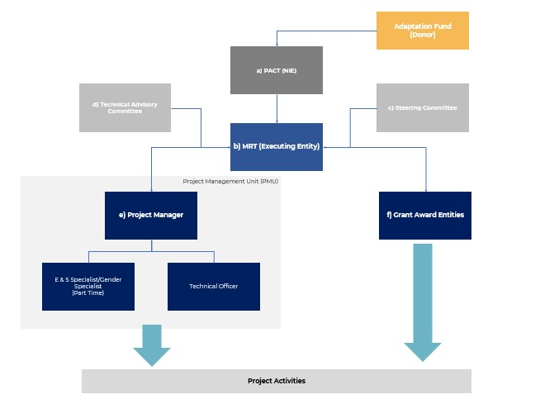

Figure 5: Governance.

Describe the measures for financial and project risk management.

The project’s funds will be administered by PACT, with disbursements requested by the MRT PMU. At all times during implementation, PACT will have custody of project funds in a (separate) project account, and these will only be disbursed for prior approved activities. The PMU will keep expenditure and commitments tracking, and a reconciliation with the project account will be made and reported in Quarterly Reports. Additionally, an annual independent audit will be conducted after the end of each Financial Year; the independent auditor will be retained throughout the project implementation period. Figure 3 details the project flow of Funds.

Project management Risks
Activity | Risks | Impact | Probability | Mitigant
Procurement | - Lack of sufficient tenders in procurement processes.  - Contracts awarded to prohibited parties.  - Lack of detailed specifications in TOR. | High | medium | - PACT will announce the project and activities soon after AF approval via video conference to describe the project and generate interest.  - MRT PMU, when onboarded, will provide video conferences prior to each procurement, detailing the assignment.  - Procurement opens to international firms, publishing in UNDB.  - Consortium of firms or subcontracting allowed.  - Budget guidance included in the ToRs.  - Detailed specifications provided by the Project Technical Committee.
Call for Proposals | - Budget insufficient to accommodate engagement.  - A low number of NGOs are interested in sending proposals.  - Low quality proposals (no indicators, or ex-ante stakeholder engagement). | High | Medium | - Entities seeking grants must show evidence in their proposal of prior community engagement.  - MRT PMU Environmental, Social & Gender Specialist will coordinate meetings with village leadership and other stakeholders for those entities seeking grants to interview communities.  - Belize has no less than 17 NGOs with grant mobilization experience in the project areas.
Contract Management | - Non-compliance by contractors | Medium | Medium | - MRT PMU and PACT will ensure legal recourse in the contracts to ensure compliance.  - MRT PMU Project Manager will be an experienced professional with technical knowledge in development projects that involve construction.
Project Account | - Inadequate custody of project funds | High | Low | - All disbursements from the AF will be made into a specific Project Account, established in a Deposit Taking institution regulated by the Central Bank of Belize.
Disbursements | - Know your customer.  - Approvals | Medium | Medium | - All payments will be made by PACT.  - All payments will be done through Bank-to-Bank transfers.  - All contract awards will require submission of identification of final beneficiaries and bank accounts.  - Two-step payment request, by memo by MRT PMU Manager to PACT.
Accounting Expenditures | - Inability for project expenditures to reflect cash accounts | Low | Low | - Expenditures will be debited from committed fund by MRT PMU.  - Budget tracking by MRT PMU.  - PACT will draw down cash from Bank accounts, monthly reconciliation.  - Annual audits.
Fund Management | - Misappropriation of project funds | Low | Low | - Project account audited annually.  - All disbursement will be approved by both MRT PMU and PACT.
Data Management and Adaptive Decision-Making | - Limited knowledge and understanding of the nature based and socio-economic context of the project activities by the targeted beneficiaries  - Delays or errors in data processing and analysis impede timely decision-making.  - Low community participation in data monitoring weakens data quality and relevance.  - Insufficient integration of local knowledge and scientific data reduces effectiveness of interventions | High | Medium | - Rigorous training of local volunteers for community – based ecological monitoring to ensure continuous, quality collection.  - Centralized digital information system with GIS, remote sensing, and analytics to maintain data integrity and accessibility accessible to all relevant stakeholders  - Regular participatory data review workshops involving community members, indigenous leaders, and technical experts to enhance date interpretation and foster co-created solutions.  - Integration of a data-driven decision-making approach, centered on community involvement, buy-in and inclusion in the decision process.
Table 10: Risks and mitigants in project management and implementation.
Procurement

The project aims to mobilize project funds through, fair, value based, and transparent allocations. Except for the Project Manager, all procurement will be managed by the MRT PMU in collaboration with PACT. All procurement will be carried out using PACT’s Procurement Policies and Procedures Manual.

Definitions:

Method | Description | Threshold  (US$) | Type | No. Processes
QCBS | Quality Cost Based Selection | Over 50,000 | Consultants / Services | 4
CQS | Consultants Qualification Selection | Up to 50,000 | Consultants / Services | 2
LCS | Least Cost Selection | Up to 25,000 | Consultants / Services | 5
ICB | International Competitive Bidding | Over 50,000 | Works, goods, non-consulting services | 1
NCB | National Competitive Bidding | Over 15,000 | Works, goods, non-consulting services | 1
IC | Individual Consultants | Up to 22,500 | Consultants / Services | 0
S | Shopping | Up to 15,000 | Works, goods, non-consulting services | 5
Sub-Total Procurement Processes |  |  |  | 18
Table11: Definitions of procurement methods

Descriptions:

Quality Cost Based Selection: Two-step process, firms must respond to an Expression of Interest (EOI) for pre-qualification, those that pre-qualify are invited to respond to a Request for Proposal (RFP) through a letter of invitation. Technical and Financial proposal are submitted separately, Technical Proposals are evaluated and ranked and only the Financial Proposal of top ranked consultants are evaluated.
Consultants Qualification Selection: Two-step process, firms must respond to an EOI for pre-qualification, and then are invited to respond to an RFP through a letter of invitation. Technical and Financial proposal are submitted separately, Technical Proposals are evaluated and ranked and only the Financial Proposal of top ranked consultants are evaluated.

Least Cost Selection: Two-step process, consultants respond to RFP, submitting technical and financial envelopes separately. Only the Financial Proposal of those consultant’s proposal that pass a minimum technical threshold are opened.

International Competitive Bidding: Two-step process, a) prequalification, and b) invitation. Firms must prequalify to receive bidding documents, which will include design studies and indicative budget. Prequalification should include track record, assets, prior work experience. Guarantees may be requested and should be published in international sites such as UNDP.

National Competitive Bidding: Two-step process, a) prequalification, and b) invitation. Firms must prequalify to receive bidding documents, which will include design studies and indicative budget. Prequalification should include track record, assets, prior work experience.

Individual Consultants: Publishing of process through PACT website and other mediums of EOI to receive CVs (or Proposals) of potential consultants. CVs (or Proposals) are evaluated on at least three options. Top ranked consultant is selected.

Shopping (Quotations): Several quotes for the same service or goods is evaluated, and best option in terms of price and value is selected. Process must be fully documented.

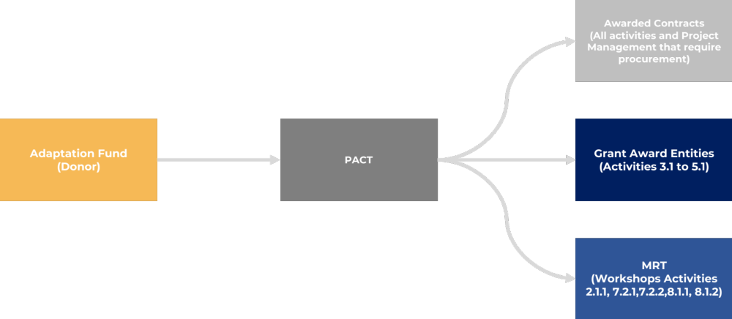
Figure 6: Flow of funds
Procurement Plan

Project Management Procurement

Activity | Contract | Tender | Type | Total Budget (USD) | Implementation Year / Quarter
Contract with Project Manager | Individual Contract (Full Time) | Yes | Quality Cost Based Selection | 135,000 | Y1 Q2
Contact with Environmental, Social & Gender Specialist | Individual Contract (Part Time) | Yes | Quality Cost Based Selection | 36,000 | Y1 Q3
Technical Officer | Individual Contract (Full Time) | Yes | Quality Cost Based Selection | 81,000 | Y1 Q2
Project Auditor | Professional Services Contract | Yes | National Competitive Bidding | 34,000 | Y1 Q4
PMU (PC, Cell) ** | Goods/Services | No | Shopping | 19,800 | Y1 Q2
Marketing & Communication*** | Goods and Non-Consulting Services | No | Shopping | 1,950 | Y1 Q2
Mid Term Evaluation Firm | Professional Services Contract | Yes | International Competitive Bidding* | 18,000 | Y2 Q3
Baseline Report | Professional Services Contract | Yes | International Competitive Bidding* | 15,000 | Y1 Q1
Final Evaluation Firm | Professional Services Contract | Yes | International Competitive Bidding* | 18,000 | Y2 Q3
Sub-Total Project Management |  |  |  | 358,750

Table12: Project Management Procurement
*If the same firm is selected to undertake both the Mid and Final Evaluation, International Competitive Bidding applies, otherwise National Competitive Bidding.

PMU IT/Office Admin includes: one laptop PC and cell phone service/credit during implementation, for each PMU member with travel milage coverage when working outside duty station. Under this, stationary supplies for the PMU will also be covered.
Also Marketing & Communication: Includes a) project signage, b) and b) graphic design for project identity.

Component 1 Procurement
Activity | Execution | Tender | Type | Total Budget (USD) | Implementation Year / Quarter
Activity (1.1.1) Contract with Firm or Consortium with expertise on solar water system in Belize, experience working with Toledo and Corozal District to design water system for each of the Communities. | Engineering Firm (s) and or Engineering Consortium (QCBS)/ Construction Firm (ICB) | Yes | Consultancy Services | 3,313908 | Y1 Q4
Activity (1.1.2) Firm contracted in 1.1.1 will undertake a consultative approach to develop each water system, and in the design and build, will specify the local skill available that could be included in the construction of the system. , undertake a series of workshops with specific training to women in construction skills. | Engineering Firm (s) and or Engineering Consortium (QCBS)/ Construction Firm (ICB) | Yes | Consultancy Services | - | Y1 Q4
Activity (2.1.1.) MRT workshop to constitute Water Board for water systems management. | MRT PMU (EE) | No | Works, Goods, and Non-Consulting Services | 16,400.00 | Y1 Q1
 | : Workshop venue rental, catering. (S)
Activity (2.1.2) Provide maintenance and trainings materials, along with capacity building to the communities (Councils, waterboards, and MRT officers) on the built systems. | Engineering Firm (s) and or Engineering Consortium and/or Qualified equipment supply firm. (LCS)* | Yes | Consultancy Services | 65,600.00 | Y4 Q1
Sub Total Component 1 |  |  |  | 3,395,908
Table13: Component 1 Procurement.
*Procurement for Activity 2.1.2 may be included in Activity 1.1.2 tender process and procured as ICB. 1
Component 3 Procurement
Activity | Execution | Tender | Type | Total Budget (USD) | Implementation Year / Quarter
Activity (6.1.1) Tender a contract for a stakeholder engagement firm to develop and implement a gender-sensitive campaign & survey, both in terms of format (languages, media) and content (climate change differentiated impacts on men and women), on the impacts of climate change on water sustainability. | Consultancy, experienced in stakeholder communication and engagement. | Yes | Consultancy Services (QBS) | 30,000.00 | Y3 Q1
Activity (7.1.1) Tender a contract for firm for the development of training materials on inclusive governance covering gender equality principles, recognizing women's rights and the importance of women's participation in project leadership positions | Consultancy (or consortium), experienced in community organizations, governance, in health and gender inclusiveness. | Yes | Consultancy Services | 24,000.00 | Y4 Q1
 |  | Yes | (QBS) | 24,000.00 | Y4 Q1
Activity (7.1.2.) Tender a contract for firm for the development of training of village schoolteachers in the four communities on WASH with a gender perspective, along with the provision of visual reference materials to be posted in school grounds. | Consultancy (or consortium), experienced in community organizations, governance, in health and gender inclusiveness. | Yes | Consultancy Services | 10,500.00 | Y4 Q2
 |  | Yes | (LCS) | 10,500.00 | Y4 Q2
Activity (7.2.1) MRT will summon interested nearby project communities to a one-day field workshop to understand the relevance of the impact of climate change i on water. | Consultancy (or consortium), experienced in climate change impacts in Belize, Central America, and the Caribbean. | Yes | Consultancy Services | 1000 | Y4 Q1
 |  | Yes | (LCS) | 1000 | Y4 Q1
 | MRT PMU (EE): Workshop venue rental, catering, transportation for community members | No | Works, Goods, and Non-Consulting Services (S) | 3,500.00 | Y4 Q3
Activity (7.2.2) MRT will summon interested nearby communities to a one-day field workshop to understand the relevance of the inclusive governance and water systems maintenance. | Consultancy (or consortium), experienced in climate change impacts in Belize, Central America, and the Caribbean. | Yes | Consultancy Services (LCS) | 1000 | Y3 Q3
 | MRT PMU (EE): Workshop venue rental, catering, transportation for community members | No | Works, Goods, and Non-Consulting Services (S) | 3,500.00 | Y3 Q3
Activity (8.1.1) Tender for a consultancy firm to conduct capacity-development seminars, including workshops for the MRT's regional and field officers to mainstream gender within their day-to-day activities, Water Board management and interaction, and maintenance of water systems (including solar / hybrid systems). | Consultancy (or consortium), experienced in inclusive governance, gender, and water systems. | Yes | Consultancy Services (LCS) | 18,000.00 | Y2 Q1
 | MRT PMU (EE): Workshop venue rental, catering. | No | Works, Goods, and Non-Consulting Services (S) | 3,750.00 | Y2 Q1
Activity (8.1.2) Tender for a consultancy firm to conduct capacity-development of the broad MRT on gender equality and women’s rights, climate risks and adaptation measures, and governance. | Consultancy (or consortium), gender, and climate change. | Yes | Consultancy Services (LCS) | 14,000.00 | Y3 Q2
 | MRT PMU (EE): Workshop venue rental, catering. | No | Works, Goods, and Non-Consulting Services (S) | 600 | Y3 Q2
Sub Total |  |  |  | 109,850

Table14: Component 3 Procurement

Project Implementation Plan

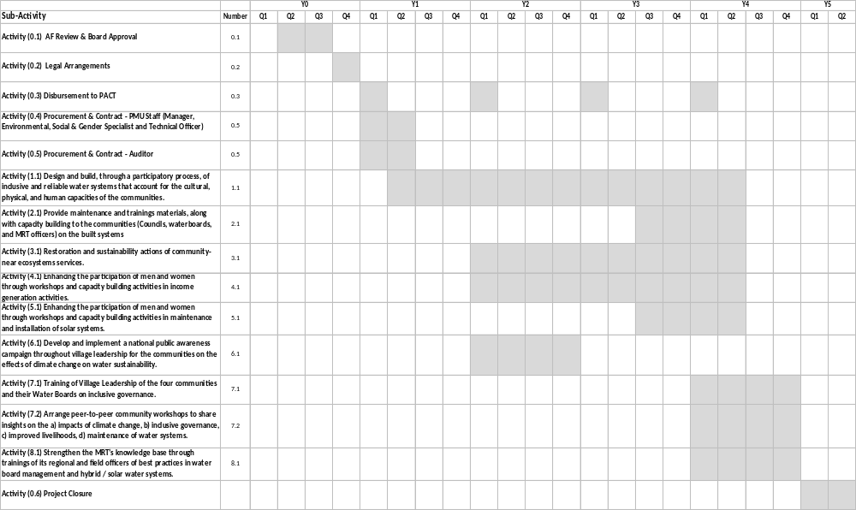
Table 15 : Implementation Schedule

Describe the measures for environmental and social risk management, in line with the Environmental and Social Policy and Gender Policy of the Adaptation Fund.

The proposed project has been assessed as a Category B project given the low to minimal risk posed to the communities and natural environment in which the project interventions are proposed. A comprehensive assessment of environmental, social and gender risk demonstrates the project is expected to yield an overall positive environmental and social benefits by developing a water supply and distribution system to provide safe, sufficient, and year-round potable water to four communities. The project aims to address the full water cycle including water shed management measures; capacity building to enhance sanitation practices to address water contamination; extraction and distribution; as well as innovative approach to wastewater use. The project anticipates a reduction in the vulnerability of men, women and children to incidences of water-borne, food borne, and vector borne diseases in addition to communicable and non-communicable diseases. Thus, making critical achievements in improving wellness and quality of health to the community. To further safeguard any non-compliance by contractual actors (awarded contracts or grants) the project contemplates two part-time officers a) and Environmental, Social & GenderSpecialist. While these add to the overall project management cost, they are inherently necessary to ensure project activities are carried out according to best practices.

Appropriate mitigation measures have been developed for those minimal adverse risks that have been identified. The environmental risk classification is low. The key environmental risks that were identified include (i) nuisance related to noise and air emissions from construction of the water system; (ii) occupational health and safety of workers and supervisors of infrastructure works; and (iii) community health and safety.

The social risk classification is also low. The key social risks include: (i) there are risks for discrimination in employment opportunities, (ii) Gender disparities inhibiting access to potential economic or social benefits and leadership roles, (iii) capacity issues of the various stakeholders, (iv) cultural understanding and protocol requirements when working with indigenous communities.

PACT will be the national implementing entity and is well versed in working with AF safeguards. It will be responsible for the oversight of the environmental and social risk management by the MRT PMU during the SEAM Project’s entire four-year implementation. The MRT PMU will ensure, at all times, that the mitigation measures included herein are adhered to, including compliance with the law, relationship between contractors and other stakeholders with the communities, and observance of any requirement that may be imposed by other governments of local entities. A part-time E&S Specialist will be part of the MRT PMU, who will have responsibility for evaluating and ensuring compliance. The PMU MRT will manage all project components and prepare the necessary procedures, assessments, mitigation measures and monitoring actions to ensure that the potential environmental and social risks and impacts are adequately addressed in a manner acceptable to the AF.

PACT will oversee that the Project Manager and MRT, will manage all project components and prepare the necessary procedures, assessments, mitigation measures and monitoring actions to ensure that the potential environmental and social risks and impacts are addressed according to PACT, AF and international standards.

SEAM will incorporate specific gender actions to ensure that women benefit fully from all the Project's components including technical assistance, potential employment during construction, leadership possibility with the Water Boards and solar maintenance. SEAM implementation strategy includes identification of gender gaps to be addressed; integration of gender responsive approach at all levels of implementation; gender- sensitization training for staff in participating institutions; inclusion of specific activities for women to obtain project services and resources, and mechanisms for addressing identified gender gaps.

Feedback from consultations made at different levels during the project cycle will inform the on-going project design process, improve implementation efficiency, and ensure that the project has an effective exit strategy. The project will ensure that the consultation platforms provided are well facilitated through technical support from experienced professionals and provide enough time and resources for stakeholders to give feedback. During consultations, feedback will be gathered and will be designed to receive complaints as well as feedback. The PMU will be the main entity responsible for receiving feedback and ensuring that issues raised are addressed. Before the end of the project, there will be a workshop to reflect on the lessons learned from the project, synthesize them, and share them with relevant stakeholders. This helps to ensure that the experience and learning from the project will not be lost once the funding runs out. This will also facilitate replicating and scaling up the project. The project will establish a community level organization to oversee some of the project’s activities, and this organization will continue after the project. Establishing and/or working through existing community institutions is a good way to encourage sustainability. If new institutions are created, to the extent possible, they should build on or be connected to existing community organizations, committees, or institutions. The project places strong emphasis on data-based decision-making to enhance the project’s innovation and ensure adaptive, evidence-driven implementation. Although the initial proposal provides limited detail, the project incorporates a comprehensive data management process that informs all phases of innovation design and execution. Firstly, baseline data collection is conducted through integrated hydrological assessments, water quality monitoring, biodiversity surveys, and socio-economic profiling within target communities. This data establishes a clear understanding of current ecosystem conditions, water resource availability, and community vulnerabilities. To capture dynamic environmental and social changes, the project implements community-based ecological monitoring programs, training local volunteers to collect ongoing data on key indicators such as water flow, native species health, and land use changes. All collected data feeds into a centralized, digital information system managed by the executing entity, which utilizes GIS mapping, remote sensing, and data analytics tools to visualize trends and identify priority intervention areas. This system supports scenario modelling and risk assessment, enabling the project team to tailor ecosystem restoration techniques and water system designs to site-specific conditions. Importantly, data interpretation and decision-making are participatory processes. Regular data review workshops with community members, Indigenous leaders, technical experts, and governance bodies ensure that local knowledge complements scientific findings, fostering co-creation of innovative solutions. These workshops also serve as feedback loops to refine project strategies based on monitoring results. Furthermore, the project’s results framework integrates data-driven indicators for tracking progress on innovation outcomes, such as system performance, biodiversity recovery, and livelihood improvements. This enables adaptive management, where interventions are adjusted in response to empirical evidence, ensuring sustained innovation impact.

The MRT's capacity to manage environmental and social risk will be strengthened via: (1) training MRT Regional and Field Officers, (2) PMU will hire an environmental and social specialist with expertise in environmental and social risk assessment and management, a gender specialist with experience with the Maya culture, and (3) seek technical support from the Ministry of Sustainable Development, Climate Change and Disaster Risk Management, which has experience in managing such water distribution projects.
Adaptation Fund ESP Principle | Potential Risks / Impacts Identified | Mitigation Measures | Responsible Party | Monitoring Indicators | Reporting Frequency
1. Compliance with National Laws | No Risk  There are no risks posed to the provisions of national and international legislation. The proposed project will ensure compliance with all relevant national legislations and international laws. | - The Project will ensure compliance with all relevant national and international law, through PMU oversight and awarded contracts.  - Contracts with consultants and Grant Award Entities will include standard provisions to ensure compliance with national legislation and international standards.  - The PMU will have a part time E&S specialist to provide oversight of compliance with national law, PACT’s E&S Safeguards and ensure AF standards are upheld. | Project Management Unit (PMU), EE,  E&S specialist | Permits secured; compliance audit reports | Quarterly
2. Access and Equity | Low Risk  Potential Risk – given budget restrictions, not all households within the community may be provided with clean water voiding Principle 2 of the AF. This risk has been taken into consideration during the initial design and  budgeting process. The project will not compromise the target community’s access to health services, clean water and sanitation, energy, education, housing, safe and decent working conditions, and land rights.  Potential Risk – only a few members of the community will benefit from the livelihood ventures to be adopted. The project will ensure that all members of the community are engaged for the selection and implementation of all livelihood ventures to ensure equitable inclusion via a participatory process. | •The project design and oversight will ensure that its benefits are being distributed fairly and encourage equity, non-discrimination and provide equal access opportunities to all.  •All the water distribution system infrastructures will be subject to competitive procurement under PACT’s Procurement Guidelines.  •The Project has been designed and budgeted for every household to receive piped, potable water to their homes.  •The alternative livelihood program will be designed to ensure all members of the community are engaged in the selection and implementation. To ensure equitable inclusion via a participatory process meeting will be available to all villagers – supported by providing meetings separated by gender (when culturally appropriate) to enhance women’s participation – especially in decision making processes.  •Practical solutions will be used to increase participation such as provision of childcare if needed and drinks and snacks. The program activities will be guided by each communities’ individual priorities.  •MRT will receive gender sensitization training as part of its capacity building.  •Training and support from the PMU Gender Specialist, and Grant awardees aim to enhance women’s voices being heard, self-advocacy for gender inclusion, and equitable access to decision making processes.  •The project targets specific areas to increase women’s participation such as training and participation on the Water Boards and solar maintenance training for women.  •The project activities will be designed to enhance engagement by working with community indicated scheduling, providing childcare to increase participation and providing gender separated activities when culturally helpful | Community Engagement Team (FIRM) | Number and diversity of participants engaged | Bi-annual
3. Marginalized and Vulnerable Groups | Low Risk  Potential Risk – the special needs of marginalized and vulnerable groups are not considered, thereby disenfranchising selected community members. Through the EE’s continuous work with the target communities, the needs of marginalized and vulnerable groups have been integrated during the design and risk management solutions will be executed during the implementation of the project. The project’s actions have been formulated with the above in mind, thereby minimizing unequal access to a basic need.  Furthermore, the project will not impose any disproportionate adverse impacts on marginalized and vulnerable groups including children, women and girls, the elderly, indigenous people, tribal groups, displaced people, refugees, people living with disabilities, and people living with HIV/AIDS.  Potential Impact to Indigenous communities is further examined under Principle 7. | •The project beneficiaries encompass the village community. The project area in the Toledo district is amongst the most impoverished areas of Belize.  •Drawing on lessons learned from other projects in the Toledo district, there have been specific measures to be gender and youth inclusive – in addition to working in the native language and familiarity with the Maya cultural, gender separation for meetings, community led meeting times and childcare or child friendly provisions.  •The MRT Field Officers, drawing on long established relationships with the communities, speak their native language and have a strong cultural understanding of the needs of these groups will enhance inclusion.  •PMU Gender Specialist will oversee Project implementation is gender-responsive and inclusive to all the community.  •MRT Field Officers will be trained in gender mainstreaming and sensitized on gender equality and women’s rights to further enhance a gender-responsive project implementation.  •Through the inclusive village consultation process gender separated surveys, the update of village profiles, the project will remain inclusive within the village context and inputs. | PMU, E&S specialist | Participation rates of marginalized groups | Quarterly
4. Human Rights | No Risk  The proposed project will respect and adhere to all relevant national legislation and international conventions on human rights and will not violate any pillar of human rights. | •The project is designed to respect and adhere to the requirements of all relevant national legislation and international conventions on human rights.  •The AF and PACT is committed to support good international practices by supporting the realization of United Nations principles expressed in the Universal Declaration of Human Rights and the toolkits for mainstreaming employment and decent work.  •This project is particularly committed to support General Assembly resolution 58/217, passed in 2004, which stresses that "water is essential for sustainable development, including environmental integrity and the eradication of poverty and hunger, and is indispensable for human health and well- being". | PMU, Legal Advisor | FPIC documentation; grievances received and resolved | Ongoing
5. Gender Equality and Women’s Empowerment | Low to Moderate Risk  Potential Risk – women from the target communities are not engage effectively throughout the project. The project will respect the rights of women and indigenous women, thereby contributing to the gender equality and women’s empowerment. The unique characteristics of Indigenous women will be taken into consideration from the project design phase. The EE will work with the village Alcaldes and Community Leaders to further engage women in the project implementation. Targeted consultation with indigenous women will be held to ensure that gender considerations for participation in the project activities are integrated. The project will promote the equal participation of men and women, leading to inclusive participation. All actions will respect the rights of Indigenous Women. | - The project provides for specific activities for women:  - (i) strengthening their awareness about: the value of clean water to the health and wellbeing of their households; health and sanitation, including the contamination of current sanitation practices and the importance of adapting alternatives; impact of water conservation (ii) technical training on solar maintenance; (iii) the integration of women into the decision-making bodies of Water Boards and other village organizations stemming from the Project and encouraging them to create autonomous organizations.  - The indicators for the project's monitoring-evaluation system are gender disaggregated: (i) specific targets of 50% for women in Water Boards, 30% of women in activities related to the livelihoods and watershed programs, and 40% for young people (40% of whom are young women) have been set in the project's logical framework.  - The project will recruit an international expert specifically in charge of gender and social inclusion.  - The unique characteristics of Indigenous women have been taken into consideration from the project design phase and peer exchanges with other projects in the districts will increase their engagement.  - The MRT FOs, after receiving gender sensitization training will work with the village Alcaldes and Community Leaders to convey the importance of women’s involvement and further engage women in the project implementation.  - Facilitate in the inclusion of women in project activities through various measures such as transportation to worksite and having culturally appropriate provisions.  - Provide childcare services to enable women to attend meetings and training workshops.  - Targeted consultation with indigenous women will be held to ensure that gender considerations for participation in the project activities are integrated.  The Contractors for the construction of the water distribution systems will be encouraged to promote the hiring of women, and training of women from the communities will be required. preferably aiming to hire a minimum 15% female staff in the construction sector. | PMU, E&S specialist | % female representation; training attendance | Quarterly
6. Core Labour Rights | No Risk  The proposed project will adhere to core national and international labour laws and rights of all parties. | - The project will fully comply with relevant national and international labor laws and rights guided by the ILO labor standards throughout implementation.  - The construction contractors will comply with the requirements relating to the safety of workers in accordance with ILO Convention No. 62 as far as they are applicable to the project.  The Contractors will have ToR that give priority to hiring labor from the surrounding areas to avoid the need for temporary workers’ camps. | Contractors, PMU | Labor audits; incident reports | Quarterly
7. Indigenous Peoples | Low to Moderate Risk  Potential Risk – Shift in traditional norms linked to introduction of new practices and technologies to Indigenous communities. The project will respect the right of the Indigenous communities in line with national and international legislations and convention. As many of the target communities are Indigenous, the EE has established and will continue to maintain a beneficial working relationship with the communities in Belize. These communities have been engaged by the EE resulting in the identification of potable water needs in the selected communities and an assessment of current water utilization. Through its work with these communities, the EE will ensure that the rights and cultural norms/values of the communities are respected during the design and implementation of the project. Community Leaders, Alcaldes and Community members will be continuously engaged in the design and implementation of the project. The participatory governance approach to project implementation will ensure that the communities are involved in the decision-making process and that their priorities and needs are fully considered. The project will ensure that Free, Prior and Informed Consent is obtained from the Alcalde’s and members of Indigenous communities. The latter will also be aligned with the protocols established under PACT’s Indigenous Peoples Policy.  Furthermore, the EE and AE will utilize the existing communications protocols and structures established to consult with Indigenous communities for the design and implementation of the project. The Belize National Indigenous Council (BENIC), the Maya Leader’s Alliance, Toledo Alcaldes Association, Norther Maya Association of Belize National Association of Village Councils (NAVCO) and District Association of Village Councils (DAVCO) will also be engaged throughout the process. | - The “Maya of Southern Belize Free Prior and Informed Consent Protocol” outlines indigenous peoples rights and protocol for engagement.  - Maya customary land tenure exists in the entire Toledo District and gives rise to collective and individual land rights within sections 3d) and 17 of the Belize Constitution. As such, Mayan land in the Toledo district is attributed with all the elements of private property and its protection within the meaning of the Belize's property laws. In complying with this PS, PACT and its clients must also comply with this decision.  - Similarly, Belize's international obligations to protect and recognize the rights of indigenous peoples under the Universal Declaration of Human Rights, the Convention on the Prevention and Punishment of the Crime of Genocide, the International Covenant on Civil and Political Rights, the Convention on the Elimination of All Forms of Racial Discrimination, and the Convention on the Rights of the Child and the United Nations Declaration on the Rights of Indigenous Peoples must be complied with as well.  - Belize Constitution support indigenous rights as follows:  - Section 3(d) and 17 in the Constitution.  - This was used in the 2007 Supreme Court ruling, declaring that Maya customary land tenure exists in all Maya villages in the Toledo District and where it exists, gives rise to collective and individual property rights.  - Belize Constitution – PREAMBLE  - States that Indigenous peoples in Belize are duly recognized by the Belize Constitution and are guaranteed the same fundamental rights and freedoms as all other citizens.  - In addition to the Belize Constitution, Belize has subscribed to international conventions which have a bearing on the protection and well-being of Indigenous Peoples:  - United Nations Declaration on the Rights of Indigenous Peoples (signed September 2007)  - International Covenant on Economic, Social and Cultural Rights (ratified in 2015)  - International Covenant on Civil and Political Rights (ICCPR) (ratified in 1996)  - International Convention on the Elimination of All Forms of Racial Discrimination (ICERD) (ratified 2001)  - Expressed support for the Universal Declaration of Human Rights  - The Convention on the Prevention and Punishment of the Crime of Genocide  - The Convention on the Rights of the Child  - SEAM must comply with the AF Policies, including Principle 7, indigenous peoples, for AF-funded projects.  - PACT’s ESMF, which adopts the eight Performance Standards (PS) of the International Finance Corporation, of which, PS 7 Indigenous People, also require all PACT projects to comply with these standards.  - Free, Prior and Informed Consent is a standard requirement for PACT's actions, projects, programs, and investments that may involve or affect indigenous people.  - The risk of adversely impacting traditional norms through the introduction of new practices to Indigenous communities will be addressed through working with the field officers that have a long-term relationship with the communities, know the culture, and speak their language. Additionally, the NGOs that will be working with the alternative livelihood and watershed management aspects are well versed in their respective regions. The solar training will be done with a Maya female solar engineer that has worked with various maya communities.  - The project will respect the right of the Indigenous communities in line with national and international legislations and convention.  - Additionally, the communities have requested a water distribution system repeatedly.  - Through its work with these communities, the EE will ensure that the rights and cultural norms/values of the communities are respected during the design and implementation of the project.  - Community Leaders, Alcaldes and community members will be regularly engaged in the design and implementation of the project. The participatory governance approach to project implementation will ensure that the communities are involved in the decision-making process and that their priorities and needs are fully considered.  - The three indigenous communities have signed FPIC consents for the projects after multiple consultations and fully understanding the components of the If changes are made to the project, Free, Prior and Informed Consent will be obtained accordingly.  - Furthermore, the EE, PACT and others involved with project training will utilize the existing communications protocols and structures established to consult with Indigenous communities for the design and implementation of the project.  - The Belize National Indigenous Council (BENIC), the Maya Leader’s Alliance, Toledo Alcaldes Association, Norther Maya Association of Belize National Association of Village Councils (NAVCO) and District Association of Village Councils (DAVCO) will also be engaged throughout the process project. | Project Management Unit (PMU), EE, E&S specialists | TEK integration; consultation records | Bi-annual
8. Involuntary Resettlement | No Risk  No project actions will involve any voluntary or involuntary resettlement of communities. | •The project activities will not involve involuntary or voluntary resettlement. | PMU, Environmental & Social Specialist | RAP implementation status: compensation provided | As needed
9. Protection of Natural Habitats | Low to Moderate Risk  The project will respect the rights of habitats that are recognized as protected by traditional or Indigenous local communities. Through consultations critical habitats will be identified with the help of community leaders and members. The project activities have been formulated based on the ecological functionality of watersheds. Therefore, the actions for restoration and alternative livelihoods will be designed to avoid any negative risk to natural habitats. PACT’s Policy on Natural Habitats and Biodiversity as well as national legislation for the protection of the natural environment will be adhered to.  During the implementation of the proposed project, prior to the selection of water extraction point, the Department of Hydrology in conjunction with the EE and the Ministry of Health and Wellness will conduct assessments of potential water sources to determine appropriate water extraction points and determine the volume of water that can be safely extracted to meet community supply needs | - The project will respect the rights of habitats that are recognized as protected by traditional or Indigenous local communities.  - Critical habitats will be identified with the help of community leaders and members.  - The project activities have been formulated based on the ecological functionality of watersheds. Therefore, actions for restoration and alternative livelihoods will be designed to avoid any negative risk to natural habitats.  - Restoration and conservation activities will take place on land either previously or currently used for agriculture, none of the protected areas will be affected negatively by project activities.  - PACT’s Policy on Natural Habitats and Biodiversity as well as national legislation for the protection of the natural environment will be adhered to.  - During the implementation of the proposed project, prior to the selection of water extraction point, the Department of Hydrology in conjunction with the MRT and the Ministry of Health and Wellness will support the system design firm to assess of potential water sources to determine appropriate water extraction points and determine the volume of water that can be safely extracted to meet community supply needs.  - The feasibility of water extraction methodologies will be further determined during the project implementation phase.  The project will identify the national critical habitat areas and monitor that the project implementation will not encroach or affect them in any way. | Technical Officer | Habitat condition monitoring reports | Quarterly
10. Conservation of Biological Diversity | Low to Moderate Risk  Potential Risk – Introduction of non-native species during reforestation activities. The project will avoid the introduction of non-native and invasive species to target reforestation areas. An assessment of local biodiversity will be used to guide the selection of species for the restoration activities. PACT’s Policy on Natural Habitats and Biodiversity as well as national legislation and international conventional to which Belize is a Party will be adhered to. | - The project will be in line with the Government's priorities in the Intended Nationally Determined Contributions (INDC) which focus on reducing vulnerability to droughts, protection against increasing the average sea level, increasing access to water, protecting biodiversity and building the resilience of rural people.  - Belize, ratified the Convention on Biological Diversity in 2013, will implement the Project in accordance with the texts adopted pursuant to the CBD on the protection of biodiversity as well as the National Biodiversity Strategy and Action Plan.  - The project will avoid the introduction of non-native and invasive species to target reforestation areas.  - An assessment of local biodiversity will be used to guide the selection of species for restoration activities.  PACT’s Policy on Natural Habitats and Biodiversity as well as national legislation and international conventional to which Belize is a Party will be adhered to. | Technical Officer | Biodiversity indicators; restoration success rates | Bi-annual
11. Climate Change | Low to No Risk  The activities included within the project will not contribute to negative climate impacts nor will it contribute any significant emission of greenhouse gases. The proposed project activities will enhance the ability of the target communities to adapt to anticipated climate change impacts. | - The project will contribute to Belize’s climate change adaptation and mitigation efforts. The project, in no way, intends to increase greenhouse gas emissions.  - The proposed project activities will enhance the ability of the target communities to adapt to anticipated climate change impacts.  - Ecosystem restoration through reforestation, mangrove rehabilitation and riparian forest management practices will include climate adaptation measures for the communities’ attention to watershed management.  - Renewable energy, through solar systems, will be utilized, with Copper Bank relying on grid energy as a backup system at night.  - Project activities will be aligned with Belize’s national climate change policies and strategies.  With the understanding of Belize’s vulnerability to hurricanes, high winds and flooding the water distribution systems will be constructed with hurricane resistant design features and be constructed away from flood zones. | PMU, EE | Climate risk assessments; adaptive management actions | Annual
12. Pollution Prevention and Resource Efficiency | Pollution Prevention and Resource Efficiency  Low to No Risk  The activities included within the project will not contribute to negative climate impacts nor will it contribute any significant emission of greenhouse gases. The proposed project activities will enhance the ability of the target communities to adapt to anticipated climate change impacts. | - The project will utilize renewable energy through implementation of a solar energy system to operate the water pumps.  - The project will produce minimal waste from the construction of water systems and will have a waste management and sanitation solution designed for workers during the implementation stage. An effort will be made to reuse or salvage waste materials.  - The waste produced will be disposed of as mandated by the laws of Belize including those included in the Environmental Protection Act.  The project will not release pollutants. | PMU, Contractors | Waste disposal records; pollution incident reports | Quarterly
13. Public Health, Safety, and Security | Low to No Risk  The activities included within the project will not contribute to negative climate impacts nor will it contribute any significant emission of greenhouse gases. The proposed project activities will enhance the ability of the target communities to adapt to anticipated climate change impacts. | - The project is expected to have a positive impact on public health, with improved access to water and improved hygiene practices.  - Relevant national standards and protocols will be adhered to in an effort to avoid the distribution of water that is deemed unsafe.  - Communities and local Water Boards will be trained on protocols included in the Operations and Maintenance Manual of Rural Water Systems developed in conjunction with the Ministry of Health and Wellness of Belize.  - The project will work to reduce COVID – 19 associated risks by following international and WHO standards.  Should large public gatherings not be possible, then suitable alternatives will be sought that are in compliance with best practices in reducing the risk of infection. | Technical Officer  Project Management Unit (PMU), EE | Water quality test results; safety incident reports | Quarterly
14. Land and Soil Conservation | Low Risk  Potential Risk – Selected alternative livelihood actions can pose potential negative impacts on land and soil conservation. The project will ensure that selected alternative livelihood options selected do not result in any negative impacts to lands and soils. Any livelihood actions involving agricultural actions will be sure to adhere to the principles of sustainable agriculture with a climate change focus. The activities under component 2 for reforestation will be sure to avoid any further potential damage to the ecological functionality of the system. | - The project aims to implement watershed management activities which are to include the conservation of soil erosion, restoration of the riparian buffer, mangrove rehabilitation and other land conservation measures.  - The activities under component 2 for reforestation will avoid any further potential damage to the ecological functionality of the system.  - Awareness raising and training on watershed restoration and management will be undertaken.  Selected alternative livelihood actions can pose potential negative impacts on land and soil conservation. The project will ensure that selected alternative livelihood options do not result in any negative impacts to lands and soils. Any livelihood actions involving agricultural actions will be sure to adhere to the principles of sustainable agriculture with a climate change focus. | Technical Officer | Soil quality monitoring; erosion control effectiveness | Bi-annual
15. Cultural Heritage | Low to No Risk  The project will pose no risk to physical and cultural heritage. Consultations will be held with community leaders and members to identify physical and cultural heritage present in the project site. The project will be designed to avoid any potential impacts to heritage in the area. Protocols established by the National Institute of Culture and History (NICH) will be adhered to as well as the principles of PACT’s Policy on Physical and Cultural Resources. | - The project will be in compliance with the law on archaeological heritage preservation.  - Consultations will be held with community leaders and members to identify if there are any physical and cultural resources in the project site.  - The project will be designed to avoid any potential impacts to heritage in the area.  - If archaeological sites, historical sites, remains and objects, including graveyards and/or individual graves during excavation is discovered during construction of the water distribution system, the Contractor shall:  - Stop the construction activities in the area of the chance find.  - Clearly delineate the discovered site or area.  - Secure the site to prevent any damage or loss of removable objects.  - In cases of removable antiquities or sensitive remains, a night guard shall be arranged until the Institute of Archaeology is able to take over;  Notify the supervisory Project Environmental, Social, Health and Safety Officer and Project Engineer who in turn will notify the Institute of Archaeology immediately.  Protocols established by the National Institute of Culture and History (NICH) will be adhered to as well as the principles of PACT’s Policy on Physical and Cultural Resources. | Project Management Unit (PMU), EE | Cultural site preservation status; consultation records | As needed
Table 16: E&S Risk Monitoring

Table 17: To manage USPs effectively and ensure environmental and social safeguards, the project will implement the following measures

Management Measure | Description
Screening and Categorization | All Unidentified Subprojects (USPs) will undergo rigorous environmental and social screening to categorize risk levels and determine appropriate mitigation measures before approval.
Stakeholder Engagement | Continuous consultations with affected communities, Indigenous peoples, and other stakeholders will guide site selection and project design to minimize adverse impacts and maximize benefits.
Environmental and Social Impact Assessments (ESIAs) | Where necessary, detailed ESIAs will be conducted for each USP to identify potential risks and develop tailored mitigation plans.
Monitoring and Adaptive Management | A robust monitoring system will track USP implementation, enabling adaptive management to promptly address emerging issues.
Capacity Building | Training for project staff and partners on USP management and safeguard compliance will be provided to ensure consistent application of standards.
Grievance Mechanism | An accessible grievance redress mechanism will be established to address concerns related to USPs in a timely and transparent manner.

Grievance Redress Mechanism

The Grievance and Redress Mechanism (GRM) will be available to all project target communities and will be open to beneficiaries and non-beneficiaries. It will allow them an accessible, transparent, fair, and effective means to communicate with project management if there are any concerns regarding the project design and implementation. All stakeholders, including the executing entity, consultants/contractors, and community members will be made aware of the grievance mechanism which will be a means to receive and facilitate the resolution of concerns and grievances about the project.

The GRM offers various means of communication that take into consideration the culture and connectivity of the community members. Additionally, any stakeholder involved with the project can use any training event or any other event organized by the project, either in public or in private to raise a grievance verbally.

As per PACT’s ESMF, projects requiring FPIC will also include project specific, local conflict resolution and grievance redress mechanism which will be developed as a first step in the implementation process with the participation of the affected communities in culturally appropriate ways and will ensure adequate representation from vulnerable or marginalized groups and sub-groups, such as women and youth. A dedicated approach for communication and participation of indigenous groups, will ensure that there are effective channels of communication, access to participation and agency in making decisions about problems that will potentially affect them (positively or negatively).

The project will establish several options for communicating grievances, including utilizing the village’s traditional systems such as the role of the Alcalde in the case of the Maya Communities. The Maya communities have existing GRM arrangements in place, where differences and conflicts can be heard and adjourned by the Alcalde acting as magistrate (cases up to US$25/BZ$50) for those cases where the Alcalde is unable to adjourn or for which there is an appeal, the case can be presented to the Toledo Alcalde Association. A case can go up to the country’s Supreme Court (advised by Toledo Alcalde’s Association).

Additionally, the Field Officers of the MRT drawing on their established relationships with the villages, can be utilized. Being cognizant of the high illiteracy rate amongst Maya ethnic groups, there will be an option for verbally conveying a grievance. In such a case, a report will be written up by the Field officer, read back to the claimant for verification of accuracy, and then submitted that day for review by the SEAM GRM.

All stakeholders, including female and male beneficiaries, will be made aware of the grievance mechanism, their options for reporting, what constitutes a grievance, and their right to anonymity; awareness of the GRM will be made available through the community leadership, the MRT officers, and the MRT PMU. Signage and complaints box will be provided in each project community and complaints provided in the box will be collected at least monthly by the MRT officer or the MRT PMU. The GRM includes specific and confidential channels that can be used by vulnerable groups. Stakeholders will be informed that the implementation of a project specific mechanism will not incur any costs and that the same mechanism remains in place for the duration of the project. During the project validation exercise, stakeholders will provide feedback and endorsement for the project specific conflict resolution mechanism and will be reminded of the grievance mechanism periodically throughout the project.

GRM allows to improve the response efficiency and accountability level to the project beneficiaries in addressing complaints and providing feedback, as well as problems identification and finding their solutions together with stakeholders. By increasing transparency and accountability, GRM seeks to reduce the project risk that unintentionally adversely affects beneficiaries and serves as a critical feedback mechanism that can help to improve the project impact. Project staff, including those from the executing entities, will also be trained to recognize grievances from community members, with a gender-sensitive approach, and be trained on how to deal with grievance reports.

Registered grievances will be reviewed and managed by the MRT PMU assigned personnel. At project inception, the following steps will be taken: (1) Identify appropriate staff within the PMU who will aid with responses to conflicts and grievance that may arise from stakeholder; (2) Develop a system, with participation with the indigenous communities, for culturally relevant and context specific indigenous GRM, (3) install specific guidelines for use by staff and other personnel who will be assigned to enact various roles for the resolution of any conflict or grievance; and (3) Provide formal training to staff and other personnel who have assigned roles to perform in the implementation of the conflict and grievance mechanism. Figure 4 enhances PACT’s established GRM to allow for a) complaints and b) request for project information.

PACT Grievance Redress Process

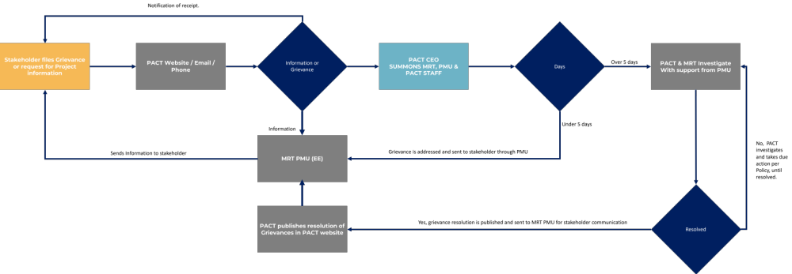
Figure 7: GRM.
PACT website grievance form. https://www.pactbelize.org/greviance-form/

Complaints regarding projects/programmes supported by the Fund can also be filed with the secretariat at the following address:

Adaptation Fund Board secretariat
Mail stop: MSN P-4-400
1818 H Street NW
Washington DC 20433 USA
Tel: 001-202-478-7347 afbsec@adaptation-fund.org

The secretariat will respond promptly to all such complaints. Where appropriate, the secretariat will refer complainants to a grievance mechanism identified by the implementing entity as the primary place for addressing complaints.

Describe the monitoring and evaluation arrangements and provide a budgeted M&E plan, in compliance with the ESP and the Gender Policy of the Adaptation Fund.

All project activities will be monitored by the MRT PMU, who will be tasked with administering procurement process, contract management, review of deliverables (with inputs from the Project Technical Committee), and report to the Project Steering Committee, PACT, and other stakeholders. Annex III - Logic Framework, Monitoring and Reporting, Detailed Budget, Financial Model provides a detailed explanation of monitoring, verification, and reporting of each of the project activities. Gender has been integrated into the log frame with distinct gender-responsive indicators and targets. The Gender Action Plan Matrix aligns with the overall project log frame. The Gender Specialist within the PMU will oversee the advancement of gender-specific indicators, detect any deviations, and recommend corrective actions to address them.

The MRT PMU will provide periodic reports to stakeholders; information from these reports will be furnished by PACT to the Adaptation Fund and to Belize’s Focal Point (which will serve in the PSC). Table 16 indicates the reports and the frequency to be provided by the MRT PMU to PACT.

Report | Description and Content | Frequency
Monthly Report | - Narrative on the activities of the PMU and its staff  - Progress on implementation of project activities  - Procurement  - Budget expenditures and commitments  - Inclusion of E&S Risk monitoring highlights for the month, such as any incidents, mitigation actions, or stakeholder engagement activities | Monthly
Quarterly Progress Report | - Report on achievement of project objectives.  - Budget execution for the period and cumulative, including next period commitments.  - Procurement processes concluded, ongoing and next period processes.  - Detailed section on E&S risk management status, including risk mitigation effectiveness, stakeholder consultations, and any adaptive management actions taken | Quarterly
Semi Annual Audit Report | - Achievement of project objectives – Logic Framework.  - Audited budget and reconciliation.  - Narrative on annual progress on activities.  - Procurement reporting.  - Lessons learned and corrective actions.  - Project risks  - Comprehensive review of E&S Risks, compliance with safeguards, and recommendations for risk management improvements | Semi-Annual (August)
Audited Budget | - Statement of Expenditures  - Committed funds and budget execution.  - Reconciliation and cash balances  - Recommendations  - Summary of E&S risk management costs and resource allocation | Annually (February-March)
Annual Project Performance Report (PPR) | - Consolidated report covering project achievements, challenges, and lessons learned  - Detailed environmental and social risk management outcomes, including monitoring results, stakeholder feedback, and mitigation effectiveness  - Updated risk register and adaptive management measures  - Recommendations for next year’s risk management and project activities | Annually (aligned with project cylce)
Table 18: PMU to PACT reporting

PACT will provide regular and periodic reports to the AF. Table 17 indicates the reports and the frequency to be provided.
Report | Description and Content | Frequency | Estimated Budget considerations
Semi-annual Progress Report | - Report on achievement of project objectives.  - Budget execution.  - Narrative on project progress and activities undertaken.  - Detailed section on environmental and social risk management status, including monitoring of risk mitigation measures, stakeholder engagement, and any emerging risks or incidents | Semi-Annual (August) | $9,500 per report ($19,000 per year)
Baseline Data Collection and Report | - - Preparation of a comprehensive baseline report based on primary and/or relevant secondary data, in line with the Fund’s Results Framework and baseline guidance.  - - Used for project design, setting targets, monitoring progress, and performance assessment.  - - May be conducted independently, semi-independently, or self-conducted.  - - Submission required no later than the first Project Performance Report (PPR). | One time, within the first 6 months, before the first PPR submission | $15,000
Annual and Audit Report + Annual PPR | - Achievement of project objectives – Logic Framework.  - Audited budget and reconciliation.  - Narrative on annual progress on activities.  - Procurement reporting.  - Lessons learned and corrective actions.  - Project risks  - - Comprehensive review of environmental and social safeguards compliance, effectiveness of risk mitigation, and recommendations for improvement  - - Inclusion of an Annual Project Performance Report (PPR) within this document or as a complementary annex, summarizing overall project performance including environmental and social outcomes | Annually (February-March) | $15,000 annually
Mid Term Evaluation | - Effectiveness and efficiency in achievement of project objectives  - Lessons learned and corrective actions.  - Action plan for implementation improvement.  - Assessment of environmental and social risk management effectiveness and adaptive management measures | After 2 years | (Mid project) $18,000
Final Evaluation | - Effectiveness and efficiency in achievement of project objectives  - Lessons learned and corrective actions.  - Final assessment of environmental and social risk management outcomes and sustainability of mitigation measures | After finalization | $18,000
Table 19: PACT to AF Reporting

In addition to periodic reporting by the PMU, an additional layer of control has been added to ensure proper, effective, and efficient use of program funds. Four audits are planned during the project implementation, and 2 evaluations, a midterm, and a final. An audit firm will be retained from project inception to carry out an audit on the financial resources of the program. The audit firm will be independent.

Two Project evaluations are planned, a Mid-Term Review after the first 24 months into the Project implementation and a Final Evaluation, 3 months before the scheduled End Date of the four-year Project. This is to allow for adequate time to finalize and formalize all final reports. The Final Evaluation will be conducted under the leadership of the Independent Evaluator procured by the PMU with the three-general criteria; degree to which the Project was logical and adequate, its performance and its success, Table 18 illustrates this:

Evaluation | Criteria
Relevance: Degree to which the objective of the project is relevant to resilient agriculture with climate change and climate variability in the project communities. | - The design of the project and its adequacy. Was there a logical approach to project planning and implementation.
Performance: The progress made by the Project relative to the  objective. | - Efficiency- Was the project planned and undertaken in a cost-effective manner and were the best options selected for the expected objectives?  - Effectiveness-Were the assumptions and risks identified on target and will the expected activities produce the objectives/Outputs?  - Timeliness - Were the outputs timely and the expected quality/quantity. relative to the expected outcomes?
Success: The extent to which the project has brought about  change | - Impact – How have the project outcomes impacted the objectives of each component and overall, towards resilience to climate change?  - Sustainability- Are there indicators of project sustainability and can they be described?
Table 20: Evaluation criteria

Results framework for the project proposal, including milestones, targets and indicators, including one or more core outcome indicators of the Adaptation Fund Results Framework, and in compliance with the Gender Policy of the Adaptation Fund.

Component 1: Design and build cost-effective solar hybrid sustainable water systems and waste management systems in the four selected communities that will allow households to have access to potable and reliable water service as well as waste management.
§ Objective 1: Reduce exposure to climate variability in 4 rural communities of Belize through an inclusive drought-resistant potable and consistent water supply.
Activity | Indicator | Baseline | Mid Term Target | Final Target | MOV | Budget
Activity (1.1) Design and build, through a participatory process, of inclusive and reliable water systems that account for the cultural, physical, and human capacities of the communities | # of design studies per community.  20% of women inclusion in the design process | Dolores = 0 | Dolores = 1 | Dolores = 1 | Acceptance of studies by Village Council & MRT
 |  | Otoxha = 0 | Otoxha = 1 | Otoxha = 1 | Acceptance of studies by Village Council & MRT
 |  | Boom Creek = 0 | Boom Creek = 1 | Boom Creek = 1 | Acceptance of studies by Village Council & MRT
 |  | Copper Bank = 0 | Copper Bank = 1 | Copper Bank = 1 | Acceptance of studies by Village Council & MRT
Objective 2: Strengthen the capacities of community members and leaders to operate and maintain their village water system. | # community members trained and participating in construction of the system, 30% of which are at least women. | Dolores = 0 | Dolores = 15 | Dolores = 15 | MRT Field officers | 3,313,908
 |  | Otoxha = 0 | Otoxha = 15 | Otoxha = 15 | PMU Gender Specialist. | 3,313,908
 |  | Boom Creek = 0 | Boom Creek = 15 | Boom Creek = 15 |  | 3,313,908
 |  | Copper Bank = 0 | Copper Bank = 15 | Copper Bank = 15 |  | 3,313,908
 |  | Participation of women = 0 | Participation of women > 30% | Participation of women > 30% |  | 3,313,908
 | # of solar hybrid water systems commissioned and operational per community.  Assets produced, developed, improved, or strengthened (e.g., water systems, waste systems)  %20 of women inclusion in the operation process | Dolores = 0 | Dolores = 1 | Dolores = 1 | Commissioning of each system by Village Council & MRT | 3,313,908
 |  | Otoxha = 0 | Otoxha = 1 | Otoxha = 1 | Commissioning of each system by Village Council & MRT | 3,313,908
 |  | Boom Creek = 0 | Boom Creek = 1 | Boom Creek = 1 | Commissioning of each system by Village Council & MRT | 3,313,908
 |  | Copper Bank = 0 | Copper Bank = 1 | Copper Bank = 1 | Commissioning of each system by Village Council & MRT | 3,313,908
 | # Number of direct beneficiaries of households with installed water and meters  %50 women benefit from the installation of water and meters | Dolores = 0 | Dolores = 50 | Dolores = 106 | Commissioning of each system by Village Council & MRT | 3,313,908
 |  | Otoxha = 0 | Otoxha = 25 | Otoxha = 54 | Commissioning of each system by Village Council & MRT | 3,313,908
 |  | Boom Creek = 0 | Boom Creek = 15 | Boom Creek = 25 | Commissioning of each system by Village Council & MRT | 3,313,908
 |  | Copper Bank = 0 | Copper Bank = 60 | Copper Bank = 150 | Commissioning of each system by Village Council & MRT | 3,313,908
Activity (2.1) Provide maintenance and trainings materials, along with capacity building to the communities (Councils, waterboards, and MRT officers) on the built systems
Component 1: Design and build cost-effective solar hybrid sustainable water systems and waste management systems in the four selected communities that will allow households to have access to potable and reliable water service as well as waste management. | # of Water Boards fully established, and all members nominated in each community  %30 inclusion of women within the waterboards | Dolores = 0 | Dolores = 1 | Dolores = 1 | MRT Field Officer | 82,000
 |  | Otoxha = 0 | Otoxha = 1 | Otoxha = 1 | MRT Field Officer | 82,000
 |  | Boom Creek = 0 | Boom Creek = 1 | Boom Creek = 1 | MRT Field Officer | 82,000
 |  | Copper Bank = 0 | Copper Bank = 1 | Copper Bank = 1 | MRT Field Officer | 82,000
 | % of people appointed to Water Board in each Community are women | Dolores = 0 | Dolores = 50% | Dolores = 50% | MRT CEO Appointment Letters. | 82,000
 |  | Otoxha = 0 | Otoxha = 50% | Otoxha = 50% | MRT CEO Appointment Letters. | 82,000
 |  | Boom Creek = 0 | Boom Creek = 50% | Boom Creek = 50% | MRT CEO Appointment Letters. | 82,000
 |  | Copper Bank = 0 | Copper Bank = 50% | Copper Bank = 50% | MRT CEO Appointment Letters. | 82,000
 | Days of training on water system in for each Water Board | Dolores = 0 | Dolores = 1 | Dolores = 8 | Consultancy Report Deliverable | 82,000
 | Days of training on water system in for each Water Board | Otoxha = 0 | Otoxha = 1 | Otoxha = 8 | Consultancy Report Deliverable | 82,000
 | Days of training on water system in for each Water Board | Boom Creek = 0 | Boom Creek = 1 | Boom Creek = 8 | Consultancy Report Deliverable | 82,000
 | Days of training on water system in for each Water Board | Copper Bank = 0 | Copper Bank = 1 | Copper Bank = 8 | Consultancy Report Deliverable | 82,000
 | % of community members in preventative maintenance of their respective water system, of which at least 30% are women.  # of knowledge products (training materials, guides, reports) produced and distributed in local languages spoken by target communities. | Dolores = 0 | Dolores = 30% | Dolores = 30% | Consultancy Report Deliverable | 82,000
 |  | Otoxha = 0 | Otoxha = 30% | Otoxha = 30% | Consultancy Report Deliverable | 82,000
 |  | Boom Creek = 0 | Boom Creek = 30% | Boom Creek = 30% | Consultancy Report Deliverable | 82,000
 |  | Copper Bank = 0 | Copper Bank = 30% | Copper Bank = 30% | Consultancy Report Deliverable | 82,000
 |  | Participation of women = 0 | Participation of women > 30% | Participation of women > 30% | PMU Gender Specialist. | 82,000
Table 21: Log Frame - Component 1

Component 2: Ensuring the sustainability of water resources through improvement of livelihoods opportunities.
§ Objective 3. Ensure long term change in attitudes towards water preservation and climate change impacts therein, through restoration of community-near ecosystem services.
§ Objective 4. Strengthen the capacities of community members to earn or diversify incomes through enhanced livelihoods options.
Activity | Indicator | Baseline | Mid Term Target | Final Target | MOV | Budget
Activity (3.1) Restoration and sustainability actions of community-near ecosystems services. | # of beneficiaries of activities realized in improvement of ecosystem services that are related to ensuring water sustainability and quality in the Toledo District.  %40 of women beneficiaries | Dolores = 0 | Dolores = 0 | Dolores = 84 | Grant award entity progress report, verified in field by PMU Staff. | 648,500
 |  | Otoxha = 0 | Otoxha = 0 | Otoxha = 70 |  | 648,500
 |  | Boom Creek = 0 | Boom Creek = 0 | Boom Creek = 123 |  | 648,500
 | # of beneficiary activities realized in improvement of ecosystem services that to the protection of Corozal Bay.  %30 of women beneficiaries  # of Hectares of coastal habitats restored (mangrove, seagrass) restored or conserved at Copper Bank  %40 of women beneficiaries | Copper Bank = 0 | Copper Bank = 0 | Copper Bank = 125  50 – 100 Hectares | Grant award entity progress report, verified in field by PMU Staff participation. | 648,500
 | Assets Produced : # of workshops and skill building events in each Toledo District community related to reforestation, conservation, and land use to ensure water sustainability, of which the participation is at least 30% women.  # of knowledge products (training materials, guides, reports) produced and distributed in local languages spoken by target communities. | Dolores = 0 | Dolores > 20 | Dolores > 40 | Grant award entity progress report, verified in field by PMU Staff participation. | 648,500
 |  | Otoxha = 0 | Otoxha > 15 | Otoxha > 30 |  | 648,500
 |  | Boom Creek = 0 | Boom Creek > 8 | Boom Creek > 15 |  | 648,500
 |  | Participation of women = 0 | Participation of women > 30% | Participation of women > 30% |  | 648,500
 | # of workshops and skill building events in Copper Bank related to restoration and conservation of the Corozal Bay estuary, of which the participation is at least 30% women.  # of knowledge products (training materials, guides, reports) produced and distributed in local languages spoken by target communities. | Copper Bank = US$100 | Copper Bank = 30 | Copper Bank = 60 | Grant award entity progress report, verified in field by PMU Staff participation. | 648,500
 |  | Participation of women = 0 | Participation of women > 30% | Participation of women > 30% |  | 648,500
Activity (4.1) improving the participation of men and women in alternative livelihoods through ecosystem restoration and improvement practices. | Gender-Needs assessment in each respective community, prior to commencement of core activities of the Grant Award Entity in activity 3.1.  %30 person of women benefit | Dolores = 0 | Dolores = 1 | Dolores = 1 | Grant Entity - Gender Needs Assessment Deliverable, reviewed by PMU Gender Analyst | 79,612
 |  | Otoxha = 0 | Otoxha = 1 | Otoxha = 1 |  | 79,612
 |  | Boom Creek = 0 | Boom Creek = 1 | Boom Creek = 1 |  | 79,612
 |  | Copper Bank = 0 | Copper Bank = 1 | Copper Bank = 1 |  | 79,612
 | Assets produced : # of workshops realized related to improve, enhance, and/or diversify community livelihoods that lead to increase in average household income through activities associated to restoration or improvement of community ecosystem services. At least, 30% of which are women 10% of which are youth (aged 20-24).  # of knowledge products (training materials, guides, reports) produced and distributed in local languages spoken by target communities. | Dolores = 0 | Dolores = 28 | Dolores = 54 | Grant award entity progress report, verified in field by PMU Staff. | 79,612
 |  | Otoxha = 0 | Otoxha = 20 | Otoxha = 41 |  | 79,612
 |  | Boom Creek = 0 | Boom Creek = 9 | Boom Creek = 17 |  | 79,612
 |  | Copper Bank = 0 | Copper Bank = 30 | Copper Bank = 61 |  | 79,612
 |  | Participation of women = 0 | Participation of women > 30% | Participation of women > 30% |  | 79,612
 |  | Youth (aged 20-24) = 0 | Youth (aged 20-24) = 10% | Youth (aged 20-24) = 10% |  | 79,612
 | Increased Income: Positive change in average household income in each community during project execution. | Dolores = US$100 | Dolores > US$115 | Dolores > US$125 | MRT Field officer survey, verified by PMU. | 79,612
 |  | Otoxha = US$100 | Otoxha > US$115 | Otoxha >US$125 | MRT Field officer survey, verified by PMU. | 79,612
 |  | Boom Creek = US$100 | Boom Creek > US$115 | Boom Creek > US$125 | MRT Field officer survey, verified by PMU. | 79,612
 |  | Copper Bank = US$250 | Copper Bank > US$265 | Copper Bank = US$275 | MRT Field officer survey, verified by PMU. | 79,612
 | # of workshops realized related on gender equality and women’s rights, carried out throughout the assignment, under the project programming by the Grant Award Entity.  %30 of women participation in the workshops  # of knowledge products (training materials, guides, reports) produced and distributed in local languages spoken by target communities. | Dolores = 0 | Dolores = 16 | Dolores = 27 | Grant award entity progress report, verified in field by PMU Staff participation. | 79,612
 |  | Otoxha = 0 | Otoxha = 13 | Otoxha = 21 |  | 79,612
 |  | Boom Creek = 0 | Boom Creek = 5 | Boom Creek = 9 |  | 79,612
 |  | Copper Bank = 0 | Copper Bank = 17 | Copper Bank = 31 |  | 79,612
 | # of community workshops and/or seminars to enhance understanding of the climate risks faced by the community and the livelihood opportunities resulting from reliable, potable water and the restoration and management of the community ecosystems.  %30 of women participation in the workshops  # of knowledge products (training materials, guides, reports) produced and distributed in local languages spoken by target communities. | Dolores = 0 | Dolores > 3 | Dolores = 7 | Grant award entity progress report, verified in field by PMU Staff participation. | 79,612
 |  | Otoxha = 0 | Otoxha > 2 | Otoxha = 5 |  | 79,612
 |  | Boom Creek = 0 | Boom Creek > 1 | Boom Creek = 2 |  | 79,612
 |  | Copper Bank = 0 | Copper Bank > 4 | Copper Bank = 8 |  | 79,612
§ Objective 5. Increased capacities in solar technologies through training of indigenous women and men in the 3 Toledo District Communities.
Activity (5.1) Enhancing the participation of men and women through workshops and capacity building activities in maintenance and installation of solar systems. | # of training seminars undertaken in operation and maintenance of distributed solar system,  %30 of women participation in the workshops  # of knowledge products (training materials, guides, reports) produced and distributed in local languages spoken by target communities. | Dolores = 0 | Dolores = 0 | Dolores = 12 | Progress report Grant Award Entity. | 43,780
 |  | Otoxha = 0 | Otoxha = 0 | Otoxha = 12 | Progress report Grant Award Entity. | 43,780
 |  | Boom Creek = 0 | Boom Creek = 0 | Boom Creek = 12 | Progress report Grant Award Entity. | 43,780
 | # of persons trained in each community operation and maintenance of distributed solar system.  %30 of women get trained  # of knowledge products (training materials, guides, reports) produced and distributed in local languages spoken by target communities. | Dolores = 0 | Dolores = 17 | Dolores = 21 | Progress report Grant Award Entity. | 43,780
 |  | Otoxha = 0 | Otoxha = 13 | Otoxha = 25 | Progress report Grant Award Entity. | 43,780
 |  | Boom Creek = 0 | Boom Creek = 5 | Boom Creek = 9 | Progress report Grant Award Entity. | 43,780
 | % of persons trained in each community operation and maintenance of distributed solar system are women  # of knowledge products (training materials, guides, reports) produced and distributed in local languages spoken by target communities. | Dolores = 0 | Dolores = 15% | Dolores = 30% | Progress report Grant Award Entity. | 43,780
 |  | Otoxha = 0 | Otoxha = 15% | Otoxha = 30% | Progress report Grant Award Entity. | 43,780
 |  | Boom Creek = 0 | Boom Creek = 15% | Boom Creek = 30% | Progress report Grant Award Entity. | 43,780
Table 22: Log Frame - Component 2

Component 3: Increase the capacities and governance of rural communities on water resources sustainability in relation to climate vulnerability and strengthen the knowledge management capacities of the public authorities and the communities.
Objective 6. Strengthen the awareness of rural communities in Belize about the impacts of climate change on water sustainability.
Activity | Indicator | Baseline | Mid Term Target | Final Target | MOV | Budget
Activity (6.1) Develop and implement a national public awareness campaign throughout village leadership for the communities on the effects of climate change on water sustainability. | awareness communication campaigns, through locally used media, on climate change and water sustainability with a gender perspective  # of knowledge products (training materials, guides, reports) produced and distributed in local languages spoken by target communities. | Campaign = 0 | Campaign = 1 | Campaign = 2 | Post awareness campaign Survey response | 30,000
 | Post-campaign survey with village leadership disaggregated, who responded awareness on water issues related to climate change with a gender perspective.  # of knowledge products (training materials, guides, reports) produced and distributed in local languages spoken by target communities. | Belize = 0 | Belize > 50 communities responding. | Belize = 181 communities responding | Post awareness campaign Survey response | 30,000
 |  | Belize = 0 | % of village leadership who responded awareness | % of village leadership who responded awareness | Post awareness campaign Survey response | 30,000
 | % of respondents to MRT survey are women | Belize = 0 | Female survey responses = 50% | Female survey responses = 50% | Post awareness campaign Survey response | 30,000
Objective 7. Improve the resiliency of four rural communities of Belize through enhanced governance of their Water Boards to ensure sustainability.
Activity (7.1) Training of Village Leadership of the four communities and their Water Boards on inclusive governance. | Assets Produced: workshop per community on inclusive water board management  # of knowledge products (training materials, guides, reports) produced and distributed in local languages spoken by target communities. | Belize = 0 | Dolores = 0 | Dolores = 1 | Consultancy Report Deliverable | 34,500
 |  | Belize = 0 | Otoxha = 0 | Otoxha = 1 | Consultancy Report Deliverable | 34,500
 |  | Belize = 0 | Boom Creek = 0 | Boom Creek = 1 | Consultancy Report Deliverable | 34,500
 |  | Belize = 0 | Copper Bank = 0 | Copper Bank = 1 | Consultancy Report Deliverable | 34,500
 | Assets produced: workshop per community on WASH with gender perspective, for schoolteachers  # of knowledge products (training materials, guides, reports) produced and distributed in local languages spoken by target communities. | Belize = 0 | Dolores = 0 | Dolores = 1 | Consultancy Report Deliverable | 34,500
 |  | Belize = 0 | Otoxha = 0 | Otoxha = 1 | Consultancy Report Deliverable | 34,500
 |  | Belize = 0 | Boom Creek = 0 | Boom Creek = 1 | Consultancy Report Deliverable | 34,500
 |  | Belize = 0 | Copper Bank = 0 | Copper Bank = 1 | Consultancy Report Deliverable | 34,500
 | % of women in each workshop | Belize = 0 | Dolores = 0 | Dolores = > 30% | Consultancy Report Deliverable | 34,500
 | % of women in each workshop | Belize = 0 | Otoxha = 0 | Otoxha => 30% | Consultancy Report Deliverable | 34,500
 | % of women in each workshop | Belize = 0 | Boom Creek = 0 | Boom Creek = > 30% | Consultancy Report Deliverable | 34,500
 | % of women in each workshop | Belize = 0 | Copper Bank = 0 | Copper Bank = >30% | Consultancy Report Deliverable | 34,500
Activity (7.2) Arrange peer-to-peer community workshops to share insights on the a) impacts of climate change, b) inclusive governance, c) improved livelihoods, d) maintenance of water systems. | Assets produced: peer-to-peer workshop in the Toledo District  # of knowledge products (training materials, guides, reports) produced and distributed in local languages spoken by target communities. | Belize = 0 | Dolores = 0 | Dolores = 1 | MRT Regional Field Officer Report | 9,000
 |  | Belize = 0 | Otoxha = 0 | Otoxha = 1 | MRT Regional Field Officer Report | 9,000
 |  | Belize = 0 | Boom Creek = 0 | Boom Creek = 1 | MRT Regional Field Officer Report | 9,000
 |  | Belize = 0 | Copper Bank = 0 | Copper Bank = 1 | MRT Regional Field Officer Report | 9,000
 | 1 peer-to-peer workshop in the Corozal District  # of knowledge products (training materials, guides, reports) produced and distributed in local languages spoken by target communities. | Belize = 0 | Dolores = 0 | Dolores = 1 | MRT Regional Field Officer Report | 9,000
 |  | Belize = 0 | Otoxha = 0 | Otoxha = 1 | MRT Regional Field Officer Report | 9,000
 |  | Belize = 0 | Boom Creek = 0 | Boom Creek = 1 | MRT Regional Field Officer Report | 9,000
 |  | Belize = 0 | Copper Bank = 0 | Copper Bank = 1 | MRT Regional Field Officer Report | 9,000
 | % of women in each workshop | Belize = 0 | Dolores = 0 | Dolores = > 30% | MRT Regional Field Officer Report | 9,000
 | % of women in each workshop | Belize = 0 | Otoxha = 0 | Otoxha => 30% | MRT Regional Field Officer Report | 9,000
 | % of women in each workshop | Belize = 0 | Boom Creek = 0 | Boom Creek = > 30% | MRT Regional Field Officer Report | 9,000
 | % of women in each workshop | Belize = 0 | Copper Bank = 0 | Copper Bank = >30% | MRT Regional Field Officer Report | 9,000
Objective 8. Strengthen the MRT's capacity to respond to water issues in the communities.
Activity (8.1) Strengthen the MRT’s knowledge base through training of its regional and field officers in best practices in water board management and hybrid / solar water systems. | 4-week course for MRT officers on climate change, inclusive governance, gender mainstreaming and solar hybrid system | MRT Field officers with diploma = 0 | MRT Field officers with diploma = 8 | MRT Field officers with diploma = 8 | Course provider Report Deliverable | 36,350
 | 2 – week course to the MRT on climate change, water board management, and gender perspective. | MRT Staff = 109 | MRT Staff = 0 | MRT Staff = 109 | Course provider Report Deliverable | 36,350
Table23: Log Frame - Component 3

Adaptation Fund Core Impact Indicators

Adaptation Fund Core Impact Indicator “Number of Beneficiaries”
Date of Report | August 7, 2025
Project Title | Securing Water Resources through Solar Energy and Innovative Adaptive
Country | Belize
Implementing Agency | Protected Areas Conservation Trust
Project Duration | March 2026 – April 2030

 | Baseline (absolute #) | Target at project approval (absolute #) | Adjusted target first year of implementation (absolute #) | Actual at completion (absolute #)
Direct beneficiaries supported by the project | 0 | Approx. 2,200 | Approx. 2,200 | (To be reported at project completion)
Female direct beneficiaries | 0 | Approx. 1,100 (50% of direct beneficiaries) | Approx. 1,100 | (To be reported at project completion)
Youth direct beneficiaries (aged 15-24) | 0 | Approx. 440 (20% of direct beneficiaries) | Approx. 440 | (To be reported at project completion)
Indirect beneficiaries supported by the project | 0 | Community-wide (population TBD) | TBD (based on monitoring and community data) | (To be reported at project completion)
Female indirect beneficiaries | 0 | Estimated proportion based on community demographics | TBD | (To be reported at project completion)
Youth indirect beneficiaries | 0 | Estimated proportion based on community demographics | TBD | (To be reported at project completion)

Adaptation Fund Core Impact Indicator “Assets Produced, Developed, Improved, or
Strengthened”
Date of Report | August 7, 2025
Project Title | Securing Water Resources through Solar Energy and Innovative Adaptive
Country | Belize
Implementing Agency | Protected Areas Conservation Trust
Project Duration | March 2026 – April 2030

Category / Sector | Baseline | Target at Project Approval | Adjusted Target First Year | Actual at Completion
Water and Waste Management | No solar hybrid water systems or waste systems | 4 solar hybrid water systems commissioned; waste systems developed | 4 solar hybrid water systems commissioned: waste systems operational | (To be reported at project completion)
Physical Assets (water systems) | 0 | 4 water systems fully designed, built, and operational | 4 systems operational
Governance Structures (Water Boards) | 0 Water Boards established | 4 Water Boards fully established with ≥30% women participation | 4 Water Boards operational & trained
Ecosystem Restoration | 0 hectares restored | 125 hectares coastal habitat restored | 125 hectares restored
Knowledge Products | 0 knowledge products (guides, training materials) | At least 100 knowledge products developed and distributed in local languages | 30% knowledge products developed

Adaptation Fund Core Impact Indicator “Natural Assets Protected or Rehabilitated”
Date of Report | August 7, 2025
Project Title | Securing Water Resources through Solar Energy and Innovative Adaptive
Country | Belize
Implementing Agency | Protected Areas Conservation Trust
Project Duration | March 2026 – April 2030

Baseline | 0 hectares
Target at project approval | 125 hectares
Adjusted target first year of implementation | 125 hectares
Actual at completion9 | (To be reported upon project completion)
Natural Asset or Ecosystem (type) | Coastal and watershed ecosystems (mangroves and seagrass beds)
Change in state | Restoration and conservation of mangrove forests and seagrass habitats improving ecosystem health and water quality
Ha or km Protected/rehabilitated, or Effectiveness Scale (1–5) | 125 hectares restored/protected; Effectiveness to be evaluated on a scale of 1 to 5 (expected 4–5)
Total number of natural assets or ecosystems protected/rehabilitated | 1 (major coastal and watershed ecosystem)

Adaptation Fund Impact Indicator “Increased income, or avoided decrease in income”
Date of Report | August 7, 2025
Project Title | Securing Water Resources through Solar Energy and Innovative Adaptive
Country | Belize
Implementing Agency | Protected Areas Conservation Trust
Project Duration | March 2026 – April 2030

Income Source (name) | Income Source Description | Baseline Income Level (USD) | Target at Project Approval (USD) | Adjusted Target First Year (USD) | Actual at Completion (USD) | Number of Households (total in project area)
Agriculture & Fishing | Primary rural livelihoods (crop farming, fishing) | $100/month approx. per household | $115/month | $125/month | (To be reported) | 471 households (approx., 4 communities combined)
Small-scale Trade and Local Services | Small businesses, local trade, informal services | $80/month approx. | $90/month | $100/month | (To be reported) | Approx. included in total households
Wage Employment (casual or formal) | Salaries from local jobs or part-time employment | $150/month | $165/month | $175/month | (To be reported) | Approx. included in total households

Demonstrate how the project aligns with the Results Framework of the Adaptation Fund

Component | Project Outcomes | Project Indicators | Fund Outcome | Fund Outcome Indicator | Grant Amount (USD)
Component 1: | Design, build, and commission solar hybrid water systems | Number of water systems commissioned and operational | Outcome 4: Increased adaptive capacity in infrastructure | 4.2 Physical infrastructure improved to withstand climate stress | 3,313,908
Component 1: | Increase household access to potable water | Number of households with installed water and meters | Outcome 4: Increased adaptive capacity in infrastructure | 4.1 Responsiveness of sector services | 3,313,908
Component 1: | Strengthen community capacity for system operation | Number of community members trained (30% women) | Outcome 8: Diffusion of innovative adaptation technologies | 8 Innovative adaptation practices rolled out | 82,000
Component 2: | Restore community-near ecosystems | Number of restoration activities; hectares restored | Outcome 5: Increased ecosystem resilience | 5 Ecosystem services and natural assets maintained or improved | 648,500
Component 2: | Strengthen livelihood diversification | Workshops on livelihoods participation & income diversification | Outcome 6: Diversified and strengthened livelihoods | 6.1% households with improved livelihood assets | 123,392
Component 3: | Strengthen Water Board governance | Number of Water Boards established; % women participation | Output 2.1: Strengthened capacity to respond to climate events | 2.1.1 No. of staff trained (gender disaggregated) | 43,500
Component 3: | Raise awareness on climate impacts on water | Communication campaigns; % population aware and applying responses | Outcome 3: Awareness and ownership at local level | 3.1% population aware; 3.2% applying adaptation responses | 30,000
Component 3: | Strengthen MRT capacity and knowledge dissemination | Number of MRT officers trained; tools and guidelines developed | Output 3.2: Capacity to capture and disseminate knowledge | 3.2.2 Number of knowledge products developed and shared | 36,350

Table 24: Alignment with Adaptation Fund Results Framework

Include a detailed budget with budget notes, a budget on the Implementing Entity management fee use, and an explanation and a breakdown of the execution costs.
Component/Section | Objective | Activity | AF Grant (USD) | Time-Bound Milestone | Notes
Component 1: Design and build cost-effective solar hybrid sustainable water systems in the four selected communities that will allow households to have access to potable and reliable water service. | Objective 1: Reduce exposure to climate variability in 4 rural communities of Belize through an inclusive drought-resistant potable and consistent water supply. | Activity 1.1: Design and build, through a participatory process, inclusive and reliable water systems that account for the cultural, physical, and human capacities of the communities. | 3,313,908 | Y1 Q4 | 1
 | Objective 2: Strengthen the capacities of community members and leaders to operate and maintain their village water system. | Activity 2.1: Provide maintenance and trainings materials, along with capacity building to the communities (Councils, waterboards, and MRT officers) on the built systems. | 82,000 | Y1 Q1 | 2
Component 2: Ensuring the sustainability of water resources through improvement of livelihoods opportunities | Objective 3: Ensure long term change in attitudes towards water preservation and climate change impacts therein, through restoration of community-near ecosystem services | Activity 3.1: Restoration and sustainability actions of the community-near ecosystems services | 648,500 | Y1 Q4 | 3
 | Objective 4: Strengthen the capacities of community members to earn or diversify incomes through enhanced livelihoods options. | Activity 4.1: Improving the participation of men and women in alternative livelihoods through ecosystem restoration and improvement practices. | 79,612 | Y1 Q4 | 4
 | Objective 5: Increased capacities in solar technologies through training of indigenous women in the 3 Toledo District Communities | Activity 5.1: Enhancing the participation of women through workshops and capacity building activities in maintenance and installation of solar systems. | 43,780 | Y3 Q3 | 5
Component 3: Increase the capacities and governance of rural communities on water resources sustainability in relation to climate vulnerability and strengthening the knowledge management capacities of the public authorities and the communities. | Objective 6: Strengthen the awareness of rural communities (villages) in Belize on the impacts on water sustainability on the effects of climate change. | Activity 6.1: Develop and implement a national public awareness campaign through village leadership for the communities on the impacts on water sustainability on the effects of climate change. | 30,000 | Y3 Q1 | 6
 | Objective 7: Improve the resiliency of four rural communities of Belize through enhanced governance of their Water Boards to ensure sustainability. | Activity 7.1: Training of Village Leadership of the four communities and their Water Boards on inclusive governance. | 34,500 | Y4 Q2 | 7
 |  | Activity 7.2: Arrange peer-to-peer community workshops to share insights on the a) impacts of climate change, b) inclusive governance, c) improved livelihoods, d) maintenance of water systems. | 9000 | Y4 Q1 | 8
 | Objective 8: Strengthen the MRT's capacity to respond to water issues in the communities. | Activity 8.1: Strengthen the MRT’s knowledge base through training its regional and field officers of best practices in water board management and hybrid / solar water systems. | 36,350 | Y2 Q2 | 9
TOTAL Project Activities |  |  | 4,277,650 |  | 10
Project Execution Cost |  |  | 365,000 |  | 11
Total Project/Programme Costs |  |  | 4,642,650 |  | 12
Implementing Entity Fees |  |  | 357,350 |  | 13
TOTAL FINANCING REQUESTED |  |  | 5,000,000 |  | 14

Table 25: Detailed Project Budget.
Budget notes

Component 1

Objective 1: Reduce exposure to climate variability in 4 rural communities of Belize through an inclusive drought-resistant potable and consistent water supply.

- Activity (1.1) Design and build, through a participatory process, inclusive and reliable water systems that account for the cultural, physical, and human capacities of the communities.
Activity | Sub-Activity | Type of Firm | USD | BZD
Activity (1.1) Design and build, through a participatory process, inclusive and reliable water systems that account for the cultural, physical, and human capacities of the communities. | Activity (1.1.1) Contract with established Firm or Consortium with expertise on solar water system in Belize, experience working with Toledo and Corozal District to design and build water system for each of the Communities | Engineering Firm (s) and or Engineering Consortium | 3,313,908 | 6,627,816
 | Activity (1.1.2) Firm contracted in 1.1.1 will undertake a consultive approach to develop each water system, and in the design, will specify the local skill available that could be included in the construction of the system. | Engineering Firm (s) and or Engineering Consortium | 3,313,908 | 6,627,816

Table 26: Activity 1.1 budget notes
Grant Allocation per Community:

Dolores | Otoxha | Boom Creek | Copper Bank
767,999 | 671,660 | 609,569 | 1,264,681
Table27: Activity 1.1 Grant allocation per community.

- Professional services firm will be tasked in coordination and collaboration with the MRT and the communities, in finding adequate drilling areas. Tank and distribution location will be designed with community input. The firm will be tasked with preparing all required material for permit obtention. PMU Environmental, Social & Gender Specialist will undertake an assessment of the sites and develop the Environmental and Social Assessment Plan, to be used during construction. The selected firm must provide evidence of a field liaison officer with experience working in each district.
- Amounts correspond to systems tailored to the number of households in each community, terrain environment, and system capacity. The system in Boom Creek cannot be scaled to number of households, due to terrain and is disproportionally more expensive per household than the others. Copper Bank requires an RO system, which adds a US$250,000 expense due to higher salinity.
- Prior to construction, the contract award firm will be required to obtain all the necessary permits.
- 30% of community members involved in the construction to be women.
- Construction days per community: 480, per day construction cost: US$1167.65.
- Labour & Contingencies are included in each allocation per community: 8.5%

Contingency Areas:
- Unforeseen Construction Costs
- Technical and Engineering Design Adjustments
- Climate Risk Mitigation
- Regulatory and Compliance Costs
Community Engagement and Participation

Objective 2: Strengthen the capacities of community members and leaders to operate and maintain their village water system.

- Activity (2.1) Provide maintenance and trainings materials, along with capacity building to the communities (Councils, waterboards, and MRT officers) on the built systems.
Activity | Sub-Activity | Type of Firm | USD | BZD
Activity (2.1) Provide maintenance and trainings materials, along with capacity building to the communities (Councils, waterboards, and MRT officers) on the built systems. | Activity (2.1.1.) MRT workshop to constitute water board for water systems management. | MRT PMU (EE): Workshop venue rental, catering. | 16,400 | 32,800
 | Activity (2.1.2) Provide maintenance and trainings materials, along with capacity building to the communities (Councils, waterboards, and MRT officers) on the built systems. | Engineering Firm (s) and or Engineering Consortium and/or Qualified equipment supply firm. | 65,600 | 131,200

Table 28: Activity 2.1 Budget notes
Component 2

Objective 3. Ensure long term change in attitudes towards water preservation and climate change impacts therein, through restoration of community-near ecosystem services.

- Activity (3.1) Restoration and sustainability actions of the community-near ecosystems services

Activity | Sub-Activity | Type of Firm | US$ | BZ$
Activity (3.1) Restoration and sustainability actions of the community-near ecosystems services | Activity (3.1.1) Call for Proposals for entities with experience working in the Toledo District, on improvement of livelihoods through the restoration of the ecosystems nearby the communities. | Qualified entity with experience in executing grants (NGOs or CSOs) | 419,750 | 839,500
 | Activity (3.1.2) Call for Proposals for entities with experience working in the Corozal District (or Orange Walk District), on improvement of livelihoods through the restoration of the watershed. | Qualified entity with experience in executing grants (NGOs or CSOs) | 228,750 | 457,500
Table 29: Activity 3.1 Budget Notes
Grant Allocation Activity 3.1 | Dolores | Otoxha | Boom Creek | Copper Bank
Activity 3.1.1 | 200,750 | 155,125 | 63,875 | -
Activity 3.1.2 | - | - | - | 228,750
Total Allocation Activity 3.1 | 200,750 | 155,125 | 63,875 | 228,750
Allocation % of Total | 31.0% | 23.9% | 9.8% | 35.3%
per household | 1,265.10 | 1,786.61 | 1,939.48 | 1,018.70

Days allocated (Activity 3.1) | Year 0 | Year 1 | Year 2 | Year 3 | Year 4
Toledo District Communities (Dolores, Otoxha, Boom Creek) | 20 | 554 | 520 | 503 | 84
Corozal District Communities (Copper Bank) | 11 | 302 | 284 | 275 | 46

- Grant to be awarded to an entity (NGO, CSO, CBO) legally based in Belize.
- Entities will submit grant proposals to be evaluated by the MRT/PMU and the Technical Advisory Committee.
- Entities must meet PACT grant award guidelines, provide evidence of solid fiduciary capacities, and experience in similar undertakings.
- The same entity that submits a proposal for 3.1 must submit a proposal for 4.1.
- Please refer to Annex II “Implementation and Operations Arrangements”.
- Duration 50 months.

Objective 4. Strengthen the capacities of community members to earn or diversify incomes through enhanced livelihoods options.

- Activity (4.1) Enhancing the participation of men and women through workshops and capacity building activities in income generation activities.

Activity | Sub-Activity | Type of Firm | US$ | BZ$
Activity (4.1) Enhancing the participation of men and women through workshops and capacity building activities in income generation activities. | Activity (4.1.1) Development of a gender-responsive needs assessment considering the interests and needs of women, men, and youth in the communities, to be carried out by the entity responsible of this activity before implementation. | Qualified entity with experience in executing grants (NGOs or CSOs) | 12,600 | 25,200
 | Activity (4.1.2) Workshops on gender equality and women's rights for the communities are carried out by entity awarded with grant for 4.1. | Qualified entity with experience in executing grants (NGOs or CSOs) | 17,293 | 34,586
 | Activity (4.1.3) Workshops and other skill building exercises related to livelihood options. Skills development in business planning, financial literacy, and market analysis to enhance and guide on navigating regulatory requirements that may open new market opportunities. | Qualified entity with experience in executing grants (NGOs or CSOs) | 43,233 | 86,466
 | Activity (4.1.4) Community seminar or workshops that socialize the risks faced by community members in climate change and opportunities to mitigate through participation in project activities. | Qualified entity with experience in executing grants (NGOs or CSOs) | 6,486 | 12,972
Table 30: Activity 4.1 Budget notes
Grant Allocation Activity 4.1 | Dolores | Otoxha | Boom Creek | Copper Bank
Activity 4.1.1 | 3,200.00 | 2,400 | 2,000 | 5,000
Activity 4.1.2 | 5,353 | 4,137 | 1,703 | 6,100
Activity 4.1.3 | 13,383 | 10,342 | 4,258 | 15,250
Activity 4.1.4 | 2,008 | 1,551 | 640 | 2,288
Total Allocation Activity 4.1 | 23,944 | 18,430 | 8,601 | 28,637
% per household | 30.1% | 23.1% | 10.8% | 36.0%
Allocation per household | 225.89 | 317.75 | 390.93 | 190.92

- Activity 4.1.1, total days allocation 63 distributed proportionally in each community for the assessment, at US$200 per day,
- Activity 4.1.2, 86 workshops, Dolores 27, Otoxha 21, Boom Creek 9, Copper Bank, 31, at US$200 per workshop.
- Activity 4.1.3, 176 workshops, Dolores 54, Otoxha 41, Boom Creek 17, Copper Bank, 61, at US$250 per workshop.
- Activity 4.1.4, 22 workshops, Dolores 7, Otoxha 5, Boom Creek 2, Copper Bank, 8, at US$300 per workshop.
- All activities are inclusive of transportation, venue, and material costs.
- Duration 50 months.

Objective 5. Increased capacities in solar technologies through training of indigenous women in the 3 Toledo District Communities.

- Activity (5.1) Enhancing the participation of women through workshops and capacity building activities in maintenance and installation of solar systems.

Activity | Sub-Activity | Type of Firm | US$ | BZ$
Activity (5.1) Enhancing the participation of women through workshops and capacity building activities in maintenance and installation of solar systems. | Activity (5.1.1) Call for Proposals for entities with experience in working with women on maintenance and installation of distributed energy for the Toledo District | Qualified entity with experience in executing grants (NGOs or CSOs) | 43,780 | 87,560
Table 31: Activity 5.1 Budget Notes
- Costs based on a two-year implementation period of GEF Small Grants Program with Plenty International of Belize; that project provided solar panels, batteries, converters to all households, community electric board, and other related activity, for a total grant of US$ 150,000, plus contributions from villages, MRT, and UNDP. This activity will only provide demonstrative installation to interested households.
- Three workshops per month, per community, during the engagement.
- Total months of grant activities 12.

Allocation | Dolores  (US$) | Otoxha  (US$) | Boom Creek
Amount | 19,540 | 14,984 | US$ 9,257
Per household | 184 | 258 | 420
Per Month | 1,628 | 1,249 | US$ 771.38

Component 3

Objective 6. Strengthen the awareness of rural communities in Belize about the impacts of climate change on water sustainability.

- Activity (6.1) Develop and implement a national public awareness campaign throughout village leadership for the communities on the effects of climate change on water sustainability.

Activity | Sub-Activity | Type of Firm | US$ | BZ$
Activity (6.1) Develop and implement a national public awareness campaign throughout village leadership for the communities on the effects of climate change on water sustainability. | Activity (6.1.1) Tender a contract for a stakeholder engagement firm to develop and implement of a gender-sensitive campaign & survey, both in terms of format (languages, media) and content (climate change differentiated impacts of men and women), on the impacts of climate change on water sustainability. | Consultancy, experienced in stakeholder communication and engagement | 30,000 | 60,000
Table 32: Activity 6.1 Budget Notes
- Consultancy/Communication days: 60, per diem US$500.
- Prices reflect costs for a recurring campaign during year 3 of the project and include ex-ante and ex-post survey.

Objective 7. Improve the resiliency of four rural communities of Belize through enhanced governance of their Water Boards to ensure sustainability.

- Activity (7.1) Training of Village Leadership of the four communities and their Water Boards on inclusive governance.

Activity | Sub-Activity | Type of Firm | US$ | BZ$
Activity (7.1) Training of Village Leadership of the four communities and their Water Boards on inclusive governance. | Activity (7.1.1) Tender a contract for firm to for the development of training materials on inclusive governance cover gender equality principles, recognize women's rights and the importance of women's participation in leadership positions | Consultancy (or consortium), experienced in community organizations, governance, in health and gender inclusiveness. | 24,000 | 48,000
 | Activity (7.1.2.) Tender a contract for firm to for the development of training of Village School teachers of the four communities on WASH with a gender perspective, along with the provision of visual reference materials to be posted in school grounds. | Consultancy (or consortium), experienced in community organizations, governance, in health and gender inclusiveness. | 10,500 | 21,000
Table 33: Activity 7.1 Budget Notes
- Consultancy/Communication days: 60, per diem US$ 400. Firm must be based in the region and be fluent in Maya.
- If PACT determines adequate firms, Activities 7.1.1 and 7.1.2 can be combined into a single tender.
- International Entities and Public Entities (Ministry of Health) may participate in the tender.

Allocation | Dolores  (US$) | Otoxha  (US$) | Boom Creek  (US$) | Copper Bank  (US$)
Amount | 2,800 | 2,100 | 2,100 | 3,500
Days | 20 | 15 | 15 | 25

- Activity (7.2) Arrange peer-to-peer community workshops to share insights on the a) impacts of climate change, b) inclusive governance, c) improved livelihoods, d) maintenance of water systems.

Activity | Sub-Activity | Type of Firm | US$ | BZ$
Activity (7.2) Arrange peer-to-peer community workshops to share insights on the a) impacts of climate change, b) inclusive governance, c) improved livelihoods, d) maintenance of water systems. | Activity (7.2.1) MRT will summon nearby project communities to a 3-day field workshop understand the relevance of the impacts of water and climate change. | Consultancy (or consortium), experienced in climate change impacts in Belize, Central America, and the Caribbean. | 1000 | 2,000
 |  | MRT PMU (EE): Workshop venue rental, catering, transportation for community members | 3500 | 7,000
 | Activity (7.2.2) MRT will summon interested communities to a 1-day field workshop understand the relevance of the inclusive governance and water systems maintenance. | Consultancy (or consortium), experienced in climate change impacts in Belize, Central America, and the Caribbean. | 1000 | 2,000
 |  | MRT PMU (EE): Workshop venue rental, catering, transportation for community members | 3500 | 7,000
Table 34: Activity 7.2 Budget Notes
- Community selection will be undertaken by the MRT, and organization and support for the workshops will be organized by the PMU.
- Consultant/Facilitator for each workshop: US$1,000
- MRT Workshop, logistics including transportation of community leaders to a centralized location, catering: US$3,500.

Objective 8. Strengthen the MRT's capacity to respond to water issues in the communities.

- Activity (8.1) Strengthen the MRT’s knowledge base through training of its regional and field officers of best practices in water board management and hybrid / solar water systems.

Activity | Sub-Activity | Type of Firm | US$ | BZ$
Activity (8.1) Strengthen the MRT’s knowledge base through trainings of its regional and field officers of best practices in water board management and hybrid / solar water systems. | Activity (8.1.1) Tender for a consultancy firm to conduct capacity-development tailored seminar, including workshops, of the MRT's regional and field officers to mainstream gender within their day-to-day activities, water board management and interaction, and water systems (including solar / hybrid systems). | Consultancy (or consortium), experienced in inclusive governance, gender, and water systems. | 18000 | 36,000
 |  | MRT PMU (EE): Workshop venue rental, catering. | 3750 | 7,500
 | Activity (8.1.2) Tender for a consultancy firm to conduct capacity-development of the broad MRT on gender equality and women’s rights, climate risks and adaptation measures, and governance. | Consultancy (or consortium), gender, and climate change. | 14000 | 28,000
 |  | MRT PMU (EE): Workshop venue rental, catering. | 600 | 1,200
Table 35: Activity 8.1 Budget Notes
- Workshops will be facilitated, part online, and part in-situ, in either Belmopan or Belize City.
- Consultancy, experienced in climate, gender inclusivity, water systems: days: 30, per diem US$600. Consultancy can provide part of the coursework online, however in-situ workshops are mandatory.
- Workshop venue rental, catering, transport of field officers: US$3,750. Ranges of venue rentals in Belmopan or Belize city can be between US$850 to US$2,000, per day.
- Consultancy/Communication days: 20, per diem US$700.
- Workshop venue accommodation (MRT), catering, transport of field officers: US$600.

- Project Execution Cost

Description | Year 1 | Year 2 | Year 3 | Year 4 | Year 5 | Total (US$)
Project Management Staffing
Project Manager (Full Time) | 30,000 | 30,000 | 30,000 | 30,000 | 15,000 | 135,000
Environmental, Social & Gender Specialist (Part-Time) | 7,500 | 7,500 | 7,500 | 7,500 | 6,000 | 36,000
Technical Officer | 18,000 | 18,000 | 18,000 | 18,000 | 9,000 | 81,000
Project Management Goods & Services
Stationery Supplies | 2,000 | 2,000 | 2,000 | 2,000 | 1,500 | 9,500
Cell Phone Service | 1200 | 1200 | 1200 | 1200 | 600 | 5,400
Travel (Office/Admin) | 2,000 | 2,000 | 2,000 | 2,000 | 1000 | 9,000
Laptop/Computers | 4000 |  |  |  |  | 4000
Graphic Design (Year 1 only) | 2500 |  |  |  |  | 2500
Signage (Village) and Visibility Materials | 18,000 | 15,300 | 15,300 |  |  | 48,600
Audit & Evaluation
Annual Audit (4 audits of $8,500 each) | 8,500 | 8,500 | 8,500 | 8,500 | - | 34,000
Total Project Execution Cost | 73,150 | 67,600 | 67,600 | 67,600 | 31,800 | 365,000

- Project audits in Belize are quoted at US$ 8,500 per audit. Project Manager, monthly Salary US$2,500, for 54 working months.
- Project Manager contract will require own transportation.
- Environmental, Social & Gender Specialist, part time, monthly Salary US$1,500, for 24 working months.
- Technical Officer, monthly salary US$1,500, for 54 working months.
- IT/Office Administration includes stationery supplies USD 9500, and cell phone service for the PMU staff for the project period, USD 5,400.
- Travel Milage allowance will be provided for PMU Staff for project activities carried out of the assigned duty station, once personal transportation is used, USD 9,000
- IT equipment includes the purchase of laptops/computers for PMU staff, USD 4000
- Marketing & Communication involve creating project images and project signage in each of the villages.
- Marketing & Communication includes graphic design services of promotional materials and project images, USD 2,500, project road signs in all four communities, providing stakeholders with project contact information and printing of project visuals, USD 48,600

- Project Cycle Management Fee Budget (NIE FEES)

Description | Year 1 | Year 2 | Year 3 | Year 4 | Year 5 | Total (USD)
Baseline Data Report | 15,000 | 0 | 0 | 0 | 0 | 15,000
Mid-Term Evaluation | 0 | 0 | 18,000 | 0 | 0 | 18,000
Final Evaluation | 0 | 0 | 0 | 0 | 18,000 | 18,000
Subtotal Evaluation Items | 15,000 | 0 | 18,000 | 0 | 18,000 | 51,000
Evaluation Support | 9,000 | 18,000 | 18,000 | 18,000 | 9,000 | 72,000
Project Support Costs | 5,400 | 21,600 | 21,600 | 21,600 | 5,400 | 75,600
Management Supervision | 2,380 | 10,000 | 10,000 | 10,000 | 2,380 | 34,760
Administrative & Financial Management | 1,320 | 26,000 | 22,175 | 22,175 | 1,320 | 72,990
Total IE Fees (Final Adjusted) | 47,600 | 75,600 | 114,600 | 78,600 | 53,600 | 357,350

- Total Project / Programme Costs
Description | Total (USD)
Project Activities | 4 4,277,650
Project Execution Cost | 365,000
Total Project/Programme Costs | 4,642,650

- TOTAL FINANCING REQUESTED
Description | Total (USD)
Project / Programme Costs | 4,642,650
Implementing Entity Fees | 357,350
Grand Total | 5,000,000

- NIE fee calculated at 8.5% CAP
1. Evaluation Support
- This category covers coordination and facilitation of all project evaluation activities, including liaison with evaluators, review of evaluation reports, and ensuring quality and timeliness of baseline, mid-term, and final evaluations. The higher allocation in Years 2 to 4 ($18,000 annually) reflects the intensive evaluation phases during project implementation when mid-term and quality assurance activities are most active. Reduced funding in Years 1 and 5 ($9,000 each) supports baseline preparations and final evaluation closeout activities respectively, ensuring comprehensive evaluation oversight throughout the project cycle.
- Evaluation costs reflect 30 per diem, at US$ 600.
- Baseline Report in Belize are around USD $12,000 to $15,000

2. Project Support Costs
- These costs include essential office and operational expenditures necessary for smooth project management under the Implementing Entity. This covers office rent, utilities such as electricity, water, and internet, and communication services including phone and email. The budget peaks in Years 2 to 4 ($21,600 annually) to reflect increased operational demands during active implementation phases. Lower allocations in Years 1 and 5 ($5,400 each) correspond to project start-up and close-out periods when office activity is reduced.

3. Management Supervision
- Management Supervision funds salaries and benefits for PACT staff responsible for overall oversight, coordination, and supervision of the project. This includes regular monitoring of project progress, supervising reporting processes, ensuring adherence to Adaptation Fund guidelines, and liaison with stakeholders and the Adaptation Fund Secretariat. The relatively low allocation in Years 1 and 5 ($2,380 each) represents lighter managerial involvement during project ramp-up and closeout, compared to the steady operational intensity in Years 2 to 4 ($10,000 annually).

4. Administrative & Financial Management
* This category supports fiduciary functions critical to project financial governance. Activities include procurement management, accounting, audit coordination, and compliance with Adaptation Fund fiduciary standards. With significant resource disbursement and procurement activities expected during the main implementation years, the budget allocates approximately $22,175 annually in Years 3 and 4, covering these core operational financial functions. The reduced amounts in Years 1, 2, and 5 ($1,320 and $26,000 respectively) correspond to project startup, scaling, and closure activities, including finance system set up and final audit processes.

Include a disbursement schedule with time-bound milestones.

 | Upon signature of Agreement | One Year after Project Start a) | Year 2b) | Year 3 | Year 4 c) | Total
Scheduled date | Mar-26 | Apr-27 | Mar-28 | Mar-29 | Apr-30
Project Funds | $3,375,732 | $757,264 | $296,413 | $ 183,411 | $ 29,830 | $ 4,642,650
Implementing Entity Fees | $32,100 | $ 88,000 | $ 87,550 | $110,200 | $39,500 | $ 357,350
Total | $3,407,832 | $845,264 | $383,963 | $293,611 | $69,330 | $5,000,000

IV Endorsement

Government Endorsement

part iV: endorsement by governmentS and certification by the Implementing Entity

- Record of endorsement on behalf of the government Provide the name and position of the government official and indicate date of endorsement for each country participating in the proposed project / programme. Add more lines as necessary. The endorsement letters should be attached as an annex to the project/programme proposal. Please attach the endorsement letters with this template; add as many participating governments if a regional project/programme:

  Mr. Carlos Pol  Ag. Chief Executive Director  Ministry of Economic Development | Date:  23/05/24

- Implementing Entity certification.

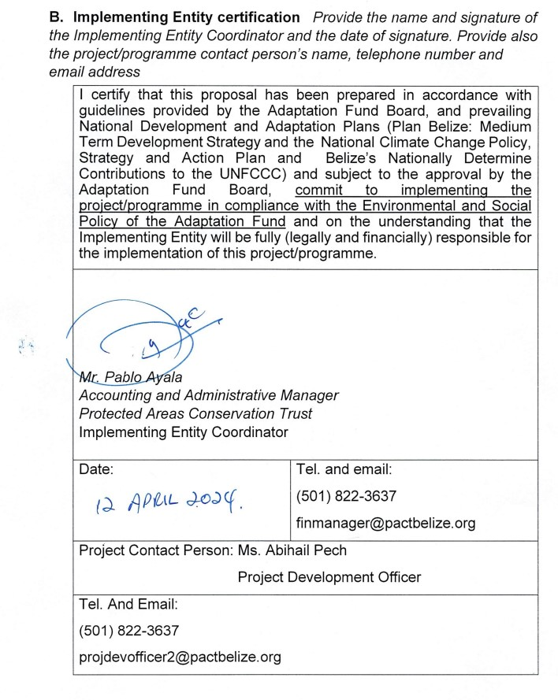

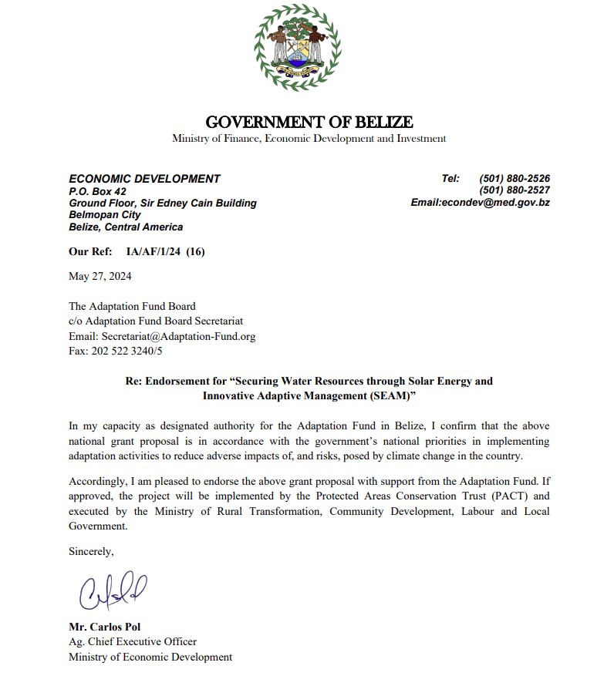

ANNEXES

Annex I: Geology, Geography and Climate

GEOGRAPHY

- BELIZE

Belize is a Central American country, formerly known as British Honduras, that borders Mexico’s Yucatan peninsula to the north and Guatemala to the South and to the West (Izabal Department). Belize also shares an ocean border in the Gulf with Honduras, with Honduras. The national territory of Belize covers a land area of approximately 22,967 km2, including 280 km of coastland. The mainland makes up 95% of the territory, and 5% is represented by small islands or Cays.

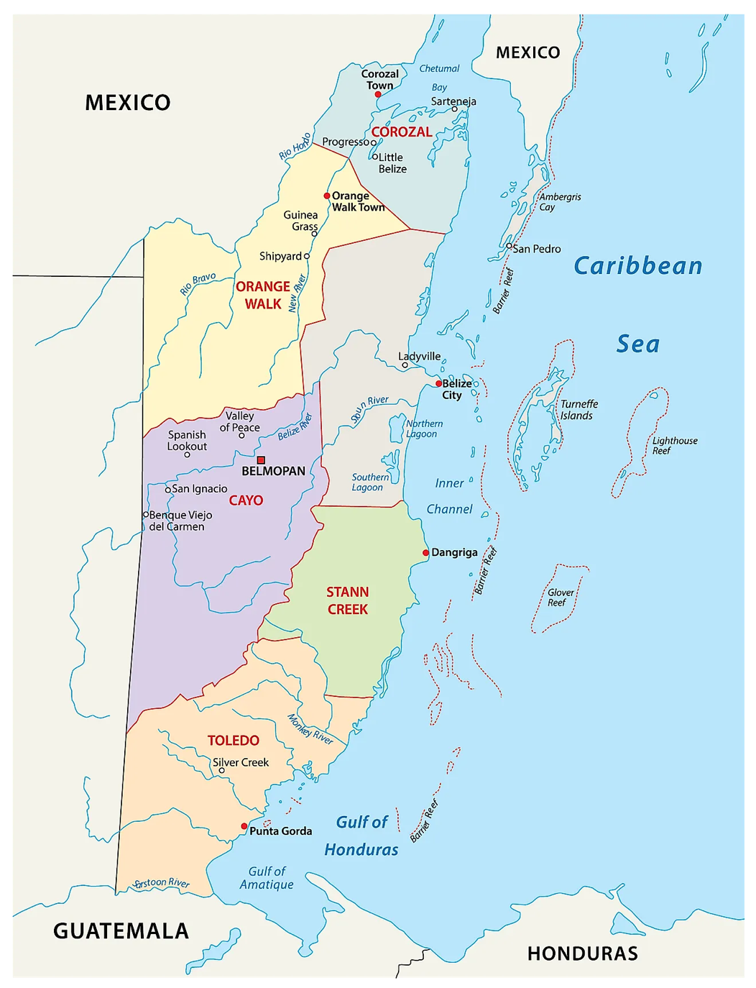
Figure 8: Administrative and Political Map of Belize
To the east, Belize borders the Caribbean Sea, with over 1,000 small islands and cays, along the Caribbean Reef. The southern border of Belize is established by Sarstoon River, which borders Guatemala in the southern front. The western border, which begins south in the Sarstoon River, following the 88°45' West meridian, north until reading the Arroyo Azul, which along with the Blue Creek and Rio Ixno-ha (from the Mexican State of Quintana Roo) are tributaries to the Rio Hondo, forming the north border with Mexico until reaching the Caribbean Sea in the Chetumal estuary. The south and western border are separated by the Maya Mountains range, which begin formation in eastern Belize, cross towards Guatemala, before the Santa Cruz Range.

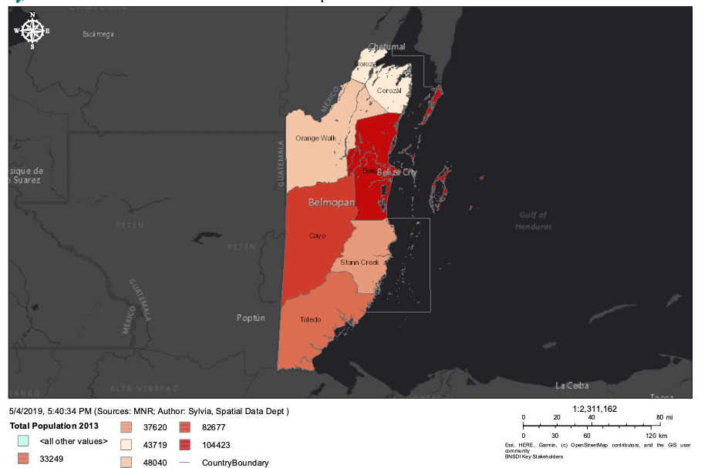
Figure 9: Geospatial map of the six administrative districts of Belize according to population.

The administrative development of Belize closely follows its geographical features; the country is divided into six administrative disticts. Cayo, Orange Walk, Belize, Toledo, Corozal, and Stann Creek Districts. The Cayo District, in western Belize, borders Guatemala, and it's characterized by its strong Maya and Spanish colonial influence, and it's nested in the northern end of the Mayan Mountain range. The Orange Walk District, in the north branching from the Guatemala Border to the eastern Caribbean seaboard, is mostly flat, and where most of the sugar cane farming is carried out. The Stann Creek District borders the Cayo District to the west, Belize District to the north, and Toledo District to the south, with a varied topography which includes the eastern branch of the Mayan mountains, and home to Belize’s highest point, the Victoria Peak (1,120 m). In the southern border, the Toledo District is mostly mountainous, albeit the topography decreases to plains and mangroves as it borders the Caribbean Sea. The central district, Belize District, is home to the largest city, and administrative capital, and also includes the cayes, which as barrier islands that extend some 100km from the coast. Most of the population of Belize is housed in the Belize District.

Each district has an administrative seat, where hospitals, government offices, banks and other services are offered. In the Corozal District, Corozal Town; in the Orange Walk, Orange Walk town; in Stann Creek, Dangriga; Cayo District, San Ignacio; and Toledo District, Punta Gorda.

- PROJECT COMMUNITIES

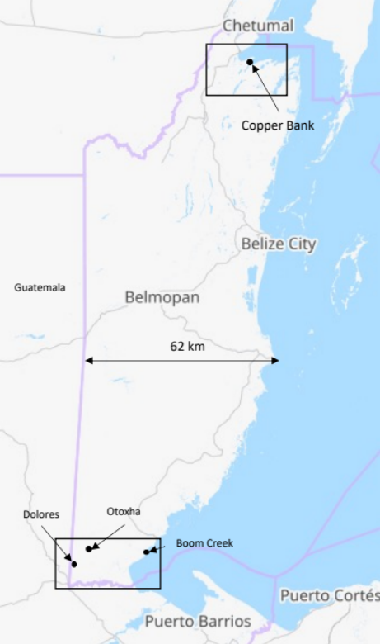
Figure 10: Project Communities, Copper Bank in the north (Corozal District), and Dolores, Otoxha, and Boom Creek to the south(Toledo District).
Three of the project communities, Dolores, Otoxha, and Boom Creek, are located in the Toledo District, a strong Maya enclave in the southern part of the country, a fourth community, Copper Bank, is located in the Corozal District. Dolores and Otoxha, are nearly 7 km apart, and Dolores is about 2km from the border of Guatemala. The largest town to these communities is Modesto Mendez, located in Guatemala. Boom Creek, located towards the western end of the Toledo District, about 15km from the district’s seat, Punta Gorda. The three Toledo district communities have some access to rivers or streams; Boom Creek, is located on the higher banks of the navigable Moho River; Dolores and Otoxha, have tributaries, albeit their water flow varies depending on the time of the year. The four towns are characterized by Maya influence, non-grid pattern street development.

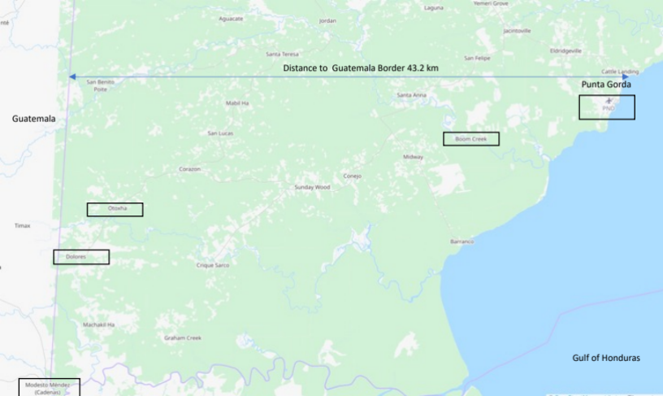
Figure 11: Dolores, Otoxha, and Boom Creek.

Copper Bank, located in the flat plain of the Corozal Bay estuary, 54km in direct distance from the western border of Guatemala, and 11km directly north from the border of Mexicoand 30km driving distance to the Mexican border. The town is connected by (unpaved) road from the main (paved) highway that connects Orange Walk with Corozal Town (26km). In contrast with the Toledo District community, Copper Bank is more urbanized, and has several towns of over 500 inhabitants, nearby, such as Chunox and Sarteneja.

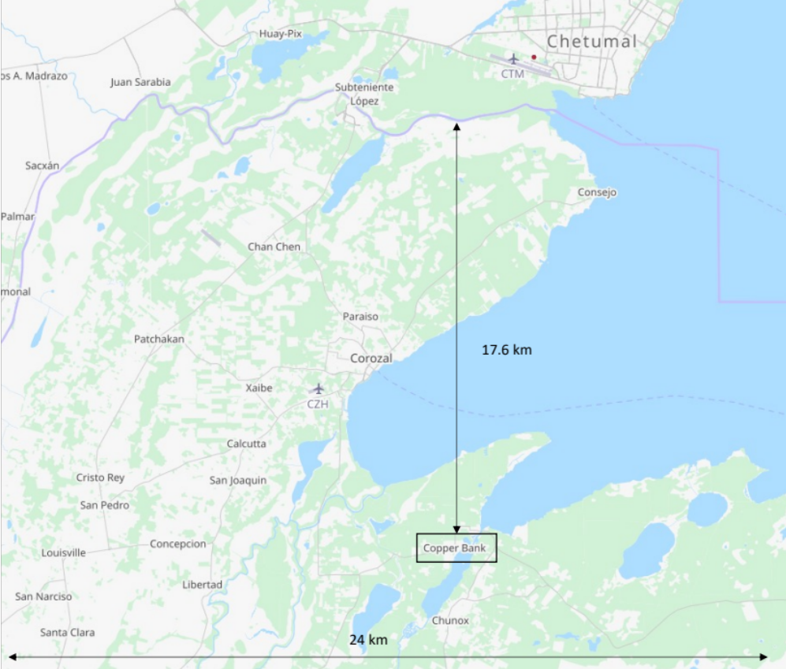
Figure 12: Copper Bank, distances from western (Belize) and norther (Mexico) borders.

GEOLOGICAL FEATRUES

The broad geology of Belize is formed by underlying limestone, with distinction between the northern flatlands and the more mountainous southwest, which are characterized by the Maya Mountains¹. Belize is characterized by seven land regions, which have been cited throughout literature and are also used in soil suite classifications²: Northern Coastal Plains, Bravo Hills, Central Coastal Plan, Central Foothills, Western uplands, Maya Mountains, and the Toledo Foothills. The project communities are located in the Northern Coastal Plain (Copper Bank) and in the Toledo Foothills (Boom Creek, Otoxha, and Dolores). Most rock formation is Belize date from the Crustaceous, through the Cenozoic and towards Neogene periods.

The northern flatlands are of limestone formation, with a shallow layer of clay, low in magnesium content, and limited drainage. The southern part of Belize, especially in the Toledo District, is composed of a mixture formation, from the granite contexture of the Maya mountains, and the limestone formation towards the lower lands².

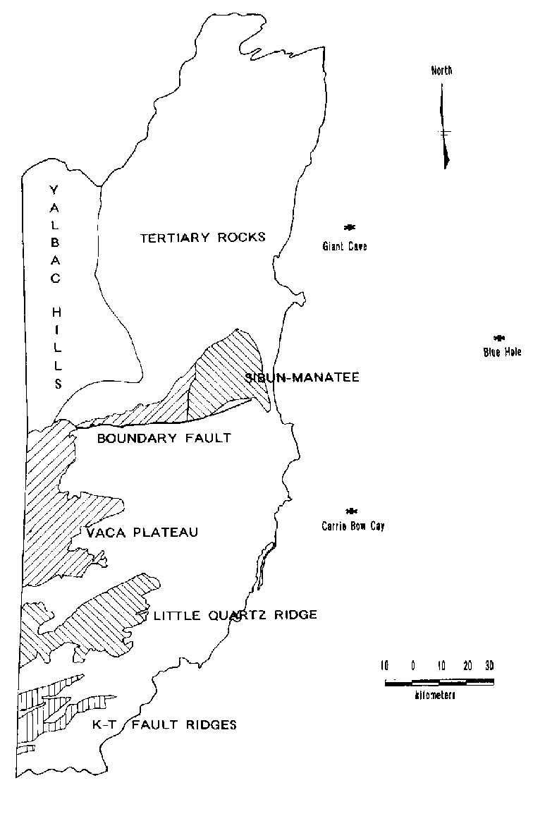
Figure 13: Geological formations in Belize³.
Other relevant regions are the Mayan Mountains and the Western Uplands. The Maya Mountains in Southern Cayo have hard rocks, high and rugged terrain, and diverse vegetation. They range from 120m to 1,124m in altitude, from 20m to 400m in local relief, and from gentle to steep in slope. The Maya Mountains are part of the Santa Rosa formation, dating to the Late Palaeozoic (Late Carboniferous to Permian). Previously, 'Doyle's Delight' was (1,124m) thought to be highest point in Belize; currently, this record is held by Victoria Peak ⁴. Granite is the rock type of much of the Mountain (Maya) Pine Plateau⁵ and the few occurrences of the Stopper Plain with Hills land system. Mountain Pine Plateau is strictly an aplite dyke consisting almost entirely of granular quartz and feldspar. The Maya Mountains, also include several land systems, characterized by the dominant rock types, mostly consisting of metasediments, hard limestone, and granite, which influence the drainage density of the soil⁵. The Western Uplands land region covers the area occupied by Cretaceous limestones in western Southern Cayo, bounded by the Central Foothills in the north, and the Maya Mountains in the east and south. it includes the area demarcated as the Vaca Plateau⁶. This area of Belize is characterized by karst, which include caves, sinkholes, and underwater rivers. The altitude ranges from 180m in the north to 700m in the south in the Maya Mountain border. The depth of the limestone formation, drains much of the rainwater, discouraging settlement.

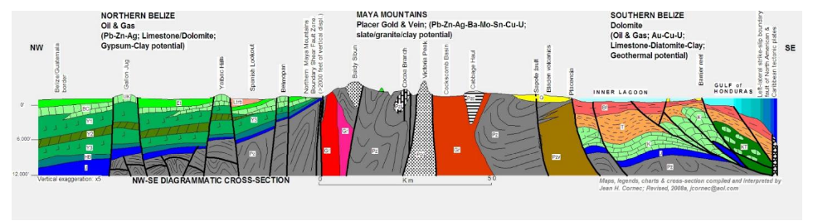
Figure 14: Cross Section of geological features of Belize⁷.

The Corozal District, part of the Northern Coastal Plains Region, also includes several land systems, the Xaibe, Glady, Blackshore, as well as the Jobo plain. The Xaibe system is characterized by shallow soils on flat plains, the Glady, forest savanna or low marsh forest mosaic with dominant forest, the Blackshore, savanna forest mosaic with dominant savanna^{2,7}. The most common rock type found in the Norther Coastal Plain region are limestone, with different levels of hardness, gypseous limestones, flint, chert limestone, alluvium, and hard limestone. Copper Bank located in Xaibe land system, shallow soils, named xaibe puluacax remate, classified as Lithic Ustropept. Xaibe soil, one of the most common soils in northern Belize. Xaibe soil has a shallow, dusky red, clay-textured surface horizon over hard limestone or weathered coral with a base saturation of less than 35 percent. Xaibe soil is well-supplied with bases, but has low effective depth, poor drainage, and micronutrient deficiencies.

The Toledo District, which is part of the Toledo Foothills region, mostly of the Paleogene age, characterized by the Coban Formation², a layer of rock that lies beneath the Western Uplands and the Toledo Foothills. This rock layer is made of thick and huge limestones and dolomites from the Cretaceous period (from about 145 to 90 million years ago). The northern part of the Toledo District, and southern Stann Creek is known for impressive karst landscapes especially in the southern part of the Western Uplands; with large caves, such as the Chiquibul Branch (one of the largest globally), in Stann Creek⁶. The rock layer has a deep section of about 700m of limestones and dolomites with salt deposits in the bottom part. This is the source of the Vaca soil suite, and one of the sources of the Chacalte Suite. The Coban Formation sometimes has shale mixed in and can be sandy. The three project communities in the Toledo District, evidence the influence of limestone drainage systems, limited capacity to sustain water levels during the drier months of the year.

Most relevant (intense) tectonic activity in Belize, arise in the late cretaceous, with minor corrections during in the Tertiary, which distributed sedimentary formations which exist today. Belize lies on the edge of the North American Plate; the boundary between the North American and Caribbean Plates bisects the Gulf of Honduras; with two tectonic regions the with boundary in uplifted the Santa Rosa Group (Maya Mountains). It’s thought that folding of the granite plates, moved some 80 million years ago., which resulted in most of the unique features of Belize, including the Maya Mountains, and the atolls along the barrier reef. The northern plate, characterized by carbonate deposits, which rose some 50m from sea level, in the Tertiary, as movements in the mountains lifted the territory. The Toledo district contains less homogenous tectonic formation, mainly due to the influence of mountains, which greatly influence this part of the country, albeit to a less degree than the central area where Stann Creek, Cayo, and Belize Districts are located. The Toledo District’s formation has been influenced by the diversity of geological context, given that the mostly non-carbonate granite mountains, are bound by sediments and tertiary carbonates, propitious to karst or limestone cave formations.

- Soils

The geological formation of Belize has influenced settlements and current agricultural production. Moreover, it appears that soil and water retention thereof, may have influenced Maya agricultural practices⁷. Milpa farming is often cited as a detriment to soil quality, albeit the term is broad, it would generally refer to cutting and burning a forest parcel, planting, and upon low yields, moving towards a new parcel using the same technique; the unused parcel regenerates forest cover, and the cycle continues. The Milpa farming system is still widely used across Belize, Guatemala, Honduras, and parts of Mexico.

Large forest covers in southern and central Belize allow for Milpa farming, however, as population levels have increased, along with persistent logging activities, the system is inadequate to alleviate soil regeneration sufficiently to accommodate for changes in climate⁸. Soils in the Toledo district, which are classified andosols, vertosols, and inceptisols are more prone to degradation than those soils in the northern part of Belize. These soils are largely developed over solid volcanic rock formation, are prone to degradation as with higher rainfalls. In contrast with the north, where soils fluvaquents, vertosols, gleysols, inceptisols^{2,9}are based on limestone and alluvium, have improved drainage. The northern part of Belize includes most larger settlements, such as Corozal Town, Belmopan, and Belize City.
The type of agricultural production of Belize is strongly influenced by the soil type. The North, provides much of the agricultural production of the country, consisting of sugar cane, bananas, and citrus. Also Mennonite communities in the north of Belize⁷have used modern agricultural techniques, enhanced by soils, to improve yields on corn (yellow), in contrast to the Maya communities who use traditional methods.

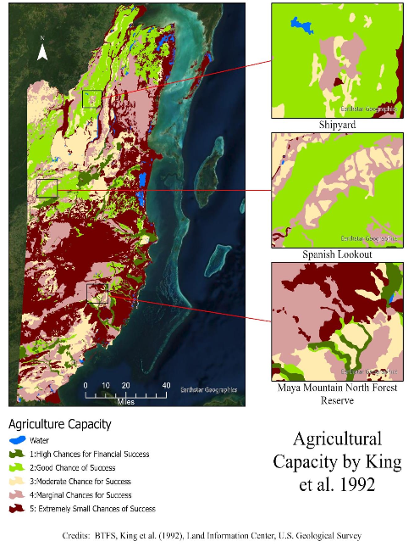
Figure 15: From "Landscape Effects on Soil Fertility Across Belize", 2022. Three communities in distinct areas of Belize, and per King et al (1992), the adequacy of the soil.

CLIMATE

- Hydrology

The hydrology of Belize is influenced by its geology, topography, climate, and land use. Belize has 18 major river catchments and 16 sub-catchments, which drain the Maya Mountains and discharge into the Caribbean Sea.

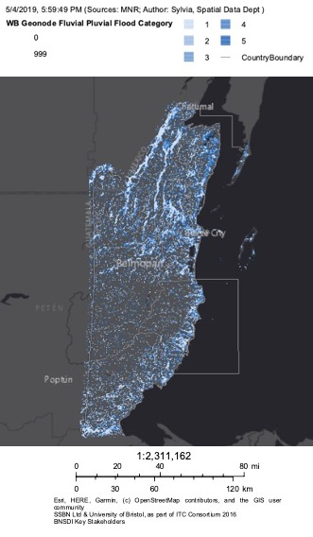
Figure 16: Belize watershed.
Figure XX, illustrates where most creek tributaries merge into larger rivers and estuaries, noting the large drainage in norther part of the country, where project community Copper Bank is located. A 1999 study commissioned by the Ministry of Education, identified sixteen principal watersheds, grouped into six main watershed regions based on general characteristics of topography, geology, soils, rainfall and land use: the Northern Watershed Region, the Northeastern, the Central, the Southeastern, the Southwestern and the Southern Watershed Region.

- Meteorology and climatology

Belize’s climate is humid and tropical, but different from other Caribbean countries, since it is on the mainland, not an island. It has a wet season from May to October, and a dry season from November to April. The temperature is usually 23-27°C, but varies based on location , with the coast being hotter than the inland. The El Niño Southern Oscillation (ENSO) and the Inter-Tropical Convergence Zone (ITCZ) affect Belize’s climate. El Niño makes it warmer from June to August, and La Niña makes it wetter, especially with tropical storms from the Atlantic. In the wet season, the south of Belize gets a lot of rain, 150-400 mm per month. The rest of the country gets very little rain, less than 100 mm per month. Belize can face hurricanes because it is in the path of most of the Atlantic storms¹⁰.

The climate of Central America is controlled by the interaction between the easterly trade winds and the central mountain ridge. The mountains divide the isthmus into a dry subtropical Pacific coast and a humid, tropical Caribbean coast. In the case of the pacific coast, trade winds push surface water away from this steep coast, allowing for nutrient rich deep waters to spout into the photic zone supporting massive phytoplankton generation and thus creating highly productive fisheries. The Caribbean Coast, where Belize is located was an ample, gentle inclined continental shelf, where onshore winds do not spout nutrients, rather, the watersheds, estuaries (mangroves and seagrasses), and corals, fulfil this role. Productive fisheries of Belize are highly dependent on runoffs.

Mean annual temperatures have increased by 0.45°C at an average rate of 0.10°C per decade since 1960. The frequency of hot days and hot nights has increased by 67 days per year, respectively, between 1960 and 2003. The frequency of cold days and cold nights has decreased by 21 days per year, respectively between 1960 and 2003. All seasons appear to have shown decreasing precipitation trends since 1960, only February, March and April have a statistically significant trend. There is insufficient daily observational data to identify trends in all aspects of rainfall extremes in Belize. The magnitude of maximum five-day rainfall shows an increasing trend of 5.37mm per decade over the period 1960 - 2006.

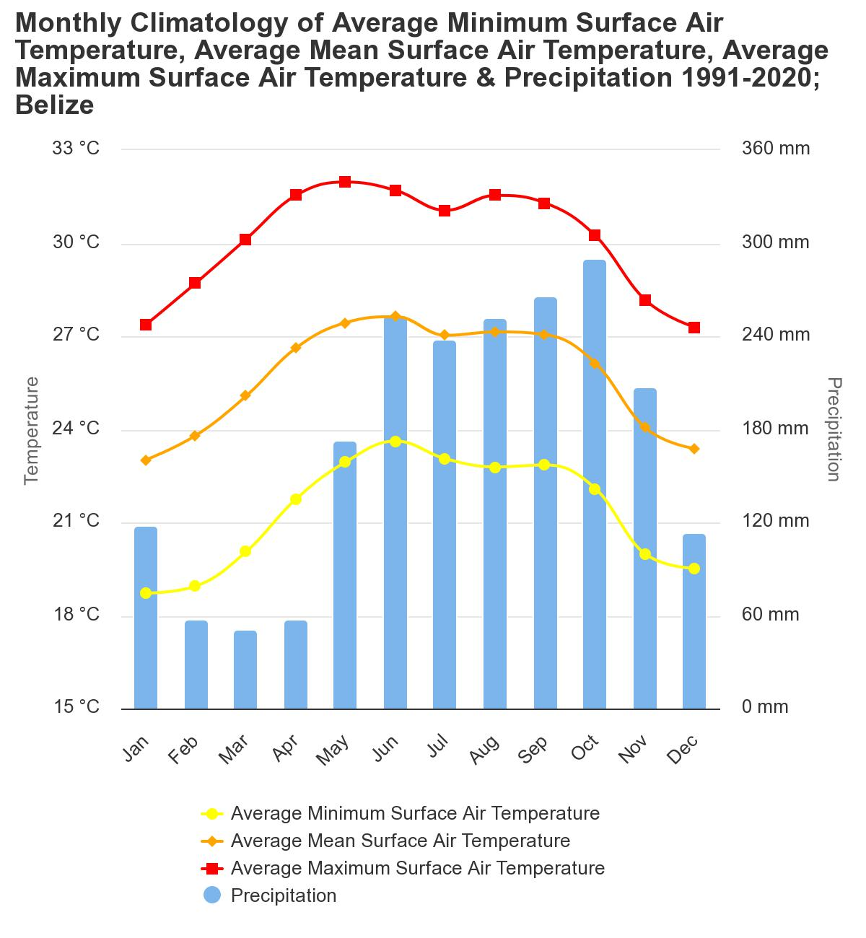
Figure 17: Seasonal surface temperature and precipitation, 1991-2020.
Since 1960, the average annual temperature in Belize has risen by 0.45°C, or 0.10°C every ten years. Between 1960 and 2003, there were 67 more days per year with high temperatures, and 21 fewer days per year with low temperatures. The average annual rainfall in Belize has dropped by 3.1mm per month every ten years since 1960, but this change is not statistically significant. Only the months of February, March and April have shown a clear decline in rainfall. The daily rainfall data is not enough to determine the trends in extreme rainfall events in Belize. However, the maximum amount of rainfall in five days has increased by 5.37 mm every ten years from 1960 to 2006¹⁰.

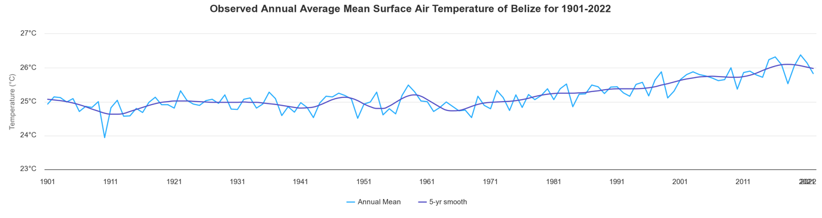
Figure 18: Air Temperature Belize (1901-2022).

Regional climate models such as PRECIS (Providing Regional Climate Impact Scenarios), provide statistical downscaling analysis divided by zone of approximately 25km (grid resolution of 0.22° × 0.22°). This model has been validated for the Caribbean and used for regional impact studies¹¹. The domain is centred on the main Caribbean basin but also includes Caribbean territories in northern South America (Guyana and Suriname) and Central America (Belize). Figure 6 below illustrates the six zones in the Caribbean.

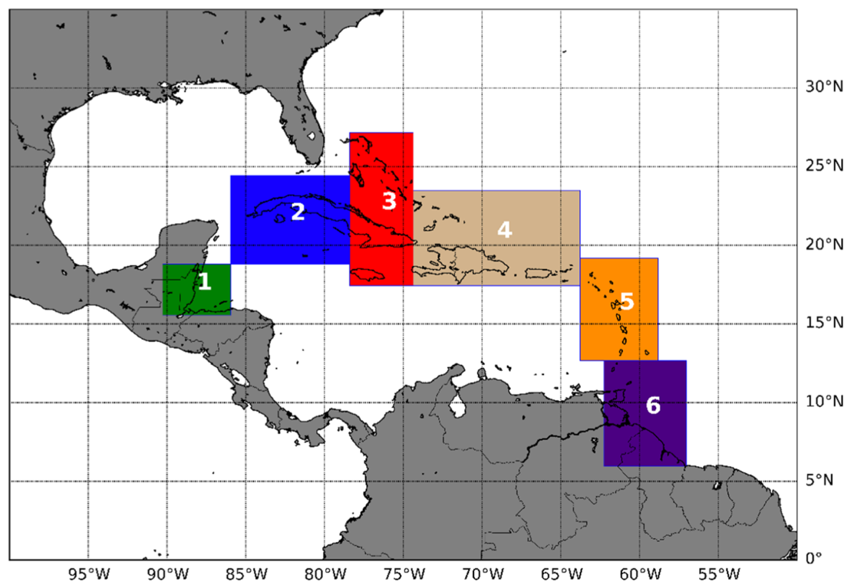
Figure 19: Climatic zones in the Caribbean

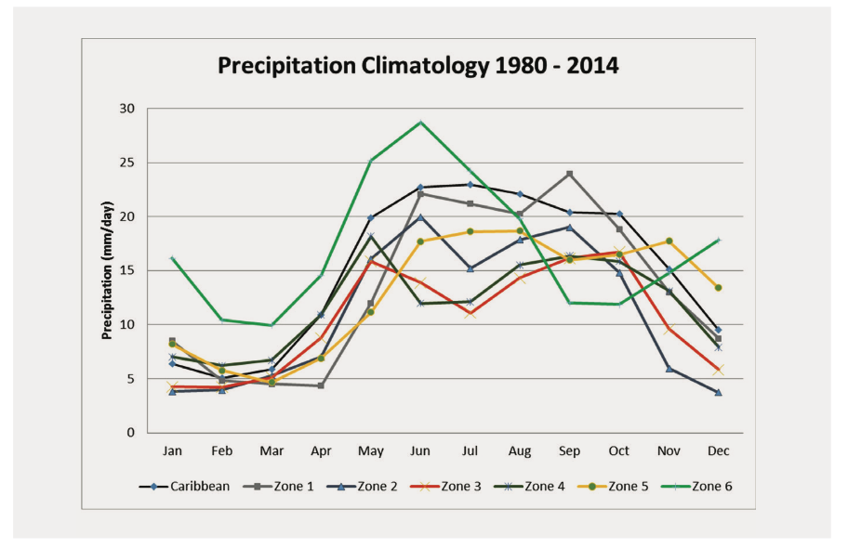

A model projected based on historical LULC maps by Nasa and the University of Alabama¹², illustrates the relationship between meteorology, land use, and changes in climate in both southern and northern Belize. The study modelled changes in land use from 2008 to 2018 to project, under three scenarios, Conservation, Business as Usual, and Development, with the main variable being the rate of deforestation. Belize has had a loss of forest cover of 10% per decade. This forest cover is a major contributor to watershed management, especially in the southern districts (Stann Creek and Toledo). The study demonstrates that, due to its unique geographical location, climate induced rain patterns, along with larger use of forest lands for agriculture and pasture, the southern portion of Belize will increase its watershed runoff. Figure XX illustrates this relationship, the three rivers in the Toledo District have increased their annual flow, Moho, Tamash, and Sartsoon; meanwhile the Rio Hondo, which discharges into Corozal, and the New River, discharges at its mouth on Copper Bank.

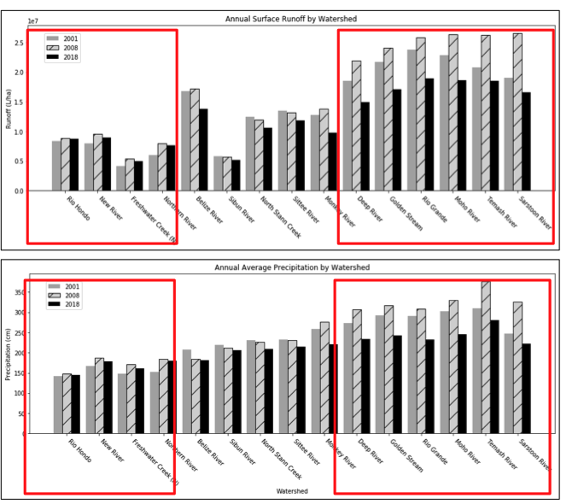

- Climate Projections and Risks

Using the latest models, the IPCC’s Sixth Assessment Report (AR-6) presents different climate scenarios for the Caribbean region. The report uses four SSP’s scenarios, which depend on the amount of GHG emissions: SSP-1, with low GHG emissions (SSP-1 2.6), two intermediate scenarios (SSP-2 4.5 and SSP-3 7.0) and one scenario with very high GHG emissions (SSP-5 8.5). The report compares the average temperature and rain fall levels to the period of 1850-1900, and the sea level rise to the period of 1995-2014. It shows how these variables will change in the short (2021-2040), medium (2041-2060) and long term (2081-2100).

- SSP scenarios | - Mean temp. near-term (2021-2040) | - Mean temp. medium-term (2041-2060) | - Mean temp. long-term (2081-2100)
- SSP-1 2.6 | - 1.3°C | - 1.6°C | - 1.6°C
- SSP-2 4.5 | - 1.3°C | - 1.3°C | - 2.4°C
- SSP-3 7.0 | - 1.3°C | - 1.9°C | - 3.2°C
- SSP-5 8.5 | - 1.4°C | - 2.1°C | - 3.8°C
.
SSP Scenarios | Rainfall near-term (2021-2040) | Rainfall medium-term (2041-2060) | Rainfall long-term (2081-2100)
SSP-1 2.6 | -3.8% | -4.3% | -4.7%
SSP-2 4.5 | -3.6% | -5.9% | -7.3%
SSP-3 7.0 | -4.7% | -8.7% | -18.3%
SSP-5 8.5 | -6.4% | -10% | -21.9%

The Caribbean as a whole will gradually dry through to the end of the century; the trend is likely driven by drying in the late wet season (September-November). The number of consecutive dry days is increasing, as well as the amount of rainfall during rainfall events. Further, climate models suggest sub-regional variation in projections with some parts of the region being more significantly impacted by drier conditions than others. A general pattern is for Belize to be amongst the most severely impacted (zones) once drying has begun.

The Caribbean as a whole, will both gradually warm and dry through the end of the century. Minimum, maximum, and mean temperatures increase irrespective of scenario through this period. Drying is expected to be less in the far north Caribbean and more in the south and southeast. Projections show an increase for both warm days and warm nights by the end of the century, warm days ranged between 51 and 251 days, and warm nights between 24 and 360 days for RCP 8.5. The trend is for a decrease in both cool days and nights. The range for cool days was between 1 and 41 days, and between 1 and 32 days for cool nights for the end of century under RCP 8.5.

There is a general increasing trend in the sea level of the Caribbean region. The trend has intensified over the last decade. A regional rate of increase of 1.8mm ± 0.1 mm/year between 1950 and 2009; higher rate of increase in later years: 1.7 ± 1.3 mm/year between 1993 and 2010. The combined range for projected rise in sea level spans 0.26-0.82m by 2100 relative to 1986-2005 levels. The range is 0.17-0.38 for 2046 – 2065. Other recent studies suggest an upper limit for the Caribbean of up to 1.5m under RCP8.5.

A major concern for Belize, will be the increase in frequency and duration of Atlantic hurricanes, which has intensified since 1995. Projections demonstrate an 80% increase in the frequency of Category 4 and 5 Atlantic hurricanes over the next 80 years (A1B scenario). The frequency is accompanied with stronger storms towards the end of the century, as measured by increases in wind speeds of +2% to +11%.
CONCLUSIONS AND DETERMINATIONS

Belize amounts volumes of research related to the impact of climate change in delicate ecosystems such as coral reefs. However, more research, especially in the impact of watershed management in southern Belize, noting the soil and traditional agricultural practices is needed.

There is an evident difference in the impacts of climate change on the project communities; the Toledo District communities have attributes such as subsistence traditional agriculture and draining soils that require forests to balance runoff. Increased reliance on traditional agricultural methods contribute to decrease in forest covers, mainly due to milpa farming¹³, which in turns limits the capacity of the ecosystem to retain water and deteriorates the nutrient base through excessive runoffs into the Caribbean Sea. Copper Bank, located in the Corozal District, has a distinct exposure to changes in climate, its location on a lagoon estuary, is prone to salination. In contrast to the Toledo District Communities, Copper Bank is an agricultural productive area of Belize with good soils and provides a livelihood for many community members.

The Toledo District communities are faced with combination of factors that will influence livelihoods as changes in climate affect, principally rainfall⁶. The Otoxha and Dolores, close to the Guatemala border, are located in the foothills of the Maya Mountains, a large granite formation that separates the northern and southern part of Belize. Consequently, the limestone and dolomite layer over the granite formation, have allowed for karst and underwater streams, filtering water towards the Moho and Sarstoon watersheds. Incidentally, Boom Creek is located along the Moho River¹². These watersheds have been found to have increased the level of nitrogen and other nutrients, thought to be derived from agricultural activities upriver; a normal level of nutrients allow for phytoplankton in the Caribbean, and sustain fisheries on which many coastal communities depend.

Belize’s meteorology is heavily affected by the eastern winds from the warm Caribbean Ocean, with the southern portion of the country receiving more rain than the north, as influenced by the Intertropical Convergence zone moving north and orographic uplifting in the Maya mountains¹². A region that receives more rain, and whose geological formation are strained by limited water retention will increase runoff into the Caribbean, taking away much needed soil nutrients required by traditional agricultural systems such as Milpa farming. Conversely, surface models predict that the northern part of Belize, will likely receive less rain affecting agricultural practices.

Much of the research reviewed has concentrated in Land Use and Land Cover in Belize; with some research focusing on the impacts of observed changes in air and sea temperature, mostly biased toward coral reefs ecosystems. Air temperatures in Belize are expected to increase in all models, however more research will have to be undertaken to understand how changes in temperature can impact livelihoods.

Work to sustain water in the project communities takes a higher level of relevance, especially in the Toledo District communities. Forest restoration, and climate smart agriculture (on going work by IFAD) are fundamental to modifying the traditional Milpa farming techniques, that which changes in climate and subdued soil conditions, will likely impact their livelihoods and the watershed serving communities downstream and potentially the reef.

Annex II: Implementation and Operations Arrangements

- Main PROJECT Governance Actors

A) PROTECTED AREAS CONSERVATION TRUST (PACT)
PACT, as NIE, will be the grant recipient, and will execute a Legal Agreement with the AF, which will provide terms and conditions that will need to be following during implementation. PACT has the duty to ensure that the proposed project complies with all AF polices, rules and requirements. Additionally, the NIE has the role to ensure the MRT, as EE, abides by the same and oversees that all contracted project participants remain in compliance. Further, PACT’s Procurement Department and Accounts and Finance Department will provide logistical support for project implementation.

B) MINISTRY OF RURAL TRANSFORMATION, COMMUNITY DEVELOPMENT, LABOUR, AND LOCAL GOVERNMENT OF BELIZE (MRT)
The MRT will be the Executing Entity for the Project and will provide guidance and logistical support for the Project Manager, the E&S Specialist, the Gender Specialist, along with the Evaluation Firm. The MRT must ensure that its internal instances are able to ensure the Project Manager is administering project activities accordingly, and that corrective actions are taken.

C) PROJECT STEERING COMMITTEE
The Project Steering Committee, established from members of Belize’s AF Focal Point, the MRT senior officials, and PACT. The role of the Project Steering Committee is to a) review reports issued by the Project Manager, b) provide guidance for successful execution of project activities, c) take corrective action to ensure successful project execution, d) evaluate procurement for those activities not included in the responsibilities of the Technical Committee. The MRT will designate an officer to be chair of the Project Steering Committee.

- Other Key Actors In Project Governance

D) PROJECT MANAGEMENT UNIT
The PMU is a non-permanent entity within the MRT that will administer the project, and reports to the MRT. The PMU is composed of the Project Manager, Technical Officer, the E&S Gender Specialist. The PMU will be led by the Project Manager.

Most of the activities of the PMU will be to undertake procurement, monitor on completion of goals established in the awarded contracts, report to the MRT, the Project Steering Committee and PACT. Further, the PMU will liaison with PACT, MRT field officers, government, and other stakeholders (See Stakeholders). The Project Manager will serve as Chairperson for the Technical Committee.

The Project Manager will maintain budget (including expenditures) records, surveys, contract deliverables, and other key project documents that will be audited and evaluated. The PMU and PACT will also manage the project GRM.

E) TECHNICAL COMMITTEE
The Technical Committee will be formed by the MRT and the Project Manager, and will appoint at least four pro-bono distinguished experts from the following areas:

- Electrical Engineering
- Civil Engineer and Infrastructure
- Indigenous Peoples Affairs
- Civil Society

The role of the Technical Committee is to support the preparation of the Tender Documents, review outputs from hired consultants, provide advice to the Project Manager on project executed related affairs, and support the evaluation of the tender process of Activities 1.1, 3.1, 4.1, and 5.1.

E) GRANT AWARD ENTITIES
Some of the project activities will be implemented by entities that are awarded, by PACT, a grant award. These entities will report on project activities to the Project Manager, according to the reporting requirements included in their grant award contract. Special attention by the Project Manager will be required to monitor the activities of these entities, especially accounting for expenditures. Grant award entities will be required to be available to report to the auditor and the evaluation firm.

The reports issued by the Grant Award entities will be verified by MRT Field Officers in each community.

STAKEHOLDERS

The project will have several stakeholders, that periodically will have to approached and informed. The Project Steering Committee and Communication (See Disclosures, Communication, and Marketing) should provide a sound basis of engagement, however other actions should also be carried out. The project contemplates an E&S Specialist that will have a key role in ensuring that a broad group of identified and new stakeholders have adequate knowledge of the project and understand the role of the GRM.

Name | Institution | Role / Position
Mark Miller & Miriam Choc | Belize Power Limited | Solar Water Pumps and Solar Engineer
Luc Zandvliet | Director Triple R Alliance | CEO, FPIC process and protocol
Leonel Requena | UNDP | Project Manager Female Solar Engineer Project
Gregory Cho’c | Commissioner, Indigenous People Affairs | FPIC process and protocol
Christina Garcia | Ya’axche NGO | Watershed management and Alternative Livelihood experience in Toledo District
Elizabeth Muschamp | Humana Belize NGO | Alternative livelihoods, solar projects, and experience in Toledo District.
Virginia Cal | Tulum Uj Womens Group | Women's group and indigenous women’s needs, experience working with MRT and in southern Belize.
Florencio Martinez | DAVCO Corozal District | Alternative livelihoods, experience in Copper Bank, experience with development and implementation of projects.
Michelle Lindo-Longsworth | BEST NGO | Organization that promotes credits and the participation of women in the social and economic development of Belize.
Anastasia Shal | Xaibe Women’s Group | Women's group from northern Belize who worked together with the MRT on needs of indigenous women
Geraldo Flowers | Resilient Rural Belize | Project manager in charge of a GCF program, which aims to minimize the impacts of climatic and economic events on smallholder farmers
Cynthia Williams | Women and Family Support Department | Gender guidelines, gender in projects, women's role in the communities
William Elder | USDA United States Department of Agriculture | Technical input for watershed management, septic and grey water solutions,
Andy Alberto Arguelles | Chairman of Copper Bank | History, structure and make up of Copper Bank – socio-economic background.
Aldean Williams | Social and Gender Specialist | Social and Gender Specialist of the Philip Goldson Highway and the Remate Bypass Upgrading Project & Coastal Highway Project
Robert Pendell | Rotary Belize | Composting latrine implementation and promotion of latrine use over open defecation with indigenous people in the Toledo District
Delroy Velorio | NAVCO | SEAM Project, training of Water Boards, challenges of sanitation and water in growing communities
Rick Mallory | Rotary Belize | Experience in implementing projects in the Toledo District communities
Heron Moreno | Corozal Sustainable Future Initiative (CSFI) NGO | Experience in implementing projects in the Toledo District communities
Hugo Rancharan | Belize Water Services Ltd. | BWS experience in wastewater management
Table 36: Identified External Stakeholders.

GRANT PROPOSALS

Activities in Component 2 will be undertaken by entities that have experience and track record of working in (or nearby) project communities and that are able to demonstrate administrative capacity to manage grant funding.

During the stakeholder consultation, 14 entities in Belize were interviewed for a) knowledge of project management, b) understanding the characteristics of the project communities, c) track record of managing grants from national or international donors, d) specialization in key project areas such as ecosystem restoration, livelihoods, gender inclusion, and environmental sustainability.

Entities seeking to administer project grants will respond to an Expression of Interest (Scope of Work and Eligibility in Section L) by providing their perspectives on how to undertake the assignment, and meeting the criterion established in PACT’s Conservation Investment Programme Policy, Procedures and Manual. Prior to submitting a full proposal, entities will be required to undergo an Organizational Assessment (OA), per PACT’s guidelines to ensure they qualify to administer the grant. The short list of entities that meet the OA, will be asked to respond to the Call for Proposal by submitting a technical document detailing their perspectives and budget to undertake the assignment.

The MRT, through the Project Manager, and PACT will convene the Technical Committee meeting and evaluate, through a valuation method based on the Call for Proposal, the proposals submitted. The top ranked entity will execute an Investment Contract Letter for the Grant, including disbursement methods and schedule. In the case that the top ranked entity does not agree with contractual obligations, the Project Manager will advise the Technical Committee, and the 2nd top ranked entity will commence contractual negotiations. PACT should provide an indicative budget for the assignment in the Expression of Interest.

The work of these entities should be mostly autonomous, with basic monitoring by the Project Manager and MRT Field Officers. MRT Field Officers should, in their ordinary course of business, engage with the entity when visiting each of the project communities. Further, grant award entities will be required to submit reports to the Project Manager, according to the Monitoring and Reporting Framework for the programme (See Annex III). Entities will be required to submit expenditure reports to the Project Manager and respond to any queries that may arise from annual audits, as well as Mid and Final Evaluation.

Three sub-activities have dedicated Call for Proposals, 3.1.1, 4.1.1, and 5.1.1, and shown in Table 2. Sub-activities 3.12,3.1.3, 4.1.2,4.1.3, are part of 3.1.1, 4.1.1, and 5.1.1, respectively, and are to be included in the Call for Proposal document, please refer to Section L. CALL FOR PROPOSALS.

CALL FOR PROPOSALS

Guidance for drafting Terms of Reference for Activities in Component 2 “Ensuring the sustainability of water resources through improvement of livelihoods opportunities”.

Component 2 has 3 objectives:

- Objective 3. Ensure long term change in attitudes towards water conservation and climate change impacts therein, through restoration of community-near ecosystem services.

- Objective 4. Strengthen the capacities of community members to earn or diversify incomes through enhanced livelihoods options.

- Objective 5. Increased capacities in solar technologies through training of indigenous women in the three Toledo District Communities.

These activities will undertake by entities (Co-managers, per PACT) specialized in administering grants through a Call for Proposal process. According to PACT’s Conservation Investment Program Policy and Procedures Manual, grants (investments) over B$ 20,000 are required to demonstrate Organizational Capacity (OA), that ensures PACT and the MRT that the entity has effective control mechanisms to administer the grant and undertake project activities. Upon confirmation of the OA, entities will be invited to participate in the Call for Proposals. The Call for Proposal Process is outlined in Figure 6.

Figure 20: Call for Proposal Process
- Preparation of Selection documents: Includes a) Project Description, b) Scope of Work, c) eligibility requirements, d) evaluation criteria. The evaluation criteria should have the dual purpose, to provide the interested entities with guidance on what is being requested, and to facilitate the evaluation of proposals (see Step 5).

- Expression of Interest (EOI): Document that indicates the service request, documentation that interested parties are required to submit, budget, and eligibility criteria. In this stage, entities will not be required to send proposal documents, rather, they should provide OA requirements; publishing the budget should also allow adequate parties to submit requirements. Sufficient time should be given for parties to collate all required information, at least five weeks. All firms that meet the criterion established in the EOI should be invited to submit proposals. Suggested minimum eligibility criteria:
  - National registration.
  - Background (short summary of the entity’s description).
  - OA assessment information.
  - Key personnel of the entity.
  - Tools and assets: including staff, software, and other assets that help the entity achieve its goals.

- Invitation to Submit Proposals: Document that evaluates the entity’s capacity, track record, and experience to undertake the project’s activity. These proposals should have a minimum level of structure to facilitate the evaluation process but should not be prescriptive in terms of format. The suggested structure is the following:
  - Description of the Entity and history.
  - Experience in managing grants for similar projects.
  - Track record of working with the project communities
  - Work Approach and Methodology, including deployable assets.
  - List of indicators (Logic frame) that will provide results to meet the given project Objective.
  - Work Plan.
  - Detailed Budget.

- Technical Committee Review: The Project Manager will distribute evaluation worksheets to all Committee members, which will include an excel worksheet with valuation of each criterion that must be met (See Step 1), the Invitation to Submit Documents, and the submitted proposals. Each member of the technical Committee will independently review the documents and assign a score in the excel worksheet; typically, a week is provided.

- Evaluation of Proposals. The Project Manager will consolidate all the evaluations and will present a tally of the scores. A meeting, physical or over Teams, will be summoned for the Technical Committee to discuss their perspectives. This process should be documented. It’s suggested that of a 6-member Technical Committee, a minimum quorum of 4 for the Technical Review is needed. The Project Manager will draft a resolution, indicating the results of the evaluation and the discussion, and this will be provided to PACT to inform the top ranked entity; entities that were not top ranked should be notified promptly indicating their score, and the next steps in the process in the case negotiations with the top ranked firm fail.

- Contract Negotiations and Award. The top ranked entity will be provided with a contract by PACT; assuming that all the conditions therein are accepted, the entity will be notified of the award and inception meetings can be established. PACT will publish, on its web page, the notification of the award, no later than 30 days after the award has been granted.

Project Objectives and Activities (Sub-Activities) under Call for Proposal

Objective 3. Ensure long term change in attitudes towards water preservation and climate change impacts therein, through restoration of community-near ecosystem services. Objective 3 has 1 Activity (3.1) “Restoration and sustainability actions of community-near ecosystems services that impact the water supply and livelihoods”.

- Activity (3.1.1) Grant for entities with experience working with Toledo District communities in ecosystem restoration, reforestation, and watershed risks.

Activity 3.1 aims to provide the three communities in the Toledo District through forest regeneration and restoration amongst others, that contribute to improving the health of the watershed. Restoration actions include reforestation of non-productive land areas around the community with local flora, and income-revenue cultivars such as coffee and cocoa. Much of the work in Activity 3.1 is directly related to improvement of livelihoods (Activity 4.1), given that all communities rely heavily in agriculture and pasture. Entities seeking a grant under Activity 3.1 will be required to also meet the criteria for Activity 4.1. PACT and the MRT PMU, with support from the Technical Committee will prepare the Call for Proposal document, including the evaluation methodology.

Entities submitting proposals will be evaluated on the following criteria:

- Provide a work plan that includes a preliminary land survey of restoration options in each community, with specific species, and clear indications on how the work will ensure restoration or improvement of water retention of the aquifers and the watershed. The work plan should also detail the sequence of actions, resources required to undertake actions, personnel in the field, and community liaison.
- Entities will be required to provide a monitor plan, with geospatial and remote sensing services to determine, over time, the improvement in soils, forest cover, and updated agricultural activities.
- Detailed budget of all activities, including any cost of workshops to be carried out during the assignment.
- Plan for community consultation, sensitization and awareness raising on climate change, ecosystem plan and natural resources management, mangroves, etc.
- Provide evidence of experience working in the Toledo District, with attention to work with indigenous communities.
- Knowledge of community assets is key, including ancestral traditions and customs.

Eligibility of Grant Award Entities:

- CSOs, NGOs, and/or CBOs legally based in Belize, with track record on the above mentioned activities.
- Solid fiduciary capacities.
- Experience working with GEF or other climate funds preferable.

Objective 3. Ensure long term change in attitudes towards water preservation and climate change impacts therein, through restoration of community-near ecosystem services. Objective 3 has 1 Activity (3.1), “Restoration and sustainability actions of community-near ecosystems services that impact the water supply and livelihoods”.

- Activity (3.1.2) Activity (3.1.2) Grant for entities with experience working with Corozal District communities in costal management, biodiversity, and other ecosystem services in the Corozal Bay area.

Activity 3.1 aims to provide Copper Bank with livelihood options through conservation of the nearby Corozal bay watershed system. Similar actions have already been successfully implemented by the Corozal Bay Wildlife Sanctuary. Mangrove (and seagrass) replenishment has demonstrated to improve the estuary’s health in recent years thus more intervention in this regard will improve the quality and quantity of the fisheries that maintain the livelihoods of many of Copper Bank’s livelihoods. Further, these actions should be complementary and coherent with the work of the Mesoamerican Reef Fund (MAR), who has set restoration and conservation guidance for the Corozal Bay. Much of the work in Activity 3.1 is directly related to improvement of livelihoods (Activity 4.1), given that Copper Bank relies on the estuary as a major livelihood source. Entities seeking a grant under Activity 3.1 will be required to also meet the criteria for Activity 4.1. PACT and the MRT PMU, with support from the Technical Committee, will prepare the Call for Proposal document, including the evaluation methodology.

Entities submitting proposals will be evaluated on the following criteria:

- Provide detailed plan of conservation actions in the Corozal Bay estuary and watershed, including remote sensing data on how the grant’s actions will contribute to restoring and/or conserving the ecosystem that the Copper Bank relies for its livelihoods and water supply. The work plan should include a sequence of actions and activities, along with the required personnel to carry out all the set activities.
- Provide a detailed monitoring and reporting plan, coherent with guidelines established by the Mesoamerican Reef Fund, and the project’s objectives.
- Plan for community consultation, sensitization and awareness raising on climate change, ecosystem plan and natural resources management, mangroves, etc.
- Provide evidence of track record of project, through achievement indicators, of the results obtained in prior assignments.
- Provide evidence or perspectives on integrating gender inclusiveness into the livelihood’s programs. (Some entities may not have gender expertise but may be able to onboard a Gender specialist).

Eligibility of Grant Award Entities:

- CSOs, NGOs, and/or CBOs legally based in Belize, with track record on the above mentioned activities.
- Solid fiduciary capacities.
- Experience working with GEF or other climate funds preferable.

Objective 4. Strengthen the capacities of community members to earn or diversify incomes through enhanced livelihoods options.

Objective 4 has one Activity (4.1) “Activity (4.1) Enhancing the participation of men and women in alternative livelihoods through ecosystem restoration and improvement practices”. Activity 4.1 will be executed through 4 sub activities.

- Activity (4.1.1) Development of a gender-responsive needs assessment considering the interests and needs of women, men, and youth in the communities, to be carried out by the entity responsible of this activity before implementation.
- Activity (4.1.2) Workshops on gender equality and women's rights for the communities are carried out by entity awarded with grant for 4.1.
- Activity (4.1.3) Workshops and other skill building exercises related to livelihood options that allow community member to gain new skills, enhance current skills, or improve existing livelihoods.
- Activity (4.1.4) Community seminar or workshops that socialize the risks faced by community members in climate change and opportunities to mitigate through participation in project activities.

Activity 4.1 aims to build on the restoration and conservation efforts in the communities under Activity 3.1. The activity will be executed by the entity awarded the grant for either Activity 3.1.1 (Toledo District) and Activity 3.1.2 (Corozal District); coherent with the project’s goal statement “if communities and rural authorities are empowered to appreciate their water resources which are affected by climate change, THEN investments in capacity building and water sustainability and its relationship to their livelihoods will allow communities to be more resilient, BECAUSE enhanced ownership in their communities is vested in strong inclusive participation and governance”. Both grant entities will be required to demonstrate capacity to build capacities that increase the income of local communities related to water supply, water conservation, and ecosystem conservation and restoration. The focus will be different for Toledo District than for Corozal, the Toledo District exhibits higher levels of poverty and lower levels of education, and most livelihoods are dependent on land use, with very limited opportunities to create new sources of income (such as commerce and services). In the case of Copper Bank, there are a broader set of opportunities to enhance current livelihoods related to the Corozal Bay estuary; these have been already implemented in nearby communities in Sarteneja and Chunox. Entities seeking a grant under Activity 4.1 will be required to meet the criteria for Activity 4.1. PACT and the MRT PMU, with support from the Technical Committee, will prepare the Call for Proposal document, including the evaluation methodology.

Entities submitting proposals will be evaluated on the following criteria (in addition to 3.1 criteria):

- Provide detailed work plan based on an ex-ante livelihood assessment of each community, including guidance on how to undertake the gender requirement of this assignment.
- Provide personnel details with experience in working with indigenous (Toledo District mandatory) and vulnerable populations, especially women and young adults.
- Provide a list, with detail on each workshop to be held to foster skills and capacity improvements, including tools to be deployed, and expected outcomes.
- For Toledo District: Provide evidence and context of experience working in livelihood improvements in the Toledo District.
- For Corozal District: provide evidence and context of experience working in livelihood improvements for coastal communities.
- Provide a monitoring and reporting plan.
- Provide evidence of track record of project, through achievement indicators, of the results obtained in prior assignments.

Eligibility of Grant Award Entities:

- Same conditions for Activity 4.1.

Objective 5. Increased capacities in solar technologies through training of indigenous women in the three Toledo District Communities.

Objective 5 has one Activity (5.1) “Enhancing the participation of men and women through workshops and capacity building activities in maintenance and installation of solar systems”, and one sub-activity:

- Activity (5.1.1) Call for Proposals for entities with experience in working with women on maintenance and installation of distributed energy for the Toledo District

Activity 5.1 seeks to provide a stop gap for the work of Activity 2.1.2 “Provide maintenance and trainings materials, along with capacity building to the communities (Councils, waterboards, and MRT officers) on the built systems” and enhance Activity 3.1. During consultation, it was indicated that not all livelihood options related to ecosystems restoration may be accepted by members of the community. In this sense, other livelihood options will be required.

Otoxha, Dolores and Boom Creek, do not have electricity service, and several NGOs have worked on Toledo District communities in teaching primarily women and some men to service solar electric systems; using the Barefoot Collage method adapted to Belize. Thus, the project will seek to enhance livelihood options through capacity building and maintenance of solar energy solutions in their villages.

The sub-activities are to be carried out by a single contract with a grant entity which will have to meet the following minimum requirements:

- Provide evidence of experience working with women and/or women’s group in distributed energy.
- Provide evidence and context of experience working in the Toledo District and with indigenous communities.
- Provide evidence of track record of project, through achievement indicators, of the results obtained in prior assignments.

The entity should be able to demonstrate the teaching methods, contacts for purchasing equipment, and business management curriculum.

PROJECT MANAGEMENT UNIT (PMU)

The project will be managed through a PMU established within the MRT. The PMU will be guided with this document and may draft other documents such as a project operation manual when fully established. The success of the project depends on the staffing of the PMU, given the level of responsibility assigned. The PMU will be composed of a three-person team, a) a Full-Time seasoned Project Manager, b) A Full-Time Technical Officer c) a Part Time E&S Specialist, and d) a Part Time Gender Specialist. The PMU will work as a team, supporting procurement, oversight and monitoring, and reporting. Figure 7 provides an illustration of the structure of the PMU.
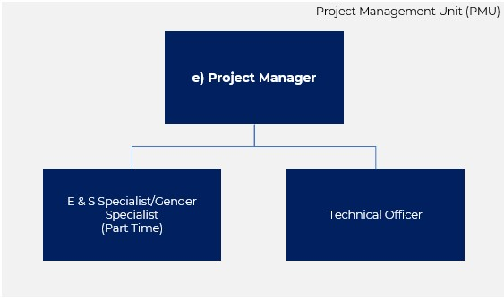
Figure 21: SEAM PMU

Project Manager: Lead administrator of the PMU, and main contact for the project. The Project Manager will be available from the beginning of project implementation until closure.

E&S Gender Specialist: Supports to assess and monitor the project’s environmental and social risks during project implementation. Lead to mainstream gender into all the project’s results framework, encompassing a gender perspective in its outcomes, objectives, components, and activities.

Technical Officer: Coordinates the activities associated with the projects and provide support to the project manager. The TO perform various administrative and technical tasks to ensure the smooth running of processes and systems. Your goal is to ensure the successful and efficient completion of projects.

- Project Manager

The Project Manager is a critical actor for the successful implementation of the project, as this role will be tasked with organizing, administering, procuring, monitoring, and reporting all project activities. Guidance of procuring the Project Manager:

Minimum Qualifications

- At least 7 years of experience working managing programs with donor funds.
- Experience developing and tracking budgets and working in the MS 365 system.
- Experience monitoring liaison with a broad group of stakeholders.
- Experience drafting reports and tracking log frame indicators.
- Degree from the following fields: Accounting and Finance, Economics, Engineering.

Desirable Qualifications

- Over 10 years of work experience managing programs for the European Union, GEF, USAID, World Bank, CDB.
- Experience IPSAS accounting or accounting for development projects.
- Experience monitoring liaison with a broad group of stakeholders.
- Experience drafting and presenting reports and tracking log frame indicators.
- PMP Certification.

Scope of Work

The Project Manager will be tasked with administering and reporting all Project Activities, including:

- Management and supervision of the Project Management Unit within the MRT.
- Convening different project stakeholders, including the Project Steering Committee, government actors, the MRT, PACT amongst others.
- Prepare reports on budget expenditures and commitments to ensure project funds are accounted properly and according to best practices.
- Monitor and liaison with those monitor specific project activities, through daily exchange to ensure project activities are carried out adequately and timely.
- Draft procurement documents and negotiate contracts with consultants, suppliers, and firms.
- Liaison with PACT regarding potential grievances submitted to the PACT’s GRM.
- Review and accept work undertaken by consultants, PMU specialists, and other stakeholders of the project to ensure compliance with project activities.
- Provide monitoring reports to PACT in accordance with the expectations of PACT and the AF.
- Engage with the project Auditor and Evaluator to allow, in the most independent manner, their work to be carried out effectively.

- Environmental , social & Gender Specialist

The Specialistwill assess and monitor the project’s environmental, social and gender risks during project implementation. While the project is not expected to have consequential E,S & Gender risks or adverse impacts, the nature of the communities, and the fact that workers and consultants are foreign to those communities requires additional safeguards to ensure all parties are informed and not adversely impacted by project activities. The Specialist will ensure the project is in full compliance with PACT’s E&S Policy and Procedures as well as maintains compliance with AF obligations. The project has been designed to mainstream gender into all its results framework, encompassing a gender perspective in its outcomes, objectives, components, and activities. The strategy employed by the project rests on three fundamental pillars. Firstly, a dedicated specialist is integral to the PMU, entrusted with the responsibility of steadfastly upholding the gender perspective throughout the project's lifecycle. This expert not only contributes significantly to the project's monitoring and evaluation but also serves as a custodian of best practices, ensuring that gender considerations remain embedded in every facet of the initiative.
This will be on a part time basis.

Minimum Qualifications

- At least five years of work experience within private, public sector, NGOs, or international donors reviewing EIAs, ESAPs, and similar.
- Degree in the following: environmental sciences, environmental Health and Safety, social sciences, or other related discipline.
- Experience working within rural communities in Belize.
- Knowledge of IFC Performance Standards.
- Previous work experience with Indigenous Communities of Belize.

Desired Qualifications

- At least 10 years of work experience within private, public sector, NGOs, or international donors reviewing Environmental Polices, EIAs, ESAPs, and similar.
- At least 5 years of professional experience in policy analysis and advocacy
- Post-Graduate (master’s degree) environmental sciences, Environmental Health and Safety, Social Sciences, economics, gender issues or other related discipline.
- Experience working as an Environmental, Social & Gender Specialist or E&S risk management in project’s funded by international donors such as CDB, IaDB, WB. Experience working with policies and legislation related to social issues within Belize, including FPIC and other indigenous rights agreements.
- Program/project management, and knowledge management, addressing the
promotion of gender equality and women's empowerment.
- Demonstrated substantive skills in design and implementation of gender equality and women's empowerment activities.
- Experience in gender statistics and gender database development would be an asset.
- Language proficiency in Mayan languages strongly preferred
- Experience in stakeholder/citizen engagement, community outreach, consultations and GRM, outreach and awareness/capacity building programs.

Scope of Work

- On the basis of the Section XX of the Proposal Document, update the Project’s Environmental and Social Assessment to current conditions, included updated surveys, stakeholder consultations, and other actions.
- Draft an Environmental and Social Action Plan with effective measures for each of the project Activities in each of the Communities.
- Communicate and advise stakeholders on the project’s Grievance Redress Mechanism.
- Update E&S instruments as needed.
- Work with the PMU and PACT procurement staff to ensure that environmental and social aspects are incorporated as appropriate in contracts for goods and services and that suppliers and contractors are fully aware of their responsibilities in this regard.
- Ensure that the necessary environmental authorizations and permits are obtained where needed.
- Support with monitoring to ensure that the consultants and contractors comply with the PACT’s Environmental and Social Policy and Guidelines.

- Support gender mainstreaming in overall project implementation,
- Capacity building and training of MRT / PMU Monitoring and reporting.
- Facilitate the incorporation of gender in project’s Terms of Reference and other procurement documents.
- Monitor and track indicators related to the project’s Gender Action Plan.
- Support reporting to PACT and the AF by the PMU.
- Provide inputs for PACT, the MRT, and the Project Manager in relation to

- Provide contributions to the regular, semi-annual and annual progress report on the project’s implementation as required by the PACT and the MRT through the Project Manager.

- .

- tECHNICAL oFFICER

The Technical Officer will provide technical and administrative support to the Project Manager and contribute to the effective and efficient delivery of technical activities (inputs, consultancies, processes, outputs, and outcomes) under the project.

Qualifications

- Minimum of a Bachelor’s degree in Environmental management/Natural Resource Management/Project Management or equivalent field.
- A minimum of 5 years of demonstrated experience in coordination management of environmental issues, policies, biodiversity, ecosystems protected areas, forest management and water resources management.
- At least 3 years demonstrated experience in Project execution and management.

Scope of Work

- Conduct regular site visits to monitor progress of project implementation and prepare reports.
- Co-ordinate the implementation of project activities as needed.
- Review and comment on technical project deliverables prepared by consultants and advise the Project Manager regarding the quality of the work undertaken and alignment with required standards.
- Assist the Project Manager in the development of the annual work plans for the project.
- Assist the Project Manager in organizing and facilitating revision meetings with partners as needed to ensure the timely revision and acceptance of technical deliverables.
- Other related duties as required by the project and instructed by the Project Manager.

PROJECT STEERING COMMITTEE (PSC)

The Project Steering Committee (PSC) will be chaired by the CEO or a designated representative in the MRT, and:

- CEO or a designated representative in the Ministry of Health & Wellness,
- CEO or a designated representative in the Ministry of Human Development Families & Indigenous People’ Affairs,
- Executive Director or a designated representative of PACT,
- CEO a designated representative in the Department of Economic Development (AF Focal Point).

The Project Manager is the recording secretary and ex-officio observer. The Project Steering Committee’s responsibilities are to initiate, promote and provide overall direction and decision-making authority to the three components of SEAM:

- Provide guidance to the progress of project activities.
- Review and endorse the project’s budget execution, including expenditures and commitments.
- Review and comment on the project quarterly progress reports.
- Discuss and facilitate critical decisions for the implementation of components.
- Review and where necessary act on annual audit reports and recommendations.
- Review and act on any action PACT is required to carry out on behalf of the AF.

The PSC does not have the authority to direct the project to undertake activities or finance expenditures that are not consistent with and supportive of the objectives of the project.

The PSC will meet quarterly for the first 2 years of the project, on a twice-yearly basis, thereafter and additionally if deemed necessary and called for by the chairs. One reason for meeting on a quarterly basis is the importance of ensuring effective coordination between the Project Manager, PACT, and the MRT. If it is found that this level of oversight is not required, the PSC could decide to move to twice per year meetings. PACT and the PMU may modify the scope of work of this committee to ensure project effectiveness.

PROJECT TECHNCIAL COMMITTEE (PTC)

The project will be served by a Technical Committee that will have specific roles, related to procurement and deliverables. In contrast to the Project Steering Committee that deals with project management issues, the Technical Committee is dedicated to ensuring that deliverables and works under the awarded contracts are delivered according to the technical specification agreed upon, and to best practices. The Committee will meet on a as needed basis, and membership is pro-bono.

Scope of work of the Technical Committee:

- Review and provide advice to the PMU on Procurement and Call for Proposal Documents.
- Participate in the evaluation of Procurement and Call for Proposal processes.
- Ensure that contractual conditions included by the PMU in relevant contracts can safeguard the interest of PACT, the MRT, and the achievement of project objectives.
- Review and provide advice to the PMU on deliverables of consultants and contractors.
- Support and provide advice to the PMU in engaging FPIC Communities, ensuring that protocols are applied according to national statue by the PMU.

Membership

- A qualified professional with experience or background in electrical engineering, preferably in solar infrastructure.
- A qualified professional with experience or background in civil engineering and/or Infrastructure, preferably in water systems in Belize.
- A seasoned expert or representative with experience working in Indigenous Peoples Affairs in Belize
- A qualified professional with experience or background in working with grant-based NGOs in Belize.

PACT and the PMU may modify the scope of work of this committee to ensure project effectiveness.

IMPLEMENTATION SCHEDULE

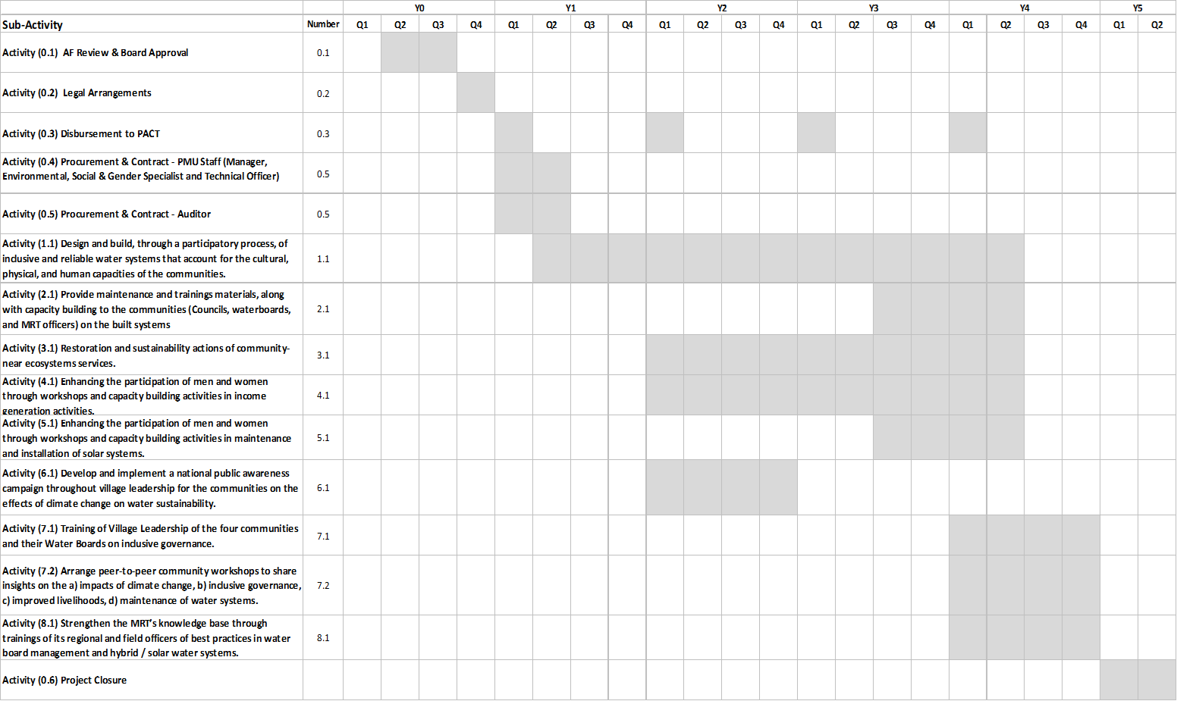

Table 37: Implementation schedule.

Annex III: Logic Framework, Monitoring and Reporting, Detailed Budget, Financial Model

Rationale for Components and Activities

Component 1: Design and build cost-effective solar hybrid sustainable water systems and waste management systems in the four selected communities that will allow households to have access to potable and reliable water service as well as waste management.

Rationale: The four communities have limited or no access to reliable potable water, which increases health and livelihood vulnerabilities. To provide the communities with reliable water service, several actions must take place, such as designing a system that is adequate to the needs and considerations of each community, ensuring that Water Boards are established, and necessary training is provided for its operation as to ensure the sustainability of the investment. Component 1 has two objectives and will be executed by the MRT’s PMU through procured consultants and engineers.

- Objective 1: Reduce exposure to climate variability in four rural communities of Belize through an inclusive drought-resistant potable and reliable water supply.

This objective aims to design and build a water system that is resilient to climate variability in four communities.

- Objective 2: Strengthen the capacities of community members and leaders to operate and maintain their village water system.

This objective aims to establish and train Water Boards to ensure built systems are operating properly and sustainably.

As indicated in Annex VI of the Proposal Document, there are four project communities located in two distinct districts, the Toledo District, and the Corozal District. The two districts are remarkably different, in terms of infrastructure, geology, culture, and livelihoods. Copper Bank, in the Corozal District, has grid energy from the national distribution company Belize Electricity Limited (BEL); while the three communities in the Toledo District, Otoxha, Dolores, and Boom Creek, are not connected to Belize’s energy grid. Further, in terms of geology, the two districts have distinct features; the Toledo District communities are located in the foothills of the granite Maya Mountains, which subdue a layer of limestone and dolomite formation, leading to the creation of karst or limestone mounts and cave formation. The geology impacts the soil quality (refer to Annex I of Proposal Document), while both district’s soils are clay based on the limestone, the soils in the Corozal District are more productive for sugar cane and citrus production, while the soils in the Toledo District, are more geared towards livestock, beans, and maize farming. The practice of milpa farming is a concern throughout the Toledo District, as it involves clearing native forest for agriculture, at times through fires, and planting until the soils no longer yield due to nutrient deficiency. Modern farming techniques have been able to substantially improve on this, especially in Mennonite Communities of Belize, but are seldom used in more rural Maya communities. Moreover, logging and milpa farming impact the capacity of the limestone aquifers to produce and store water, which exacerbates the issue. The project seeks to address depleting practices by designing activities to protect the ecosystem and build water systems tailored to each community. Note that Activities 1.1 and 1.2 are to be undertaken separately precisely for this (and other) reasons such as depth of persistent phreatic zones, agricultural zones, and community inputs.

Component 2: Ensuring the sustainability of water resources through improvement of livelihoods opportunities.

Rationale: Two identified factors influence the sustainability of water supply in the four communities, a) deterioration of the ecosystem that produces or stores water, b) limited incomes to afford sustainability of the water service to each household. The project seeks to address these factors through strengthening the capacities of each community to increase ability to earn income from other sources and improve the nearby ecosystems to ensure sufficient water production. Component 2 has 3 objectives and will be executed by the MRT through grants provided to eligible entities.

- Objective 3. Ensure long term change in attitudes towards water conservation and climate change impacts therein, through restoration of community-near ecosystem services.

Deforestation, added to the nature of soils and limestone formations, in Belize, have increased the proper functioning of watersheds. It’s expected that climate change, with rainfall variability will exacerbate this situation. It’s critical that project communities, especially those in the Toledo District, are aware and take action to ensure that the nearby ecosystem services are sustainable.

- Objective 4. Strengthen the capacities of community members to earn or diversify incomes through enhanced livelihoods options.
- Objective 5. Increased capacities in solar technologies through training of indigenous women in the three Toledo District Communities.

Objectives 4 and 5, while distinct, have similar purpose: enhance the income generation alternatives of community members, especially by leveraging their current condition. Several communities in the Toledo District have been involved in successful programs, such as bee keeping, plant nurseries, etc.

During consultations, it was evident that the Toledo District communities require particular attention, especially noting the quality of the nearby forests and aquifers. Guidance from the MRT indicates that there is sufficient water accessible (or being produced) in current and future production wells. Concerns arise on the capacity of the communities to a) meet the water payment obligation, b) restore the nearby ecosystem to ensure future water supply as well as concern for the MRT’s efforts to effectively carry out actions related to restoration of the ecosystems. In terms of income, the Toledo District communities, especially those near Guatemala, are limited in their capacity to pay a USD$5.50/month Water Board fee; a fee to make the water system sustainable would be close to USD$12, (See Baseline in this document); other income sources will be required to ensure system sustainability. Several NGOs have worked with alternative livelihood programs, with a degree of success, in implementing projects that involve cardamon cultivation, coffee, cocoa, tree nurseries, bee keeping, and other livelihoods to complement forest restoration activities and increase community income. In the case of Copper Bank in the Corozal District, the situation is different, as there is limited evidence of ecosystem degradation (mostly flatlands), and current livelihoods such as fishing will continue to be the backbone of income generation; in this case working with community members in alternative livelihoods related to improved water service and other options were included. In the case of the Toledo District, another objective has been added, given the fact that these communities are off grid, training mainly women, in providing maintenance and operation of solar systems, could also provide an additional source of income.
Component 3: Increase the capacities and governance of rural communities on water resources sustainability in relation to climate vulnerability and strengthening the knowledge management capacities of the public authorities and the communities.

Rationale: For communities to have sustainable water supply, Water Boards must be effective, and this effectiveness is bound by strong governance and public confidence. Ensuring strong governance goes beyond training Water Boards in maintaining and operating the water service, it involves understanding the challenges faced by other communities, a responsible MRT, and sensitivity to community issues. This component aims to address these concerns through understanding how changes in climate can affect water supply (and actions that can be taken to address) and strengthening the capacities of the MRT to respond to changes in climate, water sustainability, and inclusivity. Component 3 will be implemented by consultants and the MRT, through the MRT PMU.

- Objective 6. Strengthen the awareness of rural communities (villages) in Belize on the impacts on water sustainability on the effects of climate.

Objective 6 seeks aims to provide with awareness of the impacts of climate on livelihoods and water supply in rural communities in Belize; this objective is broader, given that it applies to communities under the responsibility of the MRT across Belize. Community members can share their experiences and challenges, with the support of experts and MRT field officers.

- Objective 7. Improve the resiliency of four rural communities of Belize through enhanced governance of their Water Boards to ensure sustainability.

Similar to Objective 6, this objective seeks to have targeted approach, for the four communities, through workshops with experts and other communities, on the impacts of climate change. It’s expected that community leaders can share their thoughts, challenges, and considerations with other leaders, MRT officers, and with the support of expert facilitators.

- Objective 8. Strengthen the MRT's capacity to respond to water issues in the communities.

The MRT’s main responsibility is to tend to village needs, which include water and other considerations. Ensuring that the MRT can provide adequate services, especially in relation to improved understanding about how climate can impact communities, is fundamental for sustainability and ensuring actions can be implemented to limit the impact of climatic events.

During consultations, it was identified that several skill and knowledge gaps existed in core functions of the MRT especially related to risks of water supply due to changes in climate, and basic governance functions. The MRT understands the importance of its role as community liaison, finding solutions to very present problems; however, budget and capacity restrictions, limit the ability to fully respond. While the project does not seek to resolve the MRT’s budget deficit, it aims to provide its staff with capacities in addressing and understanding climate risks (especially after extreme weather events), water sustainability and contamination, water systems especially off grid systems. The skill gap in the MRT and in village leaders is evident and must be addressed if the project is to share its achievements with other communities, and provide sustainable solutions to other communities in the future.

BASELINE FOR PROJECT COMMUNITIES

- Dolores
Population | 596
Male Population | 49%
Female Population | 51%
Households | 106
Average Household Population | 5.6
Households with water service %
Average Household Income
Current livelihoods
Water access | Yes, creek based dike, non-treated
Water contamination | Yes, organic and non-organic
Grid Energy | No
Solar Panels installed

- Otoxha
Population | 596
Male Population | 49%
Female Population | 51%
Households | 106
Average Household Population | 5.6
Households with water service %
Average Household Income
Current livelihoods
Water access | Yes, creek based dike, non-treated
Water contamination | Yes, organic and non-organic
Grid Energy | No
Solar Panels installed

- Boom Creek
Population | 596
Male Population | 49%
Female Population | 51%
Households | 106
Average Household Population | 5.6
Households with water service %
Average Household Income
Current livelihoods
Water access | Yes, creek based dike, non-treated
Water contamination | Yes, organic and non-organic
Grid Energy | No
Solar Panels installed

- Copper Bank
Population | 596
Male Population | 49%
Female Population | 51%
Households | 106
Average Household Population | 5.6
Households with water service %
Average Household Income
Current livelihoods
Water access | Yes, creek based dike, non-treated
Water contamination | Yes, organic and non-organic
Grid Energy | No
Solar Panels installed

- ASSUMPTIONS

Component 1: Design and build cost-effective solar hybrid sustainable water systems and waste management systems in the four selected communities that will allow households to have access to potable and reliable water service as well as waste management.
- Objective 1: Reduce exposure to climate variability in 4 rural communities of Belize through an inclusive draught-resistant potable and consistent water supply.
Activity | Indicator | Assumptions
Activity (1.1) Design and build, through a participatory process, of inclusive and reliable water systems that account for the cultural, physical, and human capacities of the communities | # of design studies per community. | - The contract award firm to undertake studies will deliver design plans, with production well sounding in each of the 4 communities.  - Design firm will summon each community to provide inputs on design, such as tank location, land currently used for subsistence.
 | # community members trained and participating in construction of the system, 30% of which are at least women. | - At least of 15 members of the community trained in construction of the water system and employed in construction, of which at least 30% will be women.  - Female population: Dolores, 178, Otoxha, 157, Boom Creek, 60, Copper Bank.350.  - Indicator seeks to promote skills enhancement and employment in the construction.
 | 1 Water system commissioned and operational per community. | - One water system fully functioning by Y4Q1.  - Water testing of each system by Y4Q4  - Payments to water board to begin one commissioning. Which community will begin first?
 | # of households with installed water and meters | - All households in all communities connected to the system with water meter.  - Number of households: Dolores, 106, Otoxha, 54, Boom Creek, 25, Copper Bank, 150.
- Objective 2: Strengthen the capacities of community members and leaders to operate and maintain their village water system.
Activity (2.1) Provide maintenance and trainings materials, along with capacity building to the communities (Councils, waterboards, and MRT officers) on the built systems | Water Boards fully established, and all members nominated in each community | - Water Board legally established prior to commissioning.  - Appointments by MRT.
 | % of women appointed to Water Board in each Community | - Water Board legally established prior to commissioning.  - Appointments by MRT.
 | Days of training on water system in for each Water Board | - Training by firm of activity 1.1 or 1.2 to water board members, on how to operate each system.  - Manuals to be provided in local language and for those community members who may be illiterate.

Component 2: Ensuring the sustainability of water resources through improvement of livelihoods opportunities.
- Objective 3. Ensure long term change in attitudes towards water preservation and climate change impacts therein, through restoration of community-near ecosystem services.
Activity | Indicator | Assumptions
Activity (3.1) Restoration and sustainability actions of community-near ecosystems services. | 1 Gender-Needs assessment on each Toledo District Community | - Grant award entity will undertake a gender needs assessment to tailor activities for gender inclusivity.
 | # of beneficiaries of improved livelihoods | - Number of beneficiaries in each community is estimated through participation in activities of men 15% and women 25%. More women are expected to participate as men are traditionally tasked as breadwinners.  - Dolores, population, 596, of which 305 are women, 84 potential beneficiaries. Otoxha, 357, of which 157 are women, potential beneficiaries, 70. Boom Creek, 112, of which 60 are women, potential beneficiaries, 23.
 | # of activities realized in improvement of ecosystem services | - Grant entity will provide in grant proposal document a number of planned activities that will be carried out during the 2.5-year implementation period. No less than 30 training activities per community.  - Activities should also be measured in land value that is restored to sustainability.  - Activities may include allocating land for cocoa, coffee, and cardamon, and other activities, such as bee keeping, tree nurseries, etc.
 | # of workshops realized related on gender equality and women’s rights | - At least half of the 30 training activities per community, are carried with gender lens and equality.
- Objective 4. Strengthen the capacities of community members to earn or diversify incomes through enhanced livelihoods options.
Activity (4.1) Enhancing the participation of men and women through workshops and capacity building activities in income generation activities | 1 Gender-Needs assessment in Copper Bank | - Grant award entity will undertake a gender needs assessment to tailor activities for gender inclusivity.
 | # of beneficiaries of workshops and trainings | - Total population of Copper Bank: 600, female population, 350, men 250. Workshop participation over the 2.5 years of the program, 25% and 15%, respectively. Total expected beneficiaries: 125
 | # of activities realized in improvement income generation. | - Two-and-a-half-year program, including business plans, marketing, cooking, basket weaving. Tourism, chickens. Activities may be linked to conservation. At least 1 workshop per month = 30.  - Activities should also be measured in community ecosystem sustainability.
 | # of workshops realized related on gender equality and women’s rights | - At least half of the 30 workshops/activities will be tailored to women’s livelihood improvements.
Objective 5. Increased capacities in solar technologies through training of indigenous women in the 3 Toledo District Communities.
Activity (5.1) Activity (5.1) “Enhancing the participation of women through workshops and capacity building activities in maintenance and installation of solar systems” | # of training seminars undertaken in operation and maintenance of distributed solar system, | - Using GEF, Pleny/Barefoot College curriculum, in Santa Rita Belize, a 2-year programme covering 10 training workshops.
 | # of persons trained in each community operation and maintenance of distributed solar system. | - Number of beneficiaries in each community is estimated through participation in activities of men 5% and women 10%. More women are expected to participate as men are traditionally tasked as breadwinners; it’s expected that less persons will be available to participate as percentage of overall population.  - Dolores, population, 596, of which 305 are women, 45 potential beneficiaries. Otoxha, 357, of which 157 are women, potential beneficiaries, 26. Boom Creek, 112, of which 60 are women, potential beneficiaries, 9.
 | % of women of the community trained in each community operation and maintenance of distributed solar system | - Number of beneficiaries in each community is estimated through participation in activities of men 5% and women 10%. More women are expected to participate as men are traditionally tasked as breadwinners; it’s expected that less persons will be available to participate as percentage of overall population.  - Women’s population in communities Dolores, 305, beneficiaries: 30. Otoxha, 157, beneficiaries, 16. Boom Creek, 60, 6.

Component 3: Increase the capacities and governance of rural communities on water resources sustainability in relation to climate vulnerability and strengthening the knowledge management capacities of the public authorities and the communities.
- Objective 6. Strengthen the awareness of rural communities in Belize about the impacts of climate change on water sustainability.
Activity | Indicator | Assumptions
- Activity (6.1) Develop and implement a national public awareness campaign throughout village leadership for the communities on the effects of climate change on water sustainability. | 2 awareness communication campaigns, through locally used media, on climate change and water sustainability | - 2 national awareness campaigns, carried out by a specialized firm.  - Firm will also be tasked with verification surveys.  - Firms can sub-contract climate specialists.
 | Post-campaign survey with village leadership disaggregated, who responded awareness on water issues related to climate change. | - Post campaign surveys will be developed by specialized firm, distributed through the project’ social media and website.  - Surveys will provide gender disaggregation, village council participation.
 | % of respondents to MRT survey are women
- Objective 7. Improve the resiliency of four rural communities of Belize through enhanced governance of their Water Boards to ensure sustainability.
Activity (7.1) Training of Village Leadership of the 4 communities and their Water Boards on inclusive governance. | 1 workshop per community on inclusive water board management | - Workshop to occur in Y4Q1, after each system and water board is operational. These are expert facilitated workshops, organized by the MRT in each village.
 | 1 workshop per community on WASH with gender perspective | - Workshop to occur in Y4Q2, after each system and water board is operational. These are expert facilitated workshops, organized by the MRT in each village.
 | % of women in each workshop | - MRT attendance sheet can provide % of participating women, minimum 30%, as this is the expected participation of women in each water board.
- Objective 8. Strengthen the MRT's capacity to respond to water issues in the communities.
Activity (8.1) Strengthen the MRT’s knowledge base through trainings of its regional and field officers of best practices in water board management and hybrid / solar water systems. | 4-week course for MRT officers on climate change, inclusive governance, gender community issues and solar hybrid system | - Course designed by specialized firm, interactive web-based, over zoom or teams, with a physical workshop in a centralized location.  - Headcount MRT field officers: 15
 | 2 – week course to the MRT on climate change, water board management, gender inclusivity. | - Course designed by specialized firm, interactive web-based, over zoom or teams, with a physical workshop in the MRT offices or in another location in Belmopan.  - Headcount of MRT: 109

- Reporting Schedule

Reporting to the Adaptation Fund

Report | Description and Content | Frequency
Semi-annual Progress Report | - Report on achievement of project objectives.  - Budget execution.  - Narrative on project progress and activities undertaken. | Semi-Annual (August)
Annual and Audit Report | - Achievement of project objectives – Logic Framework.  - Audited budget and reconciliation.  - Narrative on annual progress on activities.  - Procurement reporting.  - Lessons learned and corrective actions.  - Project risks | Annually (February-March)
Mid Term Evaluation | - Effectiveness and efficiency in achievement of project objectives  - Lessons learned and corrective actions.  - Action plan for implementation improvement. | After 2 years
Final Evaluation | - Effectiveness and efficiency in achievement of project objectives  - Lessons learned and corrective actions. | After finalization

Reporting to PACT and Steering Committee

Report | Description and Content | Frequency
Monthly Report | - Narrative on the activities of the PMU and its staff  - Progress on implementation of project activities  - Procurement  - Budget expenditures and commitments | Monthly
Quarterly Progress Report | - Report on achievement of project objectives.  - Budget execution for the period and cumulative, including next period commitments.  - Procurement processes concluded, ongoing and next period processes. | Quarterly
Semi Annual Audit Report | - Achievement of project objectives – Logic Framework.  - Audited budget and reconciliation.  - Narrative on annual progress on activities.  - Procurement reporting.  - Lessons learned and corrective actions.  - Project risks | Semi-Annual (August)
Audited Budget | - Statement of Expenditures  - Committed funds and budget execution.  - Reconciliation and cash balances  - Recommendations | Annually (February-March)

AUDITS AND EVALUATION

In addition to periodic reporting by the PMU, an additional layer of control has been added to ensure proper, effective, and efficient use of program funds. Four audits are planned during the project implementation, and 2 evaluations, a midterm, and a final.

- Audit of Project’s Financial Resources
An audit firm will be retained from project inception to carry out an audit on the financial resources of the program. The audit firm will be independent.

Minimum content of Independent Audits Reports:
- Independent Auditor Report: including commentary on procurement, reports provided to PSC, PACT, and AF.
- Statement of cash receipts and payments
- Statement of uses of funds by project activities
- Notes to project financial statements.
- Statements to be prepared according to IPSAS, per IPSASB.
- Audit to be conducted using International Standards on Auditing (ISA).
- Auditors should provide compliance with IESBA Board ethical standards.

- Evaluation

Two Project evaluations are planned, a Mid-Term Review after the first 24 months into the Project implementation and a Final Evaluation, 3 months before the scheduled End Date of the four-year Project. This is to allow for adequate time to finalize and formalize all final reports. The Final Evaluation will be conducted under the leadership of the Independent Evaluator procured by the PMU with the three-general criteria; degree to which the Project was logical and adequate, its performance and its success, Table XXX illustrates this:

Evaluation | Criteria
Relevance: Degree to which the objective of the project is relevant to resilient agriculture with climate change and climate variability in the project communities. | - The design of the project and its adequacy. Was there a logical approach to project planning and implementation.
Performance: The progress made by the Project relative to the  objective. | - Efficiency- Was the project planned and undertaken in a cost-effective manner and were the best options selected for the expected objectives?  - Effectiveness-Were the assumptions and risks identified on target and will the expected activities produce the objectives/Outputs?  - Timeliness - Were the outputs timely and the expected quality/quantity. relative to the expected outcomes?
Success: The extent to which the project has brought about  change | - Impact – How have the project outcomes impacted the objectives of each component and overall, towards resilience to climate change?  - Sustainability- Are there indicators of project sustainability and can they be described?

FINANCIAL MODEL
- Dolores

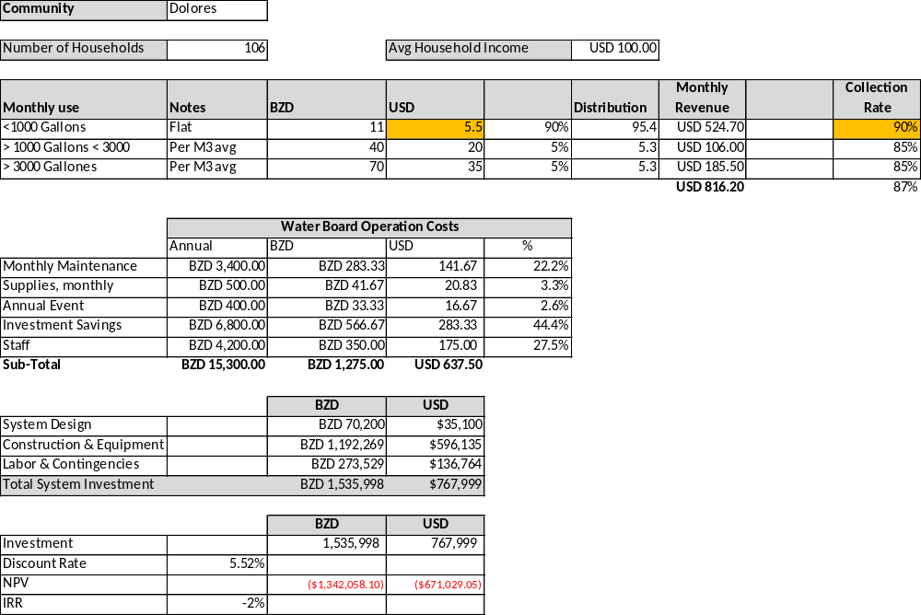

- Otoxha

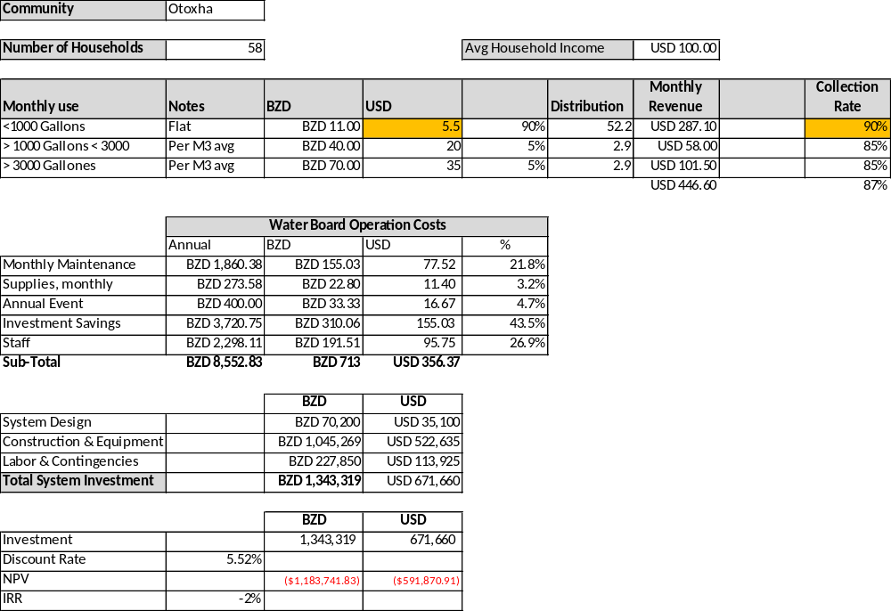

- Boom Creek

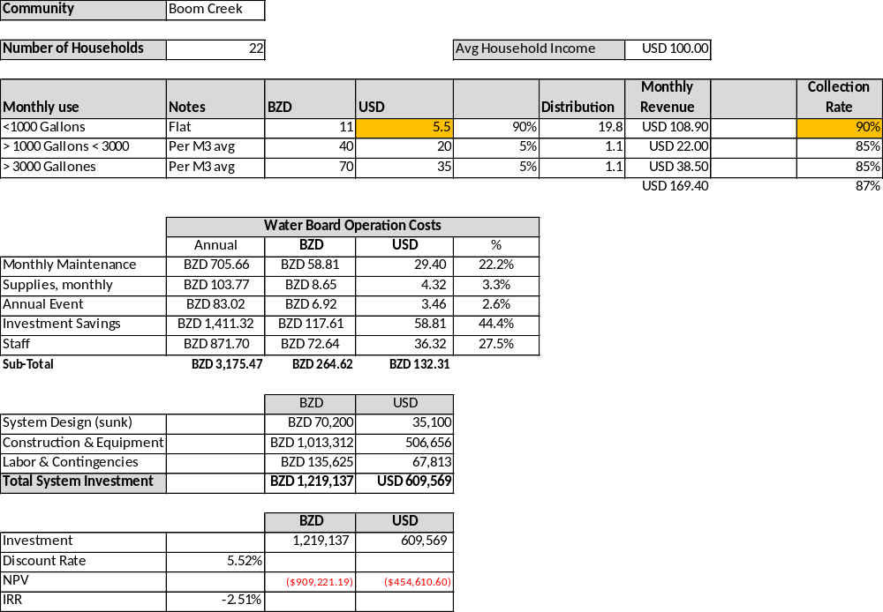

- Copper Bank

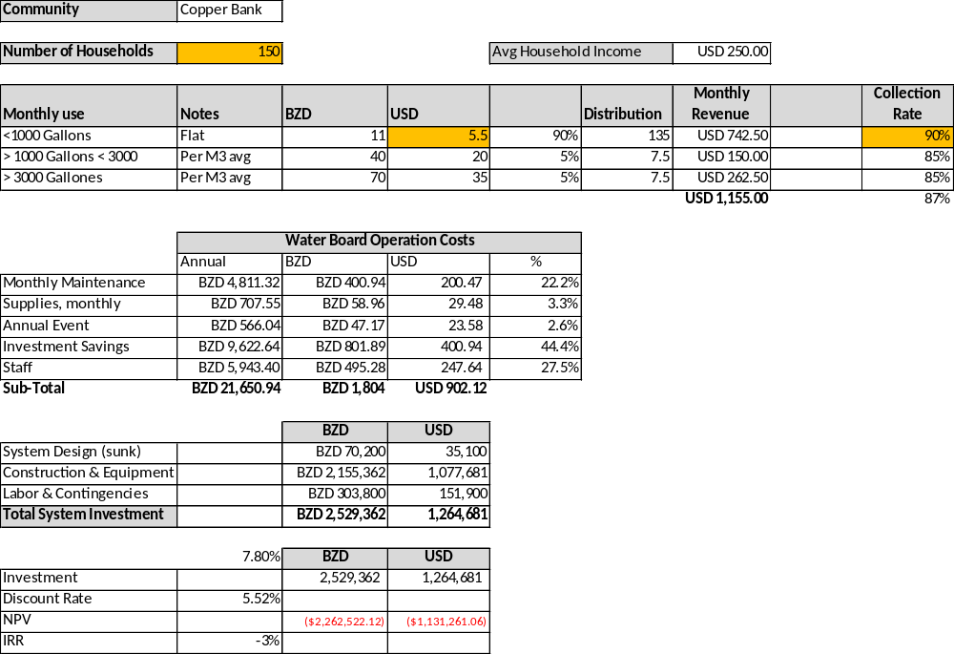

PROBLEM TREE ANALYSIS

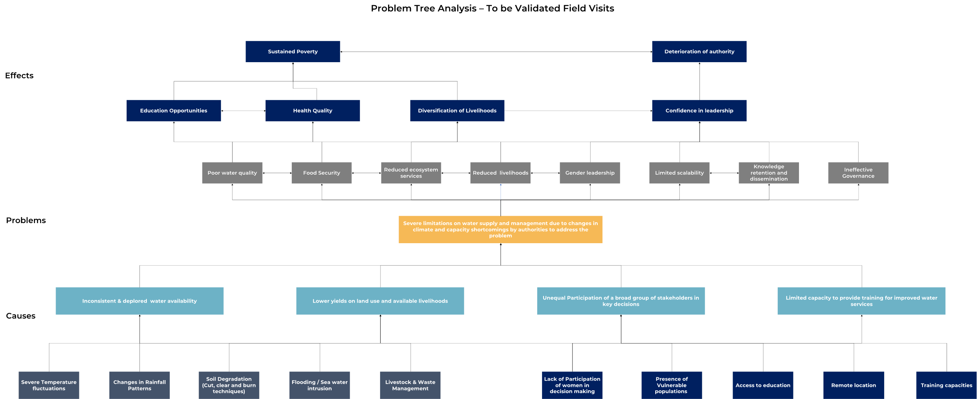

THEORY OF CHANGE

Annex IV : Social Impact Assessment

- LITERATURE REVIEW

- Review of relevant documents was undertaken to obtain information on each component of the project, including key social drivers, livelihoods, climate, and political context. Additionally, this review included literature on the history, demographics, economy, and social profiles for the Corozal and Toledo District and for each of the four Project Communities. Other relevant documents reviewed pertain to legal and policy documents related to national adaptation and climate strategies; Village Council and Water Board formation; FPIC and indigenous people’s protocol; Adaptation Fund and Pact environmental and social safeguards and others that have a direct bearing on the project were also reviewed. See References for a list of documents reviewed.

- STAKEHOLDER MAPPING

- Project stakeholders include any individuals, organizations, parties, or entities that may have an interest in the outcome of a project; this interest can be positive or negative.
- APPENDIX 2: LIST OF STAKEHOLDERS CONSULTED

- FIELD OBSERVATIONS

- Direct field observations were undertaken to gather a deeper understanding of the community context and how project activities may potentially impact different groups within the villages. Some of the key areas observed included village distance from other villages; layout of the villages; community infrastructure such as, schools, health facilities, community centers; electricity or distance from the electrical grid; access to cell phone connection; distance from working handpumps or water sources; land use; access to health care; sanitation; commercial activities such as selling goods, services, food, or materials and gender dynamics.

- CONSULTATIONS AND INTERVIEWS

The consultations were made through interviews with experts who have in-depth subject knowledge, lead project managers from other relevant Belize projects, NGOs, government entities and others who have indicated experience working directly with the communities. The intention was to combine technical expertise with direct practice, seeking a comprehensive perspective. These interviews were conducted through video calls to facilitate remote interaction, in addition to face-to-face meetings during the site visit in Belize.

Meetings with stakeholders were held through several mediums. Virtual video meetings were held on various themes in areas such as distributed solar, wastewater management, Belize water distribution projects, NGOs with community specific experience and whom have expertise in ecosystem management and alternative livelihoods, groups involved with gender, government ministries as well as other key stakeholders. In formulating the project, more than 50 people were consulted via virtual meetings and in-person meetings with project community leaders, the communities, representatives from the TAA, an Area Representative, four Field Officers; and the president of NAVCO. See Appendix 9 for a list of signatures from consultations held in Copper Bank and see Appendix 8 for the signed FPICs which provides names of those consulted.

Weekly project follow-up meetings were held with the MRT and PACT to ensure fluidity in the project formulation and access to stakeholders and documentation. In addition, an MRT focal point was assigned with the MRT to coordinate access of information gathering about the four villages. A group chat was established, numerous calls held, emails exchanged on a regular basis as well as interviews focused on specific themes of the project such as water board formation, water testing, village dynamics and the introduction of WASH capacity building within the communities.

- Indigenous communities

- Prior to the meetings held in person with each village, there were extensive consultations carried out to gain insights about Copper Bank in the North and the three indigenous communities in the South. These were primarily held through video calls with the MRT Field Officers, who maintain close interaction with these communities. Their detailed knowledge of village needs and concerns was fundamental to the design and implementation of the project. In addition, consultations were conducted via video call with various NGOs that have implemented projects in these communities, providing valuable feedback on the interaction with the members and improving engagement and participation for on-site meetings as well as for the overall success of the initiatives.

- Consultations were also conducted with indigenous organizations such as the Maya Leaders Association and the Toledo Alcaldes Association, who provided a comprehensive perspective on the governance, social structure, and decision-making processes within these communities.

- CONSULTATION THEMES

- Water management

- The consultations were conducted primarily with members of the MRT, experts who have a deep understanding of the issues in these communities. Additionally, specialists in the field, such as a water manager from Belize Water Services, were also consulted via video call to obtain specialized information and enhance the project's approach to water resource management.

- Waste management

In addition to the valuable input from ongoing conversations with the MRT Field Officers, other experts were consulted such as civil environmental engineer, Jose Garcia and Belize Water Services (BWS). Various virtual meetings were held with the Rotary Club regarding their efforts to address sanitation and hygiene through the introduction of composting latrine in the Toledo district. The meetings offered lessons learned and provided guidance for successful engagement in the communities, water conservation and WASH capacity building.

- Solar energy

To gain a deeper understanding of the implementation of solar energy in water systems, in-depth consultations were conducted. This included video call sessions with companies specializing in solar energy, such as Belize Power Limited, which provides solar services to Toledo communities. In addition, online contact was made with non-governmental organizations (NGOs) and individuals who have direct experience with completed solar energy projects in similar communities.

- Gender

Numerous discussions were held virtually to gain better understanding of the gender dynamics in these communities and how best to encourage women's participation. A more profound discussion on Gender can be found in Annex V: Gender Assessment and Action Plan.

- Other Consultation Themes

An integrated perspective was sought, combining the practical experience of specialized companies, the technical knowledge of NGOs and the direct experience of individuals involved in similar projects.

Consultations played a key role in the development of the project. The consultation process provided valuable suggestions on how to interact with the communities, approach the project and get the members actively involved in it. Also, it provided a perspective that allowed increased understanding of the project's context. The experts and individuals with experience working with the communities provided insights that helped ensure the feasibility and effectiveness of the project.

These consultation sessions also provided an opportunity to address concerns identified by the research, such as water salinity, maintenance of solar systems, water fees, and lessons learned from previous projects in these communities. As the consultations advanced, it also provided key feedback on the design of the SEAM Project, improved application of lessons learned and best practices for the different component activities and insights on the implementation plans to ensure its success.

- FIELD VISITS

In the Corozal District, a meeting was held at the community library with Copper Bank’s village leaders. This was attended by seven people, including the Village Council Chairman, four Village Council members, a Rural Community Development Officer (RCDO) from the Ministry of Rural Transformation, Community Development, Labour and Local Government (MRT) and the town librarian. Of those who attended, one was female. A Belizean Civil engineer who had conducted some studies on the water quality and potential options for the site of a well also participated by phone. The Minister of National Defense and Border Security, though invited at the guidance of the MRT, was unable to attend due to a conflict.

In the Toledo District, the first meeting was held in Punta Gorda Town, with the community leaders from the three Toledo District villages involved in the project. The MRT recommended meeting at a central location and provided transportation. These villages are self-identified indigenous communities - predominantly Maya. This meeting was attended by twenty leaders and other stakeholders, of which three were female. The meeting included the Chairmen of each Village Council, additional Council members, the Alcaldes from each community, MRT RCDO and Rural Water and Electricity Coordinator (RWEC), the vice president of the TAA, and someone from the Area Representative Office.

- The leaders’ meetings presented and engaged discussion on the following:
- Presentation describing all the components of the project.
- An outline of the project benefits and potential adverse effects.
- Critical elements of the project – community participatory approach for design and implementation; inclusion and involvement of women; and in-kind community contribution.
- Explanation of the Adaptation Fund’s project priorities.
- Outline of the process to apply for funding and the relevant timelines.
- Discussion and leadership input and feedback about the project components.
- Leader’s questions, clarifications, concerns, and expressed community priorities.
- Brainstorming on potential alternative livelihood ideas.

The meeting was structured in a way to promote participation and inclusion, with tables set up so that participants were facing one another. All attendees were encouraged to voice themselves and once the conversation started flowing, there were many thoughts shared and well formulated questions about the structure of the project and its relevance.

For example, clarification was requested on what the project would require from the community; what costs would be covered and if the community’s contribution had to be financial or in-kind; if the construction work for the water and sanitation components could potentially be a short-term means for income generation; preference for the water tank to be cement and not plastic; why sanitation was part of this project when it was not part of other water projects in nearby communities. Across the four villages, each meeting had numerous attendees earnestly express the absolute need and prioritization for getting a potable water system for their villages.

- NAVCO
There was a meeting held with the President of the National Association of Village Councils (NAVCO), a Council that represent the interests of the District Association of Village Councils (DAVCO) and is seen as a lobbying body on behalf of rural communities. It was explained that NAVCO is in charge of protecting, monitoring, and repair of systems for electrical, solar, sewage and waste/trash.

- STAKEHOLDER FEEDBACK AND IMPACT ON PROJECT DESIGN

The project values the input from the community and other stakeholders and has been considered in every stage of formulation of the project. This input came from various sources during the project formulation, such as consultations, Q&A sessions, focus groups, surveys, and other feedback methods. During implementation, inputs from stakeholders have also been considered, see Annex II: Implementation and Operations Arrangements.

A summary of the impact this feedback has had on project design can be found in Appendix 4

FPIC, CONSULTATION AND PARTICIPATION PROCESS

- CULTURALLY APPROPRIATE CONSULTATION

- The Project aims to recognize and respect the dignity, human rights, economies, and cultures of indigenous peoples, ensuring the preservation of their cultural practices and proceed through guidance of International and National policies and laws, as well as those of AF and PACT.

- The COP to the UNFCCC, including the Cancun Agreement, emphasizes the importance of involving indigenous people in climate change actions and policies. The Paris Agreement also acknowledges that Parties should respect, promote and consider their obligations on, among other things, the right of indigenous peoples when they act on climate change. It also admits that more action is needed. The COP adoption of the Paris Agreement calls for enhancing the practices and efforts of local communities and indigenous peoples in dealing with and adapting to climate change and making the local communities and indigenous people’s platform work to support this. Further, the Conference of the Parties, requests of entities to consider “to enhance [its] consideration of local, indigenous and traditional knowledge and practices and their integration into adaptation planning and practices, as well as procedures for monitoring, evaluation and reporting.”

- In the project’s indigenous communities, the Free, Prior and Informed Consultations (FPIC) has been and will continue to be implemented based on Belize’s adoption of its indigenous people’s protocol (Maya of Southern Belize Free Prior and Informed Consent Protocol); the 2022 document indicates water supply projects within self-identified indigenous communities require such procedures.

- The consultation protocol here follows the AF’s Environmental and Social Policy Principle 7 “Indigenous People” and respects the diversity of Belizean society. It aims to include and consider both indigenous and non-indigenous communities. The protocol ensures that the project will listen to and address the views and feedback of indigenous peoples and other affected communities, especially rural ones, in a culturally appropriate way during the project implementation. It also ensures that they will have access to suitable project benefits. The protocol did not apply FPIC to the non-indigenous community, but followed and will follow all other steps. The Project agrees with the UNDRIP and other relevant international instruments on indigenous peoples’ rights and responsibilities. The Special Rapporteur of the UNDRIP has not received any complaints or reports about the Project concerning the rights of indigenous peoples.

- CONSULTATION PRINCIPLES

- The Project is designed to ensure that it implements a community participative process throughout the project cycle to maintain relevance and responsiveness to the individual villages. The Project approached all the villages utilizing the same protocol with the exception that the three indigenous villages also underwent the formal documentation of consent through the Free Prior and Informed Consent (FPIC) process that is required when working with indigenous communities.

- Free, Prior and Informed Consent (FPIC) was affirmed as part of the 2007 United Nations Declaration on the Rights of Indigenous Peoples and obliges States and other third parties to consult in good faith and without coercion with Indigenous people to obtain their consent before adopting any measures or starting any development projects that may affect their communities.

- The engagement of communities is based on the principles of free, prior, and informed consultation and is conducted in a culturally appropriate manner. FPIC is defined as follows:

- Free – the engagement should be free of coercion, corruption, interference, and external pressures. Community members should have the opportunity to participate regardless of gender, age, or socio-economic status.
- Prior – the engagement should be during the design phase and prior to the execution of any project or sub-project activities that may affect them. Times of engagement should be established in advance.
- Informed – information sharing during consultation should be timely, sufficient, and accessible and should cover the potential impacts of the project whether positive or adverse.
- Consultation - the consultation process is to be carried through in good faith, is meaningful and that it meets the conditions set out by the consultation principles and adheres to established protocol.
- Culturally appropriate – the process must ensure that information is provided in the appropriate language, traditional and customary leadership and decision-making processes are respected and seek to maximize community input into the process regardless of age or gender.

- CONSULTATION PROTOCOL

- Role of Local Leadership and indigenous associations

- Water supply activities are within the list of activities that requires the FPIC process to be completed in accordance with the Maya of Southern Belize FPIC. This document states that a written notification must be sent to the Alcaldes and the Village Council since the project is to be executed in the Maya Villages. A preliminary meeting was requested in accordance with the regulation where the consultation plan was developed. The consultation took place in accordance with the consultation plan.

- The village leadership systems were identified for this assessment and protocol was followed during project formulation and will be followed when undertaking community consultations and engagement during the implementation phase of the project.

- Each of the communities in the Toledo District have an Alcalde, who was informed, and engaged with, in conjunction with the Village Councils as required when working with self-identified indigenous communities. The Maya Leaders Association (MLA), Toledo Alcalde Association (TAA) and the Commissioner of Indigenous People’s Affairs, a dependency of the Ministry of Human Development, Facilities, was consulted about the project out of respect and in accordance with Belizean indigenous people’s protocol. See APPENDIX 3: INDIGENOUS ORGANIZATIONS for a non-exhaustive list of indigenous organizations found in Belize.

- The leaders of the villages were, and will be, approached first and all arrangements for meetings are to be made by them or with their consent. The Project is aware that some communities may also have informal leaders, such as religious leaders or elders, that will be engaged to assist with the consultation process.

- Role of Rural Community Development Officers

- The MRT has a Rural Development Unit that has Rural Community Development Officers (RCDO) assigned to work with all rural communities and their Village Councils. In terms of the Project, the RCDOs play an invaluable role in liaising with communities, Village Councils, alcaldes and other stakeholders in the project.

- The RCDOs that have been involved with the Project have developed a long-term relationship with the communities for more than a decade. The familiarity with the needs and priorities of the villages, as well as the challenges and opportunities that they face place them in a key role to facilitate the Project process and engage with the assigned leaders as well as the informal leaders. They played a key role with planning and facilitating activities and promoting participation with the communities.

- CONSULTATION MEETINGS

- After the indicated preliminary steps, all community leaders, both chairmen of the village councils as well as alcaldes of their respective the Toledo villages, were contacted in writing in a letter that outlined all components of the project and requested an opportunity to meet. In the case of Copper Bank, the MRT recommended including a sending a written request for a meeting to the Village Council Chairmen as well as to Minister of National Defense and Border Security.
- The leaders of the communities were contacted with more than three weeks’ notice before the proposed date to discuss the project.

- The consultation meetings with the leaders of Copper Bank were held in their village, while the those with the leaders of the three Toledo villages were held in Punta Gorda as a group, in addition to members of the Village Council and Alcaldes, a TAA representative and an Area Representative of the Electoral Division attended. The meetings held with the community as a whole were held in individual villages.

- CONSULTATION METHODS IMPLEMENTED

- The Project consultations were participatory, inclusive, and complied with international good practices, as well as the AF and PACT policies and standards. The methods used to convey information and engage community members in consultation were, and will be, done using appropriate methods. This included holding meetings in their preferred language.

- In Copper Bank, presentations and meetings were done in Spanish and English to make it accessible to all the attendees; Spanish is widely spoken in this part of Belize both for its nearness to the Mexican Border and due to large diaspora of Belizeans living and working in the nearby Mexican state of Quintana Roo. The MRT field officer assigned to this village has a long-established relationship with the village and is bilingual. All organizations working with this community will be bilingual or use a translator.

- Boom Creek meetings were addressed bilingually, to ensure all attendees are being interacted with in their native tongue, while in Otoxha and Dolores, Q'eqchi' was, and will be, the language utilized as it is their indigenous language.

- The two MRT field officers who have been participating during the Project formulation, are bilingual. One, is bilingual in Spanish and English, and has assigned Boom Creek. The other, with more than a decade of experience working in the Toledo District and who is intended as to be a project district focal point in the Toledo District, amongst other languages is fluent in English and Q'eqchi'. Additionally, in most cases, there are community members who can translate from their indigenous languages to Spanish and/or English.

- Meetings were held in a participatory fashion and should use formats that are geared toward ease of understanding, using visuals, direct language and be presented in a culturally respectful and gender inclusive manner. The information will be provided in an objective format. As is common in a sustainable development project that aim to carry out capacity building introducing new or unfamiliar topics, it is common to get a delayed response from participant at the beginning and follow-up meetings should be anticipated and prepared for.

PROJECT COMMUNITY SOCIAL ASSESSMENT

- Responding to the increasingly severe water shortages and quality issues and the prioritization of water within its national strategy, the Project identified four remote rural communities that have a history of severe water shortages and have never had a potable water distribution system. These communities rely on collecting water from hand pumps; spring fed community spigots; rainwater harvesting; or contaminated hand dug wells. The Project will take place in the Northernmost Corozal District and in the Southernmost Toledo District.

- COROZAL DISTRICT

- The Corozal District, comprised of 31 cities, towns and villages, has an area of 718 square miles and sits along Chetumal Bay on the Caribbean coastline. Corozal Town is the administrative capital and largest city.

- The Corozal region is primarily known for agriculture, sugar cane production, and its status as a Free Trade Zone with Mexico. Many people are drawn to Corozal for its low cost of living and proximity to Mexico. This has influenced Spanish as the predominant language in the district as well as in the food and culture. English is also common as it is Belize’s primary language and is taught in school.

- Though there are many local ethnic populations, Mestizo, Creole, Maya, Garifuna, East Indian, Chinese, and North American ex-pats, the Corozal District is inhabited predominantly by Mestizos, who are descendants of indigenous Maya and European Spaniards. They first came into northern Belize from southern Yucatan, Mexico, as refugees escaping the Caste War of Yucatán in 1848. Even though Belizean Mestizos of the north share Maya ancestry from Mexico they do not as an ethnic group self-identify as indigenous peoples. Most consider themselves Mestizos and do not claim indigenous status.

- There is vast Maya archaeological richness in this district that is still in the process of being revealed through new excavations and accidental finds from construction – most recently through a major road infrastructure project in the district. Corozal Town, the capital and main city of the district, is said to be built on an ancient Maya city.

- COPPER BANK

- Location

- The Maya were the first inhabitants of what is now Copper Bank – evidenced by its location next to the Ruins of Cerro Maya which covers 53 hilly acres beside the Chetumal Bay. This is the only Maya archaeological site along the coast. The Cerros served as an important jade and obsidian trading center from 400 BC to 100 AD. When the British arrived in 1977, they named the settlement after some old copper coins that had been found there. Originally named Cababenque in 1895, this small fishing village was renamed Copper Bank in 1915.

- Located in the Corozal District of Northern Belize. It is situated on the west bank of Laguna Seca, a shallow lagoon that empties into Chetumal Bay just north-east of the village. The closest neighboring village is Chunox, located approximately 1.25 miles away on the east bank of the Laguna Seca.

- Access

- The village can be reached by road, road and ferry or by sea. The route from Corozal Town to Copper Bank requires a crossing of the New River via the hand cranked Pueblo Nuevo ferry. Three vehicles can be transported at one time which can result in long wait times. Access via the populated community of Sarteneja is by a ferry across the mouth of Laguna Seca.

- Background

- The town, with a population of 600 people, with approximately a 45.5% male to 54.5% female ratio. There are 150 households, 98% of which are Mestizo and the remaining 2% are Caucasian. The predominant language spoken is Spanish though a large percent of the village members also speaks English. The head of the households is predominantly male, and the main religion is Catholic. The village is considered lower-middle class in accordance with the SIB Poverty Index. 85% of village transportation is private motor vehicles, while around 15% travel by bus.

Date | Activity
1800 | First families (Diaz, Cobb, Ake, Awayo)
1895 | Cababenque – 1st given to the community.
1915 | Copper Bank – Renamed.
1955 | Hurricane Janet
1960 | Park was built
1970 | Catholic church was built
1985 | Roads and streets constructed
1988 | Telephone
1990 | Electricity
2007 | VHF radio (Belize Red Cross) *not currently available.
2007 | Hurricane Dean
 | ProVention – Belize Red Cross “Protected Schools Project”
 | ProVention Micro-project, transforming school latrines to flush toilet and 4 school lockers
2009 | Vulnerability Capacity Assessment training with Copper Bank, Chunox, and Sarteneja
Table 38: Historical profile of main events at Copper Bank (Source: Red Cross Vulnerability and Capacity Assessment 2009).
- Infrastructure

- The streets of Copper Bank were constructed in 1985 and telephone lines were put in three years later. Since the 1990s, the village has been connected to the national grid. There is a concrete primary school building, two restaurants, four small food stores, a bar, four churches and a community library. There is no water infrastructure to date, beyond the school donated system and handpumps.

- In 2019, the government of Belize signed a contract with a Taiwanese firm and the Organization for European Economic Co-operation (OECC) to design and upgrade 27 miles of road, including the construction of two bridges. One of these bridges will replace the quaint hand cranked old sugar barge which runs as a ferry at Pueblo Nuevo which carries three cars across at a snail’s pace ‘powered’ by two amiable men turning the crank as the ferry is pulled across on a cable. There is another bridge reported to replace the ferry for Laguna Seca.

- This construction will inevitably have a noteworthy economic impact on the village as it will provide a much faster, reliable, direct and all-weather link between Corozal Town and Copper Bank (as well as various other communities). The road is being both widened as well as raised considerably to avoid the chronic flooding that occurs in the area. It is being paved to climate resilient standards with a doubled chip and seal and with proper drainage considerations to ensure its resilience against climate change impacts. This will especially ease traveling to and from high school for the village’s youth who were impacted by road conditions. By year end, this bridge and improved road system will dramatically impact the access to and from Copper Bank.

- The construction, however, has received some criticism as it has destroyed numerous Maya artifacts found in the many house-mounds throughout this culturally rich area. Most of the homes in the village of Copper Bank are concrete houses (60%), mix structure 39% and wooden houses 1%.

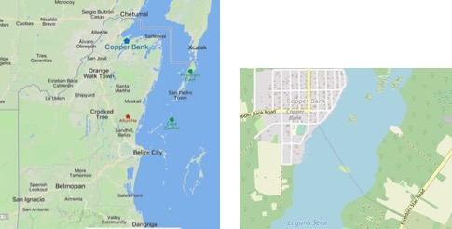
Figure 22: Copper Bank Map (Source: Mapcarta.com)
- Land Tenure

- In the 2020 community profile, when village leaders were asked whether the residents held titles to their land, leased or squatted, it was reported that 20% had freehold (purchased), 70% had leases, 10% were squatting on the land they occupy which at some point in time a member of their family may have had a leasehold which expired. The same question to the 2023 village leaders stated that 70% held land titles.

- Transportation

- About 85% of the village uses private motor vehicles as their primary means of transportation, there are 74 in total. About 15% travel by bus. There are 3 fishing boats, 12 boats, and 5 speed boats.

- Livelihood

- Copper Bank was historically highly dependent on sugar cane farming and participated heavily in the sugar industry. Though the sugar industry is the predominant industry in northern Belize, the village’s chairman reports that approximately 90% of the community earns its income from fishing, with the highest price paid for from conch and lobster. Approximately 2% of the village’s income from construction, about 2% from cane farming and approximately 5% of women in the town earn money by doing domestic work.

- The average monthly income per family in the fishing trade is around $1,500 -$2000 a month during the period February 15th to July 1st. Those in cane farming average monthly income is $350-$500 per month. Those in the construction trade earn approximately $1,000 to $2,000 a month.

- Fishing income varies greatly and is impacted by the high price paid during conch and lobster season. Belize’s susceptibility to hurricanes impacts not only the ability to go out to sea and their equipment, but also produces damaging currents that can extend down 200 feet or more below the surface. This can impact the underwater formations that act as habitats for the fish. Increased amounts of low dissolved oxygen can also result in large amounts of dead fish.

- During the project presentation to the community and during the focus group, 11 of the 13 women present decided to form a women’s group to begin to brainstorm alternative livelihood options and join together in support of bringing portable water to the community. Two village women were elected chairlady and vice chairlady, and contact information was exchanged. Two of these members were US women that offered to teach preserve making and baking and were promoting fundraising for the Copper Bank library.

- Energy

- Since the 1990s, the village has had electricity via the national grid, provided and maintained by Belize Electricity Limited (BEL), and the majority of the village is connected. There are no known solar panels being used at this time.

- Education

- In 1960, Copper Bank started its first primary school at the RC Church, providing classrooms during the weekdays and sermons on the weekend. In 1990, the school moved from the church to a three classroom newly constructed cement school building. In 1993, two additional classrooms were added on. The school has toilets with a septic system, but it is in poor condition.

- This primary school, kindergarten through 6th grade, has five teacher and 92 students (48 males and 44 females). The school has introduced fundraising measures by charging students BZ$1 per week for ‘casual/no uniform’ Fridays. One mother explained that the money was being raised to fix the ceiling of the classrooms which was contaminated by rodent waste that was believed to be making the children sick.

Classes | Males | Females | Total enrolment
Pre-School | 5 | 8 | 13
Primary School | 48 | 44 | 92
Secondary | 20 | 34 | 54
Table 39: Education rates in Copper Bank (Source: Copper Bank Village Community Profile 2020).

- The Audubon Society donated a rainwater filtration system to the school, which filters and chlorinates water for drinking purposes only. A teacher is in charge of maintenance of the school’s water supply. The piped well water is used for handwashing and cleaning only. The school charges BZ$10.00 per student per school year for this water, which is paid by 90% of the parents.

- For village children to receive further education, they need to travel to either Chunox or Corozal Town to continue their education. Though Chunox is relatively close, located across the lagoon, it can take as little as 15 minutes by ferry but can take much longer if traveling by road – especially during poor weather, making the trips close to an hour. Corozal Town is 15 miles away by rough road that is prone to flooding and requires a ferry ride. Once the new bridge is completed this should greatly reduce the time required.

- Water

- The main source of drinking water comes from rainwater collection – which varies greatly depending on the time of year. Households harvest rainwater for drinking and utilize water from their hand dug wells for other purposes. Considering that the elevation above sea level is quite low, influenced by the distance from the lagoon, water can be found anywhere from four to 15 feet deep below ground.

- Approximately 60% of the households use electric pumps to bring rainwater into their homes for household use. Water pumps are used by approximately 90% of households to pipe the well water into their homes for toilets, laundry and for other household use. Of the 85 wells in the community only about 20% remain with water during the dry season from January to May. This leaves 80% of the households to have to collect water from the community hand pumps. Copper Bank has three community wells with hand pumps, although only one pump is functional at this time.

- The village is experiencing extreme instability accessing water. Most private wells have gone dry because of the reduced water table and the prolonged dry season. Villagers have resorted to digging more wells within their properties in search of water and if none can be found, those with pickup trucks fill large plastic containers from the one functioning handpump and transport water for household use while other residents fetch water by bucket, carrying them by hand.

- There are several exposed wells that are at ground level that pose a risk to young children and animals. These wells are exposed to contamination from human waste and surface runoff. The villagers that attended the meeting where the Project was presented were fully committed to having a water distribution system in their village. Water shortages and poor quality have been an on-going issue and those that attended were adamant about its importance. The feedback received during this meeting was that there was a general skepticism that the project would receive the needed funding and not get de-railed by political agendas like it has in the past. It was recounted that promises for a water system had been made repeatedly in the past with no forward movement.

- Of the 14 bacteriological water tests run in Copper Bank between 2019 to 2023 half came back with fecal coliform or e-coli bacterial contamination. These results stemmed from private wells, rainwater tanks and the one hand pump that is functioning. Twice the Bamboo purified water supplier in Copper Bank had elevated bacteria levels. Table 11 details the severity of the situation. Table 12 provides details on water quality at three distinct locations.

- Normally when there are test results indicating bacterial contamination it is shared with the Water Board who has the role of addressing the issue. Considering Copper Bank does not have a Water Board, which is reserved for villages with water distribution systems, the test results were not shared with the village leadership and could have gone unknown.

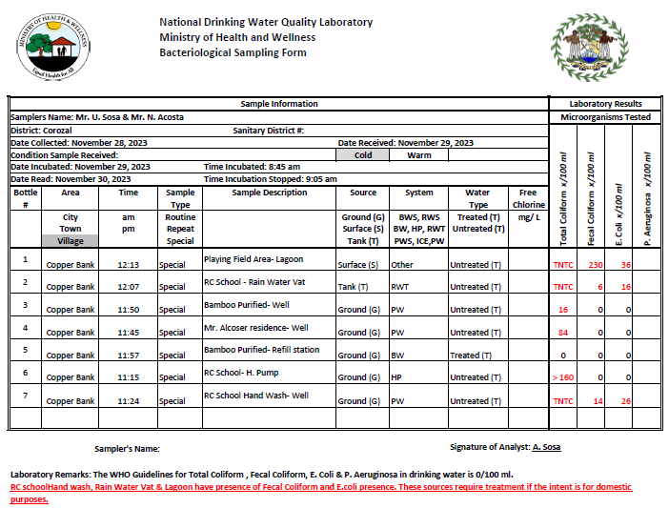

Table 40: Copper Bank Bacterial Water Test (Source: National Drinking Water Quality Laboratory, Ministry of Health and Wellness; Environmental Health Unit).
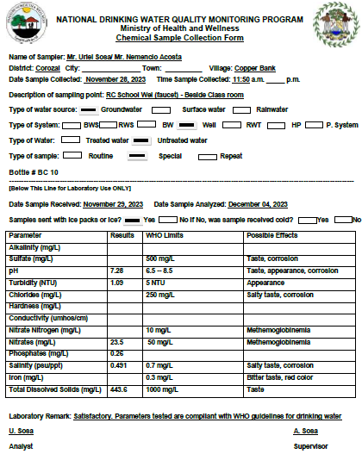

Table:41: Copper Bank Chemical Water Test – RC School Well (Source: National Drinking Water Quality Laboratory, Ministry of Health and Wellness; Environmental Health Unit).

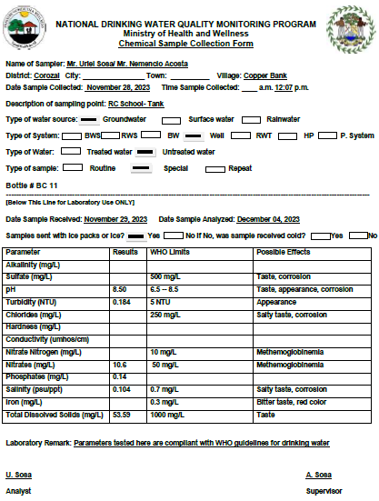

Table:42: Copper Bank Chemical Water Test – RC School Tank (Source: National Drinking Water Quality Laboratory, Ministry of Health and Wellness; Environmental Health Unit).

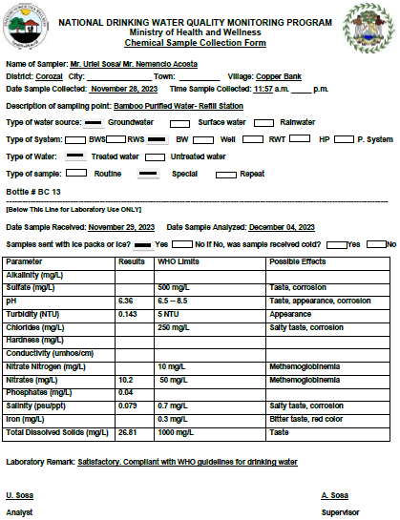

Table:43: Copper Bank Chemical Water Test – Bamboo Purified Water, Refill Station (Source: National Drinking Water Quality Laboratory, Ministry of Health and Wellness; Environmental Health Unit).

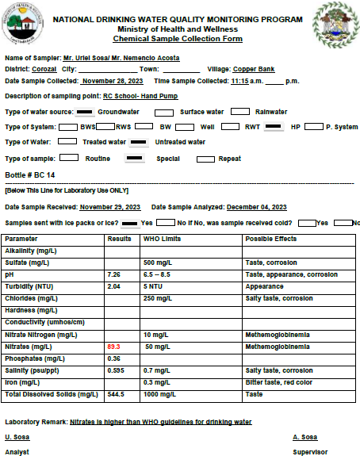

Table:44: Copper Bank Chemical Water Test – RC School Hand Pump (Source: National Drinking Water Quality Laboratory, Ministry of Health and Wellness; Environmental Health Unit).

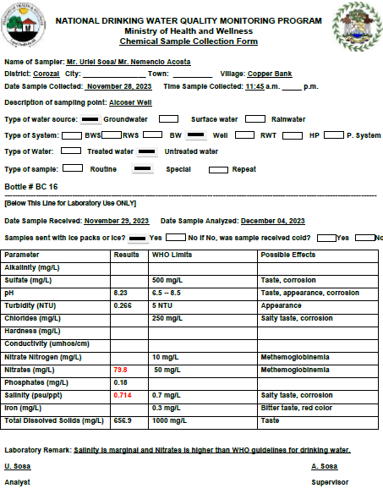

Table:45: Copper Bank Chemical Water Test - Alcoser Well (Source: National Drinking Water Quality Laboratory, Ministry of Health and Wellness; Environmental Health Unit).

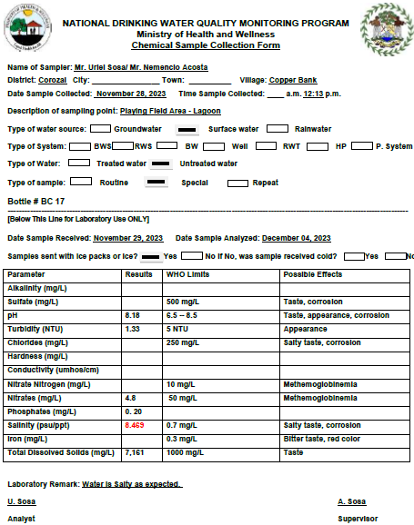

Table:46: Copper Bank Chemical Water Test - Playing Field Area, Lagoon (Source: National Drinking Water Quality Laboratory, Ministry of Health and Wellness; Environmental Health Unit).

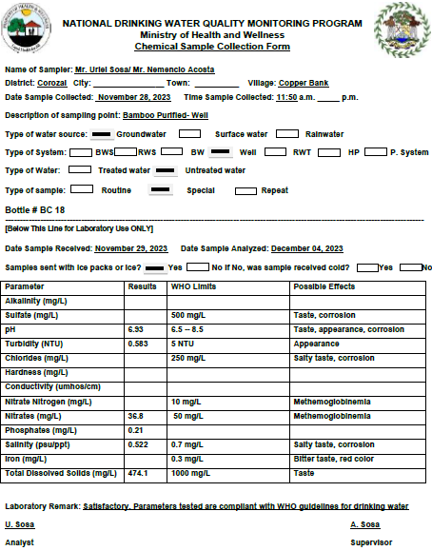

Table47: Copper Bank Chemical Water Test - Bamboo Purified Well (Source: National Drinking Water Quality Laboratory, Ministry of Health and Wellness; Environmental Health Unit).

- These water test results were submitted to various Ministries in the government with the request for assistance for this village – one of the only in Northern Belize without a water system. On 10/23/2023, updated chemical and bacterial water testing for the following locations within Copper Bank were requested from the MRT to establish a baseline:

- RC School well
- RC school Hand pump
- Bamboo Purified well
- Bamboo Purified refill
- Annie Alcoser’s well
- Infant 1RC school rainwater tank
- Lagoon – near playing field

- Wastewater Disposal

- Grey water is typically disposed of through pipes that empty into the backyards and flow into the ground or into old wells that are no longer in use.

- Waste Disposal

- Trash is primarily burned or put in a village dumpsite which is encouraged by village leadership.

- Sanitation

- Copper Bank has had a dramatic increase in the number of households that have indoor plumbing in the village, making up about 90% of the population. These indoor toilets are connected to septic tanks that are commonly cement blocks with open bottoms which leach wastewater into the ground and ultimately enter the shallow water shed. The high rate of bacterial contamination can be explained by these septic systems and the remaining pit latrines that are being utilized. Some latrines and family garbage dumps are located too close to the wells (within 30 meters) causing further water contamination.

- Communication

- About 98% of the villagers rely on information from the radio and internet (Facebook). Around 98% have access to TV from Mexican channels which is more accessible due to location. 99% of the community members have access to cell phone services and there is adequate connectivity.

- Health

- There is no health clinic in Copper Bank. In the case of health concerns, the nearest health facility is the Polyclinic in Corozal or Chunox – approximately 20 minutes by ferry to Chunox and 50 minutes to Corozal Town by car. There is no ambulance or emergency transport available. The last outbreak of gastroenteritis was in February 2017.

Vulnerabilities: | Capacities/Resources:
Hurricanes/Tropical Storms | The school is used as shelter during storms.
Flood
Lagoon
River
Roads
Drought | None. Water purchased when financially able.
Fire | There is no fire brigade established in the town and only handpumps and the lagoon available for water.  In the past 30 years, there have been no fires.  It Is reported that cane cutting during the dry season when the cane fields are more susceptible to catching fire. The practice is to take drums of water with their vehicles to the field and with the help of other villagers they spray the water and try their best to control the fire.
Wells – without walls | Most wells have walls of about 3-4 feet high around them. However, when a well runs dry households commonly dig another – abandoning the other.
Water Contamination | Clorox is commonly used to disinfect well water which is only used for cleaning and bathing.
Garbage | Village dump
Thatch houses | Few
Animals – loose in the village | 7 dogs, 20 cats and sheep.
Latrines – in low lying areas to overflowing | Approximately 16
Culverts – collapsed and clogged | Recently replaced
Table 48: Mapping of Copper Bank identifying vulnerabilities and capacities: (Source: Interviews with Chairmen of Copper Bank Village Council and Librarian, 2023).
- Early Warning and Communication

- Copper Bank has been connected to the electrical grid since the 1990s which has allowed the village to be in better connection to the outside despite the remoteness of its location. It has benefited from basic services such as radios, telephone, and television. Today the vast majority of the residents own or have access to home phones or cell phones, and many have internet services in their homes or through the library.

- There is an Early Warning System in place that is coordinated with NEMO Central District Coordinator office. There is no VHF radio in case of emergencies but there is a hurricane shelter established.

- Belize is thought to have excellent capabilities to warn and respond potential disasters, having the only Doppler radar system on the Central America Atlantic seaboard (operational 2011). In fact, the U.S. National Hurricane Center depends on Belize Doppler Radar to feed into its hurricane analysis and progressions reports. Hurricane shelters exist along the coastline, but food and water supplies during disasters are either non-existent or inadequate.

- Village Reported Priorities

- During the community meeting and focus groups potable water was stated as the village's top priority.

- TOLEDO DISTRICT

- The Toledo District, with an area of 1,795 square miles, is comprised of 63 cities, towns and villages. This district is located on the coastal plain, backed by mountains, and situated between the mouths of the Grande and Moho rivers. Punta Gorda Town, affectionately called PG, is the capital and its main town, as well as the largest town in southern Belize. Located 180 ft. above sea level, PG contains 25% of the district’s population with the remainder residing in its surrounding rural villages.

- Toledo is culturally diverse, with descendants of the Maya, Garifuna, and other heritages sharing the land and has many archaeological sites – though in a poor state. Sparsely populated villages are filled with Mopan and Q'eqchi subsistence farmers, where Punta Gorda has large East Indian populations. The homes in the rural areas are predominantly wood and traditional thatched roofs, with schools and community centers often made from reinforced concrete, which are commonly used as hurricane shelters.

- Toledo has 25% of all farms in Belize, and 77% of small farms (below 20 acres). Known for agriculture, producing beans, corn, rice and citrus as well as coffee, sweet potatoes, avocado and other vegetables and root crops. There has been an increasing involvement in producing export quality cocoa as well. Toledo Cocoa Growers Association has been cultivating organic cocoa, which is purchased by the UK's Green and Blacks for the production of what has now become its award-winning Maya Gold chocolate bars.

- Over 61% of Toledo’s 30,000 citizens identify as Maya, with a much higher proportion in the region’s rural areas. The Maya culture can be felt throughout the Toledo District, more than anywhere else in Belize. Many of Toledo’s rural citizens speak either Q'eqchi or Mopan Maya at home. Less than half (48%) of Toledo’s residents above age three speak English well enough to hold a conversation. The inability to speak Belize’s official language is an obstacle to integrating or qualifying for certain jobs.

- The Maya lifestyle is largely through subsistence farming and small-scale agriculture predominated by corn and rice. The traditional Maya communities have longstanding cultural and historic claims to the land where they are settled but no legal titles making land tenure an on-going legal struggle. This will be discussed further in the Land Tenure section. This complex issue around land rights is contributing to their economic insecurity – especially in the face of growing interest in the region’s natural resources by the national and international entities.

- There are over 715,000 acres of protected land in the Toledo District. This includes three national parks, two wildlife sanctuaries, one nature reserve, seven forest reserves, two marine reserves, two archaeological sites, and several private reserves.

- There are many NGOs present in this area of the country, including both international and local, ranging from environmental conservation to gender advocacy, to cultural organizations and beyond. The Maya have formed several NGOs that have been advocating for indigenous rights over lands and natural resources in the region.

- The region contains a multitude of plant and animal species and is home to the jaguar, puma, manatee, harpy eagle, Baird's tapir, jaguar, howler monkey and scarlet macaw and other rare and endangered species. Despite its lush and pristine topography its people face Belize’s highest poverty rates and extreme vulnerability to climate issues.

- BOOM CREEK

- Location

- Boom Creek Village, originally settled in the 1940s, is located along the Mojo River in the Toledo District of Southern Belize, approximately 6 miles from Punta Gorda Town. It is lush and junglelike, with heavy rainfall that commonly floods the roads and riverbanks. Although the only access to the village was originally by a four-hour canoe/dory ride, there was a road constructed in 1992. However, considering it sits approximately 20 feet above sea level, the road becomes impassable during the rainy season where the village can only be accessed by boats along the Moho River. During the rainy season it is common for the road to remain flooded for various days and the students go to school by boat.

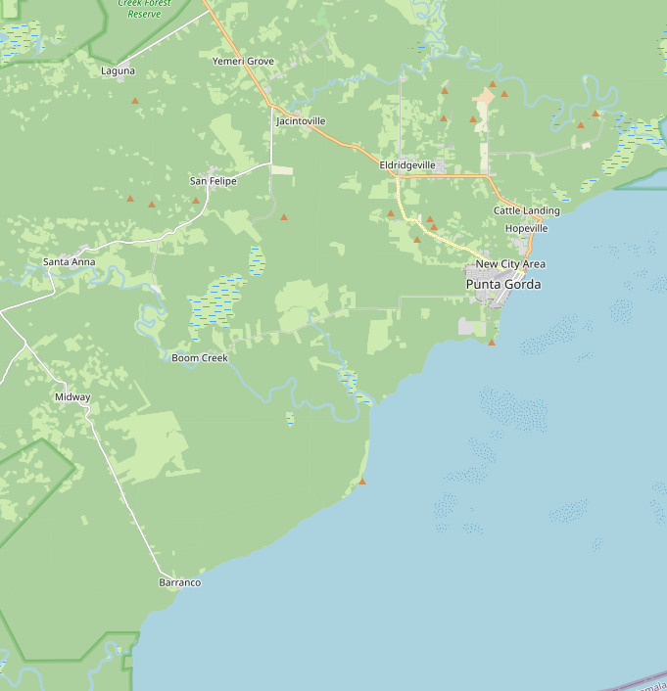
Figure 23 : Boom Creek Map (Source: Mapcarta.com).
- Access

- The only access to Boom Creek was by river which entailed a four-hour canoe ride paddling up the Moho River, until 1992 when its first road was built. Although transformative to the village, this road commonly floods during the heavy rains of the Toledo District wet season making it impassable. During these times, it is not uncommon to see boats ride along the flooded roads transporting children and maintaining the pace of the village. VILLAGE PHOTOS.

- Background

- The village population is 112, made up of approximately 46% males and 54% females, living in 25 households (in 2021, five others under construction). Of these households, there are 16 Mestizo and eight Maya and one Mennonite. Sixteen households speak both Spanish and English, while eight speak Maya Q'eqchi /Mopan and English and the one Mennonite household speaks only English. The majority of the community attends the village’s one church - the Living Word Church.

- The concrete primary school and wooden church built on stilts along the banks of the Moho River are used for meetings, Alcaldes Court Hearing and Village Council meetings. There is one primary school building, one church, one corn mill, and two petty shops. The village has no electricity. Twenty-two (22) households have access to solar power and three (3) still use candles or homemade lamps. Only SMART phone service is accessed within the village.

- Infrastructure

- There is a rough dirt road that commonly floods that leads into the village lined by most of the village’s houses. The distance between the first house and the last is 1.25 miles. There are two households that are built about 600 feet off this road. Of the houses in the village, five are concrete homes, 11 are wood and zinc roofs, while the others are thatched roofs. The primary school is constructed of cement. There is a wooden church built on high stilts along the Banks of the Moho River.

- The closest connection to the electrical grid is in Punta Gorda Town about 6 miles away. There are 20 solar panels of various sizes. The village has two functioning hand pumps, one contaminated production well that is decommissioned, and three wells which go dry in the dry season.

- Groceries, medicine, building materials are all purchased in Punta Gorda as there are no stores in the village.

- Land Tenure

- Very few villagers have titles to their land. As of 2020, 85% of the villagers were reported to be in favor of a communal land system. The village is in the process of acquiring and demarcating their land for the village through the Alcalde system. The land is mainly used for agricultural purposes, most commonly corn, and traditionally agricultural processes such as crop rotation are practiced.

- Transportation

- There are 12 private vehicles, 21 motorcycles and six boats.

- Livelihood

- Agriculture makes up a large portion of the village’s livelihood activities. Though limited income is generated, mostly due to the reliance on subsistence farming. 16% of the community depends on subsistence farming. Commonly cultivated crops are corn, rice, and beans. The villagers are also known to fish and hunt. Approximately, 20% of the village earns income from the livestock rearing, mostly cattle, pigs. There are strict bylaws that prohibit wandering livestock, which are abided by. Logging accounts for 12% of income generating activity in the village.

- Energy

- The national electrical grid stops at the outskirts of Punta Gorda Town which is approximately 6 miles away. 20 of the 25 households have solar panels, mostly to charge cell phones and light their homes with 12 volt and small AC voltage light bulbs. Five households rely on lanterns and candles.

- Education

- The concrete primary school was constructed in 1992. Before this time, students traveled by canoe up the Moho River to join students in the school at Santa Anna. There are 28 students in the primary school, with two teachers. There are five students attending Toledo Community College and five enrolled in the University of Belize. The government recently took over management of the school. The school (Living Word Government School) has a rainwater collection system for the children’s use.

- Water

- Boom Creek has two functional hand pumps but mostly relies on rainwater catchment systems. The hand pumps are mostly utilized during dry season which is a burden for families that do not have vehicle to transport containers. There are only a few hand-dug wells in Boom Creek which mostly go dry seasonally. Water is not typically treated with chlorine or regular boiling.

- In addition to the Moho River, the village also has a creek that is used by some villagers for bathing and washing clothes. Females do laundry at the creek as the river’s salt content makes it difficult for washing.

- The MRT drilled a 120-foot-deep production well in 2011 but it has not been utilized due to an excessive iron content. There are two families that have installed solar pumps into this well to withdraw water for washing and bathing in their individual households.

- The production well was tested in 2011 after being completed. Though the well tested free of bacteria, the findings indicated Iron content significantly higher than World Health Organization guidelines. WHO Iron 0.3 mg/1 while Boom Creek tested Iron 1.06 mg/1.

- The Boom Creek water has only been tested three times from four locations since 2014. Two tests were performed from different locations on the same day in 2015. The school rainwater tank tested positive for fecal coliform. The next test was not conducted until 2017 and again the school rainwater tested positive for fecal coliform. There is no evidence to indicate that this was resolved in any way, and it is likely the bacterial contamination continued without follow up for two years. Boom Creek has had no chemical water testing done other than the production well’s initial test, which shut the well down for public use.

District | Collected | Location | Establishment | Source | System | Village | Fecal Coliform | Count 2 (per 100 ml) | E coli
Toledo | 26-Oct-15 | H. Pump |  | Ground water | Hand Pump | Boom Creek | Negative | 0 | Negative
Toledo | 26-Oct-15 | RWT @ primary school | School | Rain water | Rain water tank | Boom Creek | Positive | 2 | Negative
Toledo | 06-Feb-17 | RWT @ Primary school | Academic | Rain water | Rain water tank | Boom Creek | Positive | 6 | Positive
Toledo | 28-May-18 | School-tap | Academic | Rain water | Rain water tank | Boom Creek | Negative | 0 | Negative
Table49: Boom Creek Bacterial Water Testing 2015-2023 (Source: Source: National Drinking Water Quality Laboratory Ministry of Health and Wellness; Environmental Health Unit).
- As mentioned, when water test results indicate bacterial contamination, it is shared with the Water Board who has the role of addressing the issue. Considering Boom Creek does not have a Water Board, which is reserved for villages with water distribution systems, the test results were not shared with the village leadership and may have gone unknown.

- On 10/23/2023, updated chemical and bacterial water testing for the following locations within the village were requested from MRT to establish a baseline.

Boom Creek
- School hand pump
- School rainwater tank
- River
- One well
- Production well after well restoration

- Hope Springs Water, an international NGO, dedicated to providing clean water, improved sanitation, public health, and hygiene education, had been working with the MRT to drill a well for the village but COVID-19 put the plan on hold as volunteers stopped going to Belize.

- Wastewater Disposal

- Used water is disposed of in their backyards either by pipe if they have them or by bucket.

- Waste Disposal

- Each villager is responsible for disposing of their own waste which is typically done by burning, burying, or dumping in their backyard or the surrounding woods.

- Sanitation

- Five households have indoor toilets operated by solar powered water pumps and septic systems. These systems are built with a ‘soak away’ or leach field which due to the water table level is adding to the water contamination issues. The majority of the remaining have outdoor pit latrines. When these latrines, which are simply holes dug into the earth, become full, they are covered, and another latrine is dug.

- A project spearheaded by Sustainable Harvest International and Rotary Club Belize installed dual raised composing latrines. In discussion with these parties during consultation, it was generally considered to be a failed sanitation project, although there are a few of these composting latrines from this project that are still operational. The idea is that while one side of the latrine is being used, the other side is decomposing; the remnants of the decomposition can be used for fertilizer for the garden. The project suffered difficulties on many levels, principally in terms of a) design, and b) corruption or malfeasance. In terms of design, community members and MRT officers indicated that the design of these latrines did not take into consideration the separation of liquid from solid waste which led to a lack of drying out and decomposition, as well as foul odors and insects. The latrines were designed to separate out liquids, and if after each use, organic matter is added (dry soil, saw dust, leaves), which enhances the anaerobic decomposition occurs. Over time, the metal lids on the separation compartments rusted and the wooden floors rooted, likely due to the high humidity and precipitation level of the Toledo District. It was also mentioned, albeit not verified, that the cement needed to have rebar to reinforce it and prevent it from cracking.

- Communication

- Boom Creek, albeit relatively close to Punta Gorda (11km) does not have cell service in the area, nor cable internet.

- Health

- The villagers travel to Punta Gorda to seek medical attention.

- Early Warning and Communication

- There is no designated hurricane shelter although the cement primary school is used for this purpose.

- Village Reported Priorities

- Water, Light, Community Center/Hurricane Shelter, Better Road, Health Post.

- OTOXHA

- The statistical information found in this section was largely collected from the Bridging the Toledo Poverty Gap through Improved Governance Project as well as the site visit and community meetings. Additional, information was provided from a Community Needs Assessment Survey conducted by the Toledo Development Corporation and Program for Toledo Children and Adolescents.

- Location

- Otoxha, a charming, small Maya village surrounded by crop fields, secondary vegetation, small creeks, and swampy areas, is located about 34 miles from Punta Gorda, less than four miles from Dolores, and six miles from the Guatemala border. Otoxha village is situated on approximately 50 acres within the ‘reservation’.

- It is comprised of thatched roof homes that are built along the side of the main rural road and has a sturdy wooden health outpost and a newly constructed, mostly unused, donated bakery with six solar panels. 2% of the town has cement block homes. The town has been the recipient of various NGO projects which have had varying degrees of impact.

- Access

- There is one main road (which connects the town to Punta Gorda) that varies greatly in condition depending on the season and severity of the rains. The road is unpaved and has limited maintenance. It takes about 1 hour and 45 minutes on rough road to arrive by truck. There are buses that take this route on a regular basis, which high school students use on a regular basis to get to school. You will commonly see motorcycles along this route loaded down with products coming from Guatemala whose prices are considered much better.

- Background

- In 1924 the inhabitants of Otoxha Village, as known today, came from Chacalte’ and other Maya settlements of the district of Coban Alta Vera Paz, Petén, Guatemala. They, like many others, were fleeing hardship and mistreatment from exploitative manual labor being forced on them during the construction of major infrastructure throughout Guatemalan government.

- Otoxha once had a large population, but it gradually declined as community members migrated and formed the villages of San Benito Poite, Mabil Ha, Corazon, San Lucas, and Valley of Peace.

- The population is now 357 people, with approximately 47.5% male and 49.6% female, living in 58 households. More than 85% of the village identified themselves as Q’eqchi’ Maya, with the remaining Mopan Maya. Almost all villagers speak, with only 1% speaking Mopan. A 56% speak some English, with 26% being able to write English as well. There is a traditional Maya household structure with predominantly male heads of household, and the main religion is Catholic. Written Q’eqchi’ Maya is only available to the community in the Bible and song books. The MRT field officer confirmed the lack of written Q’eqchi’ Maya when he explained that the sign in sheet for the community meeting would not be understood in their native tongue.

- Like much of the area, there are karst formations, including several limestone caves and sink holes that have been historically important to the Maya culture for traditional religious rituals and offerings. These rituals are very important to community elders during the preparation of milpa fields, planting and harvesting. The practices, though largely abandoned by the younger generations, are intended to show respect to “mother earth” by asking permission and blessings for seasonal agricultural or cultural activities.

- Infrastructure

- There is one main gravel road and some ‘bush’ trails to various communities. While the closest connection to the electrical grid is Punta Gorda, there are some solar panels, and 11% of the village is reported to use gas and diesel generators. The village has three wooden bridges which are repaired by the government every three to four years or when it is pressing to do so. There are two physical areas in the primary school, one wooden and the other built of concrete. Other infrastructure includes a health post, a concrete-built community center, a concrete drying floor, 8 water hand pumps (some of which are functional) and a large church building.

- Land Tenure

- Like most land that is resided on by the Maya population in Belize, the villagers have no titles to land in this community and are considered to be on ‘reservation land’. Despite this land rights issue, 98.1% indicated that they own their own home on that land.

- Livelihood

- The primary means of transportation to and from the community is by public passenger bus on Mondays, Wednesdays, Fridays and Saturdays which is accessible by road during dry weather. The road may become inaccessible during the rainy season, because of flooding of the Blue Creek Bridge but there is a short cut that leads to Sunday Wood Village. There are a few trucks in the village and some motorcycles.

- Livelihood

- The village of Otoxha is experiencing some of the highest levels of poverty in Belize. With an average monthly income of less than BZ$100 per month, they are well below the poverty line. Villagers reported that though almost 58% fell in this income bracket, 22% earned between $101- $250 and a small percent above that.

- The majority of the community members are subsistent farmers. Most men and women are not in the paid labor force. Their main source of income is from seasonal milpa and rice. Each family cultivates an average of four to five acres of rice; five to six acres of corn (maize), and two to three acres of pumpkins. Most of what is produced beyond their family consumption is sold at Guatemalan local markets. Other forms of income come from the sales of local pigs, handicraft products, small scale logging and copal incenses – a ‘cleansing incense’ growing in popularity. Most of what is produced beyond their family consumption is sold at Guatemalan local markets.

- Villagers consider the primary source of income to be from agriculture/livestock. Other sources of income included: wages from government employment 9.3%, 9.3% Social Security, 5.6% construction, 1.9% logging and 1.9% artisanry. The limited services such as corn mills, shops, chainsaw logging and extension services, as well as the distance to sell their goods, are some of the community’s greatest obstacles to improving their livelihoods. The nearest market to sell rice is approximately 30 miles north.

- Energy

- Otoxha is 34 miles from the closest connection to the national energy grid. The source of light for homes are homemade lamps fueled by kerosene. A few families, considered ‘well-to-do’, own a solar powered system, and uses low watts florescent bulb for electricity.

- Education

- The first school in Otoxha was a thatched roof building named St. Mark’s R. C. School. Though the school was intended to open September 1950, the teacher did not arrive until November of that year. When it opened its doors, it had over 70 students who attended class for the first time. Otoxha now has a cement primary school that has three classrooms, with 183 students attending, 49% male and 51% female. The school has a student to teacher ratio of 22 to 1, with a total of three male teachers. To continue their schooling, students travel to another town for high school. There are 28 students in high school, 54% male and 46% female. The village reported that 11.2% of high school students dropped out of school. On average students took 5-15 minutes to get to the primary school depending on where they lived in the village, while high school students who need to travel to other towns take 1 – 2 hours by bus.

School Type | Male | Female | Total
Pre-School |  |  | 0
Primary School | 89 | 94 | 183
High School | 15 | 13 | 28

Table 50: Otoxha School demographics (Source: Otoxha Community Profile and site visit).
- The school has three bathrooms separated by male, female and teacher which are operated by dumping a bucket of water from the handpump into the toilet bowl to force the water down. The system is reported to be connected to a septic but appears to move through a rudimentary holding tank and soak away or drainage field. There are non-functional sinks outside the bathroom that can be used with water from the handpump.

- Water

- 68.5% of the villagers used hand pumps, 9.3% from spring water, 9.3% well, 3.7% surface water and 1.9% water piped into the yard. A total of 75.9% of villagers indicated that they treated their drinking water supply by boiling.

- The town experiences water contamination issues from rainwater runoff carrying bacteria from the practice of open defecation and the abundance of roaming pigs that are especially inclined to make ponds, called ‘pig ponds’, from the hand pump runoff. The creek was the main source of water for washing.

District | Collected | Expr1006 | Location | Place | Source | Water Type | Systems | Village | Area | Chlorine
Toledo | 01-Feb-17 | Routine | last h. pump |  | Ground | Untreated | Hand Pump | Otoxha | Rural
Toledo | 01-Feb-17 | Routine | H. Pump by the community center |  | Ground | Untreated | Hand Pump | Otoxha | Rural
Toledo | 01-Feb-17 | Routine | first h. pump |  | Ground | Untreated | Hand Pump | Otoxha | Rural
Toledo | 05-Sep-18 | Routine | Ack residences- last H. Pump | Residence | Ground | Untreated | Hand Pump | Otoxha | Rural
Toledo | 05-Sep-18 | Routine | H. Pump across C. H. W |  | Ground | Untreated | Hand Pump | Otoxha | Rural
Toledo | 05-Sep-18 | Routine | H. Pump near the school | Academic | Ground | Untreated | Hand Pump | Otoxha | Rural
Toledo | 05-Sep-18 | Routine | H. Pump near the entrance |  | Ground | Untreated | Hand Pump | Otoxha | Rural
Table 51: Otoxha Bacterial Water Testing 2017-2018(Source: Source: National Drinking Water Quality Laboratory Ministry of Health and Wellness; Environmental Health Unit)
District | Collected | Location | Place | Systems | Village | Area | Chlorine | Fecal Coliform | Count 2 | E coli | Count 3 | Source | Sample Type
Toledo | 15-Jul-22 | Proposed Well |  | Well | Otoxha | Rural |  | Negative | 0 | Positive | 10 | Ground | Routine
Toledo | 23-Jan-23 | Last H. Pump |  | H. Pump | Otoxha | Rural |  | Negative | 0 |  |  | Ground | Routine
Toledo | 23-Jan-23 | H. Pump by Church |  | H. Pump | Otoxha | Rural |  | Negative | 0 |  |  | Ground | Routine
Toledo | 23-Jan-23 | H. Pump by the shop |  | H. Pump | Otoxha | Rural |  | Negative | 0 |  |  | Ground | Routine
Toledo | 18-Apr-23 | HP in the Village |  | H. Pump | Otoxha | Rural |  | Negative | 0 |  |  | Ground | Routine
Toledo | 18-Apr-23 | Community Center | Government Building | Well | Otoxha | Rural |  | Negative | 0 |  |  | Ground | Routine
Toledo | 18-Apr-23 | HP Entrance of Village |  | H. Pump | Otoxha | Rural |  | Negative | 0 |  |  | Ground | Routine
Table 52: Otoxha Chemical Water Testing (Source: Source: National Drinking Water Quality Laboratory Ministry of Health and Wellness; Environmental Health Unit

On 10/23/2023, updated chemical and bacterial water testing for the following locations within the village were requested from MRT to establish a baseline.

Otoxha
• First-hand pump
• Ack Residence – last handpump
• Proposed well site/ working hand pump that has production well capacity
• Hand pump with pig pond (2nd on the left)

Wastewater Disposal

- Wastewater is commonly disposed of by dumping it into the yard.

- Waste Disposal

- More than half of the village burns their trash, while a third reports dump it, and a very small percent indicate they use an authorized dump site.

- Sanitation

- There is no septic system infrastructure in Otoxha. There are few households that use pit latrines, where the majority practice open defecation (commonly referred to as ‘using the bush’). 1.9% reported having a flush system – though there is no information about such a system.

- There is a large number of pigs that wander the village searching foraging and leaving a trail behind which leads to contamination issues.

- Communication

- The main source of information was received by radio (mostly charged by small, 6x8 inch solar panels, that were distributed from an NGO project).

- Though the majority of the villagers did not have telephone access in their homes, 79.6% reported that they had access to a cellular phone if needed, though commonly had to climb to higher elevations to receive signal through a Guatemalan phone company.
- Health

- Though there is a well-constructed health post, it is only served by a mobile health clinics every six weeks. At this time, the community primarily is seen by a Community Nursing Aids (CNA) whose self-identified primary occupation is bush doctor. 55.6% of the village women reported access to antenatal care, while 7.4% reported that they had no access. Two deaths of children under the age of 1 year or under the age of 5 years were reported within the last year. 70.4% of women gave birth at the home and 18.5% elsewhere. The most common illnesses for children under age 5 years are: eye infection, parasites, respiratory problems, and skin problems. Other common illnesses included: common cold and cold and fever.

- Early Warning and Communication

- No information available.

- DOLORES

- Location

- Dolores, located on a piece of the privately owned 18,513 acres Cramer Estate, is located 40 miles from Punta Gorda in the Toledo District. It is about 6 miles from Otoxha and 6 miles away from the border with Guatemala. This community lies along the Maya Mountains and is surrounded by picturesque farmland and secondary growth.

- The community farming boundary is marked by landmarks such as hills, creeks, caves, and hard wood trees. Dolores has a verbal farming boundary agreement with Otoxha and Hicattee. Dolores is within the Adjacency Zone but from they do not experience any conflict with neighboring Maya of Guatemala, since they are friends and have a frequent trading system among themselves. The community believes that it is only the leadership of the two countries that have international problems, not the citizens.

- Access

- The main way to get to Dolores is by a very unpaved gravel road that comes from Punta Gorda constructed in 2003. The road ends at the village though there are small bush roads that go from there.

- Background

- Dolores Village was established in 1929 by a group of Q’eqchi Mayas originating from Guatemala. In response to a long dry season, the settlers of a nearby community moved in search of fertile land and water. Dolores, with its beautiful mountain water springs, was selected. The villagers are considered squatters on privately held land.

- In 1930, 25 additional families moved to the settlement, planted milpa and built thatched houses at which time the Catholic Church statue Santa Dolores inspired the villages name – Dolores.

- In the late 1960’s, the Alcalde received a letter from the owner of the land stating the village was on private land. The property has been sold many times since, without large consequence on the security of its residence. It was explained during the site visit that the current owner, having failed to pay taxes, has made an agreement with the government that the residents can remain on the land indefinitely. There is no documentation of this but there does not appear to be any conflict or attempt for eviction.

- The population is approximately 596 people, with approximately 49% male and 51% female, living in 106 households. All of the village is Q’eqchi’ Maya, whose mother tongue is Q’eqchi’, with few villagers speaking some conversational English. There is a high illiteracy rate in the village.

- Infrastructure

- The village has a few roads – the main road from Punta Gorda which is now accessible year-round; the Hicattee road; and a road that goes to Machakilha.

- The structures include the cement school building; four cement water reservoirs; three concrete churches and two made of lumber with zinc roofs. The majority of the houses are thatched roofs with rough wooden plank walls. There are two petty shops that sell mainly washing detergents and a few basic household items. The closest shopping centers are in Los Angeles, Guatemala, which is much closer and offers more reasonable prices.

- Land Tenure

- No community members in Dolores hold land titles, but the village is in the process of trying to acquire and demarcate 2,000 acres of communal land. The villagers are aware that they are squatting on a private land and are in the lengthy process of trying to have their village communal land recognized. The dwellings are largely in the center of the approximately ten acres that makes up Dolores, with a few families along the foothills of the mountains.

- Transportation

- The only means of transportation is by a passenger bus owned by a Santa Theresa Villager that travels only on Wednesday’s and Friday’s. Villagers hitch hike with visiting motorists coming in and out of the village; horses are used to transport black beans and corn to local markets in Guatemala. Transportation is a major problem especially selling rice paddy, since transportation cost is too high, the trail to Guatemala is usually muddy during the rainy season and there is no individually owned private transportation.

- Livelihood

- The majority of community members are subsistence farmers who grow primarily corn, beans, rice, root vegetables, cardamom, and cocoa. They also rear domestic animals such as pigs, chicken, turkey, ducks, and cattle. The excess of their crops and animals that are not needed for their own consumption, are most commonly sold at the nearest markets in Guatemala.

- Very seldom would community members shop in Punta Gorda Town, which is the only commercial area in the district, but is more expensive. The only rice paddy market is available in Big Falls Marketing and Development Corporation which pays in Belize currency. In Guatemala, farmers are paid in Quetzal currency. Due to its proximity to Guatemala, the community use two types of currency in the village, the Belizean Dollar, and the Guatemalan Quetzal, making it difficult for the two petty shops in the village, to realize a profit. The Belizean products sold, are being purchased in Quetzal and it is not profitable after the exchange rate is considered.

Other forms of income are as follows:

- Corn and black beans are sold to local markets in Los Angeles and Cadenas, both communities in Guatemala. It is easier for this community to trade with Guatemala because of its proximity. However, they complained that the prices are low at times, but it is the only available market.
- Renting of horses to other villagers to transport their produce to markets in Guatemala.
- Copals are being sold to peddlers and at times to villagers. Men and women participate in extracting the sap out of the copal tree as an alternative source of income. A pound of copals sold locally for BZ$5.00
- Seldom sell cooked annatto and other ground foods
- Two petty shops that mainly sells Guatemalan merchandize.

- The land is mainly used for agricultural purposes, and traditionally is used on a rotational basis. Approximately, an average of 8 – 10 acres of land is being used individually for each seasonal crop. Secondary vegetation is mainly used for clearing new areas for housing, cattle rearing and corn and beans. High (virgin) forest is mainly used for rice and corn.

- Maya rituals serve a useful purpose to gain good yield in agricultural and non-agricultural products. Rituals are common among farmers, musicians, craftsmen, and traditional healers. When conducting rituals, offering food is in respect to the belief that every part of the cosmos and environment is sacred. Therefore, consultation with the gods asking for permission, protection, blessing, and forgiveness is necessary before utilizing God’s resources; these are very important through Maya rituals.

- Energy

- The closest connection within Belize to the national electrical grip is Punta Gorda. All of the houses have fire hearth to do their cooking which are fueled by wood.

- Education

- The concrete primary school was donated to the town, has flush toilets from gravity fed rainwater catchment tanks on the roof of the building. It has 156 students and seven teachers and is bright and cheery inside.

- The only sanitation in the village is the flush toilet at the school that has a damaged septic system behind the school.

- Water

- The town has benefitted from their natural springs and the water reservoir that were built but experience inconsistency and contamination issues regularly. In 2014, the MRT’s Department of Rural Development drilled a well and installed a hand pump located in the center of the village. This hand pump serves most of the villagers during the dry season. The other water source of the village, and where most of the water needs are being met, is in mountain springs that collect water in cement reservoirs and piped down to the community. These cement reservoirs which hold approximately 1,000 gallons each, were constructed in 2018 by US Missionaries. From these water tanks, 2” pvc pipes are connected, running downhill and branching off to homes in the village. One of the water lines is used by the school, for drinking and washing, while the rainwater catchment is used for flushing toilets

- During the dry season, two out of three water sources maintain some water in the tank, while the other that connects to the school runs very low. These natural springs are limestone cave formations that filter water during the rainy season and store it during the dry season. However, towards the later part of the dry season, these natural aquafers more often go dry, and little water enters the concrete reservoirs; water rationing is very common. Not all households in Dolores are connected to this system - especially those living further away.

- Water is available for approximately 12 hours per day during the rainy season and four to five during the dry season. During dry season, the springs water level draws down to six inches deep. It is estimated that each inhabitant consumes nearly 5 gallons of water per day.

- In May 2013, the MRT RCDO wrote a formal request to the National Rural Development Coordinator asking the MRT to begin drilling three wells for handpumps to address the pressing water shortages in the town.

- There is potentially a high contamination risk of the water due to the breaks in the main lines of the water system, the use of fertilizers and chemicals in the surrounding areas, roaming pigs and turkeys and the practice of open defecation. The water is not chlorinated nor routinely boiled. The MRT, through the Ministry of Health, has performed several water tests, which confirm the recent presence of fecal coliforms; a summary of these tests is detailed in Tables 17 and 18.

District |  | Collected |  | Location |  | Establishment |  | Source |  | Water Type |  | Systems |  | Village | Area | Chlorine | Fecal Coliform | Count 2 (100 ml) |  | E coli | Count 3 (100 ml)
Toledo | 01-Feb-17 |  | church- tap |  |  |  | Ground |  | Untreated |  | RWS |  | Dolores |  | Rural |  | Positive |  | 28
Toledo | 01-Feb-17 |  | tap in mid village |  |  |  | Ground |  | Untreated |  | RWS |  | Dolores |  | Rural |  | Negative |  | 0
Toledo | 01-Feb-17 |  | school yard- tap |  | Academic |  | Ground |  | Untreated |  | RWS |  | Dolores |  | Rural |  | Positive |  | > 80
Toledo | 05-Sep-18 |  | Vicente Pan- tap |  | Residence |  | Ground |  | Untreated |  | RWS |  | Dolores |  | Rural |  | Positive |  | 1
Toledo | 05-Sep-18 |  | C. Center- tap |  | Gov’t Bldgs. |  | Ground |  | Untreated |  | RWS |  | Dolores |  | Rural |  | Negative |  | 0
Toledo | 05-Sep-18 |  | Primary school- tap |  | Academic |  | Ground |  | Untreated |  | RWS |  | Dolores |  | Rural |  | Negative |  | 0
Table 53: Dolores Water testing 2017-2018 (Source: National Drinking Water Quality Laboratory Ministry of Health and Wellness; Environmental Health Unit).

District | Units | Collected | Location | Establishment | Systems | Village | Area | Chlorine | Total Coliform | Fecal Coliform | Count 2 | E coli | Count 3 | Source | Sample Type
Toledo | PG | 23-Jan-23 | RC School-Tap | Academic | RWS | Dolores | Rural |  |  | Positive | 16 |  |  | Ground | Routine
Toledo | PG | 23-Jan-23 | RC School-Tap (NOT Spring) | Academic | RWS | Dolores | Rural |  |  | Positive | 13 |  |  | Ground | Routine
Toledo | PG | 23-Jan-23 | Church-Tap | Private | RWS | Dolores | Rural |  |  | Positive | 18 |  |  | Ground | Routine
Table 54: Dolores Water testing 2019-2023 (Source: National Drinking Water Quality Laboratory Ministry of Health and Wellness; Environmental Health Unit).

District | Collected |  | Village |  | Location |  | Source |  | System |  | Water Type |  | Alkalinity |  | Sulfate |  | pH |  | Turbidity |  | Salinity |  | Chlorides | Hardness | Conductivity |  | Nitrate Nitrogen |  | iron |  | TDS
Toledo |  | 02-Dec-15 |  | Dolores | church-tap | Ground |  | RWS |  | Untreated |  | 214 |  | n/d |  | 7.61 |  | 4.40 |  |  |  | <1 |  | 215 |  | 417 |  | 0.8 |  | 0.03 |  | 208
Toledo |  | 06-Apr-16 |  | Dolores | school- tap | Ground |  | RWS |  | Treated |  | 239 |  | n/d |  | 7.87 |  | 3.84 |  |  |  | < 1 |  | 232 |  | 442 |  | 1.0 |  | 0.01 |  | 222
Toledo |  | 01-Feb-17 |  | Dolores | Church tap | Ground |  | RWS |  | Untreated |  | 225 |  | 1 |  | 7.34 |  | 1.41 |  |  |  | < 1 |  | 235 |  | 444 |  | 1.8 |  | n/d |  | 222
Toledo |  | 06-Sep-18 |  | Dolores | Primary school- tap | Ground |  | RWS |  | Untreated |  | 186 |  | 3 |  | 6.89 |  | 15.0 |  |  |  | 1 |  | 175 |  | 363 |  | 1.1 |  | 0.22 |  | 182
Toledo |  | 23-Jan-23 |  | Dolores | Standpipe RC School | Ground |  | RWS |  | Untreated |  | 190 |  | ND |  | 7.57 |  | 1.75 |  | 0.224 |  | 3 |  | 211 |  | 360.3 |  | 0.07 |  | 0.07 |  | 177.0
Toledo |  | 23-Jan-23 |  | Dolores | Standpipe RC School | Ground |  | RWS |  | Untreated |  | 199 |  | ND |  | 7.61 |  | 2.74 |  | 0.239 |  | 2 |  | 213 |  | 392.2 |  | 1.2 |  | 0.05 |  | 192.7
Toledo |  | 17-Apr-23 |  | Dolores | Nazarene Church-tap | Ground |  | RWS |  | Untreated |  | 226 |  | n/d |  | 7.62 |  | 0.495 |  | 0.249 |  | 1.8 |  | 222 |  | 411.4 |  | 1.2 |  | 0.01 |  | 202.0
Table 55: Dolores Chemical Water Testing (Source: National Drinking Water Quality Laboratory Ministry of Health and Wellness; Environmental Health

IMAGES
The following are photos showing different locations of the villages.
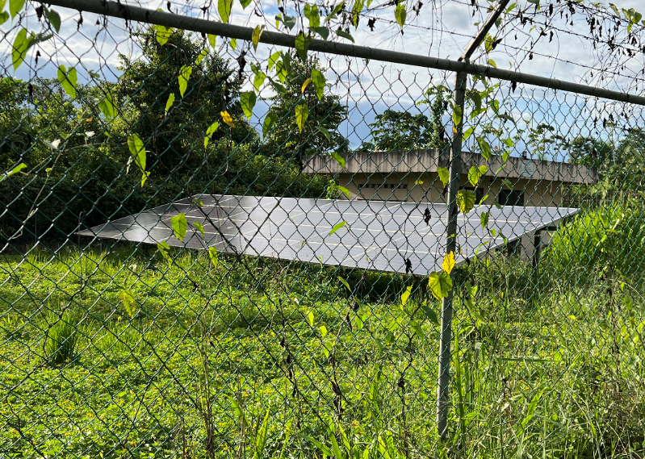
Figure 24: Example of Solar Panels used for Water Pump (Source: Site visit 2023).

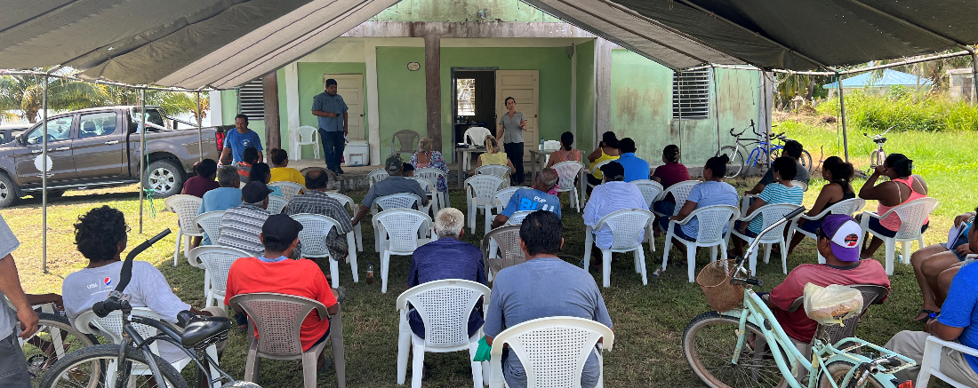
Figure 25: Consultation Meeting with Copper Bank.

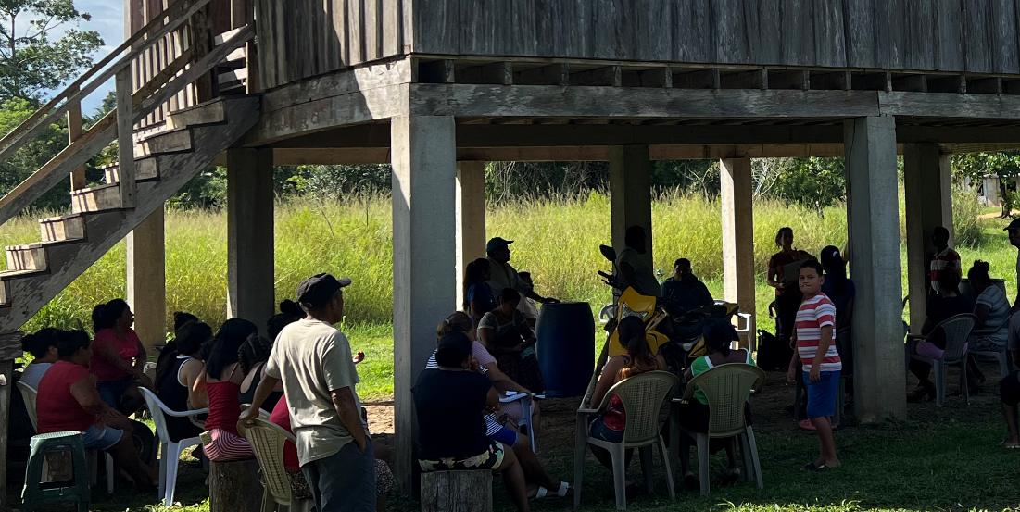
Figure 26: Consultation Meeting with Boom Creek.
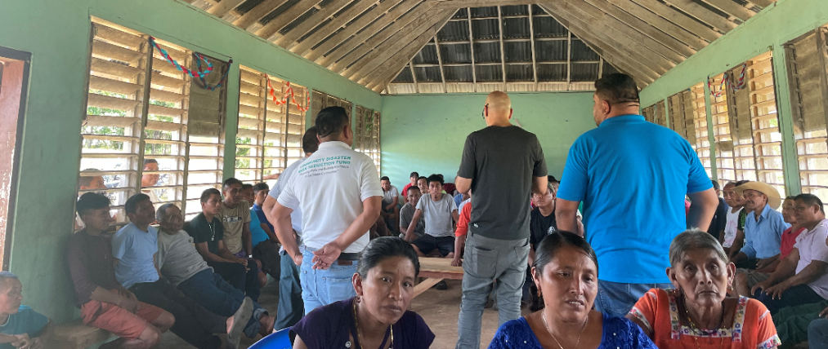
Figure 27: Consultation Meeting with Otoxha.
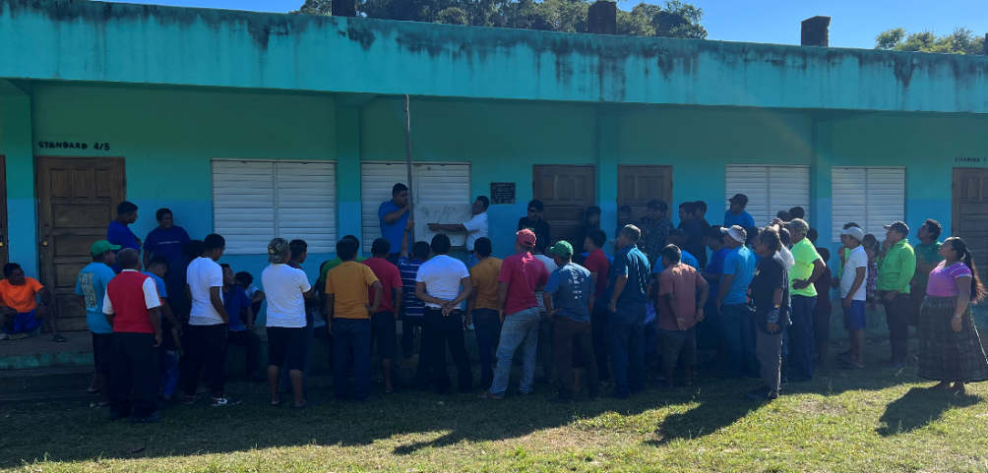
Figure 28: Consultation Meeting with Dolores Village.
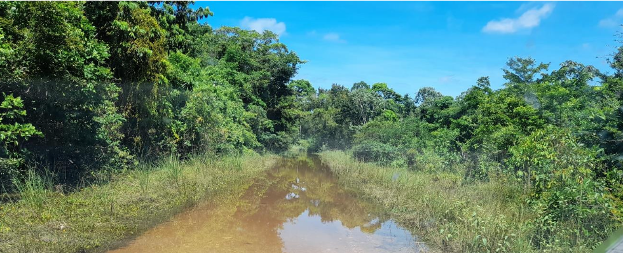

Figure 29: Boom Creek Road during flooding (Source: Boom Creek Village Needs and Assets Assessment, 2021).
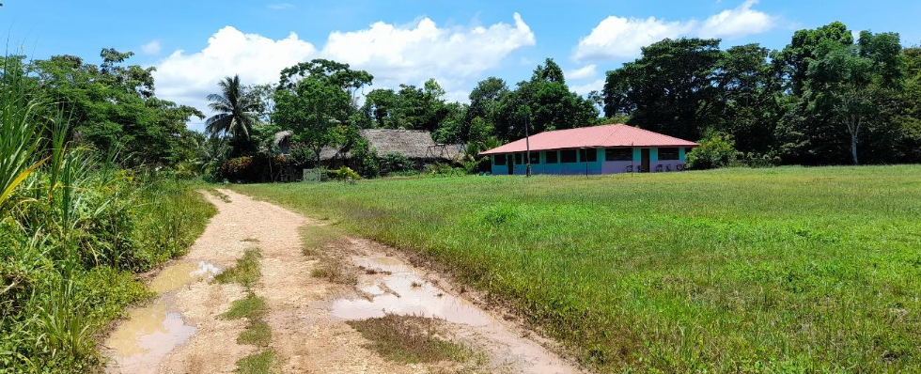
Figure 30: Living Word Government School (Source: Boom Creek Village Needs and Assets Assessment, 2021).
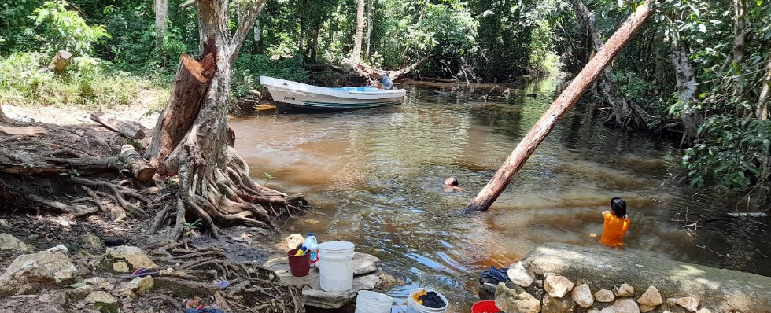
Figure 31: (Source: Boom Creek Village Needs and Assets Assessment, 2021).
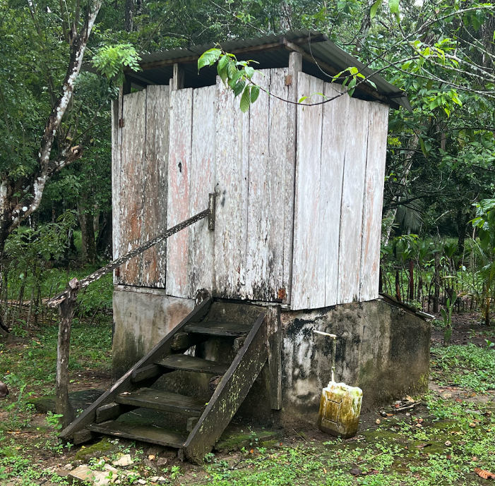

Figure 32: Boom Creek Sustainable Harvest International Latrine (Source: Site visit, 2023).

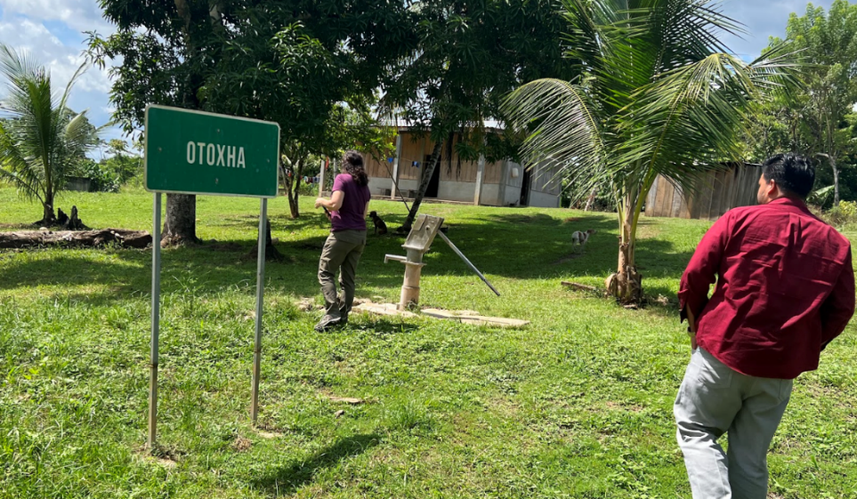

Figure 33: Water Hand Pump at the entrance of Otoxha Village (Source: Site visit, 2023).

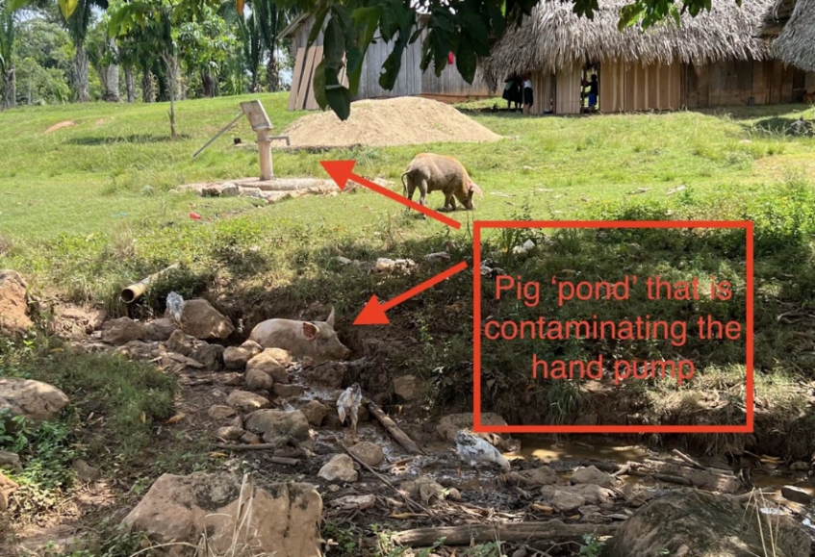
Figure 34: Foraging Pigs contaminating the Hand Pumps in Otoxha (Source: Site visit, 2023)

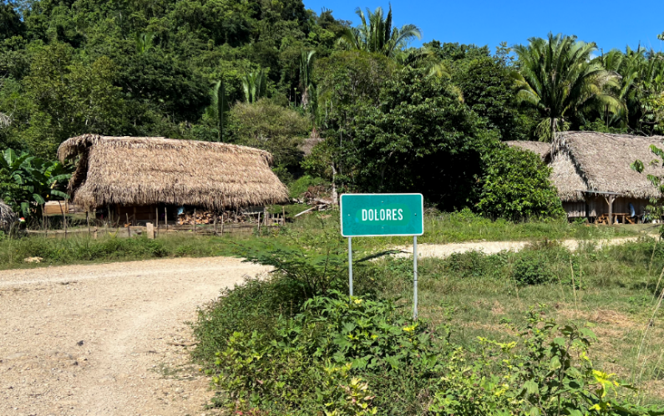

Figure 35: Dolores Entrance (Source. Site visit, 2023)

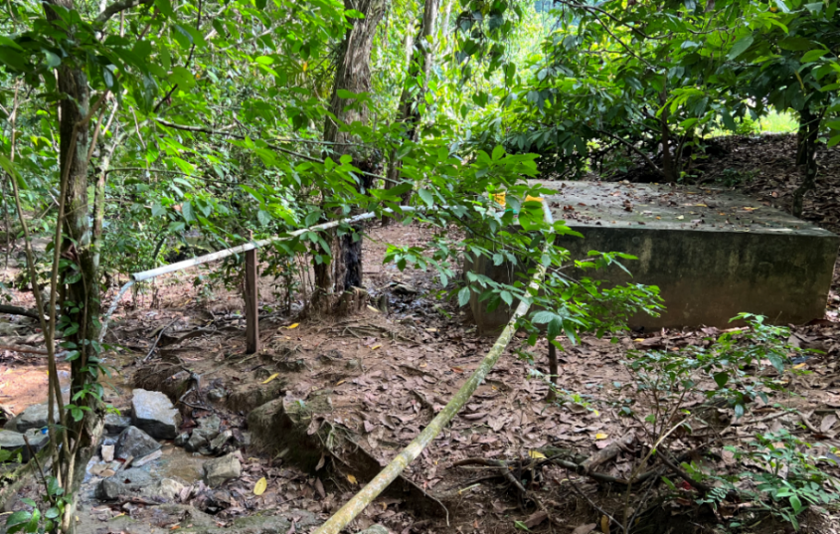
Figure 36: Spring Water Reservoirs with PVC Pipes to the Village (Source: Site visit 2023).

APPENDIX 1: DOCUMENTS REVIEWED

- 3rd National Comm UNFCCC (2016)
- 4th National Comm UNFCCC (2022)
- Adaptation Fund Gender Policy
- Adaptation Fund Gender Policy and Gender Action Plan (2021)
- Adaptation Fund Review Criteria (PPT)
- AFB.B.40.14 - Report of the Fortieth Meeting of The Adaptation Fund Board (2023)
- AFB.PPRC.31.47 addendum - Project Formulation Grant for Belize (2023)
- Belize Country Strategy (2016-2019)
- Belize Growth and Sustainable Development Strategy 2016-2020 (2016).
- Belize International Fund for Agricultural Development (IFAD) | Decision B.22/07
- Belize Marine Conservation and Climate Adaptation Project (2014)
- Belize: Multi-dimensional poverty index 2023
- Belize Technology Needs Assessment Mitigation (2017)
- Boom Creek Bacteriological Results (2011)
- Boom Creek Chemical Results (2011)
- Boom Creek Village Needs Assessment (2021)
- Climate Finance Strategy of Belize 2021– 2026
- Climate Smart Agriculture in Belize (2015)
- Communities under the FPIC Protocol Memo (2022)
- Concept Note SEAM Project (2021)
- Consultancy Completion Report: Groundwater Flow Regime Assessment Report from Northern Belize (2023).
- Copper Bank Data for PACT Adaptation Fund Information Request (2022)
- Copper Bank Village Community Profile (2020)
- Country Strategy (2021) IFAD
- Creek Villages -Belize`s most rural and remote communities
- Dolores Community Profile (2004)
- Dolores Village Needs and Assets Assessment (2021)
- Elements of Sustainable Solar Water Pumping System Design (2015).
- Enhancing jaguar corridors and strongholds through improved management and threat reduction (2021)
- Enhancing the Resilience of Belize’s Coastal Communities to Climate Change Impacts (2020)
- Environmental and Social Management Framework for the REDD+ Readiness Project in Belize (2021)
- ESP. Guidance for IE on Compliance with AF Gender Policy (2022)
- Financial Regulation for Village Council Water Boards (2004)
- FPIC Regulation Toledo District (2004)
- Global Photovoltaic Power Potential (2020)
- Global Photovoltaic Power Potential Factsheet Belize (2020)
- Growth and Sustainable Development Strategy Belize 2016- 2019 (2016)
- Guidance for IE on Compliance with AF Gender Policy (2022)
- Guidance Note Use of Solar Pumping (2018)
- Horizon 2030 National Development Framework for Belize 2010-2030 (2010).
- Indigenous & Tribal peoples’ Rights in Practice: A Guide to ILO Convention 169, International Labor Organization (2009)
- Indigenous Female Solar Engineers Scaling up Solar Energy to Machakilha and Graham Creek Villages - Belize`s most rural and remote communities.
- Indigenous Peoples Planning Framework – guidelines for developing (2022)
- Inferior Courts Act
- Instructions for Preparing a Request for Project Funding AF
- Knowledge, Attitudes, and Practices Study on Climate Change Belize (2016)
- Legal Opinion on FPIC
- Maya Customary Land Policy (2023)
- Maya Of Southern Belize Free Prior and Informed Consent Protocol
- Maya People of The Toledo District in Southern Belize Consultation Framework
- Methodologies for Reporting AF Core Indicator
- MHD Annual Technical Report 2021
- Modelled Impacts of LULC and Climate Change Predictions on the Hydrologic Regime in Belize
- MRT Checklist - Copper Bank – 2022
- Multiple Indicator Cluster Survey (2015-2016)
- National Biodiversity Strategy and Action Plan (2016-2020)
- National Climate Resilience Investment Plan (2013)
- National Environmental Policy & Strategy (2014-2024)
- National Integrated Water Resources Mangement Policy (2008)
- Operational & Maintenance Manual for Rural Water Supplier (2013)
- Otoxha Community Demographics (ND)
- Otoxha Community Profile (ND)
- P101: Resilient Rural Belize (Be-Resilient)
- Proposal For Large Innovation Project for Belize AF (2023)
- Proposal-for-Enhanced-Direct-Access-Grant-for-Belize
- Proposal-Guatemala Honduras and Belize (2022)
- Solar Powered Water Supply System -Toolkit-for-Communities
- Solar pumping for rural water supply- life-cycle costs from eight countries
- Solar Water Pumping Miniguide (2018)
- Roles and Responsibilities of Water Boards
- Stakeholder for multi-annual indicative programme (MOP for Priority Area 1)
- Summary: Guidance for IE Compliance with AF Gender Policy
- Technology Action Plan for Climate Change Adaptation and Mitigation (2018)
- The Future we dream, Maya Leaders Alliance and Toledo Alcaldes Association
- The Revised National Gender Policy (Updated 2013)
- Toward equality of opportunity for equality of results. A situation analysis of gender politics in Belize
- Village Council Act
- Water and Sanitation in Belize (2013)
- Water Board Statue (ND)
- Water Quality Monitoring Report for Wells in Copper Bank Village (2022)
- Water Shortages Report in Dolores Village (2013)
- Water Test Results (2023)

APPENDIX 2: LIST OF STAKEHOLDERS CONSULTED

Date | Name | Institution | Topic | Principles of choice | Communication
3/9/2023 | Mark Miller | Belize Power Limited | Solar Water Pumps and Solar Engineer  Solar Water Pumps and Solar Engineer | Experience implementing solar energy systems in the communities. | Microsoft Teams
3/9/2023 | Miriam Choc
3/9/2023 | Luc Zandvliet | Director Triple R Alliance | FPIC process and protocol | Good practices and conditions for success engaging IP in project process and design | Microsoft Teams
4/9/2023 | Leonel Requena | UNDP | Female Solar Engineer Project | Experience in programs of installation of solar systems to indigenous communities | Microsoft Teams
9/6/2023 | Gregory Cho’c | Commissioner, Indigenous People Affairs | Consent in Belize and FPIC in the project | Role of the Field Officers, water situation in the communities | Microsoft Teams
9/6/2023 | Christian Loza | Rural Community Development Officer - MRT | Consent in Belize and FPIC in the project |  | Microsoft Teams
9/6/2023 | Ismer Ortega | Northern Regional Rural Coordinator - MRT | Consent in Belize and FPIC in the project |  | Microsoft Teams
9/6/2023 | Adrian Cus | Rural Community Development Officer - MRT | Consent in Belize and FPIC in the project |  | Microsoft Teams
9/6/2023 | Valentino Shal | Chief Executive Officer - MRT | Consent in Belize and FPIC in the project |  | Microsoft Teams
9/6/2023 | Joyce Tun | Grants Officer - Protected Areas Conservation Trust (PACT) | Consent in Belize and FPIC in the project |  | Microsoft Teams
9/6/2023 | Ary Sosa | Ministry of Health & Wellness | Consent in Belize and FPIC in the project |  | Microsoft Teams
9/6/2023 | Tennielle Hendy | Principal Hydrologist - National Hydrological Service | Consent in Belize and FPIC in the project |  | Microsoft Teams
12/9/2023 | Christina Garcia | Ya’axche | Alternative Livelihoods | Experience working with Belizean communities to address climate change impacts in order to promote sustainable development. | Microsoft Teams
12/9/2023 | Denise Garcia
12/9/2023 | Elizabeth Dorgay
13/9/2023 | Carlos Tun | BSIF (Social Investment Fund Projects) | FPIC, development of projects in the communities | Experience carrying out water projects, including with Maya communities in the Toledo District | Microsoft Teams
13/9/2023 | Norys Rosales
13/9/2023 | Angeles itzab
13/9/2023 | Randulfo Mendoza
13/9/2023 | Ivor Mendoza
18/9/2023 | Jesus Hernandez | MRT | Water sources, wastewater, water contamination, gender issues | Field Officers long-term understanding of communities and language ability for fluid conversation. Clarity on main issues facing and past project initiatives in water that did not materialize | Microsoft Teams
18/9/2023 | Leonardo Cal
18/9/2023 | Nemencio C. Acosta
18/9/2023 | Neville T Wade
18/9/2023 | Pedro
18/9/2023 | Adrian Cus
20/9/2023 | Nemencio Acosta | MRT | Support during visits to the 4 communities - Water boards | SEAM Project focal point for the MRT. Lead FO to accompany and support during visits to the communities. | Microsoft Teams
22/9/2023 | Elizabeth Muschamp | Humana Belize | Engagement with Women and with the communities in general | Experience working with Toledo District communities | Microsoft Teams
29/10/2023 | Virginia Cal | Tulum Uj Womens Group | Operation of the women's groups and needs of indigenous women | Women's group from southern Belize who worked together with the MRT | WhatsApp voice notes
2/10/2023 | Florencio Martinez | DAVCO Corozal District | Livelihoods, situation in Copper Bank | Experience in development and implementation of projects in the communities | Microsoft Teams
2/10/2023 | Delroy Velorio | NAVCO | Projects carried out, women's participation | Experience in development and implementation of projects in the communities | Microsoft Teams
3/10/2023 | Michelle Lindo-Longsworth | BEST | Gender, livelihoods, experience working with the communities | Organization that promotes credits and the participation of women in the social and economic development of Belize | Microsoft Teams
3/10/2023 | Anastasia Shal | Xaibe Women’s Group | Operation of the women's groups and needs of indigenous women | Women's group from northern Belize who worked together with the MRT | WhatsApp Call
11/10/2023 | Gerarldo Flowers | Resilient Rural Belize | Experience with communities, water fee | In charge of a GCF programme, which aims to minimize the impacts of climatic and economic events on smallholder farmers | Microsoft Teams
12/10/2023 | Elsa Cardinez | MRT | Presentation of the IR | National Coordinator, Rural Development Department | Microsoft Teams
13/10/2023 | Cynthia Williams | Women and Family Support Department | Gender guidelines, gender in projects, women's role in the communities | Experience in gender | Microsoft Teams
13/10/2023 | Lorraine Johnson
13/10/2023 | Makesha Suazo
15/10/2023 | William Elder | USDA United States Department of Agriculture | Watershed management, septic, and grey water options for rural communities | Knowledge of technical aspects of watershed and wastewater management | Phone call
16/10/2023 | Andy Alberto Arguelles | Chairman of Copper Bank | History, structure and makeup of the village | Copper Bank Authority | Phone calls
17/10/2023 | Andy Alberto Arguelles | Chairman of Copper Bank | Villages contamination issues and septic needs | Copper Bank Authority and technical expertise on water access projects | Phone call
17/10/2023 | Jose García | Belizean Civil Environmental Engineer | Villages contamination issues and septic needs |  | Phone call
17/10/2023 | Aldean Williams | Social and Gender Specialist | Gender dynamics, gender roles, Projects with women | Social and Gender Specialist of the Philip Goldson Highway and the Remate Bypass Upgrading Project & Coastal Highway Project | Microsoft Teams
19/10/2023 | Robert Pendell | Rotary Belize | Latrine design revised design to address problems and best practices for implementation success with indigenous communities | Experience with latrine implementation and promotion of latrine use over open defecation with indigenous people in the Toledo District | Phone call
20/10/2023 | Delroy Velorio | NAVCO | SEAM and water and wastewater management | SEAM Project, training of water boards, challenges of sanitation and water in growing communities | In person
21/10/2023 | Rick Mallory | Rotary Belize | Project design change, corruption, role of sanitation worker in solving problems at Boom Creek. | Experience in implementing projects in the communities | In person
1/11/2023 | Heron Moreno | Corozal Sustainable Future Initiative (CSFI) | CSFI's way of working, possible solutions to water problems, | Experience in protection and conservation of ecosystems | Microsoft Teams
1/11/2023 | Nemencio Acosta | MRT and Belize Water Services | Waste water management | BWS Persons within the MRT who have the most experience in wastewater management | Microsoft Teams
1/11/2023 | Hugo Rancharan
1/11/2023 | Adrian Cus
1/11/2023 | Elsa Cardinez
1/11/2023 | Jesus Hernandez
2/11/2023 | Jose Garcia | Belizean Civil Environmental Engineer | Technical aspects of wells, salinity, and waste management systems. | Experienced engineer with extensive experience in water access projects in Belize and waste management. | Microsoft Teams
9/11/2023 | Evelio Castaneda | MRT | Revision of the survey and recommendations | Field officers who will conduct the surveys | Microsoft Teams
9/11/2023 | Neville T Wade
9/11/2023 | Nemencio C Acosta

A site visit took place between October 16th to 23rd, 2023 with the goal to present the project with updated components and consult with the villages’ leaders and community members.

^{DATE} | ^{VILLAGE} | ^{GOAL}
^{10/17/23} | ^{Copper Bank} | Leader's meeting; followed by community meeting.
^{10/18/23} | ^{Boom Creek}  ^{Otoxha}  ^{Dolores} | Joint meeting of the leaders in Punta Gorda
^{10/18/23} | ^{Boom Creek} | ^{Site visit}
^{10/19/23} | ^{Otoxha} | ^{Site Visit}
^{10/19/23} | ^{Dolores} | ^{Site Visit}
^{10/21/23} | ^{Dolores} | ^{Community Meeting}
^{10/21/23} | ^{Boom Creek} | ^{Community Meeting}  ^{Signing of the FPIC}
^{10/22/23} | ^{Dolores} | ^{Community Meeting}  ^{Signing of the FPIC}
^{10/22/23} | ^{Otoxha} | ^{Community Meeting}  ^{Signing of the FPIC}

APPENDIX 3: INDIGENOUS ORGANIZATIONS

NATIONAL ORGANIZATIONS
Belize National Indigenous Council | BENIC was established in 1989. Its constituent members are the Maya Leaders Association/Toledo Alcaldes Association, the National Garífuna Council, and the Northern Maya Association of Belize. Born of the recognition of the need for an organization to fight for the rights of indigenous peoples in Belize, to promote harmonious and cooperative relations, to promote the principles of justice, equality and non-discrimination, and to ensure the dignity, survival and well-being of the indigenous peoples of Belize. Pillars of work are land security, indigenous rights, women’s participation, recovery and preservation of indigenous culture, education and the environment.  https://www.facebook.com/BENIC-449994402439140/ belize.indigenous.council@gmail.com
Garifuna National Council | Its mission is to preserve, strengthen and develop our culture, and to promote economic development among the Garifuna people.  http://www.ngcbelize.org/index.php https://www.facebook.com/ngcbelize/  Tel: (501) 669-0639  Email: ngcbelize@gmail.com
Toledo Alcaldes Assoc. | Coalition of 78 alcaldes, including a first and second alcalde of 39 Maya villages in the Toledo District  Voice of America Road, Punta Gorda Town, Toledo, Belize, C.A. Email: taa1992@gmail.com Telephone: (501) 662-1663
Maya Leaders Alliance | The Maya Leaders Alliance was created in 1999 and is constituted by the leaders of several organizations of the Q’eqchi’ and Mopan Maya people of Toledo district. The Toledo Alcaldes’ Association, Toledo Maya Women’s Council, the Q’eqchi’ Council of Belize and the Toledo Maya Cultural Council make part of the organization. They have enjoyed considerable success, including legal victories against a permit to allow oil exploration within a national park considered part of Maya customary territories. The case led to the establishment of a framework to inform the consultation process between economic actors, the government and local communities, thereby giving the Maya a voice they previously had lacked. MLA was awarded the Equator Prize in 2015  Email: mayaleadersbelize@gmail.com
Q’eqchi Council of Belize | No online data available
Toledo Maya Women’s Council | https://www.facebook.com/Toledo-MAYA-Womens-Council-594753317253806
Maya Leaders of Southern Belize | Founded in 1999 to monitor land development in the Toledo District of Belize.  They have formed alliances such as the Maya Leaders Alliance of Toledo, bringing together the five organizations of the south  https://www.facebook.com/mayaleadersofsouthernbelize/
Maya Institute of Belize | It is a founding organization of the Enlace Continental de Mujeres Indígenas de las Américas (ECMIA)

APPENDIX 4: STAKEHOLDER FEEDBACK IMPACT ON PROJECT

Topic | Feedback | Recommendations/ Impact on project formulation
Overall programme | Consultations revealed IP’s main interest is Component 1 – the water distribution system. | Every community stated an urgency for a system to provide reliable, potable water and asked that the project be expedited.
Country Context | There was a perception that political interference or political agenda may influence receiving the necessary project funds, especially if there is a change of political party. | It was highlighted during consultations that the project will have to adhere to strict requirements as established by the Adaptation Fund which would decrease the probability of political interference that could redirect funds intended for SEAM.
Environmental and social safeguards | During the consultation with the MLA and TAA there was concern over awareness and following FPIC protocol and ensuring consideration of the communities’ priorities.  Additionally, it was pointed out that a grievance redress mechanism needs to be established in a way that is suitable to the remoteness and structures of the indigenous communities.  Further, projects should always consider and respect the rights of the indigenous people.  Consulted representatives also highlighted the need to ensure that IPs are consulted throughout a project's implementation, not only at the beginning. | Project team conducted an extensive review of FPIC (national and international) as well as received guidance from the MRT on IP protocol. FPIC procedure and IP protocol was successfully followed and the FPIC was presented and signed (Appendix 8) by each indigenous community.  The project design includes a system of on-going consultation as part of the project.  A GRM was developed that considered the remote location and literacy rates in the project area.  Roles and responsibilities for monitoring is structures in a transparent and inclusive manner.
Role of technical assistance | During consultations, it was argued that TA should support beneficiaries in accessing credit (e.g. sufficient micro-finance to start producing or acquiring the materials to execute the livelihood being introduced).  It was highlighted that the alternative livelihood activities are inherently weak without support with marketing or an absence of markets for products produced.  Additionally, there was concern there would be insufficient follow-through on the training after the initial capacity building was complete. | It was explained that this project was not a micro-finance project but that the TA for alternative livelihoods would be tailored to expressed needs and interests of the community. Alternative livelihood training will include how to market what is produced (e.g. honey, artisanry)  The livelihood option must be commercially viable within the existing market infrastructure and sustainable post-training.  Emphasis will be placed in ensuring that women from indigenous communities are actively targeted by the TA provider to ensure that they are not excluded from benefitting from the activity.
Grievance redress mechanism | The Maya communities have existing GRM arrangements in place, where differences and conflicts can be heard and adjourned by the Alcalde acting as magistrate (cases up to BZ$ 50) for those cases where the Alcalde is unable to adjourn or for which there is an appeal, the case can be presented to the Toledo Alcalde Association. A case can go up to the country’s Supreme Court (advised by Toledo Alcalde’s Association). | Where relevant due to location, the projects will adapt the GRM to integrate the existing customary mechanisms of the Maya villages.  The villages will also be invited to participate in further adapting the project specific GRMs in their own communities to increase accessibility.
Sanitation | The feedback from the FOs, and the communities’ response in Otoxha and Dolores, conveyed a reluctance to discuss latrines or sanitation. Though the leaders expressed willingness to have latrines as part of the project the process of changing this cultural norm would require additional consideration. | Though sanitation was considered as part of the project components, the feedback resulted in removing sanitation infrastructure and focus instead on WASH training as a step for preserving the watershed and decreasing contamination. Additionally, other mitigants were developed to avoid contamination.  Gender sensitive and culturally appropriate WASH training will be provided.  Training teachers to provide WASH in schools with the goal that children disseminate the information to their parents.  Plan on multi-step process that draws on good practices from WASH programs conducted worldwide.
Wells | Two of the communities’ leaders expressed specific locations for the well to be drilled.  Community members voiced that they wanted to maintain their private wells in case the water system failed or to use as an additional water source for gardens and livestock. | The Hydrological Unit that identifies the most advantageous spot to find water will work with the community leaders to determine if the village selected spots are viable and discuss with them the options and anticipated results.  After discussion with the communities, the MRT will agree that wells would not be required to be shut down if the communities are willing to agree the wells would not be used for human consumption (as the impact on tracking water related health issues is complex if multiple sources of water are being consumed). The water could be used for animal and irrigation purposes or for flushing toilets and cleaning.
Temporary Employment | The leaders and community members said they want the opportunity to be hired as temporary laborers for the water distribution system and other construction needs of the project.  The community expressed willingness to provide in-kind contribution by digging the trenches to their individual households. | The project design now includes that construction contractor’ will either have as part of the ToR the requirement, or be strongly recommended, to hire as many local villagers as possible, regardless of gender, to be involved with all construction that can be outsourced to them.  The construction contractors will also provide inclusive construction training as needed.  The community offered to provide the work at a discounted rate to reflect in-kind contribution if that would increase the chances for employment opportunities.  All rules and regulations for workers would be followed.

APPENDIX 5: FPIC

Boom Creek FPIC

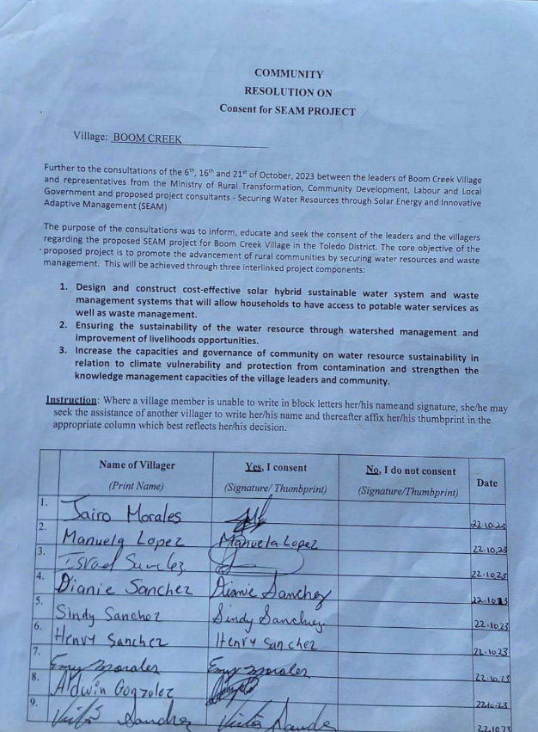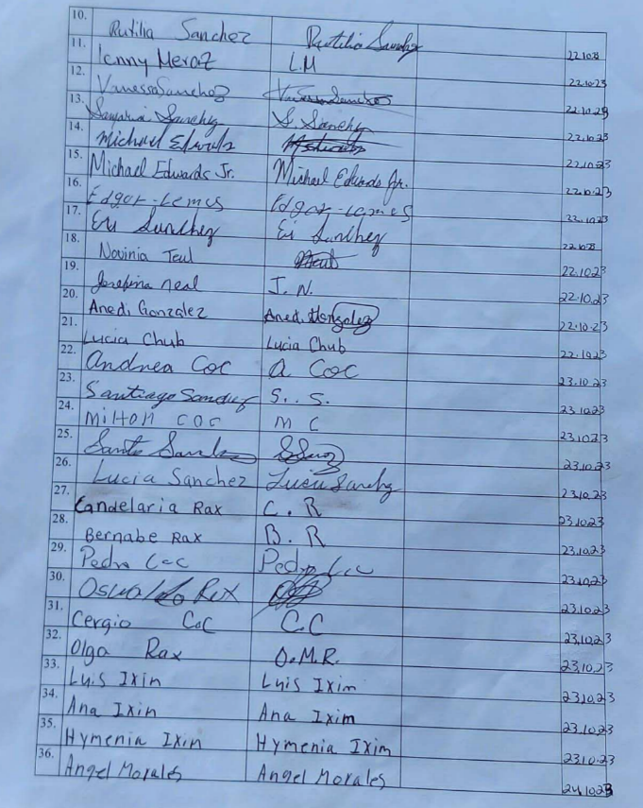



Dolores FPIC
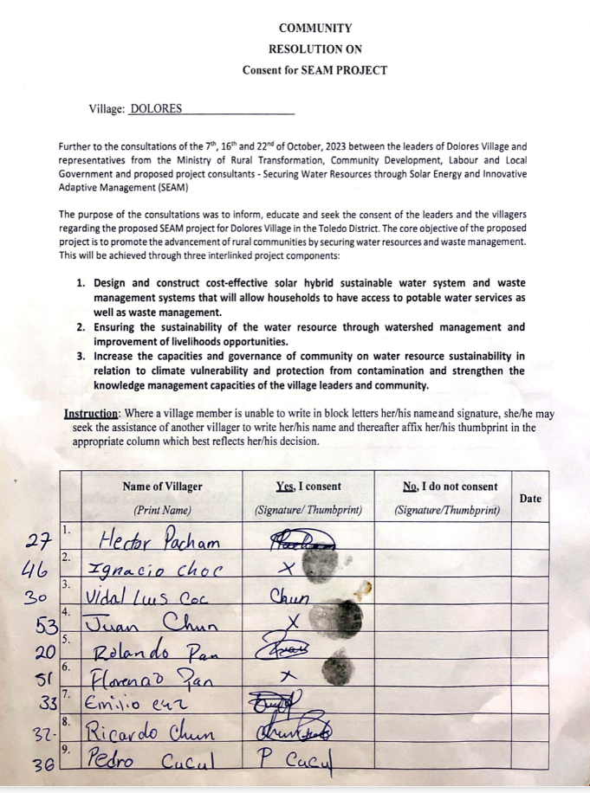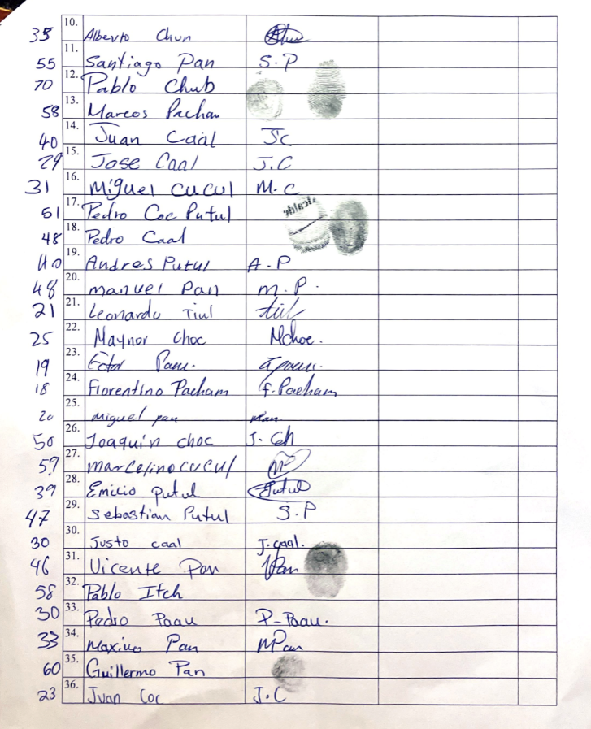

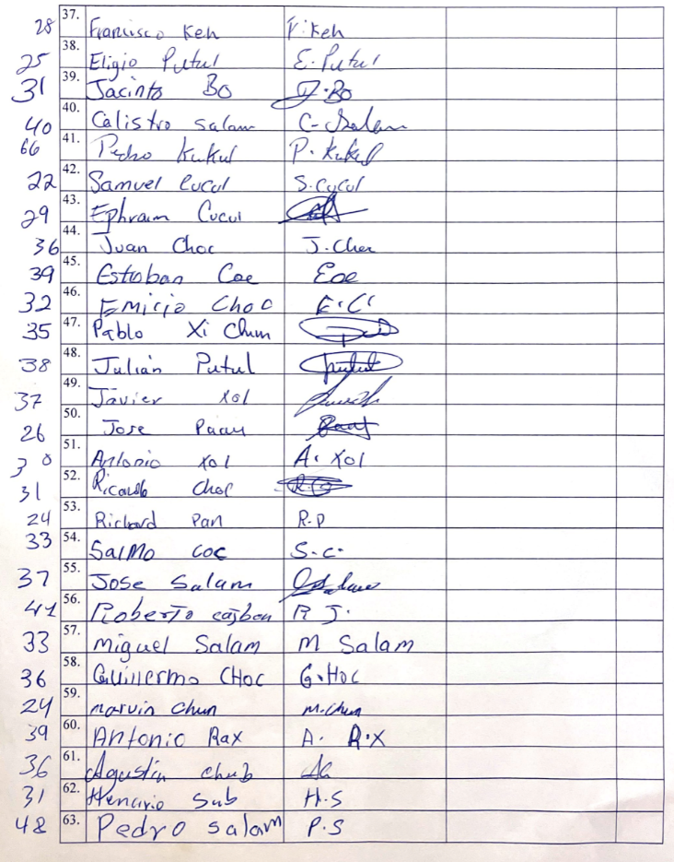
Otoxha FPIC
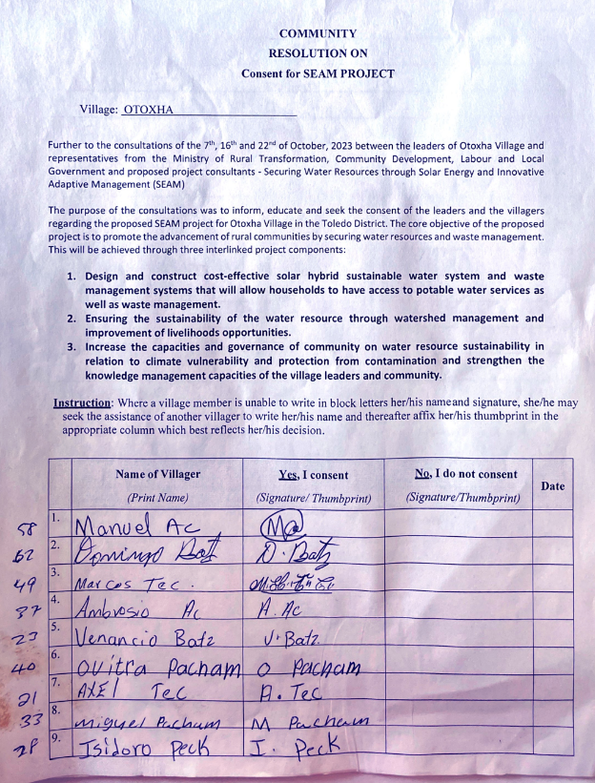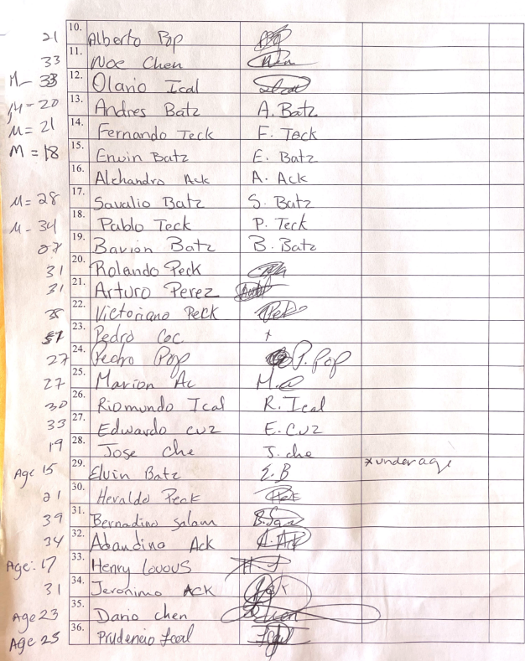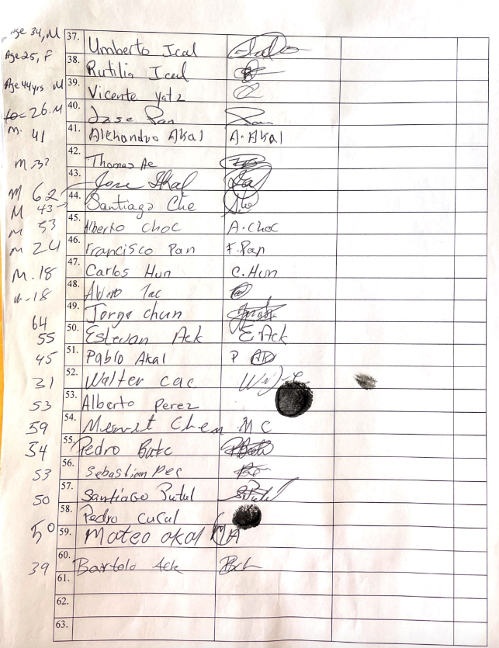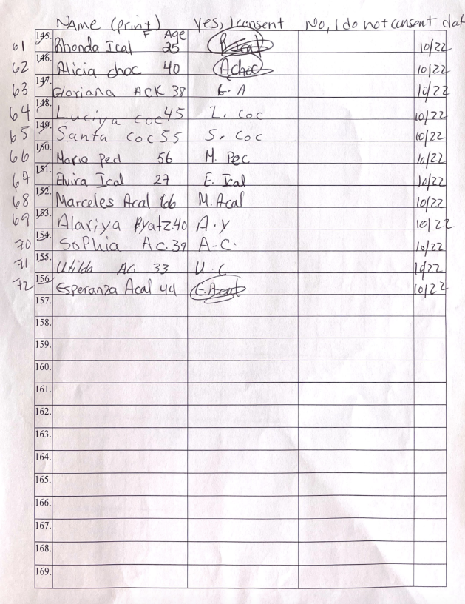

APPENDIX 6: COPPER BANK LEADER AND COMMUNITY MEMBERS CONSULTED

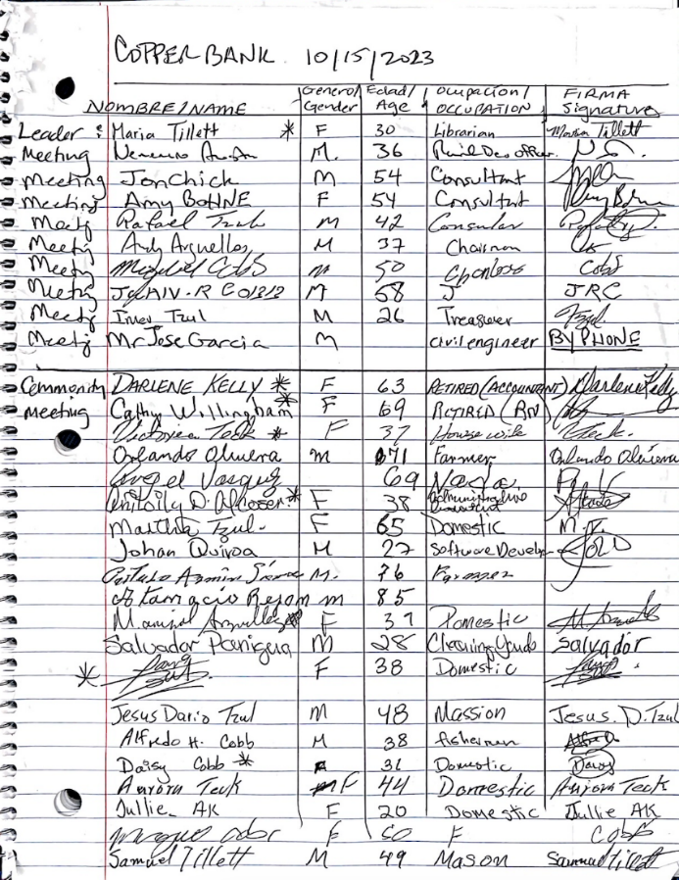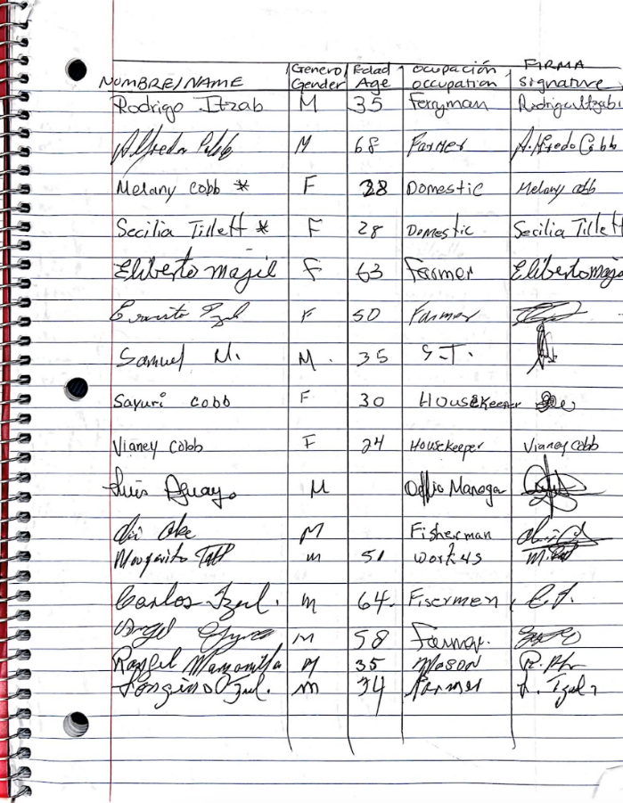

Annex V: Gender Assessment and Action Plan

Gender Assessment

In the initial part of this segment, the foundational legal framework supporting gender equality will be explored, followed by an examination of the institutional mechanisms, with particular attention to national women's machineries dedicated to advancing gender equality. The socio-economic landscape of Belize will be analyzed through a gender lens, accompanied by a thorough examination of educational and health contexts in the country. Additionally, cultural dimensions intertwined with gender dynamics will be elucidated, followed by an exploration of gender-based violence.

Transitioning to the subsequent section, the gender division of labor will be scrutinized, encompassing both productive and reproductive spheres, such as domestic chores and caregiving activities. This analysis will unfold at both the national and community levels. Following this, the third section will unravel power dynamics in gender relations. Moving forward, the fourth section will shed light on the differentiated access to resources, including land, natural resources, and financial assets. Conclusively, this segment will culminate with a dedicated section addressing the impacts of climate change and their disparate effects on women and men, considering information at both the national and community levels.

This whole presentation will leverage national statistics to provide a comprehensive understanding of the realities faced by communities within the project's sphere of influence.

Gender-specific socio-economic, cultural and legal context

This section delves into the socio-economic, cultural, and legal landscape, providing a concise overview of the distinctive contexts shaping gender dynamics within the project's scope.

Education

The intersection of education and Maya culture reveals enduring challenges. Historical legacies, coupled with religious educational institutions, contribute to disapproval of Maya cultural practices. The educational curriculum often fails to align with daily needs, particularly affecting the Maya people, perpetuating cultural insensitivity and educational disadvantages. especially among Maya women who face distinct challenges, such as language barriers and cultural marginalization. Roman Catholic primary schools, which account for 35.9% of total schools at the national level and for 59% at the Toledo district (Ministry of Education, Culture, Science & Technology, 2023), reinforce traditional gender roles and subtly controlling girls' bodies through unsuitable uniforms designed to de-emphasize sexuality (Sarstoon Temash Institute for Indigenous Management, 2023). Addressing these issues demands a holistic approach that considers cultural diversity and strives for inclusive and equitable educational opportunities for all.

When examining data collected for the four communities where SEAM project is going to be implemented, one discovers that girls consistently surpass boys in school enrollment across all levels in these communities, deviating from the district's female-to-male ratios. The data reveals that primary school enrollment is notably higher for girls in Boom Creek and Dolores than the Toledo district's average of 0.96 in rural areas, with Otoxha falling within the district’s range. Copper Bank exhibits a primary enrollment ratio surpassing Corozal's average of 0.89 in rural areas. Examining trends in secondary school enrollment, females consistently outnumber males in all communities, contradicting prevailing trends in the Toledo district and even surpassing national trends in rural areas.

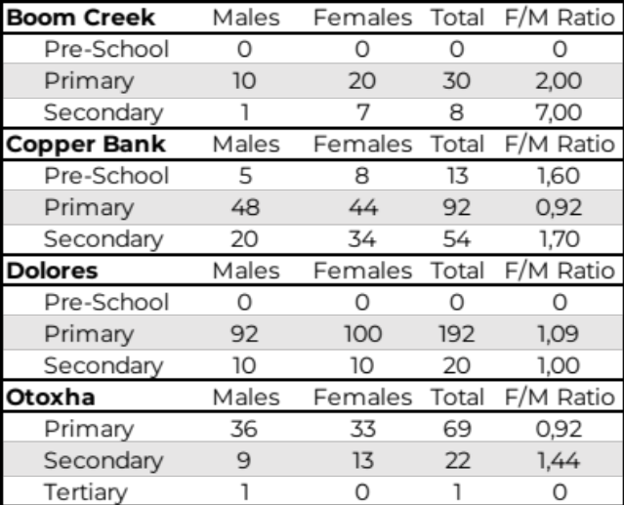
Table 56: Education statistics for SEAM project communities (Source: Compiled data provided by MRT).
In conclusion, the educational landscape in these communities showcases a commendable gender parity, with girls consistently outperforming boys in both primary and secondary school enrollment. This positive trend reflects a noteworthy commitment to providing equal educational opportunities for both genders in these regions.

Cultural Aspects
In all 2023 quarters, the age group exhibiting a higher prevalence of abuse comprised women aged 25-29 years (Belize Crime Observatory 2023a; Belize Crime Observatory 2023). This not only underscores the persistence of GBV in Belize but also raises the possibility that younger women may be less hesitant to report incidents, suggesting a potential shift in women's behavior trends. To address underreporting, the Gender Advocates Program, initiated in 2021, collaborates with UNICEF and aims to strengthen services and support networks in rural areas. Seventeen advocates have been trained to extend their assistance across 18 rural communities (NWC 2023, 35).

Furthermore, female murder rates fluctuated from 2009 to 2020, reaching their lowest point in 2020 after a surge in 2018. Belize has endeavored to combat all forms of violence, yet challenges persist, including law enforcement gaps, limited access to justice, and short-term protection measures. Additionally, language barriers hinder non-English speaking victims' access to services (Ministry of Economic Development 2017), which also may be a cause for underreporting in Maya communities.

The Statistical Institute of Belize and UNICEF assessed the attitudes of women and men aged 15-49 years towards wife/partner beating by asking the respondents whether husbands/partners are justified to hit or beat their wives/partners in a variety of situations.
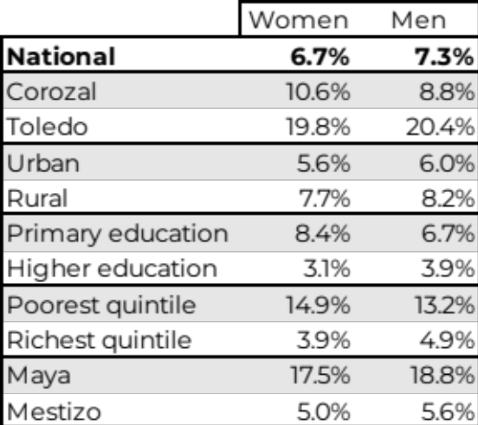
Table 57: Percent of population age 15-49 years who believe a husband is justified in beating his wife (Source: Statistical Institute of Belize and UNICEF, 2017).
The aim of these inquiries was to comprehend the societal rationale behind the use of violence (particularly in environments where women hold a subordinate status) as a punitive measure when a woman deviates from prescribed gender norms. It is essential to note that these patterns could potentially elucidate the elevated levels of gender-based violence observed in Belize, highlighting, in particular, the deeply entrenched patriarchal nature of Maya culture.

- Gender division of labor
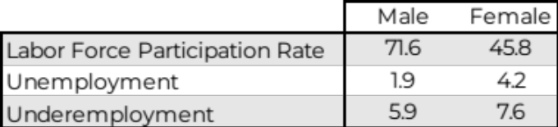
Table 58: Belize’s employment indicators, April 2023 (Source: Compiled from data by Statistical Institute of Belize, 2023).
Unemployment rates further illuminate the gender divide, with women experiencing a rate of 4.2%, more than twice that of men (1.9%). This trend persists across various education levels, with higher rates for females with primary (3.4%) or secondary (3.7%) education. Regional variations also surface, revealing that while Toledo records the highest overall unemployment rate (5%), Cayo claims the highest female unemployment rate (6.4%) (Statistical Institute of Belize 2023b). Notably, women's unemployment rates consistently double those of men, regardless of their ethnic background (Statistical Institute of Belize, 2021).

 | Male | Female
Creole | 8.5% | 15.9%
Garífuna | 5.2% | 14.7%
Maya | 11.3% | 20.5%
Mestizo/Hispanic | 5.5% | 10.2%
Other | 3.2% | 12.1%
DK/NS | 0.0% | 0.0%
Total | 6.7% | 13.0%
Table 59: Belize’s unemployment rate by sex & ethnicity, September 2021 (Source: Statistical Institute of Belize, 2021).
Delving into specific sectors, over half of the 190,037 employed individuals in April 2023 engage in 'Wholesale and Retail Trade, Repairs' (16.1%), 'Community, Social & Personal Services; Extra Territorial Organizations & Bodies' (14.1%), 'Tourism' (13.3%), and 'Agriculture and Related Activities' (11.5%). Males dominate most occupational categories, with exceptions noted in 'Services and Sales Workers,' 'Clerical Support,', 'Professionals,' and ‘Managers’ (Statistical Institute of Belize, 2023), where a semblance of gender parity emerges, challenging traditional occupational gender norms.
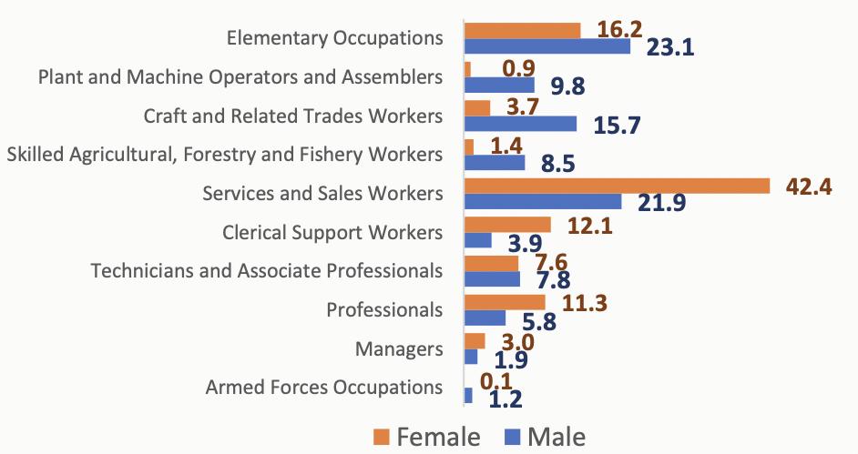
Figure 37: Share of employed person by main occupation, April 2023 (Source: Statistical Institute of Belize, 2023).
Informal employment, representing 37.2% of the employed population, has seen an increase from 35.3% in October 2022. The average working week spans 41.5 hours, and the average monthly income holds steady at $1,358. 'Managers' and 'Professionals' stand as the highest income earners in the workforce (Statistical Institute of Belize, 2023).

Gender-based power structure

At the community level, Village Councils (VC) are the main local government for villages. VCs are formed by seven members: Chairperson is elected by electors, while elected VC members choose among themselves a deputy chairperson, a secretary, and a treasurer.

In Maya communities there is also another indigenous traditional system that overlaps with VCs, the Alcalde system. Thus, Maya communities, such as Dolores,Otoxha, and Boom Creek have First Alcaldes and Second Alcaldes, who are elected by community members.

Historically, local power structures, like government ones, have been male dominated, even though women have accessed decision-making positions at some point in all communities, being Boom Creek the most equal one and Otoxha the least, where no woman has been elected in the past three elections.

 | 2016 Election |  | 2019 Election |  | 2021 Election
 | Female | Male | Female | Male | Female | Male
VC Boom Creek | 5 | 2* | 3 | 4* | 4 | 3*
VC Copper Bank | 0 | 7* | 0 | 7* | 1 | 6*
VC Dolores | 0 | 7* | 3 | 4* | 0 | 7*
VC Otoxha | -- | -- | 0 | 5* | 0 | 3*
*Indicates Chairperson’s gender
Table 60: Village Council historic elections in SEAM project communities (Source: MRT).
Water boards consist of seven people: the Chairmen of the Village Council, a Village Council member nominated by the Village Council, five other members appointed by the MRT after consultation with the Village Council and Electoral Division Area Representative. There are four main roles: Chairperson, Deputy Chairperson, Secretary and Treasurer, and they hold office for three years.

Women’s participation all along the project cycle, from design through project closure, but, more importantly, within the Water Boards, is essential to ensure water systems sustainability. Inclusive public participation is pivotal for successful water management, as highlighted by prior studies (Svahn, 2011) (Preparing for the next generation of watershed management programmes and projects. Water resources for the future, 2003) (Preparing for the next generation of watershed management programmes and projects., 2005); since it fosters a sense of ownership and responsibility (Swallow, 2005) and enables a deeper understanding of water user requirements and local challenges (Svahn, 2011) (Bonnal, 2005). In this regard, women's participation is a key factor in water project effectiveness and sustainability (Svahn, 2011) (Gender and Water Alliance, 2006), because equal participation of women and men in decision-making enhances project outcomes and promotes efficient water use and maintenance, optimal funding arrangements, as well as reduces breakdowns (Svahn, 2011).

- Access to resources

Concerning financial resources, data from the Development Finance Corporation (DFC). In the year 2022, DFC granted approval for a total of 763 loans, amounting to $32.38 million. Among the beneficiaries, 463 were male, and 300 were female, benefiting from various loan products (DFC, 2023). Furthermore, the breakdown of DFC's portfolio value by gender, as illustrated in the table below, indicates that women constitute 42% of all borrowers. There is also a discernible gender bias concerning the type of loans contracted, with more women than men seeking financial assistance for education and micro-finance (see MSE EBL, Empowered Business Loans for entrepreneurs), while housing loans exhibit a somewhat balanced distribution.
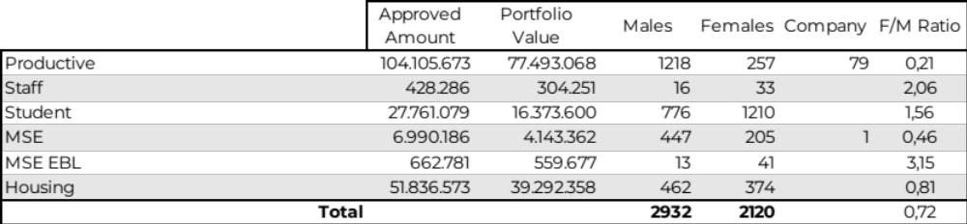
Table 61: DFC’s portfolio in 2022 (Source: Table compiled from DFC data).
Numerous studies have identified limited access to real estate as a primary obstacle for women and youth seeking financing. The Empowered Business loans have played a pivotal role in addressing this issue, contributing to a more equitable distribution of loans between men and women. In 2021, 55% of the recipients of DFC's loans were male, while 45% were female—a notable increase from the 30% recorded for women in 2019 (DFC, 2022).

DFC data from 2021 mirrors the patterns observed in 2022: women consistently opt for higher loan amounts for education, irrespective of the urban or rural setting, while gender parity is noted in mortgage loans. Notably, men in the agriculture sector secured loans of larger amounts (DFC, 2022). Specifically, the cattle sub-sector underscores a distinct male predominance, with merely two women among the 28 borrowers who have availed themselves of cattle loans. Furthermore, the loan amounts for women are markedly lower, averaging $35,625 compared to the male average of $166,310 (DFC, 2023).
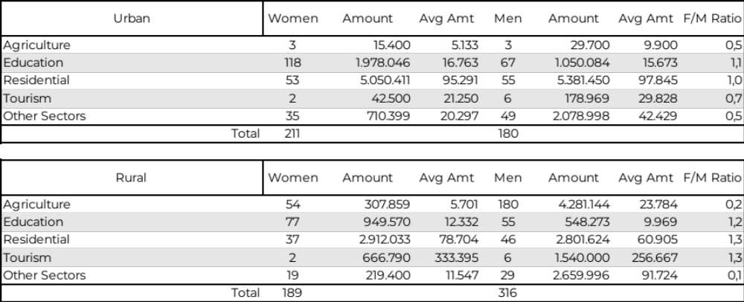
Table 62: DFC’s portfolio in 2021 ( Source: Table compiled from DFC data).
Interestingly, according to Global Findex 2014, both men and women face distinct challenges. While more women (52%) than men (44%) hold accounts at financial institutions, men tend to own more credit cards (12% vs. 10%). Additionally, women are slightly more likely to have inactive accounts (1 percentage point higher). The data also reveals that women are more inclined to save (63% vs. 56%) and borrow (56% compared to the 54% male average), particularly for mortgages (15% vs. 10% for men). However, a significant gender gap exists in terms of income sources, with substantially more men receiving wages (32% vs. 23% of women) and payments for the sale of agricultural products, livestock, or crops (17% of men compared to 13% of women). On the other hand, women receive more domestic remittances (22% compared to 14% for men). As seen in the next table, which focuses on youth, not even a third of young women between 15 and 24 years has a job, while more than half of young men of the same age do. Similar gender gaps appear when one observes those rates by district, ethnicity or level of education.

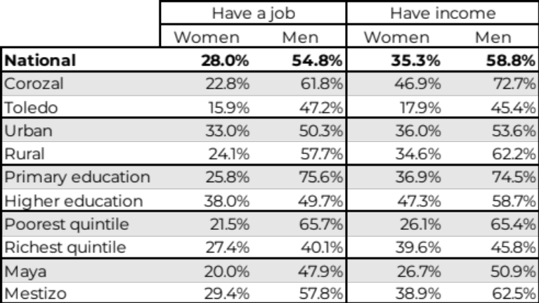
Table 63: Source: Percentage of population age 15-24 years who have a job or income (Statistical Institute of Belize and UNICEF 2017).
This discrepancy highlights women's vulnerabilities in terms of earnings and underscores the higher dependence on men's income, reflecting traditional societal norms where heteropatriarchal family structures prevail.

Gender mainstreaming strategy in SEAM Project

Gender-responsive consultations

The SEAM project design involved a thorough, meaningful and gender-responsive consultation process, aligning with the Maya of Southern Belize Free Prior and Informed Consent Protocol (MSB-FPIC). Adhering to this protocol is essential to guarantee that indigenous women are well-informed about the policies and initiatives that affect them and can also influence the project design.

Efforts have been diligently undertaken to foster the active involvement of women in the consultation process, underscoring a steadfast commitment to inclusivity. The initiative commenced early in the design phase, emphasizing the importance of timely disclosure of pertinent project information to communities. The collaboration with the MRT’s field officers' network played a pivotal role in successfully executing these consultations. Following the MSB-FPIC, formal invitations were extended to Village Councils and Alcaldes, with ongoing communication by the MRT’s network ensuring coordination with leadership villages for culturally appropriate and gender-responsive meeting organization.

Measures were carefully crafted to tailor the format of meetings to meet the needs of both women and men in the communities, creating a safe space that respected traditional indigenous norms. Specific actions included counting on Spanish and Maya translators to facilitate effective communication for women and men. Dedicated separate meetings were arranged to administer questionnaires, offering a comfortable environment for women to share their perspectives. Scheduled on, these sessions aimed to accommodate diverse schedules and allowed mothers to participate, children in tow, while snacks were thoughtfully provided. Choosing communal spaces as locations adhered to Maya customs.

Moreover, following MSB-FPIC guidelines and recognizing the pivotal role of women's participation within the Maya framework, Alcaldes were given priority in the consultation process and explicitly informed of the indispensable role women play in contributing to the discussions. These collective initiatives were designed to ensure that women's voices were not only heard but also given due consideration in decision-making processes. The success of these efforts is evident in the substantial global participation of women, reaching 29% in the consultation process, engaging a total of 191 individuals.

To comprehensively understand the needs and priorities of community members, a strategically worded questionnaire was devised, emphasizing the use of the singular "I" to capture individual viewpoints. Focused on key themes such as water access, water quality, and climate change knowledge, the questionnaire's primary objective was to gauge community interest in project activities, ensuring their alignment with local necessities.

Regarding the current water situation, 97% of respondents from all four towns collectively emphasized the imperative for both improved water quantity and safety, even in Copper Bank, highlighting the unequivocal demand for a rural water system, while 85% of them expressed dissatisfaction with available water quantity. The exception was Copper Bank, where some households have piped water sourced from private wells, with 77% of its respondents being content about their water conditions. A significant 92% deemed the water unsafe for consumption, with nuanced views in Boom Creek, where 62% of men considered it partially safe. Furthermore, a noteworthy 96% recognized the positive impact of a new wastewater solution on community well-being, affirming the crucial role of addressing water-related challenges comprehensively.

The interconnection between waste disposal practices and water quality was clearly understood, with 99% recognizing the need for improved waste disposal methods. This acknowledgment underscores the vital link between waste management and water quality, reinforcing the necessity for holistic interventions. A striking 98% reported instances of family illnesses attributed to water-related issues, emphasizing both the community's awareness of the interconnectedness between water quality and health and the prevalence of waterborne diseases in the communities. Practical challenges were evident, as 97% reported difficulties in accessing water, while 89% stated feeling safe during water collection.

An essential aspect for the sustainability of the project is the willingness of all communities to bear the financial responsibility. Impressively, 99% of respondents expressed agreement, either wholly or partially, with the prospect of paying for services. Moreover, a remarkable commitment to community-wide equitable water usage is demonstrated, with a unanimous willingness to limit water consumption to ensure that the entire village has sufficient supply. In Boom Creek and Copper Bank, where private wells are available, 65% of respondents would contemplate disconnecting from these wells if the project offers a dependable water service, illustrating a shared dedication to the success of the project. Interestingly, all men in Copper Bank expressed opposition to disconnection, while conversely, all women were in favor. The discrepancy in responses between men and women in Copper Bank may suggest a gendered perspective on the perceived benefits and drawbacks of disconnecting from private wells, difference that may stem from distinct roles, priorities, or perceptions within the community.

In response to the prospect of introducing a program on alternative livelihoods, a resounding 95% of respondents expressed agreement or partial agreement. Notably, unanimous support was observed among women across all communities, while a minority of men in Otoxha and Copper Bank disagreed. In Dolores, 71% of men opted for partial agreement, suggesting a nuanced response to the idea of diversifying employment opportunities.

When queried about their openness to acquiring new skills for the potential of additional income, a substantial 93% of respondents voiced agreement or partial agreement. However, 12 men in Otoxha and two men in Copper Bank expressed disagreement, potentially indicating a certain complacency in their existing skill sets or financial stability. Conversely, all women in the surveyed communities exhibited unanimous support for embracing new skills.

The proposition that women in the community could enhance their families' well-being by acquiring new skills and earning additional income garnered agreement from 91% of respondents. While women universally endorsed this idea, men in Dolores exhibited a degree of hesitation, with all expressing partial agreement. In Otoxha, a quarter of men disagreed, as did two men in Copper Bank. This strong response among women, linked to their willingness to learn new skills, underscores the potential not only for the livelihoods program but for transforming traditional gender norms, as it suggests approval of the notion of women seeking employment outside the home. Overall, these findings highlight the complex interplay between traditional expectations and evolving aspirations within the communities.

Furthermore, an encouraging outcome emerged with the establishment of a women's group in Copper Bank subsequent to the consultation process. Spearheaded by a local female leader, this initiative showcased a proactive engagement of women in the community. The group swiftly became a hub for the exchange of knowledge on various practices and skills. There was a palpable eagerness among the participants to acquire new abilities, exemplified by their interest in learning activities like bakery or basket weaving with recycled materials. This positive development indicates not only a growing sense of empowerment and solidarity among women but also a tangible commitment to skill development and knowledge-sharing within the community.

The consultation process extended its reach to a diverse array of stakeholders (see Annex B for the complete list), aiming to glean comprehensive insights into gender dynamics within the communities. Beyond insightful interviews with MRT field officers, who possess in-depth knowledge of the districts and communities and their culture dynamics, the consulting team engaged in dialogues with key figures such as Officers from the Women’s Department in MHD, gender focal points, the Commissioner of Indigenous Peoples, and project implementation units actively involved in initiatives with rural women. Understanding the nuances of Maya culture and its power structure was facilitated through crucial interactions with the National Association of Village Councils, the District Association of Village Councils, and, notably, the Maya Leaders Association and the Toledo Alcaldes Association.

To delve into the intricacies of engaging women effectively, the consultation process involved collaborations with civil society organizations with a track record of working with women in Toledo and Corozal, such as BEST, Humana, and Ya’axché, and with other donors, such as UNDP, who provided important insights on the design and implementation of other projects working with female solar engineer. These partnerships provided invaluable insights into the consultation process and offered important knowledge for future project implementation. Additionally, engagement with NGOs proved instrumental in identifying potential partners for the implementation of several activities.

Recognizing the significance of grassroots perspectives, the consultation process sought input from local women’s groups, including the Xaibe Women’s Group in Corozal District and the Tumul Uj Pueblo Mopan Women’s Group in Toledo District. These interactions aimed to better comprehend the needs of indigenous women, assess the perceived utility of women’s groups, and gauge the reception of such initiatives in traditionally patriarchal societies like the Maya. Encouragingly, the feedback was positive, reflecting the enthusiasm and satisfaction of women involved in these groups. The valuable insights gathered from these diverse stakeholders played a pivotal role in understanding cultural backgrounds, particularly within Maya communities, anticipating potential obstacles to women’s participation, and effectively organizing consultation meetings. The lessons learned were seamlessly integrated into the project design through the gender action plan.

- Incorporation of public consultations into project design

The project design for the implementation of solar-powered water systems and livelihood programs has been strongly influenced by the valuable insights gathered during public consultations in Toledo and Corozal. Leaders from the communities in Toledo district expressed a genuine interest in actively contributing to the project by providing a workforce as an in-kind contribution. Their commitment extends to suggesting suitable sites for installing water systems and well digging, showcasing a collaborative approach that incorporates local knowledge and community needs into the project's design.

Recognizing the crucial role of education in promoting proper sanitation and hygiene, the consultations revealed a consensus on the importance of children's involvement. As a result, the project is considering kids' training programs aimed at raising awareness among the entire population. Moreover, the proposal to train teachers in WASH (Water, Sanitation, and Hygiene) demonstrations underscores a strategic approach to convey key information, encouraging healthy behaviors and emphasizing the importance of maintaining clean bathroom facilities.

Additionally, both men and women expressed keen interest in acquiring new skills and developing various products. Women articulated a desire for training in food processing, including bakery skills, and embroidery. Additionally, there is a high demand for micro-financing and assistance in marketing products. The project design reflects these community aspirations by incorporating plans for relevant training programs and support for income-generating activities such as the production of cohune nut oil, cardamom cultivation, and beekeeping.

In essence, the project's design phase demonstrates a responsive and community-driven approach, integrating the views, needs, and skills of Corozal and Toledo residents to ensure the initiatives align with their aspirations and contribute to sustainable development.

GAP Matrix

In terms of ensuring inclusiveness and fostering women's participation, given the traditional roles and norms in Maya communities, here is the Gender Action Plan (GAP) matrix:

Outcome Statement | Women and men from project’s communities are empowered to appreciate their water resources, which are affected by climate change, through investments in capacity building and water sustainability and its relationship to their livelihoods, allowing communities to be more resilient, to be vested through strong inclusive participation and governance permitting an improved response to changes in climate
Output Statement | Cost-effective solar hybrid sustainable water systems designed and built in a participatory process with men and women
Activities |  | Indicators | Target | Timeline | Responsibilities | Costs
Gender Specialist to be part of PMU |  | Specialist hired | 1 | By 1st year | MRT | US$ 80,000 (US$ 20,000 per year)
Activity (1.1) Design and build, through a participatory process, of inclusive and reliable water systems that account for the cultural, physical, and human capacities of the communities |  | % of community members who participated in design workshops are women | 50% | By 1st year | PMU (MRT) / Contractor | See project budget activity
Activity (1.2.2) Contracted firm in 1.1.1, will, ex-ante construction, undertake a series of workshops with specific training to women in construction skills. |  | Number of workshops done | 12 | By 4th year | PMU (MRT) / Contractor | US$ 7,500 per community
Activity (1.3) Provide maintenance and trainings materials, along with capacity building to the communities (Councils, waterboards, and MRT officers) on the built systems |  | % of community members trained in water systems maintenance are women | 50% | By 4th year | PMU (MRT) / Contractor | See project budget activity
Activity (1.3.1) Water boards are constituted for water systems management |  | % of board members who are women | 50% | By 4th year | MRT / Village Leadership | No cost
Output Statement | The sustainability of water resources is ensured through the improvement of livelihoods opportunities for women and men.
Activity (3.1) Restoration and sustainability actions of community-near ecosystems services |  | % participants in restoration and sustainability actions are women | 30% | By 4th year | PMU (MRT) / CFP Entity | See project budget activity
 |  | % participants in restoration and sustainability actions are young people (aged 20-24) | 10% | By 4th year | PMU (MRT) / CFP Entity | See project budget activity
Activity (3.1.1) Development of a gender-responsive needs assessment considering the interests and needs of women, men, and youth in the communities, to be carried out by the entity responsible of this activity before implementation |  | Gender-responsive needs assessment done | 1 | By 2nd year | PMU (MRT) / CFP Entity | No extra cost
Activity (3.1.2) Workshops on gender equality and women's rights for the communities are carried out by entity awarded with grant for 3.1 |  | % of community members who participated in the workshops on gender equality and women's rights are men | 30% | By 4th year | PMU (MRT) / CFP Entity | See project budget activity
Activity (4.1) Enhancing the participation of men and women through workshops and capacity building activities in maintenance of water systems |  | % of community members who participated in the livelihoods program are women | 30% | By 4th year | PMU (MRT) / CFP Entity | See project budget activity
 |  | % of community members who participated in the livelihoods program are young people (aged 20-24) | 10% | By 4th year | PMU (MRT) / CFP Entity | See project budget activity
Activity (4.1.1) Development of a gender-responsive needs assessment considering the interests and needs of women, men, and youth in the communities, to be carried out by the entity responsible of this activity before implementation. |  | Gender-responsive needs assessment done | 1 | By 2nd year | PMU (MRT) / CFP Entity | No extra cost
Activity (4.1.2) Workshops on gender equality and women's rights for the communities are carried out by entity awarded with grant for 4.1 |  | % of community members who participated in the workshops on gender equality and women's rights are men | 30% | By 4th year | PMU (MRT) / CFP Entity | See project budget activity
Activity (5.1.) Enhancing the participation of women through workshops and capacity building activities in maintenance of water systems |  | % of community members trained in the implementation of solar energy technologies are women | 100% | By 4th year | PMU (MRT) / CFP Entity | See project budget activity
Output Statement | The capacities and governance of women and men from rural communities on water resources sustainability, in relation to climate vulnerability, is increased; and the knowledge management capacities of the public authorities and the communities is strengthened.
Activity (6.1.) Develop and implement a national public awareness campaign through village leadership for the communities on the impacts on water sustainability on the effects of climate change. |  | % of respondents to MRT survey are women | 50% | By 3rd year | PMU (MRT) / CFP Entity | See project budget activity
Activity (6.1.1) Tender a contract for a stakeholder engagement firm to develop and implement of a gender-sensitive campaign & survey, both in terms of format (languages, media) and content (climate change differentiated impacts of men and women), on the impacts of climate change on water sustainability. |  | Gender-sensitive campaign & survey done | 1 | By 3rd year | PMU (MRT) / CFP Entity | No extra cost
Activity (7.1) Training of Village leadership of the four communities and their Water Boards on inclusive governance. |  | % of Water Board members who received training are women | 50% | By 4th year | PMU (MRT) / CFP Entity | See project budget activity
Activity (7.1.1) Tender a contract for firm to for the development of training materials on inclusive governance cover gender equality principles, recognize women's rights and the importance of women's participation in leadership positions |  | Training materials include gender equality principles and women’s rights | 4 | By 4th year | PMU (MRT) / CFP Entity | See project budget activity
Activity (7.1.2.) Tender a contract for firm for the development of training of Village leadership, Water Boards, and School teachers of the four communities on WASH with a gender perspective, along with the provision of visual reference materials to be posted in school grounds. |  | % of Village leadership and Water Board members | 100% | By 4th year | PMU (MRT) / CFP Entity | US$ 7,500 per community
 |  | % of teachers trained in WASH | 100% | By 4th year | PMU (MRT) / CFP Entity | US$ 7,500 per community
Activity (7.2) Arrange peer-to-peer community workshops to share insights on the a) impacts of climate change, b) inclusive governance, c) improved livelihoods, d) maintenance of water systems. |  | % of community members who participate in peer-to-peer workshops are women | 30% | By 4th year | PMU (MRT) / CFP Entity | See project budget activity
Activity (8.1.1) Tender for a consultancy firm to conduct capacity-development tailored seminar, including workshops, of the MRT's regional and field officers to mainstream gender within their day-to-day activities, Water Board management and interaction, and water systems (including solar / hybrid systems). |  | % of MRT officers who receive training on gender mainstreaming | 100% | By 2nd year | PMU Gender Specialist | No extra cost
Activity (8.1.2) Tender for a consultancy firm to conduct capacity-development of the broad MRT on gender equality and women’s rights, climate risks and adaptation measures, and governance. |  | % of MRT staff who receive training on gender mainstreaming | 100% | By 4th year | PMU Gender Specialist | No extra cost

Annex B: Stakeholders Consultation Process

- Date (d/m/y) | - Name | - Institution | - Topic | - Channel
- 3/9/2023 | - Mark Miller | - Belize Power Limited | - Solar Water Pumps and Solar Engineer  - Solar Water Pumps and Solar Engineer | - Microsoft Teams
- 3/9/2023 | - Miriam Choc | - Belize Power Limited |  | - Microsoft Teams
- 3/9/2023 | - Luc Zandvliet | - Director Triple R Alliance | - FPIC process and protocol | - Microsoft Teams
- 4/9/2023 | - Leonel Requena | - UNDP | - Female solar engineer | - Microsoft Teams
- 9/6/2023 | - Gregory Cho’c | - Commissioner, Indigenous People Affairs | - Prior consent guidelines in Belize and FPIC in the project | - Microsoft Teams
- 9/6/2023 | - Christian Loza | - Rural Community Development Officer - MRT | - Prior consent guidelines in Belize and FPIC in the project | - Microsoft Teams
- 9/6/2023 | - Ismer Ortega | - Northern Regional Rural Coordinator - MRT | - Prior consent guidelines in Belize and FPIC in the project | - Microsoft Teams
- 9/6/2023 | - Adrian Cus | - Rural Community Development Officer - MRT | - Prior consent guidelines in Belize and FPIC in the project | - Microsoft Teams
- 9/6/2023 | - Valentino Shal | - Chief Executive Officer - MRT | - Prior consent guidelines in Belize and FPIC in the project | - Microsoft Teams
- 9/6/2023 | - Joyce Tun | - Grants Officer - Protected Areas Conservation Trust (PACT) | - Prior consent guidelines in Belize and FPIC in the project | - Microsoft Teams
- 9/6/2023 | - Ary Sosa | - Ministry of Health & Wellness | - Prior consent guidelines in Belize and FPIC in the project | - Microsoft Teams
- 9/6/2023 | - Tennielle Hendy | - Principal Hydrologist - National Hydrological Service | - Prior consent guidelines in Belize and FPIC in the project | - Microsoft Teams
- 12/9/2023 | - Christina Garcia | - Ya’axche | - Alternative Livelihoods | - Microsoft Teams
- 12/9/2023 | - Denise Garcia | - Ya’axche | - Alternative Livelihoods | - Microsoft Teams
- 12/9/2023 | - Elizabeth Dorgay | - Ya’axche | - Alternative Livelihoods | - Microsoft Teams
- 12/9/2023 | - Norys Rosales | - Ya’axche | - Alternative Livelihoods | - Microsoft Teams
- 12/9/2023 | - Angeles itzab | - Ya’axche | - Alternative Livelihoods | - Microsoft Teams
- 12/9/2023 | - Randulfo Mendoza | - Ya’axche | - Alternative Livelihoods | - Microsoft Teams
- 12/9/2023 | - Ivor Mendoza | - Ya’axche | - Alternative Livelihoods | - Microsoft Teams
- 18/9/2023 | - Jesus Hernandez | - MRT | - Water sources, wastewater, water contamination, gender issues | - Microsoft Teams
- 18/9/2023 | - Leonardo Cal | - MRT |  | - Microsoft Teams
- 18/9/2023 | - Nemencio C. Acosta | - MRT |  | - Microsoft Teams
- 18/9/2023 | - Neville T Wade | - MRT |  | - Microsoft Teams
- 18/9/2023 | - Pedro | - MRT |  | - Microsoft Teams
- 18/9/2023 | - Adrian Cus | - MRT |  | - Microsoft Teams
- 20/9/2023 | - Nemencio Acosta | - MRT | - Support during visits to the 4 communities - Water boards | - Microsoft Teams
- 22/9/2023 | - Elizabeth Muschamp | - Humana Belize | - Engagement with Women and with the communities in general | - Microsoft Teams
- 29/10/2023 | - Virginia Cal | - Tulum Uj Womens Group | - Operation of the women's groups and needs of indigenous women | - Whats App voice notes
- 2/10/2023 | - Florencio Martinez | - DAVCO Corozal District | - Livelihoods, situation in Copper Bank | - Microsoft Teams
- 2/10/2023 | - Delroy Velorio | - NAVCO | - Projects carried out, women's participation | - Microsoft Teams
- 3/10/2023 | - Michelle Lindo-Longsworth | - BEST | - Gender, livelihoods, experience working with the communities | - Microsoft Teams
- 3/10/2023 | - Anastasia Shal | - Xaibe Women’s Group | - Operation of the women's groups and needs of indigenous women | - Whats App Call
- 11/10/2023 | - Gerarldo Flowers | - Resilient Rural Belize | - Experience with communities, water fee | - Microsoft Teams
- 12/10/2023 | - Elsa Cardinez | - MRT | - Presentation of the IR | - Microsoft Teams
- 13/10/2023 | - Cynthia Williams | - Women and Family Support Department | - Gender guidelines, gender in projects, women's role in the communities | - Microsoft Teams
- 13/10/2023 | - Lorraine Johnson | - Women and Family Support Department |  | - Microsoft Teams
- 13/10/2023 | - Makesha Suazo | - Women and Family Support Department |  | - Microsoft Teams
- 17/10/2023 | - Aldean Williams | - Social and Gender Specialist | - Gender dynamics, gender roles, Projects with women | - Microsoft Teams

Annex C: Occupation & Skills Gendered Profiles of SEAM Communities

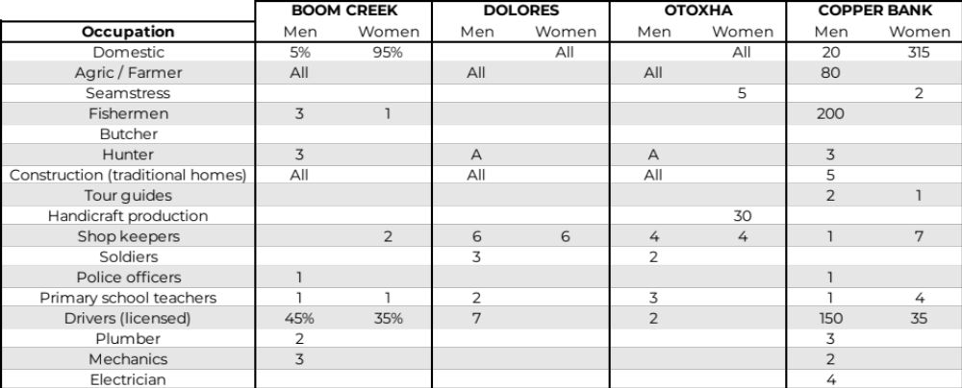
Table 65: Occupations by gender in each community (Source: Compiled from community profiles provided by MRT).

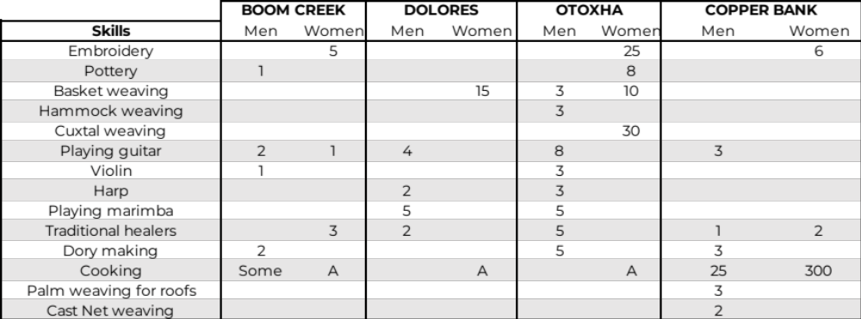
Table 66:. Skills by gender in each community (Source: Compiled from community profiles provided by MRT).
Annex VI: Feedback from indigenous and non-indigenous stakeholders and recommendations on program design.

During the development of SEAM, extensive consultations were held with a wide variety of stakeholders (see Annex II Implementation and Operations Arrangements for a list). In regard to indigenous people, consultations were held with the Maya Leaders Alliance (MLA), Toledo Leaders Alliance (TAA), the Commissioner of Indigenous Peoples Affairs, the Alcaldes of each village and with indigenous villages as a whole through a community meeting utilizing translators. The table below summarizes the main feedback and recommendations received during the consultations.

Issue | Feedback | Recommendations / Impact on project formulation
Overall programme | Consultations revealed that the main interest from IPs was Component 1 – the water distribution system. | Every community stated an urgency to implement the new system and asked that the project was expedited.
Overall | There is a perception of political interference or agenda to receiving the necessary funds, especially if there is a change of political party. | It was highlighted during consultations that the project will have to adhere to strict requirements as established by the Adaptation Fund which would ensure that there is no political interference in the redirection of funds obtained for SEAM.
Environmental and social safeguards | During the consultation with the MLA and TAA there was concern over awareness and following FPIC protocol and ensuring consideration of the communities’ priorities. Additionally, it was pointed out that a grievance redress mechanism needs to be established in a way that is suitable to the remoteness and structures of the indigenous communities.  Further, projects should always consider and respect the rights of the indigenous people.  Consulted representatives also highlighted the need to ensure that the Indigenous People (IP) are consulted throughout the implementation of a project and not only at the beginning. | Established system of on-going consultation as part of the project as well as outline the roles and responsibilities for monitoring, and the mechanisms to address grievances from communities in a transparent manner.
Role of technical assistance | During consultations it was argued that TA should support beneficiaries in the process of accessing credit (e.g. sufficient micro-finance to start producing or acquiring the materials to execute the livelihood being introduced).  It was highlighted that the alternative livelihood activities are inherently weak without support with marketing or an absence of markets for products produced.  Additionally, there was concern there would be insufficient follow-through on the training after the initial capacity building was complete. | It was explained that this project was not a micro-finance project but that the TA for alternative livelihoods would be tailored to expressed needs and interests of the community. Identification of specific places to market the goods produced would be added as can marketing approach for the product.  It will be a requirement that the livelihood option be commercially viable within the existing market infrastructure.  TA should have a financial literacy component.  Emphasis will be placed in ensuring that women from indigenous communities are actively targeted by the TA provider to ensure that they are not excluded from benefitting from the activity.
Grievance redress mechanism | The Maya communities have existing GRM arrangements in place, where differences and conflicts can be heard and adjourned by the Alcalde acting as magistrate (cases up to US$25/BZ$50) for those cases where the Alcalde is unable to adjourn or for which there is an appeal, the case can be presented to the Toledo Alcalde Association. A case can go up to the country’s Supreme Court (advised by Toledo Alcalde’s Association). | Where relevant due to location, the projects will adapt the GRM to integrate the existing customary mechanisms of the Maya villages.  The villages will also be invited to participate in developing the project specific GRMs in their communities.
Wells | Two of the communities’ leaders expressed specific locations for the well to be drilled.  Community members voiced that they wanted to maintain their wells in case the water system failed or to use as an additional water source. | Under component 1, activity 1.1, the design firm will work with the communities and the MRT, utilizing the geo-resistivity results provided by the Hydrological Unit, to identify the most advantageous spot to find water.  The MRT came to agree wells would not be required to be shut down if there was agreement that they would not be used for human consumption (as the impact on tracking water related health issues became complex if multiple sources of water are being consumed). The water could be used for animal and irrigation purposes or for flushing toilets and cleaning.
Temporary Employment | The leaders and community members want the opportunity to be hired as temporary laborers for the construction of the water distribution system and other construction needs of the project. They agree to provide in-kind contribution by digging the trenches to their individual households. | The contractors will either have as a requirement in the ToR, or a strong recommendation, to hire as many local villagers as possible, regardless of gender, and to be involved with all construction that can be outsourced to them. The community discussed doing so at a discounted rate to reflect in-kind contribution if that would increase the chances for opportunities. All rules and regulations for workers would be followed.
Table 67: Community feedback on project design and recommendations

References

1. UCLouvain. EM-DAT, CRED Database. EM-DAT (2023).
2. Mann, P. Overview of the tectonic history of northern Central America. Special Paper of the Geological Society of America vol. 428 1–19 Preprint at https://doi.org/10.1130/2007.2428(01) (2007).
3. Miller, T. E. & -Geologic, H. Controls on Karst and Cave Development in Belize. • Journal of Cave and Karst Studies vol. 58 (1996).
4. Martín-Arias, V. et al. Modeled Impacts of LULC and Climate Change Predictions on the Hydrologic Regime in Belize. Front Environ Sci 10, (2022).
5. World Bank, I. C. for T. A. (CIAT). Climate-Smart Agriculture in Belize, CSA Country Profiles for Latin America and the Caribbean Series. (2018).
6. Karla Juliana Rodríguez-Robayo, M. E. M.-L. A. M.-V. L. J. What do we talk about when we talk about milpa? A conceptual approach to the significance, topics of research and impacts of the maya milpa system. J Rural Stud 77, 47–54 (2020).
7. Bonmatin, J. M. et al. A survey and risk assessment of neonicotinoids in water, soil and sediments of Belize. Environmental Pollution 249, 949–958 (2019).
8. International Fund for Agricultural Development (IFAD). Belize Country Strategy Note. (2021).
9. Huggins, T., Baksh, R. & Associates, C. D. B. Caribbean Development Bank - Country Gender Assessment: Belize. (2016).
10. Richardson, R. B. Belize and Climate Change: The Costs of Inaction 2009 Human Development Issues Paper United Nations Development Programme.
11. WWF Germany. WWF Water Filter Risk Country Indicators - Belize. https://wateractionhubfrontdoor-d6dwaqhbgwebcfg2.z01.azurefd.net/media/files/2020/08/18/Country_Profile_22.pdf (2020).
12. Ministry of Rural Transformation, C. D. L. and L. Government. Annual Technical Report. (2021).
13. Geomedia. Assessment of Groundwater Resources in the Southern Coastal Water Province of Belize Referred to as Savannah Groundwater Province Final Report Volume A. www.geomedia.cz (2014).
14. Ake, J., Waight, K., Romero, J. & Thiagarajan, T. A Study of a Rudimentary Potable Water System in a Rural Community. J Water Resour Prot 07, 449–455 (2015).
15. Waight, K., Ake, J., Romero, J. & Thiagarajan, T. A Preliminary Study of Water Quality in Rural Belize. J Microbiol Res (Rosemead, Calif) 2015, 41–45 (2015).
16. Statistical Institute of Belize. 2010 Census of Population and Housing. www.statisticsbelize.org.bz (2013).
17. Statistical Institute of Belize. Belize Multidimensional Poverty Index - 2021. (2023).
18. UNDP. MDG Accelerator Framework Belize - Water and Sanitation. http://www.undp.org.bz (2011).
19. Dachary, A. C. The Mexico-Belize Border. The Americas: World Boundaries Volume 4 (2002).
20. Williams, A. N. Land in the Caribbean: Issues of Policy, Administration, and Management in the English-Speaking Caribbean. www.terrainstitute.org (2003).
21. Vasquez, A. A., Trejo-Martinez, J. & Ram, J. L. Diversity and parasitic load of freshwater fish of the Shipstern Peninsula, Sarteneja, Corozal District, Belize, Central America from recent collections and historical archives. (2022) doi:10.20944/preprints202212. 0133.v1.
22. Barnes, E. Mangroves as a Solution to the Climate Crisis. WWF https://www.worldwildlife.org/stories/mangroves-as-a-solution-to-the-climate-crisis#:~:text=One%20of%20mangroves%27%20biggest%20strengths,and%20the%20carbon—in%20place (2002).
23. MAR2R (WWF-GEF). Comprehensive and Integrated Watershed Management Plan to Restore and Protect the New River Watershed. https://www.sica.int/documentos/comprehensive-and-integrated-watershed-management-plan-to-restore-and-protect-the-new-river-watershed_1_132273.html (2023).
24. Lohberger, S., Atwood, E. C., Cornish, N., Mott, C. & Siegert, F. Second Measurement of Seagrass and Mangrove Area Cover in the Five Marine and Coastal Priority Protected Areas of Phase II of the MAR Fund Project Manatee Sanctuary State Reserve Bahía de Chetumal, Mexico. www.rssgmbh.de.
25. Meerman, J. Forest Cover and Change in Corozal District (2005-2011-2015). Belize Tropical Forest Studies (2015).
26. National Oceanic and Atmospheric Administration. What is Blue Carbon? National Ocean Service: (2023).
27. UNDP, N. S. Knowledge and Attitudes and Practice Study on Climate Change - Belize. (2016).
28. UN Women. Gender Inequality of Climate Change and Disaster Risk in Belize. (2021).
29. Drexler, K. A Community Capitals Assessment of Climate Adaptations to Traditional Milpa Farming Practices in Mayan Communities of Southern Belize. Climate 10, (2022).
30. Commonwealth Secretariat. National Climate Finance Strategy of Belize 2021–2026. (2021).
31. Ministry of Economic Development. Medium-Term Development Strategy: Belize. (2022).
32. Belize Enterprise for Sustainable Technology (BEST). National Adaptation Strategy and Action Plan to Address Climate Change in the Water Sector of Belize. http://www.caribbeanclimate.bz (2009).
33. National Climate Change Office. Belize’s 4th National Communication National Climate Change Office, Ministry of Sustainable Development, Climate Change and Disaster Risk Management.
34. Svahn, K. Women’s Role and Participation in Water Supply Management-The Case Study of the Republic of Ghana. (Uppsala Universitet, Stokholm, 2011).
35. Achouri, M. & Tennyson, L. Preparing for the next Generation of Watershed Management Programmes and Projects. (2002).
36. Swallow, B., Onyango, L. & Meinzen-Dick, R. Catchment Property Rights and the Case of Kenya’s Nyando Basin. in Proceedings of the African Workshop (FAO, 2003).
37. Bonnal, J. The Sociological Approach in Watershed Management: From Participation to Decentralization. in Proceedings of the African Workshop (ed. Swallow) (FAO, FORC, Nairobi, 2005).
38. Gender Water Alliance (GWA) & United Nations Development Programme (UNDP). Mainstreaming Gender in Water Management. (2006).

Single Country and Regional Concept proposals should complete Part I and Part II of the Project Proposal Template.
Thematic areas are: Agriculture, Coastal Zone Management, Disaster risk reduction, Food security, Forests, Human health, Innovative climate finance , Marine and Fisheries, Nature-based solutions and ecosystem based adaptation, Protection and enhancement of cultural heritage, Social innovation, Rural development, Urban adaptation, Water management, Wildfire Management.
Annex V: SIA, 90.
Annex IV: SIA, 62.
Annex I: Geography, Geology, Climate, 2.
A Lower score indicates lower risk.
Annex VI: SIA, S.179; S.212; S.270.
FAO. 2011. Country Programming Framework (CPF) 2011-2015 for Belize
During field consultations, it was indicated that several NGOs, Missionaries, and Government Projects provided the Village with Solar Panels, Pit Latrines, and other solutions, which were well received by some members of the community, but not necessarily with widespread adoption.
During field consultations, the MRT field officer indicated that community participants could not read the sign-in sheet for the community meeting in Q’eqchi’ Maya.
Annex IV: SIA, S.232
Annex IV: SIA, S.230.
Annex IV: SIA, S.224
Annex IV: SIA, S.235.
Annex IV: SIA, S.239.
Annex IV: SIA. S. 277.
Annex IV: SIA, S. 270.
Comprehensive and Integrated Watershed Management Plan to Restore and Protect the New River Watershed 2021
Annex III: Log Frame, Theory of Change
Recent WFP in nearby Guatemala suggests incomes in the US$ 500, IFAD Be-Resilient, a GCF funded project, demonstrates similar figures.
Activity 8.1 addresses these items at an institutional level.
Strategic Environmental and Social Assessment Final Report - Promoting Sustainable Growth in the Blue Economy Program (Burgos E. (2023).
IFAD does not indicate which rural roads will be improved. So far one road is being improved (Nago Road) in the Belize District.
A Memorandum of Understanding (MOU) will be established between the Village Council and the MRT detailed the responsivities in each party.
Water Board members have been trained on village Water Board regulations in the Village Council Act Chapter 88, Revised Edition 2003, which outlines their obligations and duties and ensure the abilities.
https://spcommreports.ohchr.org/TmSearch/Mandates?m=26
^{6.} Each Party shall designate and communicate to the secretariat the authority that will endorse on behalf of the national government the projects and programmes proposed by the implementing entities.
Manual para la Restauración Ecológica de Manglares del Sistema Arrecifal Mesoamericano y el Gran Caribe (2021).
The Development Finance Corporation is Belize’s only Development Bank. Their purpose is to support the strengthening and expansion of Belize’s economy by providing developmental financing on an economically sustainable and environmentally acceptable basis to individuals, businesses, and organizations. For more information, visit: https://www.dfcbelize.org/who-we-are/
More information at: https://www.worldbank.org/en/publication/globalfindex#sec3
The “Indigenous Female Solar Engineers Scaling up Solar Energy to Machakilha and Graham Creek Villages- Belize’s Most Rural and Remote Communities” project was financed by the GEF Small Grants Programme, implemented by UNDP.
These Activities 3.1 and 4.1, and their sub-activities are to be implemented under the same grant (one grant for Toledo District, one for Corozal District).
These Activities 3.1 and 4.1, and their sub-activities are to be implemented under the same grant (one grant for Toledo District, one for Corozal District).
PACT can make available a Final Consultation Report that provides detailed account of consultations. Also, the Annex IV “Social Impact Assessment” provides an in-depth assessment of Maya communities.

